Code: 20CS3503, 20IT3503
PVP 20
III B.Tech - I Semester – Regular / Supplementary Examinations NOVEMBER 2023

COMPUTER NETWORKS
(Common for CSE & IT)

Detailed Solution Set

1 a) Examine the need of layering. Draw the seven layers of OSI model and explain the function of each layer in detail. 7 M
Need of layering- 2 marks
OSI model diagram with description- 5 marks
Need for Layering:
- Protocol layering enables us to divide a complex task into several smaller and simpler tasks
- Protocol layering allows us to separate the services from the implementation.
- Another advantage of protocol layering, which cannot be seen in our simple examples but reveals itself when we discuss protocol layering in the Internet, is that communication does not always use only two end systems; there are intermediate systems that need only some layers, but not all layers. If we did not use protocol layering, we would have to make each intermediate system as complex as the end systems, which makes the whole system more expensive.

OSI Model:
Open Systems Interconnection (OSI) model. It was first introduced in the late 1970s.An open system is a set of protocols that allows any two different systems to communicate regardless of their underlying architecture. The purpose of the OSI model is to show how to facilitate communication between different systems without requiring changes to the logic of the underlying hardware and software. The OSI model is not a protocol; it is a model for understanding and designing a network architecture that is flexible, robust, and interoperable. The OSI model was intended to be the basis for the creation of the protocols in the OSI stack.
The OSI model is a layered framework for the design of network systems that allows communication between all types of computer systems. It consists of seven separate but related layers, each of which defines a part of the process of moving information across a network.

Physical Layer: The lowest layer of the OSI Model is concerned with electrically or optically transmitting raw unstructured data bits across the network from the physical layer of the sending device to the physical layer of the receiving device. It can include specifications such as voltages, pin layout, cabling, and radio frequencies. At the physical layer, one might find “physical” resources such as network hubs, cabling, repeaters, network adapters or modems.

Data Link Layer: At the data link layer, directly connected nodes are used to perform node-to-node data transfer where data is packaged into frames. The data link layer also corrects errors that may have occurred at the physical layer.

The data link layer encompasses two sub-layers of its own. The first, media access control (MAC), provides flow control and multiplexing for device transmissions over a network. The second, the logical link control (LLC), provides flow and error control over the physical medium as well as identifies line protocols.

Network Layer: The network layer is responsible for receiving frames from the data link layer, and delivering them to their intended destinations among based on the addresses contained inside the frame. The network layer finds the destination by using logical addresses, such as IP (internet protocol). At this layer, routers are a crucial component used to quite literally route information where it needs to go between networks.

Transport Layer: The transport layer manages the delivery and error checking of data packets. It regulates the size, sequencing, and ultimately the transfer of data between systems and hosts. One of the most common examples of the transport layer is TCP or the Transmission Control Protocol.
Session Layer: The session layer controls the conversations between different computers. A session or connection between machines is set up, managed, and termined at layer 5. Session layer services also include authentication and reconnections.

Presentation Layer: The presentation layer formats or translates data for the application layer based on the syntax or semantics that the application accepts. Because of this, it at times also called the syntax layer. This layer can also handle the encryption and decryption required by the application layer.

Application Layer: At this layer, both the end user and the application layer interact directly with the software application. This layer sees network services provided to end-user applications such as a web browser or Office 365. The application layer identifies communication partners, resource availability, and synchronizes communication.
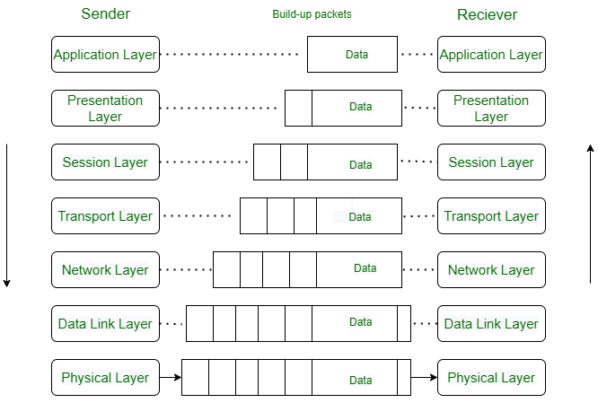

1 b) A bit stream 1101010100110 is transmitted using the standard CRC method. The generator polynomial is x⁵+x+1. What is the actual bit string transmitted? Calculate CRC at the receiver side also, and find out is there any error. 7 M
CRC Computation- 5 marks
CRC Validation- 2 marks

Data: 1101010100110
Generator polynomial is x⁵+x+1 = 100011

CRC Calculations at senders side:

100011) | 1 | 1 | 0 | 1 | 0 | 1 | 0 | 1 | 0 | 0 | 1 | 1 | 0 | 0 | 0 | 0 | 0 | 0 | (1101111000100
 | 1 | 0 | 0 | 0 | 1 | 1
 | x | 1 | 0 | 1 | 1 | 0 | 0
 |  | 1 | 0 | 0 | 0 | 1 | 1
 |  | x | 0 | 1 | 1 | 1 | 1 | 1
 |  |  | 0 | 0 | 0 | 0 | 0 | 0
 |  |  | x | 1 | 1 | 1 | 1 | 1 | 0
 |  |  |  | 1 | 0 | 0 | 0 | 1 | 1
 |  |  |  | x | 1 | 1 | 1 | 0 | 1 | 0
 |  |  |  |  | 1 | 0 | 0 | 0 | 1 | 1
 |  |  |  |  | x | 1 | 1 | 0 | 0 | 1 | 1
 |  |  |  |  |  | 1 | 0 | 0 | 0 | 1 | 1
 |  |  |  |  |  | x | 1 | 0 | 0 | 0 | 0 | 1
 |  |  |  |  |  |  | 1 | 0 | 0 | 0 | 1 | 1
 |  |  |  |  |  |  | x | 0 | 0 | 0 | 1 | 0 | 0
 |  |  |  |  |  |  |  | 0 | 0 | 0 | 0 | 0 | 0
 |  |  |  |  |  |  |  | x | 0 | 0 | 1 | 0 | 0 | 0
 |  |  |  |  |  |  |  |  | 0 | 0 | 0 | 0 | 0 | 0
 |  |  |  |  |  |  |  |  | x | 0 | 1 | 0 | 0 | 0 | 0
 |  |  |  |  |  |  |  |  |  | 0 | 0 | 0 | 0 | 0 | 0
 |  |  |  |  |  |  |  |  |  | x | 1 | 0 | 0 | 0 | 0 | 0
 |  |  |  |  |  |  |  |  |  |  | 1 | 0 | 0 | 0 | 1 | 1
 |  |  |  |  |  |  |  |  |  |  | x | 0 | 0 | 0 | 1 | 1 | 0
 |  |  |  |  |  |  |  |  |  |  |  | 0 | 0 | 0 | 0 | 0 | 0
 |  |  |  |  |  |  |  |  |  |  |  | x | 0 | 0 | 1 | 1 | 0 | 0
 |  |  |  |  |  |  |  |  |  |  |  |  | 0 | 0 | 0 | 0 | 0 | 0
 |  |  |  |  |  |  |  |  |  |  |  |  | x | 0 | 1 | 1 | 0 | 0

The transmitted Frame is: 110101010011001100

At the receiver side if we compute CRC
- If we will get the reminder as all 0’s then the transmitted frame is correct .
- If the reminder is other than all 0’s that means there is some error occurred in the frame during transmission.

2 a) Explain guided transmission media in detail. 7 M
Guided media-4 marks
Unguided media- 3 marks
Guided media, which are those that provide a conduit from one device to another, include twisted-pair cable, coaxial cable, and fiber-optic cable. A signal traveling along any of these media is directed and contained by the physical limits of the medium. Twisted-pair and coaxial cable use metallic (copper) conductors that accept and transport signals in the form of electric current. Optical fiber is a cable that accepts and transports signals in the form of light.

Twisted-Pair Cable:
A twisted pair consists of two conductors (normally copper), each with its own plastic insulation, twisted together, as shown in Figure

One of the wires is used to carry signals to the receiver, and the other is used only as a ground reference. The receiver uses the difference between the two. In addition to the signal sent by the sender on one of the wires, interference (noise) and crosstalk may affect both wires and create unwanted signals. The most common twisted-pair cable used in communications is referred to as
unshielded twisted-pair (UTP). IBM has also produced a version of twisted-pair cable for its use, called shielded twisted-pair (STP). STP cable has a metal foil or braidedmesh covering that encases each pair of insulated conductors. Although metal casing improves the quality of cable by preventing the penetration of noise or crosstalk, it is bulkier and more expensive. The most common UTP connector is RJ45. Twisted-pair cables are used in telephone lines to provide voice and data channels.

Coaxial Cable:
Coaxial cable (or coax) carries signals of higher frequency ranges than those in twistedpair cable, in part because the two media are constructed quite differently. Instead of having two wires, coax has a central core conductor of solid or stranded wire (usually copper) enclosed in an insulating sheath, which is, in turn, encased in an outer conductor of metal foil, braid, or a combination of the two. The outer metallic wrapping serves both as a shield against noise and as the second conductor, which completes the circuit. This outer conductor is also enclosed in an insulating sheath, and the whole cable is protected by a plastic cover. Coaxial cables are categorized by their Radio Government (RG) ratings.

To connect coaxial cable to devices, we need coaxial connectors. The most common type of connector used today is the Bayonet Neill-Concelman (BNC) connector. Coaxial cable was widely used in analog telephone networks where a single coaxial network could carry 10,000 voice signals.

Fiber-Optic Cable:
A fiber-optic cable is made of glass or plastic and transmits signals in the form of light. Optical fibers use reflection to guide light through a channel. A glass or plastic core is surrounded by a cladding of less dense glass or plastic. The difference in density of the two materials must be such that a beam of light moving through the core is reflected off the cladding instead of being refracted into it.

The outer jacket is made of either PVC or Teflon. Inside the jacket are Kevlar strands to strengthen the cable. Kevlar is a strong material used in the fabrication of bulletproof vests. Below the Kevlar is another plastic coating to cushion the fiber. The fiber is at the center of the cable, and it consists of cladding and core. The subscriber channel (SC) connector is used for cable TV. It uses a push/pull locking system. The straight-tip (ST) connector is used for connecting cable to networking devices. It uses a bayonet locking system and is more reliable than SC. Fiber-optic cable is often found in backbone networks because its wide bandwidth is
cost-effective.

2 b) Explain the operation of ARP with an example. 7 M
About ARP- 2 marks
Description of ARP with Example- 5 marks

ARP accepts an IP address from the IP protocol, maps the address to the corresponding link-layer address, and passes it to the data-link layer.The ARP protocol is one of the auxiliary protocols defined in the network layer. Anytime a host or a router needs to find the link-layer address of another host or router in its network, it sends an ARP request packet. The packet includes the link-layer and IP addresses of the sender and the IP address of the receiver. Because the sender does not know the link-layer address of the receiver, the query is broadcast over the link using the link-layer broadcast address. Every host or router on the network receives and processes the ARP request packet, but only the intended recipient recognizes its IP address and sends back an ARP response packet. The response packet contains the recipient’s IP and link-layer addresses. The packet is unicast directly to the node that sent the request packet.

Example:
In Figure below, the system on the left (A) has a packet that needs to be delivered to another system (B) with IP address N2. System A needs to pass the packet to its data-link layer for the actual delivery, but it does not know the physical address of the recipient. It uses the services of ARP by asking the ARP protocol to send a broadcast ARP request packet to ask for the physical address of a system with an IP address of N2.
This packet is received by every system on the physical network, but only system B will answer it, as shown in Figure b. System B sends an ARP reply packet that includes its physical address. Now system A can send all the packets it has for this destination using the physical address it received.

3 a) What is packet switching? Explain in detail the datagram approach with the help of diagram. 7 M
About packet switching- 2 marks
Description of Datagram approach with example- 5 marks

Although in data communication switching techniques are divided into two broad categories, circuit switching and packet switching, only packet switching is used at the network layer because the unit of data at this layer is a packet. Circuit switching is mostly used at the physical layer; the electrical switch mentioned earlier is a kind of circuit switch.

At the network layer, a message from the upper layer is divided into manageable packets and each packet is sent through the network. The source of the message sends the packets one by one; the destination of the message receives the packets one by one. The destination waits for all packets belonging to the same message to arrive before delivering the message to the upper layer. The connecting devices in a packet-switched network still need to decide how to route the packets to the final destination. Today, a packet-switched network can use two different approaches to route the packets: the datagram approach and the virtual circuit approach.

Datagram Approach: Connectionless Service
When the Internet started, to make it simple, the network layer was designed to provide a connectionless service in which the network-layer protocol treats each packet independently, with each packet having no relationship to any other packet. The idea was that the network layer is only responsible for delivery of packets from the source to the destination. In this approach, the packets in a message may or may not travel the same path to their destination. When the network layer provides a connectionless service, each packet traveling in the Internet is an independent entity; there is no relationship between packets belonging to the same message. The switches in this type of network are called routers. A packet belonging to a message may be followed by a packet belonging to the same message or to a different message. A packet may be followed by a packet coming from the same or from a different source.
Each packet is routed based on the information contained in its header: source and destination addresses. The destination address defines where it should go; the source address defines where it comes from. The router in this case routes the packet based only on the destination address. The source address may be used to send an error message to the source if the packet is discarded. Figure below shows the forwarding process in a router in this case. We have used symbolic addresses such as A and B.

3 b) What parameters are used in measuring the performance of a network? Explain the types of Delays and how they are calculated? 7 M
List of network performance metrics- 2 marks
Example description of each metric- 5 marks

The performance of a network can be measured in terms of delay, throughput, and packet loss.

Delay
All of us expect instantaneous response from a network, but a packet, from its source to its destination, encounters delays. The delays in a network can be divided into four types: transmission delay, propagation delay, processing delay, and queuing delay.
1. Transmission Delay
A source host or a router cannot send a packet instantaneously. A sender needs to put the bits in a packet on the line one by one. If the first bit of the packet is put on the line at time t1 and the last bit is put on the line at time t2, transmission delay of the packet is (t2 − t1). Definitely, the transmission delay is longer for a longer packet and shorter if the sender can transmit faster. In other words, the transmission delay is
Delay_{tr} = (Packet length) / (Transmission rate).

2. Propagation Delay
Propagation delay is the time it takes for a bit to travel from point A to point B in the transmission media. The propagation delay for a packet-switched network depends on the propagation delay of each network (LAN or WAN). The propagation delay depends on the propagation speed of the media, which is 3 × 108 meters/second in a vacuum and normally much less in a wired medium; it also depends on the distance of the link. In other words, propagation delay is
Delay_{pg} = (Distance) / (Propagation speed).

3. Processing Delay
The processing delay is the time required for a router or a destination host to receive a packet from its input port, remove the header, perform an error detection procedure, and deliver the packet to the output port (in the case of a router) or deliver the packet to the upper-layer protocol (in the case of the destination host). The processing delay may be different for each packet, but normally is calculated as an average.
Delay_{pr} = Time required to process a packet in a router or a destination host

4. Queuing Delay
Queuing delay can normally happen in a router. As we discuss in the next section, a router has an input queue connected to each of its input ports to store packets waiting to be processed; the router also has an output queue connected to each of its output ports to store packets waiting to be transmitted. The queuing delay for a packet in a router is measured as the time a packet waits in the input queue and output queue of a router.
Delay_{qu} = The time a packet waits in input and output queues in a router

5. Total Delay
Assuming equal delays for the sender, routers, and receiver, the total delay (source-to destination delay) a packet encounters can be calculated if we know the number of routers, n, in the whole path.
Total delay = (n + 1) (Delay_{tr} + Delay_{pg} + Delay_{pr}) + (n) (Delay_{qu})
Note that if we have n routers, we have (n + 1) links. Therefore, we have (n + 1) transmission delays related to n routers and the source, (n + 1) propagation delays related to (n + 1) links, (n + 1) processing delays related to n routers and the destination, and only n queuing delays related to n routers.

4 a) Both NAT and DHCP can solve the problem of a shortage of addresses in an organization, but by using different strategies. Justify the usage of each of these strategies. 7 M
Small note on NAT - 2 marks
Small note on DHCP- 2 marks
Justification of answer whether NAT and DHCP solve the problem of shortage in an organization- 3marks

Network Address Resolution (NAT)

The distribution of addresses through ISPs has created a new problem. Assume that an ISP has granted a small range of addresses to a small business or a household. If the business grows or the household needs a larger range, the ISP may not be able to grant the demand because the addresses before and after the range may have already been allocated to other networks. In most situations, however, only a portion of computers in a small network need access to the Internet simultaneously. This means that the number of allocated addresses does not have to match the number of computers in the network.

For example, assume that in a small business with 20 computers the maximum number of computers that access the Internet simultaneously is only 4. Most of the computers are either doing some task that does not need Internet access or communicating with each other. This small business can use the TCP/IP protocol for both internal and universal communication. The business can use 20 (or 25) addresses from the private block addresses (discussed before) for internal communication; five addresses for universal communication can be assigned by the ISP.
A technology that can provide the mapping between the private and universal addresses, and at the same time support virtual private networks, is Network Address Translation (NAT). The technology allows a site to use a set of private addresses for internal communication and a set of global Internet addresses (at least one) for communication with the rest of the world. The site must have only one connection to the global Internet through a NAT-capable router that runs
NAT software.

As the figure shows, the private network uses private addresses. The router that connects the network to the global address uses one private address and one global address. The private network is invisible to the rest of the Internet; the rest of the Internet sees only the NAT router with the address 200.24.5.8. All of the outgoing packets go through the NAT router, which replaces the source address in the packet with the global NAT address. All incoming packets also pass through the NAT router, which replaces the destination address in the packet (the NAT router global address) with the appropriate private address. Figure shows an example of address translation.

Dynamic Host Configuration Protocol (DHCP):

After a block of addresses are assigned to an organization, the network administration can manually assign addresses to the individual hosts or routers. However, address assignment in an organization can be done automatically using the Dynamic Host Configuration Protocol (DHCP). DHCP is an application-layer program, using the client-server paradigm, that actually helps TCP/IP at the network layer. DHCP has found such widespread use in the Internet that it is often called a plug and-play protocol. In can be used in many situations. A network manager can configure DHCP to assign permanent IP addresses to the host and routers. DHCP can also be configured to provide temporary, on demand, IP addresses to hosts. The second capability can provide a temporary IP address to a traveller to connect her laptop to the Internet while she is staying in the hotel. It also allows an ISP with 1000 granted addresses to provide services to 4000 households, assuming not more than one-forth of customers use the Internet at the same time.

Justification
NAT and DHCP contribute to effective IP address management, they are part of a broader set of strategies an organization should consider to address IP address shortages, with IPv6 adoption being a fundamental solution for long-term scalability.

4 b) Explain IPv6 header Format. How it is differentiated from IPv4? 7 M
IPv6 header Format-5 marks
Differences of IPv4 and IPv6- 2marks

The IPv6 packet is shown in Figure. Each packet is composed of a base header followed by the payload. The base header occupies 40 bytes, whereas payload can be up to 65,535 bytes of information.
The description of fields follows.
- Version. The 4-bit version field defines the version number of the IP. For IPv6, the value is 6.
- Traffic class. The 8-bit traffic class field is used to distinguish different payloads with different delivery requirements. It replaces the type-of-service field in IPv4.
- Flow label. The flow label is a 20-bit field that is designed to provide special handling for a particular flow of data. We will discuss this field later.
- Payload length. The 2-byte payload length field defines the length of the IP datagram excluding the header. Note that IPv4 defines two fields related to the length: header length and total length. In IPv6, the length of the base header is fixed (40 bytes); only the length of the payload needs to be defined.
- Next header. The next header is an 8-bit field defining the type of the first extension header (if present) or the type of the data that follows the base header in the datagram. This field is similar to the protocol field in IPv4, but we talk more about it when we discuss the payload.
- Hop limit. The 8-bit hop limit field serves the same purpose as the TTL field in IPv4.
- Source and destination addresses. The source address field is a 16-byte (128-bit) Internet address that identifies the original source of the datagram. The destination address field is a 16-byte (128-bit) Internet address that identifies the destination of the datagram.
- Payload. Compared to IPv4, the payload field in IPv6 has a different format and meaning, as shown in Figure. The payload in IPv6 means a combination of zero or more extension headers (options) followed by the data from other protocols (UDP, TCP, and so on). In IPv6, options, which are part of the header in IPv4, are designed as extension headers. The payload can have as many extension headers as required by the situation.
Comparison of Options between IPv4 and IPv6:
The following shows a quick comparison between the options used in IPv4 and the options used in IPv6 (as extension headers).
- The no-operation and end-of-option options in IPv4 are replaced by Pad1 and PadN options in IPv6.
- The record route option is not implemented in IPv6 because it was not used.
- The timestamp option is not implemented because it was not used.
- The source route option is called the source route extension header in IPv6.
- The fragmentation fields in the base header section of IPv4 have moved to the fragmentation extension header in IPv6.
- The authentication extension header is new in IPv6.
- The encrypted security payload extension header is new in IPv6.

5 a) Describe about Distance Vector Routing with an example. What are its limitations?
7 M
Distance Vector Routing with example- 5 marks
Limitation of DVR- 2 marks

Distance-Vector Routing:
The distance-vector (DV) routing is used to find the best route. In distance-vector routing, the first thing each node creates is its own least-cost tree with the rudimentary information it has about its immediate neighbors. The incomplete trees are exchanged between immediate neighbors to make the trees more and more complete and to represent the whole internet. We can say that in distance-vector routing, a router continuously tells all of its neighbors what it knows
about the whole internet (although the knowledge can be incomplete). The heart of distance-vector routing is the famous Bellman-Ford equation. This equation is used to find the least cost (shortest distance) between a source node, x, and a destination node, y, through some intermediary nodes (a, b, c, . . .) when the costs between the source and the intermediary nodes and the least costs between the intermediary nodes and the destination are given. The concept of a distance vector is the rationale for the name distance-vector routing. A least-cost tree is a combination of least-cost paths from the root of the tree to all destinations. These paths are graphically glued together to form the tree. Distance-vector routing unglues these paths and creates a distance vector, a one-dimensional array to represent the tree.

Each node in an internet, when it is booted, creates a very rudimentary distance vector with the minimum information the node can obtain from its neighborhood. The node sends some greeting messages out of its interfaces and discovers the identity of the immediate neighbors and the distance between itself and each neighbor. It then makes a simple distance vector by inserting the discovered distances in the corresponding cells and leaves the value of other cells as infinity. These rudimentary vectors cannot help the internet to effectively forward a packet.
For example, node A thinks that it is not connected to node G because the corresponding cell shows the least cost of infinity. To improve these vectors, the nodes in the internet need to help each other by exchanging information. After each node has created its vector, it sends a copy of the vector to all its immediate neighbors. After a node receives a distance vector from a neighbor, it updates its distance vector using the Bellman-Ford equation (second case). However, we need to understand that we need to update, not only one least cost, but N of them in which N is the number of the nodes in the internet. If we are using a program, we can do this using a loop; if we are showing the concept on paper, we can show the whole vector instead of the N separate equations. We show the whole vector instead of seven equations for each update in Figure.

Limitations of Distance Vector Routing:

Count to Infinity: A problem with distance-vector routing is that any decrease in cost (good news) propagates quickly, but any increase in cost (bad news) will propagate slowly. For a routing protocol to work properly, if a link is broken (cost becomes infinity), every other router
should be aware of it immediately, but in distance-vector routing, this takes some time. The problem is referred to as count to infinity. It sometimes takes several updates before the cost for a broken link is recorded as infinity by all routers.

5 (b)
Need of fragmentation- 4 marks.
Example- 3 marks.
Need of Fragmentation:
Identification, Flags, and Fragmentation Offset are related to the fragmentation of the IP datagram when the size of the datagram is larger than the underlying network can carry.

The 16-bit identification field identifies a datagram originating from the source host. The combination of the identification and source IP address must uniquely define a datagram as it leaves the source host. When the IP protocol sends a datagram, it copies the current value of the counter to the identification field and increments the counter by one. As long as the counter is kept in the main memory, uniqueness is guaranteed. When a datagram is fragmented, the value in the identification field is copied into all fragments.

The 3-bit flags field defines three flags. The leftmost bit I s reserved (not used). The second bit (D bit) is called the do not fragment bit. If its value is 1, the machine must not fragment the datagram. If it cannot pass the datagram through any available physical network, it discards the datagram and sends an ICMP error message to the source host (discussed later). If its value is 0, the datagram can be fragmented if necessary. The third bit (M bit) is called the more fragment bit. If its value is 1, it means the datagram is not the last fragment; there are more fragments after this one. If its value is 0, it means this is the last or only fragment.

The 13-bit fragmentation offset field shows the relative position of this fragment with respect to the whole datagram. It is the offset of the data in the original datagram measured in units of 8 bytes. Figure 19.6 shows a datagram with a data size of 4000 bytes fragmented into three fragments. The bytes in the original datagram are numbered 0 to 3999. The first fragment carries bytes 0 to 1399. The offset for this datagram is 0/8 = 0. The second fragment carries bytes 1400 to 2799; the offset value for this fragment is 1400/8 = 175. Finally, the third fragment carries bytes 2800 to 3999. The offset value for this fragment is 2800/8 = 350. Remember that the value of the offset is measured in units of 8 bytes. This is done because the length of the offset field is only 13 bits long and cannot represent a sequence of bytes greater than 8191. This forces hosts or routers that fragment datagrams to choose the size of each fragment so that the first byte number is divisible by 8.

Example:
6 (a)
Border Gateway Protocol (BGP) with examples- 4 marks
BGP Routing functionality with description- 3 marks

Border Gateway Protocol (BGP):
- It is the only interdomain routing protocol used in the Internet today.
- BGP4 is based on the path-vector algorithm.
- Example of an internet with four autonomous systems. AS2, AS3, and AS4 are stub autonomous systems; AS1 is a transient one. In our example, data exchange between AS2, AS3, and AS4 should pass through AS1.
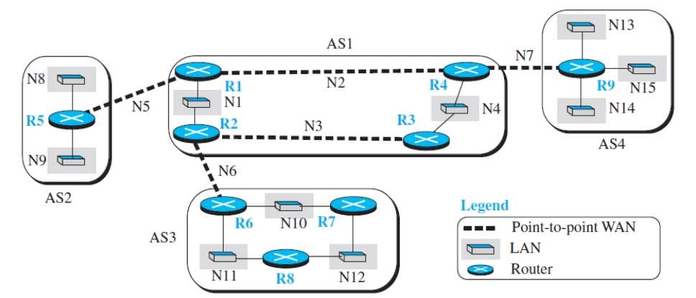
- Each autonomous system uses one of the two common intradomain protocols, RIP or OSPF.
- BGP Routing functionality:
- To enable each router to route a packet to any network in the internet:
  - A variation of BGP4, called external BGP (eBGP) on each border router (the one at the edge of each AS which is connected to a router at another AS).
  - We then install the second variation of BGP, called internal BGP (iBGP), on all routers.
  - This means that the border routers will be running three routing protocols (intradomain, eBGP, and iBGP), but other routers are running two protocols (intradomain and iBGP).
  - Operation of External BGP (eBGP)
    - BGP is a kind of point-to-point protocol.
    - BGP software installed on routers create a TCP connection using the well-known port 179.
    - The two routers that run the BGP processes are called BGP peers or BGP speakers.
    - The eBGP variation of BGP allows two physically connected border routers in two different ASs to form pairs of eBGP speakers and exchange messages.
    - Each logical connection in BGP parlance is referred to as a session.
    - The messages exchanged during three eBGP sessions help some routers know how to route packets to some networks in the internet, but the reachability information is not complete.
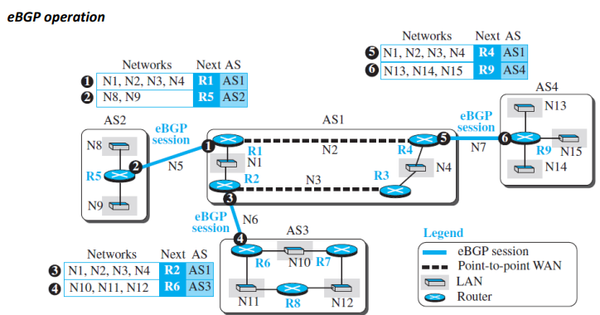
- Operation of Internal BGP (iBGP)
  - The iBGP protocol is similar to the eBGP protocol in that it uses the service of TCP on the well-known port 179
  - It creates a session between any possible pair of routers inside an autonomous system.
  - If an AS has only one router, there cannot be an iBGP session.
  - If there are n routers in an autonomous system, there should be [n × (n − 1) / 2] iBGP sessions in that autonomous system (a fully connected mesh) to prevent loops in the system.
  - Each router needs to advertise its own reachability to the peer in the session instead of flooding what it receives from another peer in another session.
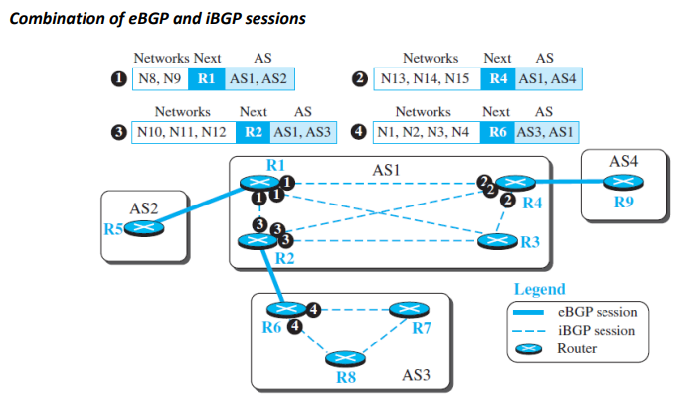
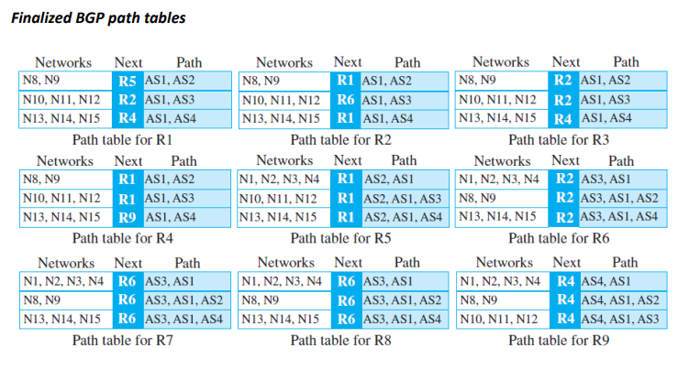
6 (b)
Definition of routing – 1 mark
Link state routing algorithm description- 3 marks
Example of link state routing algorithm- 3 marks

Routing:
Routing is the process of path selection in any network. A computer network is made of many machines, called nodes, and paths or links that connect those nodes. Communication between two nodes in an interconnected network can take place through many different paths.

Link-State Routing Algorithm:
- A routing algorithm that directly follows our discussion for creating leastcost trees and forwarding tables is link-state (LS) routing.
- This method uses the term link-state to define the characteristic of a link (an edge) that represents a network in the internet.
- In this algorithm the cost associated with an edge defines the state of the link. Links with lower costs are preferred to links with higher costs; if the cost of a link is infinity, it means that the link does not exist or has been broken.
- To create a least-cost tree with this method, each node needs to have a complete map of the network, which means it needs to know the state of each link. The collection of states for all links is called the link-state database (LSDB).
- Each node can send some greeting messages to all its immediate neighbors collect two pieces of information for each neighboring node: the identity of the node and the cost of the link. The combination of these two pieces of information is called the LS packet (LSP); the LSP is sent out of each interface. This can be done by a process called flooding.
- When a node receives an LSP from one of its interfaces, it compares the LSP with the copy it may already have. If the newly arrived LSP is older than the one it has (found by checking the sequence number), it discards the LSP. If it is newer or the first one received, the node discards the old LSP (if there is one) and keeps the received one. It then sends a copy of it out of each interface except the one from which the packet arrived. This guarantees that flooding stops somewhere in the network (where a node has only one interface). Once all LSP of all nodes are received at each node, each node creates LSDB.
- It then calculates the spanning tree/ least cost tree using Dijstraw’s Algorithm and LDSB.

Example:
LSPs created and sent out by each node to build LSDB
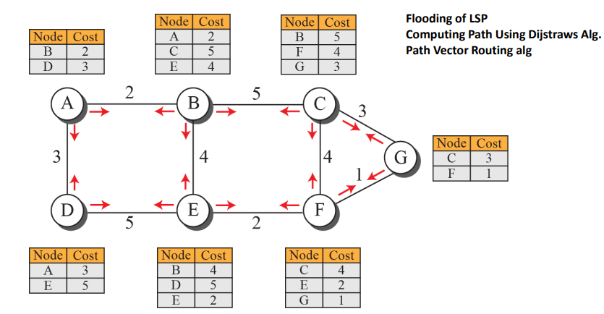
Example of a link-state database
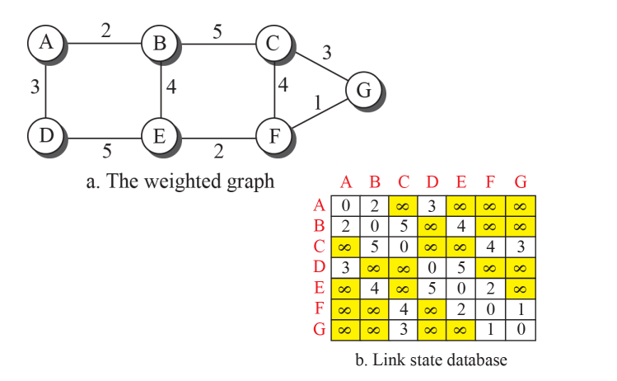
Least-cost tree
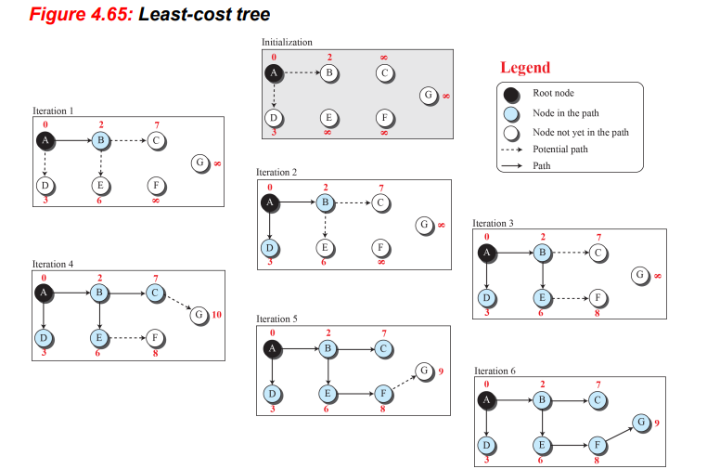

7 (a)
TCP Connection Management- 7 marks

TCP Connection Management
- TCP is connection-oriented; a connection-oriented transport protocol establishes a logical path between the source and destination.
- All of the segments belonging to a message are then sent over this logical path.
- Using a single logical pathway for the entire message facilitates the acknowledgment process as well as retransmission of damaged or lost frames.
- Phases of Connection management:
  - Connection Establishment
    - Three-Way Handshaking
  - Data Transfer
    - Pushing Data
    - Urgent Data
  - Connection Termination
    - Three-Way Handshaking
    - Half-Close
Connection Establishment
- TCP transmits data in full-duplex mode.
- The connection establishment in TCP is called three-way handshaking.
- The process starts with the server. The server program tells its TCP that it is ready to accept a connection. This request is called a passive open.
- The client program issues a request for an active open.
- The connection establishment is done by exchanging 3 messages between the two parties:
  - SYN segment- A SYN segment cannot carry data, but it consumes one sequence number
  - SYN + ACK segment- A SYN + ACK segment cannot carry data, but it does consume one sequence number.
  - ACK segment- An ACK segment, if carrying no data, consumes no sequence number
. 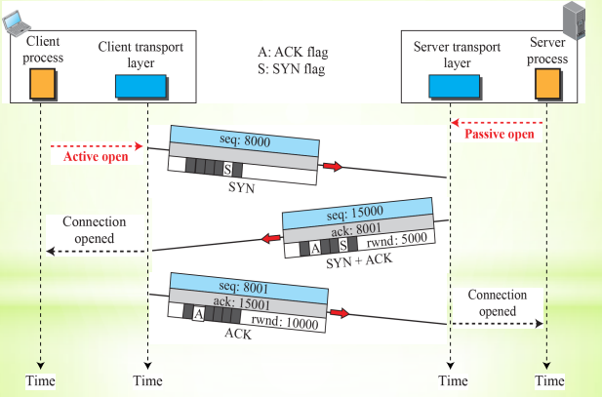

Data transfer
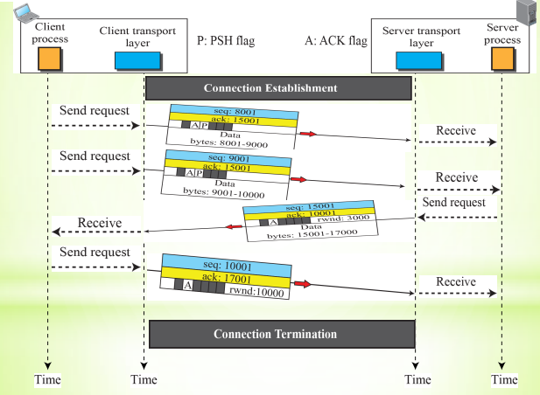
Connection Termination
- Most implementations today allow two options for connection termination: three-way handshaking and four-way handshaking with a half-close option.
- Three-way handshaking for connection termination includes exchange of three messages between the two parties:
  - FIN segment- The FIN segment consumes one sequence number if it does not carry data.
  - FIN + ACK segment- The FIN + ACK segment consumes only one sequence number if it does not carry data.
  - ACK segment
- Connection termination using three-way handshaking
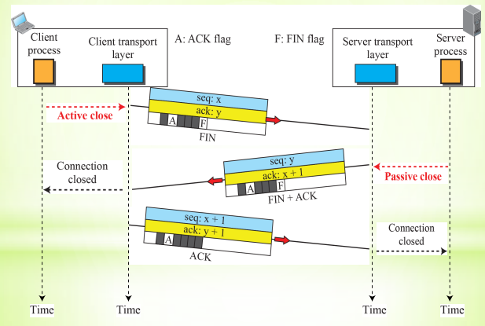

- Half-close

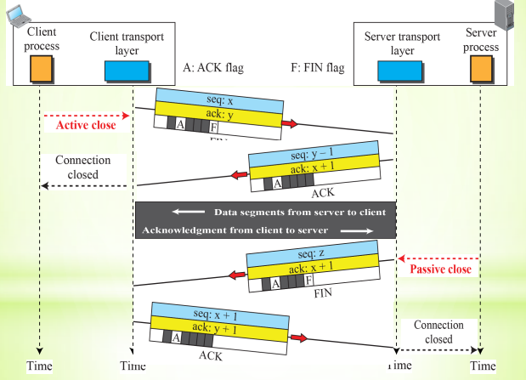

7 (b)
Definition of Piggybacking- 2 mark
Design of piggybacking in Go-Back-N- 5 marks
Piggybacking
Data packets flow in only one direction and acknowledgments travel in the other direction.
In real life, data packets are normally flowing in both directions: from client to server and from server to client. This means that acknowledgments also need to flow in both directions. A technique called piggybacking is used to improve the efficiency of the bidirectional protocols.
Design of piggybacking in Go-Back-N and its performance analysis.
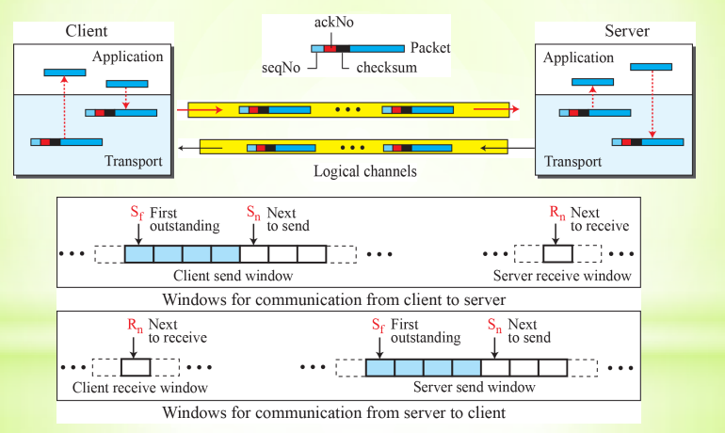

8 (a)
About user datagram protocol- 2 marks
UDP performance in multimedia applications- 5 marks

User datagram protocol (UDP):
- The User Datagram Protocol (UDP) is a connectionless, unreliable transport protocol.
- It does not add anything to the services of IP except for providing process-to-process instead of host-to-host communication.
- UDP is a very simple protocol using a minimum of overhead
- UDP packets, called user datagrams, have a fixed size header of 8 bytes made of four fields, each of 2 bytes (16 bits). the format of a user datagram. The first two fields define the source and destination port numbers. The third field defines the total length of the user datagram, header plus data. The 16 bits can define a total length of 0 to 65,535 bytes.

Is UDP performing better in multimedia applications?
Yes because
- UDP is a suitable transport protocol for multicasting. Multicasting capability is embedded in the UDP software but not in the TCP software. Example Assume we are downloading a very large text file from the Internet. We definitely need to use a transport layer that provides reliable service. We don’t want part of the file to be missing or corrupted when we open the file. The delay created between the deliveries of the parts is not an overriding concern for us; we wait until the whole file is composed before looking at it. In this case, UDP is not a suitable transport layer.
- The live video-streaming appliances are not designed with TCP streaming. The IP multicast significantly reduces video bandwidth requirements for large audiences; TCP prevents the use of IP multicast, but UDP is well-suited for IP multicast.
- UDP is a shoot and forget protocol; TCP is an error detecting and retransmitting protocol. UDP is best when lose packets and still get enough information through streaming. A single packet lost, will not notice any problem, with TCP a lost packet is delaying all following packets as it must be retransmitted until the recipient acknowledges it. For file transfer UDP is useless as must write a higher level of handshaking to correct for packet loss.
- UDP is normally used for interactive real-time applications that cannot tolerate uneven delay between sections of a received message. For example, assume we are using a real-time interactive application, such as Skype. Audio and video are divided into frames and sent one after another. If the transport layer is supposed to resend a corrupted or lost frame, the synchronizing of the whole transmission may be lost. The viewer suddenly sees a blank screen and needs to wait until the second transmission arrives. This is not tolerable. However, if each small part of the screen is sent using one single user datagram, the receiving UDP can easily ignore the corrupted or lost packet and deliver the rest to the application program. That part of the screen is blank for a very short period of time, which most viewers do not even notice.
- A client-server application such as SMTP, which is used in electronic mail, cannot use the services of UDP because a user can send a long e-mail message, which may include multimedia (images, audio, or video). If the application uses UDP and the message does not fit in one single user datagram, the message must be split by the application into different user datagrams. Here the connectionless service may create problems. The user datagrams may arrive and be delivered to the receiver application out of order. The receiver application may not be able to reorder the pieces. This means the connectionless service has a disadvantage for an application program that sends long messages.

8 (b)
Reno TCP- 3 marks
New Reno TCP- 3 marks
Improvement of Performance of New Reno TCP over Reno TCP- 1 mark
Reno TCP
- A newer version of TCP, called Reno TCP, added a new state to the congestion-control FSM, called the fast-recovery state.
- This version treated the two signals of congestion, time-out and the arrival of three duplicate ACKs, differently.
- In this version, if a time-out occurs, TCP moves to the slow-start state (or starts a new round if it is already in this state)
- If three duplicate ACKs arrive, TCP moves to the fast-recovery state and remains there as long as more duplicate ACKs arrive. The fast-recovery state is a state somewhere between the slow-start and the congestion avoidance states • In the fast-recovery state, it behaves like the slow start, in which the cwnd grows exponentially, but the cwnd starts with the value of ssthresh plus 3 MSS (instead of 1).
- When TCP enters the fast-recovery state, three major events may occur. If duplicate ACKs continue to arrive, TCP stays in this state, but the cwnd grows exponentially. If a time-out occurs, TCP assumes that there is real congestion in the network and moves to the slow-start state. If a new (nonduplicate) ACK arrives, TCP moves to the congestionavoidance state, but deflates the size of the cwnd to the ssthresh value, as though the three duplicate ACKs have not occurred, and transition is from the slow-start state to the congestion-avoidance state.
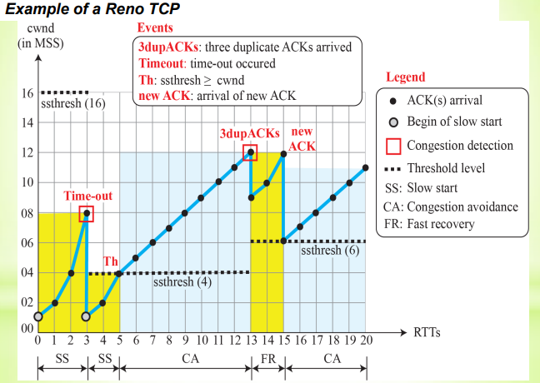
New Reno TCP
- A later version of TCP, called NewReno TCP, made an extra optimization on the Reno TCP.
- When TCP receives three duplicate ACKs, it retransmits the lost segment until a new ACK (not duplicate) arrives. (Fast Recovery Sate)
- If the new ACK defines the end of the window when the congestion was detected, TCP is certain that only one segment was lost. However, if the ACK number defines a position between the retransmitted segment and the end of the window, it is possible that the segment defined by the ACK is also lost.
- NewReno TCP retransmits this segment to avoid receiving more and more duplicate ACKs for it
- Out of the three versions of TCP, the Reno version is most common today.
- If we ignore the slow-start states and short exponential growth during fast recovery, the TCP congestion window is cwnd = cwnd + (1 / cwnd) when an ACK arrives (congestion avoidance), and cwnd = cwnd / 2 when congestion is detected. i.e. Additive increase, multiplicative decrease (AIMD)
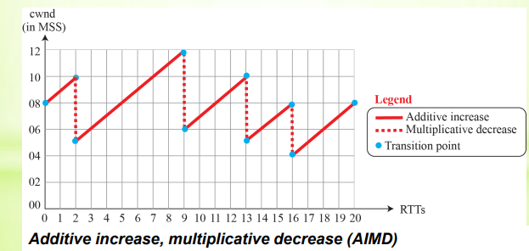
Improvement of Performance of New Reno TCP over Reno TCP
TCP New Reno is the extension of TCP Reno. TCP Reno is the second variant of the TCP which came up with an in-built congestion algorithm. The idea was to overcome Reno’s limitations. The limitations of Reno are: 1. it takes a lot of time to detect multiple packet losses in the same congestion window. 2. it reduces the congestion window multiple times for multiple packet loss in the same window, where one reduction was sufficient. How new reno improves, the trick was to let know the sender that it needs to reduce the cwnd by 50% for all the packets loss that happened in the same congestion window. This was done using partial ACK. The new type of ACK was introduced for letting know the sender about this. In Reno, after half window of silence when it receives the ACK of the retransmitted packet it considers it a new ACK and comes out fast recovery and enters AIMD then again if packet loss (same cwnd) occurs then it repeats the same procedure of reducing cwnd by half. But NewReno sender will check if the ACK of the retransmitted packet is new or not in the sense that all the packets of that particular cwnd are ACKed by the receiver or not. If all packets of that particular cwnd are ACKed by the receiver then the sender will consider that ACK as new otherwise partial ACK. If it is partial ACK then the sender will not reduce cwnd by 50% again. It will keep is same and won’t come out of the fast recovery phase.

9 (a)
Working of DNA with diagram-7 marks
Domain Name System (DNS)
To identify an entity, TCP/IP protocols use the IP address, which uniquely identifies the connection of a host to the Internet. However, people prefer to use names instead of numeric addresses. Therefore, the Internet needs to have a directory system that can map a name to an address. This is analogous to the telephone network. A telephone network is designed to use telephone numbers, not names. People can either keep a private file to map a name to the corresponding telephone number or can call the telephone directory to do so. Since the Internet is so huge today, a central directory system cannot hold all the mapping. In addition, if the central
computer fails, the whole communication network will collapse. A better solution is to distribute the information among many computers in the world. In this method, the host that needs mapping can contact the closest computer holding the needed information. This method is used by the Domain Name System (DNS).
A user wants to use a file transfer client to access the corresponding file transfer server running on a remote host. The user knows only the file transfer server name, such as afilesource.com. However, the TCP/IP suite needs the IP address of the file transfer server to make the connection. The following six steps map the host name to an IP address:
- The user passes the host name to the file transfer client.
- The file transfer client passes the host name to the DNS client. Each computer, after being booted, knows the address of one DNS server.
- The DNS client sends a message to a DNS server with a query that gives the file transfer server name using the known IP address of the DNS server.
- The DNS server responds with the IP address of the desired file transfer server.
- The DNS client passes the IP address to the file transfer server.
- The file transfer client now uses the received IP address to access the file transfer server.
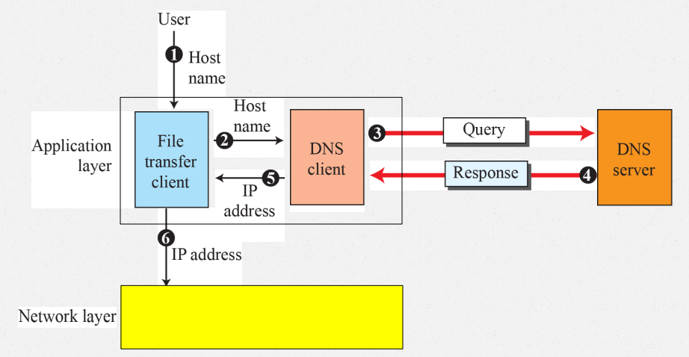

9 (b)
Procedure of sending and receiving email- 7 marks

Electronic Mail
Electronic mail (or e-mail) allows users to exchange messages. The nature of this application, however, is different from other applications discussed so far. In an application such as HTTP or FTP, the server program is running all the time, waiting for a request from a client. When the request arrives, the server provides the service. In the case of electronic mail, the situation is different.
Mail Box:
- The administrator has created one mailbox for each user where the received messages are stored. A mailbox is part of a server hard drive, a special file with permission restrictions.
- The administrator has also created a queue (spool) to store messages waiting to be sent.
Uses three different agents:
- a User Agent (UA)
- a Mail Transfer Agent (MTA), and
- a Message Access Agent (MAA).
The electronic mail system needs two UAs, two pairs of MTAs (client and server), and a pair of MAAs (client and server).
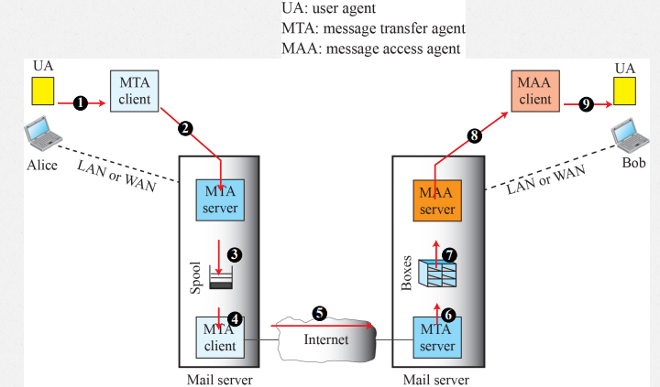

Sending Mail
- To send mail, the user, through the UA, creates mail that looks very similar to postal mail. It has an envelope and a message.
- The envelope usually contains the sender address, the receiver address, and other information.
- The message contains the header and the body.
Receiving Mail
- The user agent is triggered by the user (or a timer). If a user has mail, the UA informs the user with a notice.
- If the user is ready to read the mail, a list is displayed in which each line contains a summary of the information about a particular message in the mailbox

Format of an e-mail
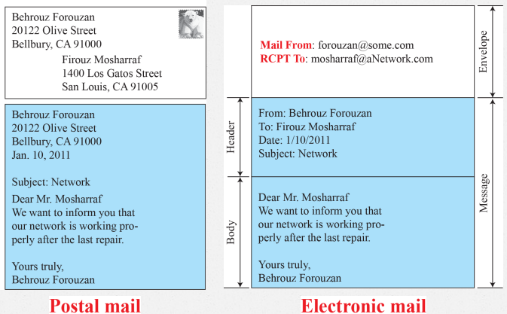

Protocols used in electronic mail
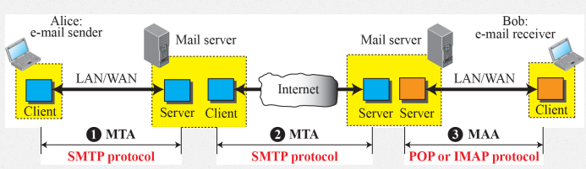
- Simple Mail Transfer Protocol (SMTP)-MTA, Well known port 25
- Post Office Protocol(POP3) and Internet Mail Access Protocol(IMAP4)- MAA, Well known port 110

10 (a)
Description of Hypertext transport protocol (HTTP) - 7 marks
Hyper Text Transfer Protocol (HTTP)
- It is a protocol that is used to define how the client-server programs can be written to retrieve web pages from the Web.
- HTTP Client sends request and HTTP Server returns a response
- Server Port Number:80
- Client Port Number: temporary port Number
- HTTP is connection oriented i.e. uses TCP protocol which is connection oriented and reliable
- The type of connections to retrieve a web pages are:
- Persistent Connection
- Non Persistent Connection

Non-persistent connection.
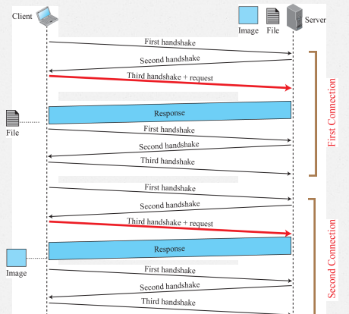
Persistent connection.
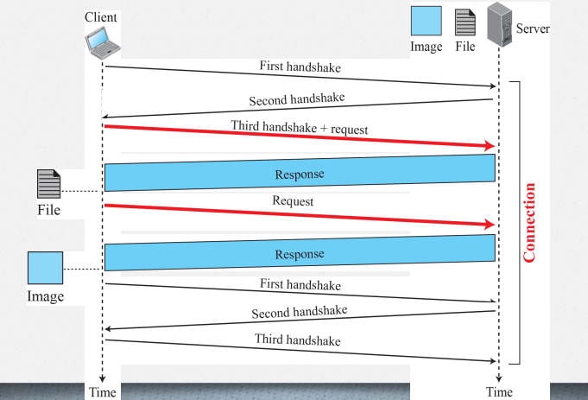

Message Formats of the request and response messages
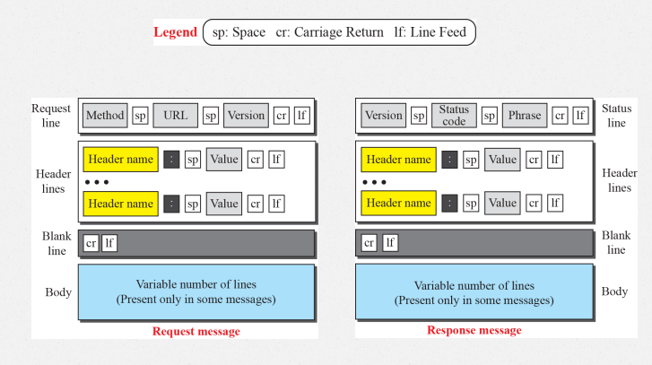

Methods
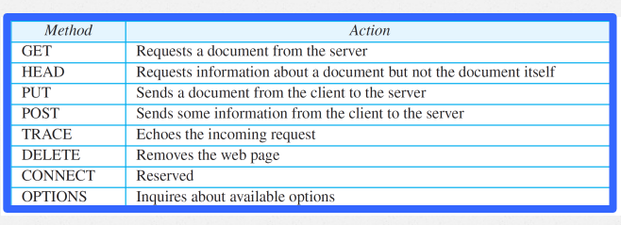
Request Header Names
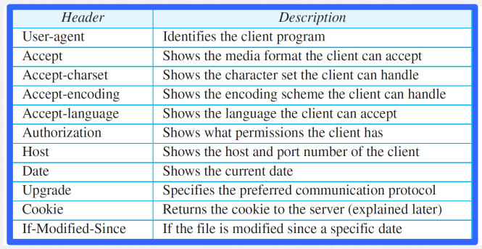
Response Header Names
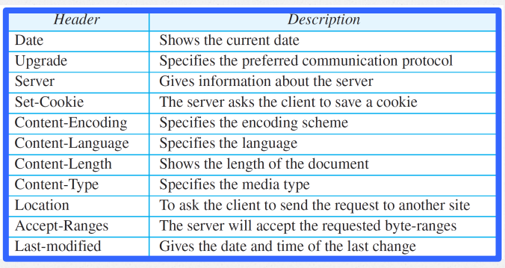

Example
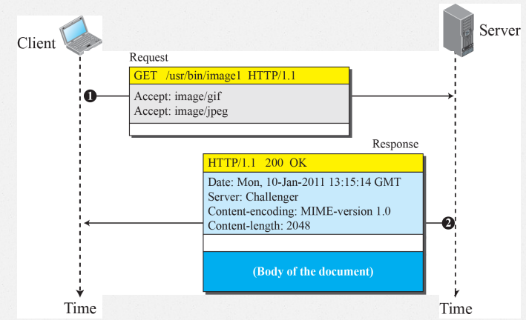

10 (b)
Description of File transport protocol (FTP)- 7 marks

File Transfer Protocol(FTP)
- Standard protocol provided by TCP/IP for copying a file from one host to another.
- Connection Oriented Protocol
- Though HTTP can also transfer files FTP is ideal protocol and better choice for large files.
- Several issues have to be handled by FTP, for example, two systems may use different file name conventions, different ways to represent data, different directory structures.
- Components of FTP Client: user interface, client control process, and the client data transfer process.
- Components of FTP Server: the server control process and the server data transfer process
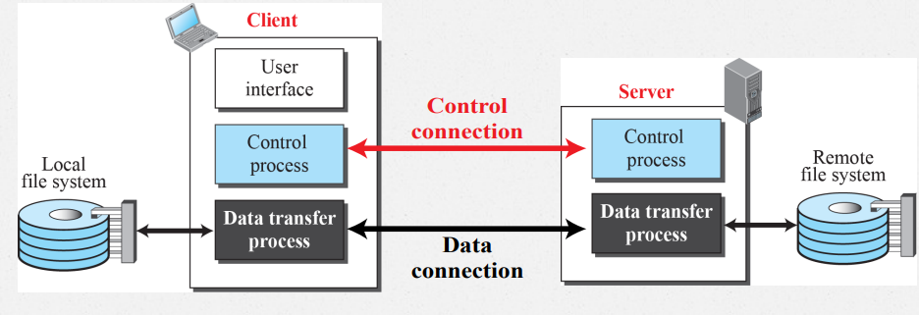

- FTP uses two well-known TCP ports:
  - port 21 is used for the control connection, and port 20 is used for the data connection.
- FTP Uses Two Connections
  - The control connection is made between the control processes.
- The data connection is made between the data transfer processes.
- Separation of commands and data transfer makes FTP more efficient
- Two connections in FTP have different lifetimes
- The control connection remains connected during the entire interactive FTP session.
- The data connection is opened and then closed for each file transfer activity.
- When a user starts an FTP session, the control connection opens.
- While the control connection is open, the data connection can be opened and closed multiple times if several files are transferred.
Control Connection
- Port-21
- It uses the NVT ASCII character set commands are sent from the client to the server.
- Responses are sent from the server to the client.
- Commands, which are sent from the FTP client control process, are in the form of ASCII uppercase, which may or may not be followed by an argument
- Each line is terminated with a two-character (carriage return and line feed) end-of-line token
- Every FTP command generates at least one response
- We want to transfer files through the data connection.
- The client must define the type of file to be transferred, the structure of the data, and the transmission mode using commands in control connection.
Some FTP commands
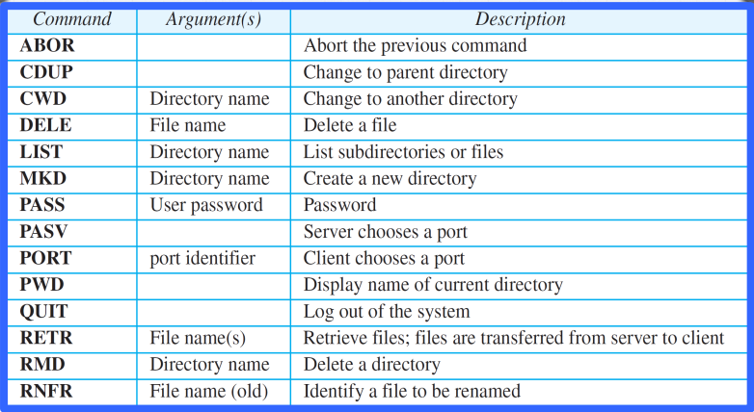
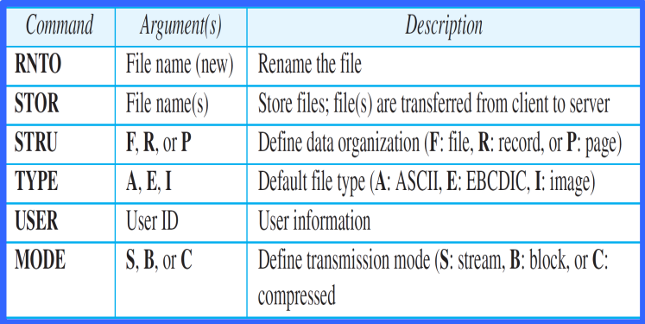

Data Structure
Three kinds of interpretations
- The file structure format (used by default) has no structure. It is a continuous stream of bytes.
- In the record structure, the file is divided into records. This can be used only with text files.
- In the page structure, the file is divided into pages, with each page having a page number and a page header. The pages can be stored and accessed randomly or sequentially

