PRASAD V. POTLURI SIDDHARTHA INSTITUTE OF TECHNOLOGY,
KANURU, VIJAYAWADA
DEPARTMENT OF COMPUTER SCIENCE & ENGINEERING
INNOVATIVE TEACHING METHODOLOGY
Academic Year: 2024 - 25
Teaching Methodology – Video Activity (Presentation)
Class : III B.TECH
Semester: II - Semester
Section: S3
Name of the Course: MERN Stack Development
Name of the Faculty: Dr. K. Jyothsna Devi
---------------------------------------------------------------------------------------------------------------

Name of the Topic: Third party State management libraries in React: Redux, Flux,
Number of Students Involved : 70
Student Name &Regd Number:
S.No | Register No. | Name of the Student | S.No | Register No. | Name of the Student
1 | 22501A05D3 | PADAKALA ANAND KUMAR | 36 | 22501A05H0 | SOMALA THANU SRI
2 | 22501A05D4 | PAIDIMUKKULA LAVANYA | 37 | 22501A05H1 | SOMULA VENKATA SYAM PRASAD REDDY
3 | 22501A05D5 | PARASA KAMAL SIDDARDHA | 38 | 22501A05H2 | SREELAKSHMI SUDEEKSHA MEDARAMETLA
4 | 22501A05D6 | PARIMISETTI SAI ADVAITH | 39 | 22501A05H3 | SREERAM SARATH CHANDRA
5 | 22501A05D7 | PARVATANENI AMULYA | 40 | 22501A05H4 | SYED LATHEEF AHMMAD
6 | 22501A05D8 | PARVATHANENI PHANI KRISHNA | 41 | 22501A05H5 | SYED MUHAMMAD AFZAL
7 | 22501A05D9 | PATHIVADA HARSHAVARDHAN | 42 | 22501A05H6 | TADEPALLI NAGA SRI SAMANVITHA
8 | 22501A05E0 | PAVAN KUMAR CHENNUPATI | 43 | 22501A05H7 | TATI GAYATHRI
9 | 22501A05E2 | PEDAPATI MAHESH BABU | 44 | 22501A05H8 | TATIPARTHI MEGHANA

10 | 22501A05E3 | PEDAPUDI MEGHANA | 45 | 22501A05H9 | TATIPARTHI TEJ MAHENDRA REDDY
11 | 22501A05E4 | PEDDIBHOTLA SREE SATYA HARSHA | 46 | 22501A05I0 | THIRANDI RAMYA
12 | 22501A05E5 | PERUMALLA HARSHITHA | 47 | 22501A05I1 | THIYYAGURA HEMA HARSHITHA
13 | 22501A05E6 | PILLUTLA CHAITANYA | 48 | 22501A05I2 | THUMMALACHARLA THANUJA
14 | 22501A05E7 | PODILI NAVEEN KUMAR | 49 | 22501A05I3 | TIPPIREDDY YOGITHA
15 | 22501A05E8 | POLIMETLA NIKHIL | 50 | 22501A05I4 | TUMMURU VIMALA REDDY
16 | 22501A05E9 | POTHINENI THRINATH | 51 | 22501A05I5 | TUNGALA REVANTH
17 | 22501A05F0 | POTLURI NIKITHA | 52 | 22501A05I6 | UPPALAPATI HARSHITA
18 | 22501A05F1 | PRODDUTURU SUNANDA | 53 | 22501A05I7 | VALLABHANENI DHANUSH
19 | 22501A05F2 | PUVVADA MITHIL | 54 | 22501A05I8 | VALLABHANENI SUMANTH
20 | 22501A05F3 | RAYALA BABY AKSHITHA | 55 | 22501A05I9 | VALLURU DIVYA CHARITHA
21 | 22501A05F4 | RAYAPUDI SAI ROSHINI | 56 | 22501A05J0 | VANAMATLA ANITHA
22 | 22501A05F5 | RENDUCHINTALA SRIHARI SAI PRANEETH | 57 | 22501A05J1 | VARANASI VIJAYA SAI VIGNESH
23 | 22501A05F6 | RUKSANA SHAIK | 58 | 22501A05J2 | VEERANKI PHANI SIRISHA
24 | 22501A05F7 | SAMBHANA SURYA HARSHA | 59 | 22501A05J3 | VEMULAPALLI GNANESWARI
25 | 22501A05F8 | SANAPALA YASWANTH SAI NARASIMHA | 60 | 22501A05J4 | VIKRUTI SRIJA
26 | 22501A05F9 | SASANAM MOHIT | 61 | 22501A05J5 | VUYYURU KEERTHI REDDY
27 | 22501A05G0 | SAYILA SANTHI DEEPIKA | 62 | 22501A05J6 | YALAKALA ABIGNA
28 | 22501A05G1 | SHAIK FAKRUDDIN | 63 | 22501A05J7 | YANAGANTI ANUSHA
30 | 22501A05G2 | SHAIK IRFAN HARIS | 64 | 22501A05J8 | YARLAGADDA ESWAR ADITYA
31 | 22501A05G4 | SHAIK SAHIRA | 65 | 23505A0513 | SUDABATHULA SIVA TULASI TEJASWI
32 | 22501A05G5 | SHAIK SAMEENA | 66 | 23505A0514 | TIRUNAGARI SAI RITISH
33 | 22501A05G6 | SHAIK SEEMA JABEEN | 68 | 23505A0515 | VALLURU MALLIKA
34 | 22501A05G7 | SIDDHARTHA SAI VENKAT Y | 69 | 23505A0516 | VASANA VENKATA GANESH
35 | 22501A05G8 | SIDDULA SUSHRUTH | 70 | 23505A0517 | VEERANKI REVANTH

Topics:
1) Discuss the importance of State Management in React
2) Explain the Third Party State management tools
3) Explain the Redux implemenattaion
5) Explain the Flux implementation
6) Explore the case studies on Redux and Flux
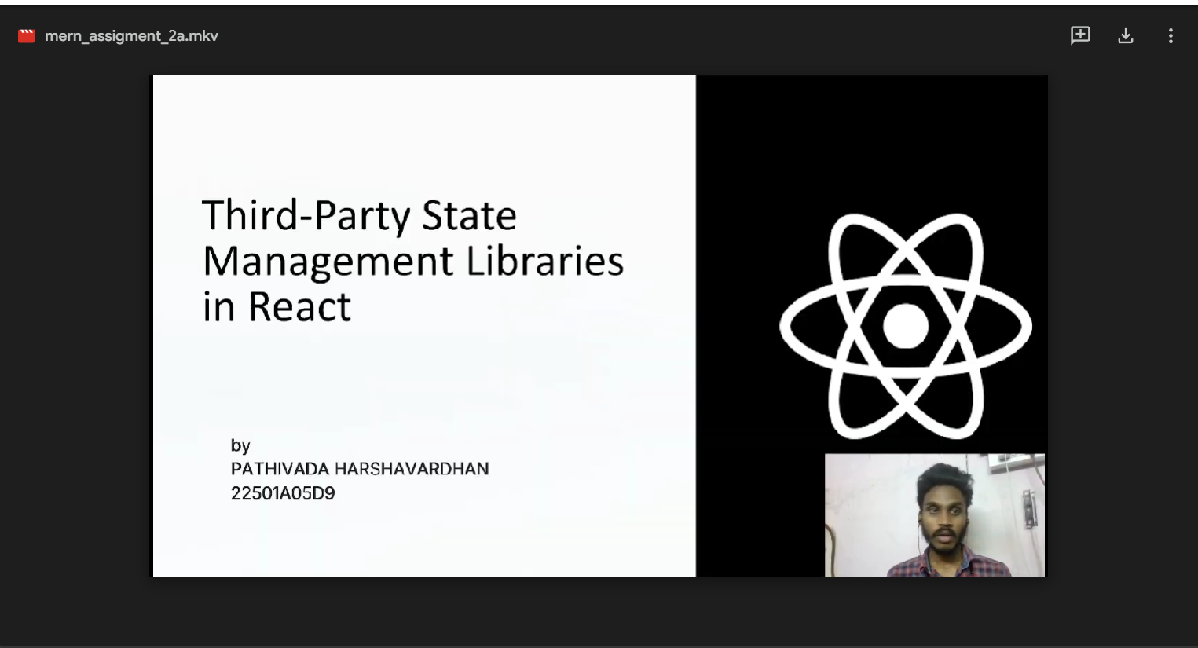
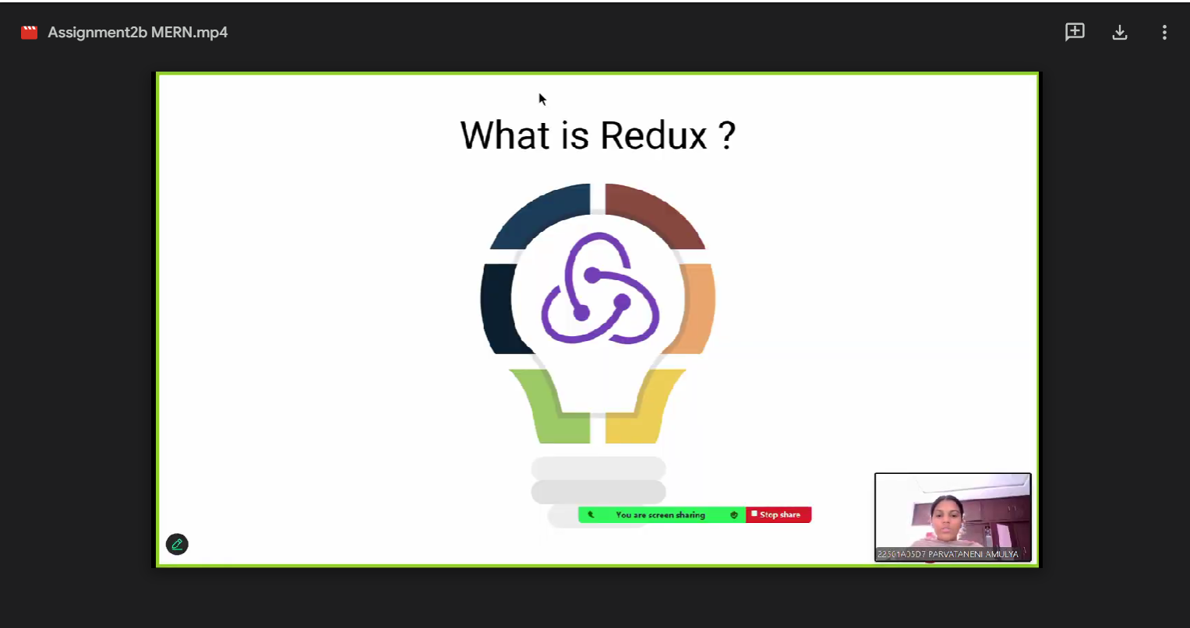

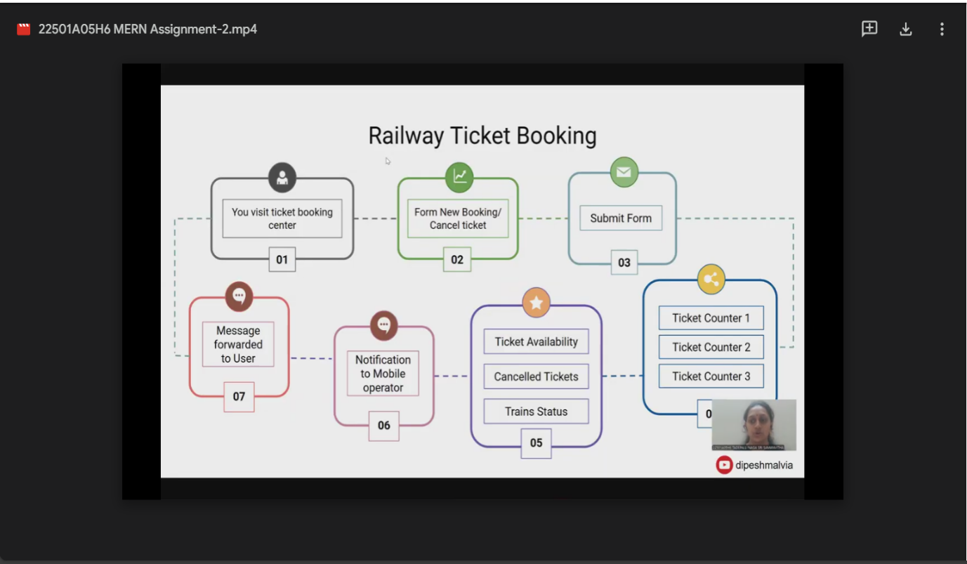
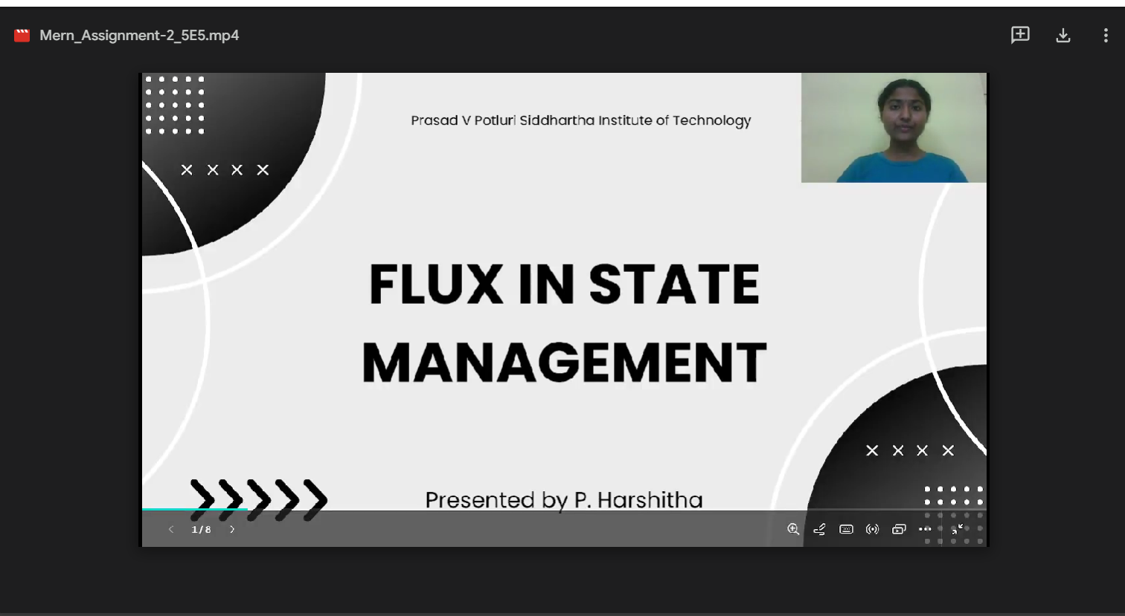

Signature of the Faculty

