POSTMAN

Installation:
- Open browser and Search: https://www.postman.com/
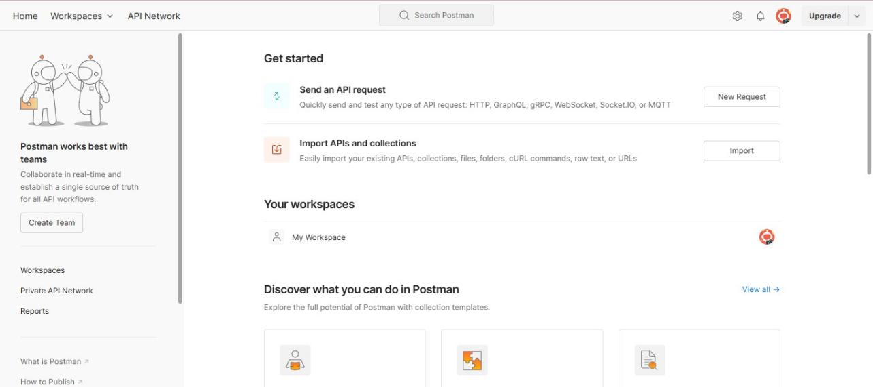

- In this page, in sidebar there us an option Download Desktop App.

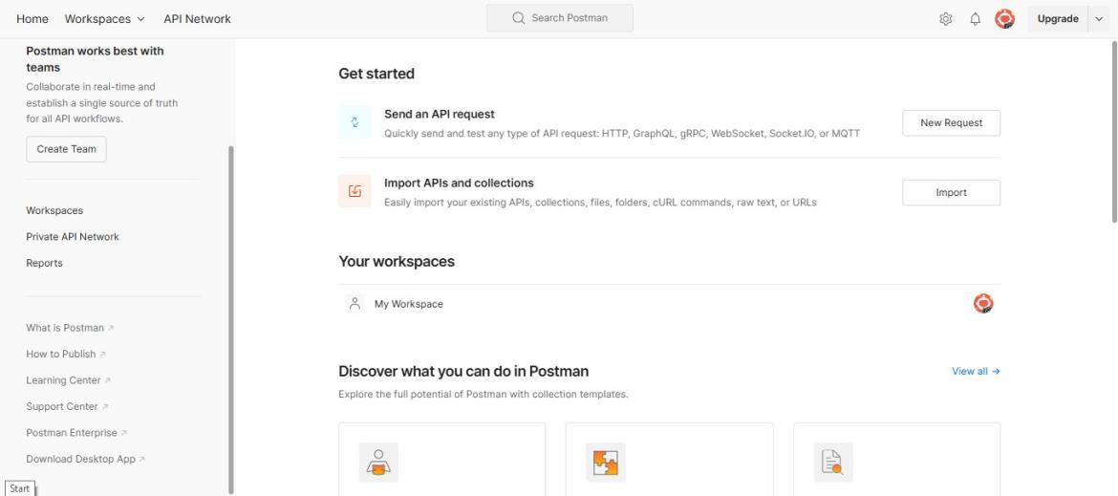


- Click on it to download the Postman App.

- It is Navigated to the following page. Choose the appropriate OS and click on it to download.
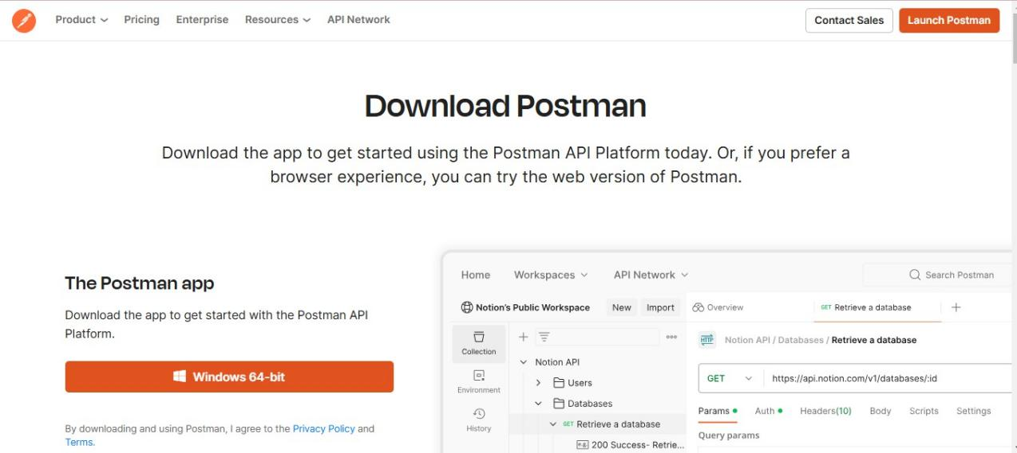

- Now open the postman App in system.
- Create Account in Postman using Google.
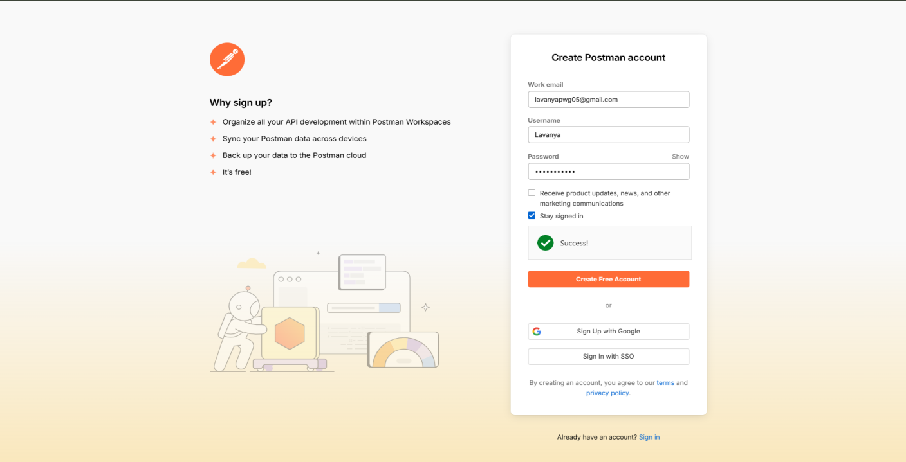

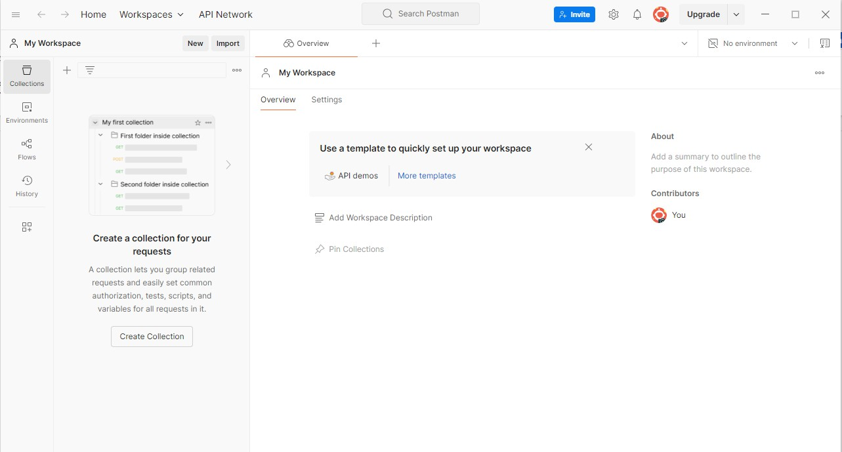
- ​
Click on New tab.

- Choose HTTP in the List
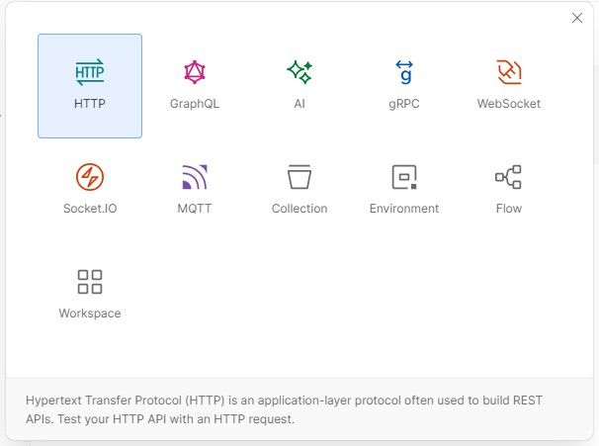

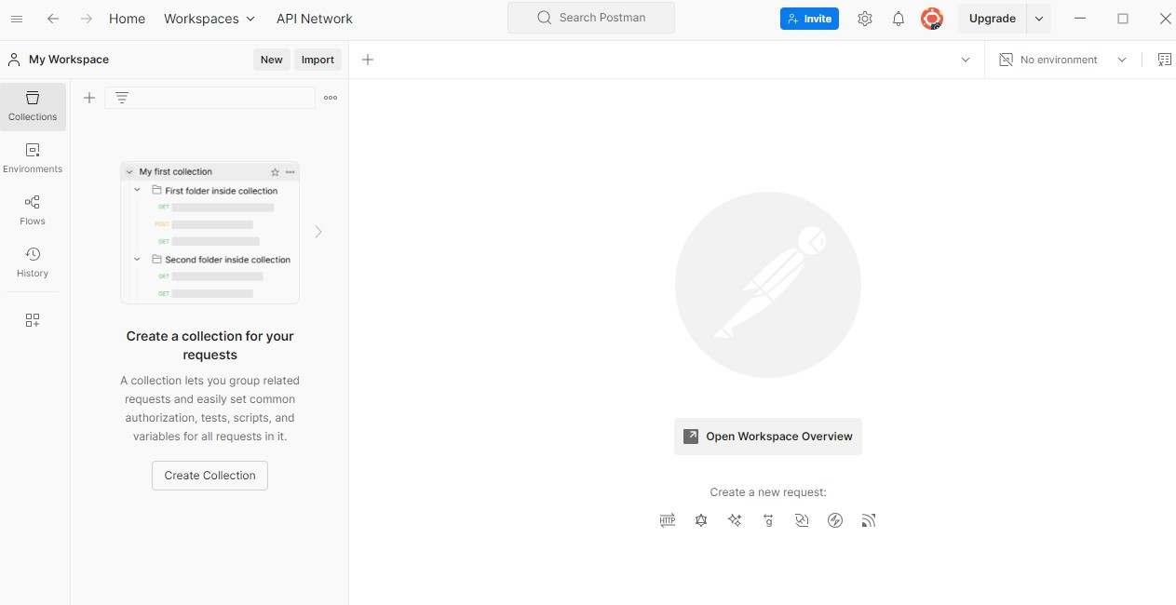
- Click on Create Collection

- Now give a name to Collection
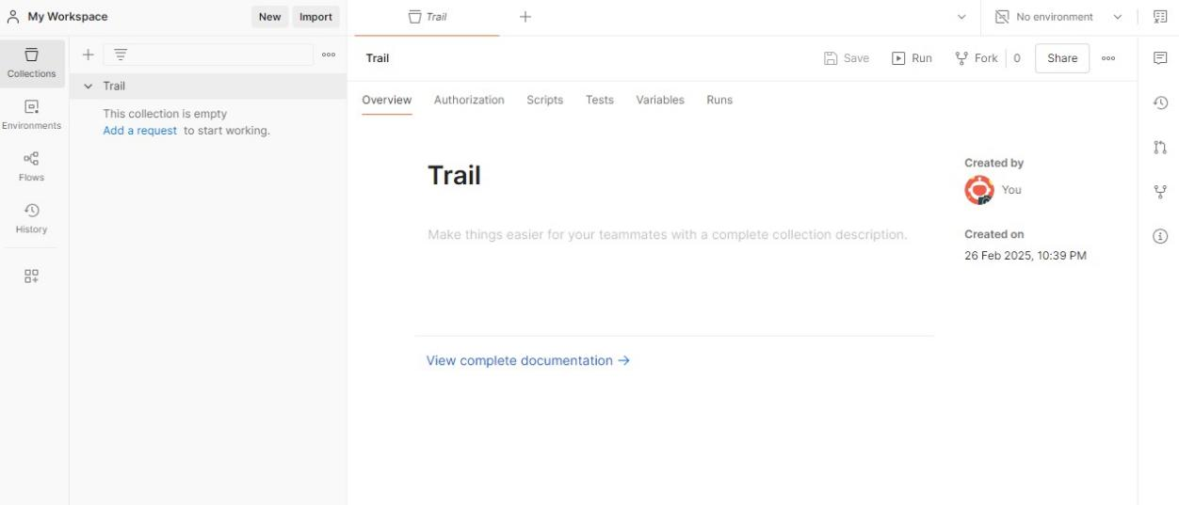

- Open VS code and write the server code and start the server.

Server.js:
const http = require('http'); const fs = require('fs');
const path = './employees.json'; function readEmployeeFile() { if (!fs.existsSync(path)) {
fs.writeFileSync(path, JSON.stringify([]));
}
const data = fs.readFileSync(path);

return JSON.parse(data);
}
function writeEmployeeFile(data) { fs.writeFileSync(path, JSON.stringify(data, null, 2));
}
const server = http.createServer((req, res) => { res.setHeader('Content-Type', 'application/json');
if (req.url === '/employees' && req.method === 'GET') { const employees = readEmployeeFile(); res.end(JSON.stringify(employees));
} else if (req.url === '/employees' && req.method === 'POST') { let body = '';
req.on('data', chunk => { body += chunk.toString();
});
req.on('end', () => {
const newEmployee = JSON.parse(body); const employees = readEmployeeFile(); employees.push(newEmployee); writeEmployeeFile(employees); res.statusCode = 201;
res.end(JSON.stringify({ message: 'Employee added successfully' }));
});
} else if (req.url.startsWith('/employees/') && req.method === 'PUT') { const id = parseInt(req.url.split('/')[2]);
let body = ''; req.on('data', chunk => {
body += chunk.toString();
});
req.on('end', () => {
const updatedEmployee = JSON.parse(body); const employees = readEmployeeFile();
const index = employees.findIndex(employee => employee.id === id);

if (index !== -1) {
employees[index] = { ...employees[index], ...updatedEmployee }; writeEmployeeFile(employees);
res.end(JSON.stringify({ message: 'Employee updated successfully' }));
} else {
res.statusCode = 404;
res.end(JSON.stringify({ message: 'Employee not found' }));
}
});
} else if (req.url.startsWith('/employees/') && req.method === 'PATCH') { const id = parseInt(req.url.split('/')[2]);
let body = ''; req.on('data', chunk => {
body += chunk.toString();
});
req.on('end', () => {
const partialUpdate = JSON.parse(body); const employees = readEmployeeFile();
const index = employees.findIndex(employee => employee.id === id); if (index !== -1) {
employees[index] = { ...employees[index], ...partialUpdate }; writeEmployeeFile(employees);
res.end(JSON.stringify({ message: 'Employee data updated successfully' }));
} else {
res.statusCode = 404;
res.end(JSON.stringify({ message: 'Employee not found' }));
}
});
} else if (req.url.startsWith('/employees/') && req.method === 'DELETE') { const id = parseInt(req.url.split('/')[2]);
const employees = readEmployeeFile();
const filteredEmployees = employees.filter(employee => employee.id !== id); if (employees.length !== filteredEmployees.length) {

writeEmployeeFile(filteredEmployees);
res.end(JSON.stringify({ message: 'Employee deleted successfully' }));
} else {
res.statusCode = 404;
res.end(JSON.stringify({ message: 'Employee not found' }));
}
} else if (req.url.startsWith('/employees/') && req.method === 'HEAD') { const id = parseInt(req.url.split('/')[2]);
const employees = readEmployeeFile();
const employeeExists = employees.some(employee => employee.id === id); if (employeeExists) {
res.statusCode = 200; res.end();
} else {
res.statusCode = 404; res.end();
}
} else if (req.method === 'OPTIONS') {
res.setHeader('Allow', 'GET, POST, PUT, PATCH, DELETE, OPTIONS');
res.end();
} else {
res.statusCode = 404;
res.end(JSON.stringify({ message: 'Route not found' }));
}
});
const PORT = 3000; server.listen(PORT, () => {
console.log(`Server running at http://localhost:${PORT}/`);
});

Now open the Postman and give URL and select the request type and send.
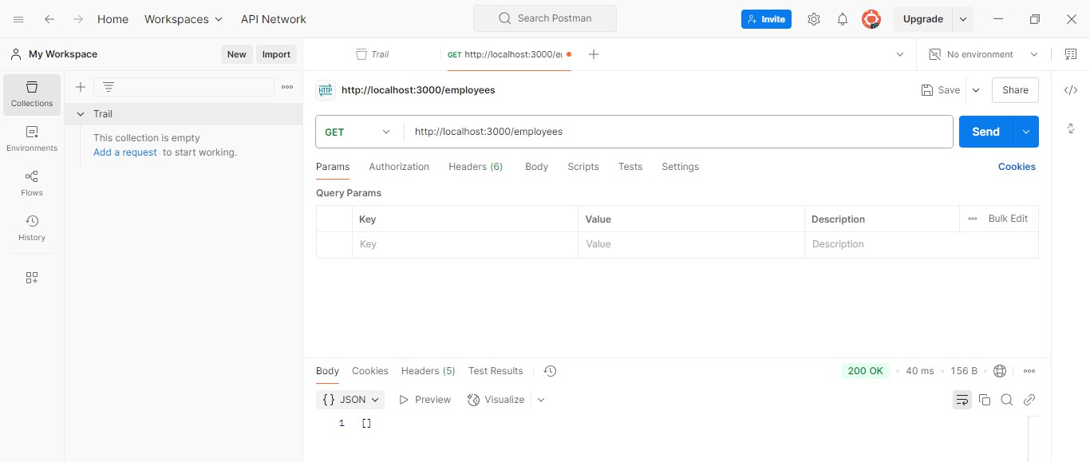
GET request

- To save the request in Collection click on Save button

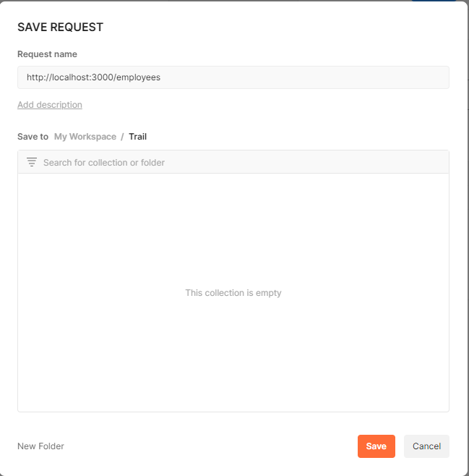
- Click on the Collect and click Save.
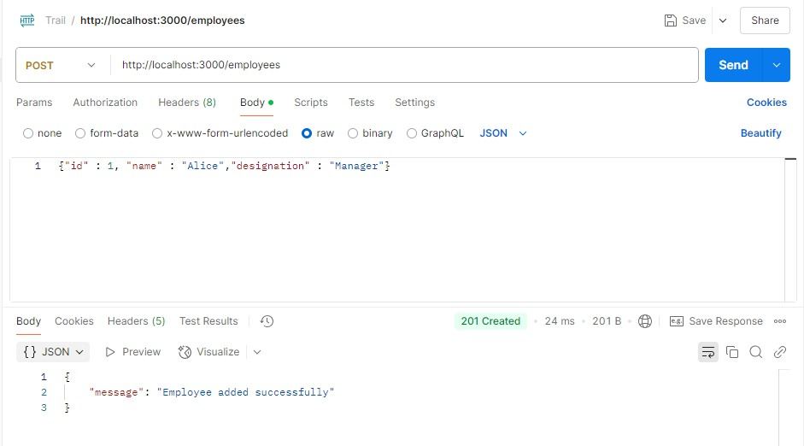
POST request

- Save it in the same collection.

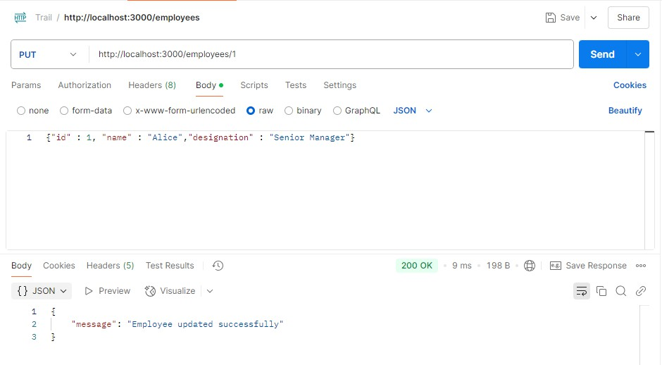
PUT request

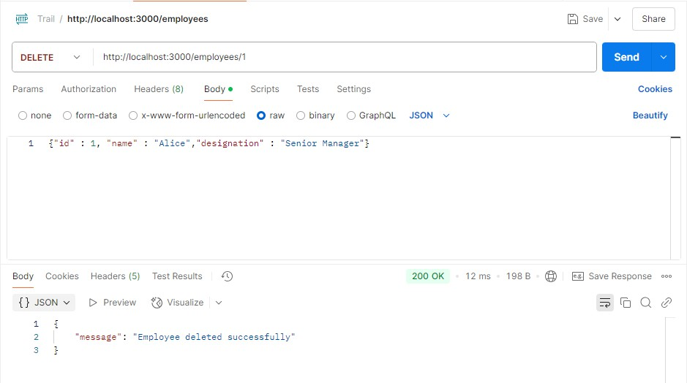
DELETE request

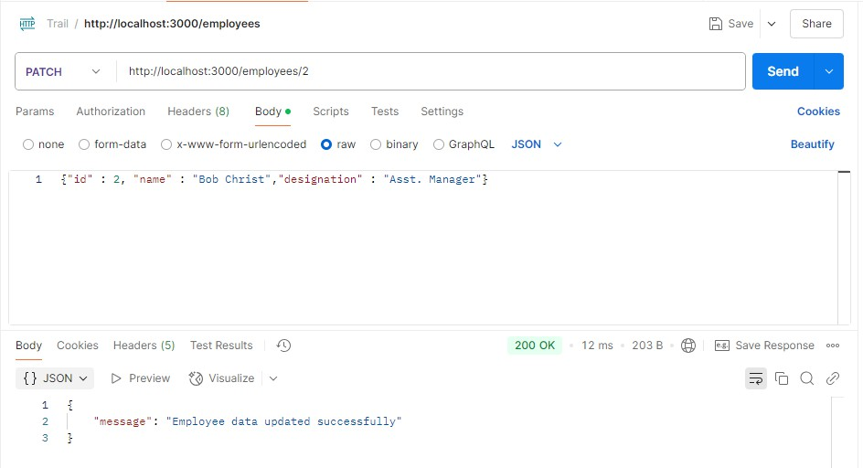
PATCH request

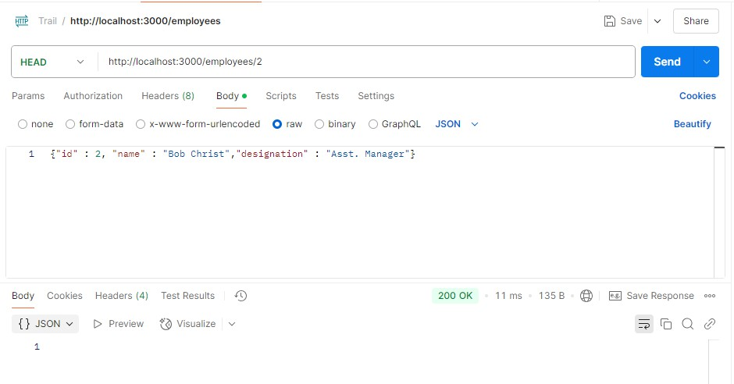
HEAD request

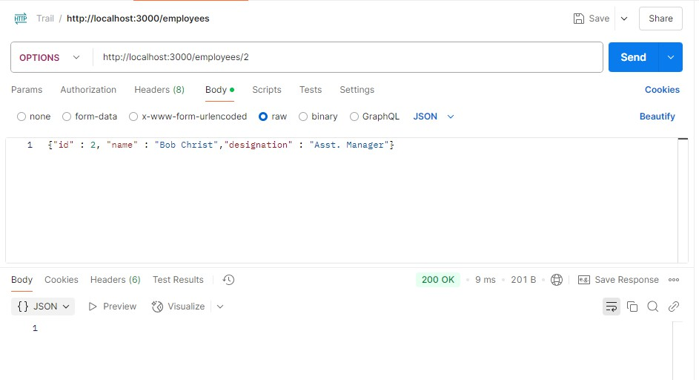
OPTIONS request

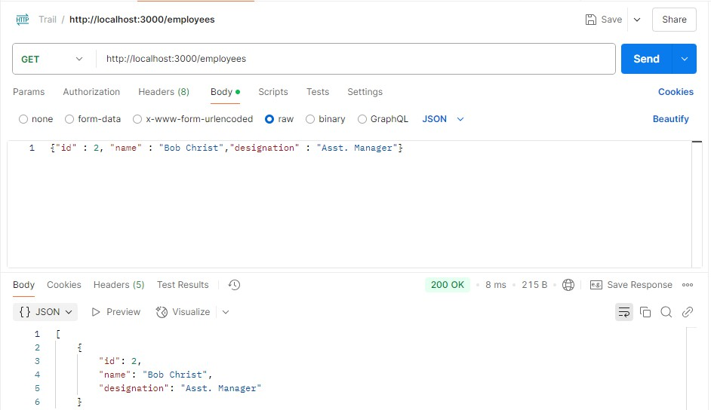
GET request

- Now Click on Collection and open the collection
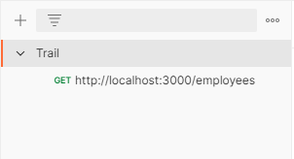
- Click on View Complete documentation.

