EX - 5: Disjoint Sets

Program Description:
Disjoint sets are also known as disjoint collections or non-intersecting sets and refer to those sets which don’t have any identical element common between them.
Example, A = {1, 2, a} and B = {3, 4, b} then, A ∩ B = ϕ.
For this example, A and B are disjoint sets as both do not contain the same element.
The disjoint sets are also called mutually exclusive sets or independent sets.
A disjoint-set data structure is defined as one that keeps track of a set of elements partitioned into a number of disjoint (non-overlapping) subsets.
The disjoint set data structure supports following operations:
- Adding new sets to the disjoint set.
- Merging disjoint sets to a single disjoint set using Union operation.
- Finding representative of a disjoint set using Find operation.
- Check if two sets are disjoint or not.

A union-find algorithm is an algorithm that performs two useful operations on such a data structure:

- Find: Determine which subset a particular element is in. This can determine if two elements are in the same subset.
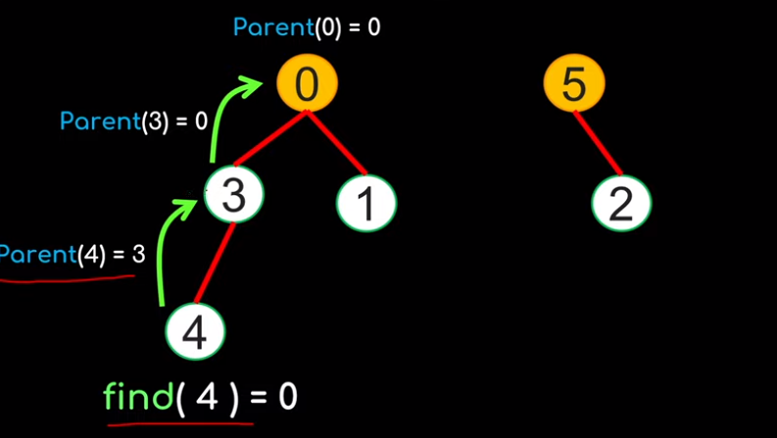
- Union: Join two subsets into a single subset. Here first we have to check if the two subsets belong to the same set. If not, then we cannot perform union.
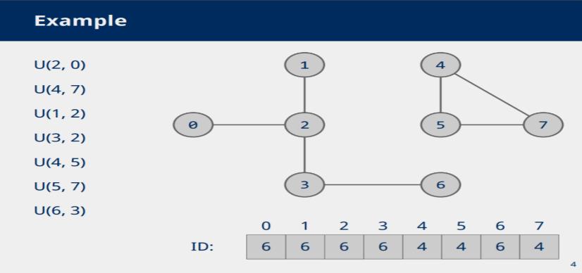

Simple Union-Find algorithm:
Procedure:
- Initialize every element as considered as separate tree
- P[i], easch and every node has to maintain parent node address.
P[i] – Parent of Node[i]
3. Root node P[i]=-1
4. Perform Union and update P[i] value

Algorithm SimpleUnion(I,j)
{
P[j]=I;
}
Algorithm SimpleFind(i)
{
while(P[i]>=0)
{
i=P[i];
}
return i;
}
Time complexity: O(n)
Example:
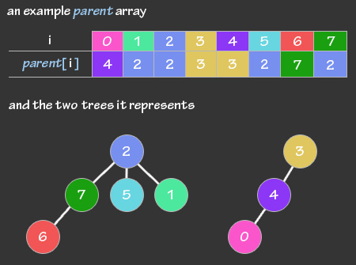

Applications:
- Union-Find is used to determine the connected components in a graph.
- It is used to determine the cycles in the graph. In the Kruskal’s Algorithm, Union Find Data Structure is used as a subroutine to find the cycles in the graph, which helps in finding the minimum spanning tree

Program code:
- Implement simple find and union algorithm

Input and Output:

Application programs:
- https://www.hackerrank.com/challenges/merging-communities/problem?isFullScreen=true
- https://www.hackerrank.com/challenges/components-in-graph/problem?isFullScreen=true
- https://www.hackerrank.com/challenges/kundu-and-tree/problem?isFullScreen=true
- https://www.hackerearth.com/practice/algorithms/graphs/breadth-first-search/practice-problems/algorithm/containers-of-choclates-1/
- Given a connected undirected graph, check if it contains any cycle or not.
