File Handling in Python
File handling is an essential part of Python programming. It allows you to interact with files stored on your system. Python provides several built-in functions to read from and write to files.

Basic Operations:
- Opening a File: You can open a file in different modes such as read ('r'), write ('w'), append ('a'), and others.
file = open('filename.txt', 'mode')
Reading a File: To read a file, you can use methods like read(), readline(), or readlines().
- read(): Reads the entire content of a file.
- readline(): Reads one line at a time.
- readlines(): Reads all lines into a list.
content = file.read()
Writing to a File: You can write text to a file using write() or writelines() methods. If the file does not exist, it is created.
file.write("This is a line of text")
Closing a File: It's important to close a file after you're done working with it to free up system resources.
file.close()
Alternatively, using the with statement ensures the file is properly closed after its suite finishes, even if an exception occurs:
with open('filename.txt', 'r') as file:
content = file.read()

- Program to Sort Words in a File and Write to Another File
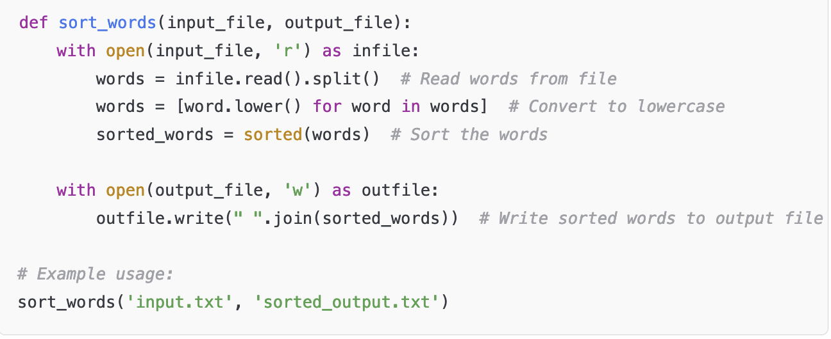
- Python Program to Print Each Line of a File in Reverse Order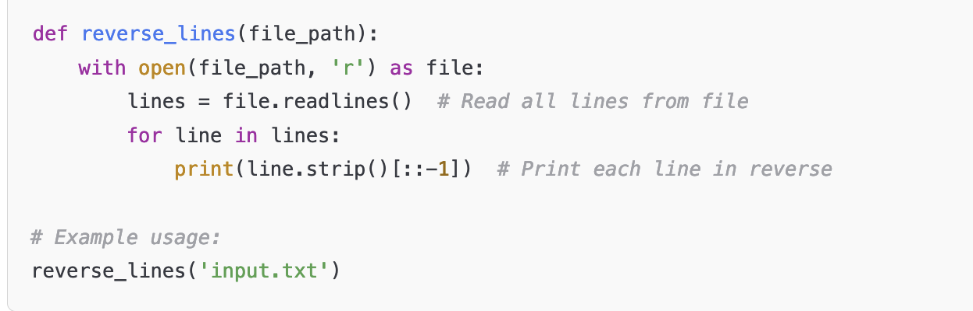
- Python Program to Compute the Number of Characters, Words, and Lines in a File
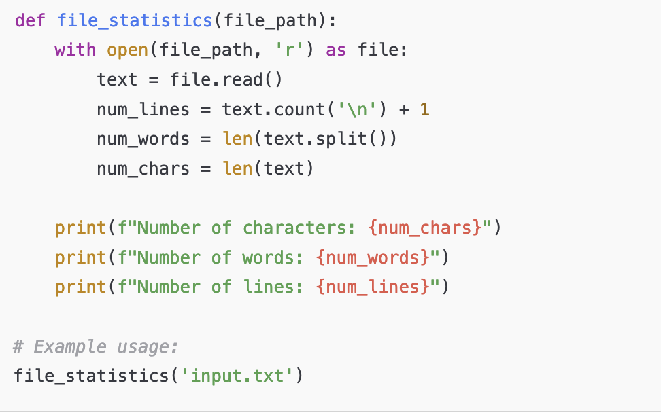

- Function lines_count() to Display Lines Starting with Vowels
