P.V.P Siddhartha Institute of Technology
Department of Computer Science and Engineering
Course: B.Tech. |  | Year: III | Semester: II | A.Y:2024–25
Subject Code: 20CS3601 |  | Subject Name: Compiler Design |  |  | Regulation:PVP20
ASSIGNMENT-2
Q. No | QUESTION
- Compute LR(0) items for the given grammar & construct SLR parsing table S->L=R|R
L->*R|id
R->L
- What is a LALR parser? Construct the set of LR(1) items for given grammar
- What is an activation record? Write the various fields of an activation record
- Construct Quadruple, Triple, indirect triple representation for the expression X:= (A-B)+(C-D)-(A+B+C+D)
- Convert the program into basic blocks and draw flow graph
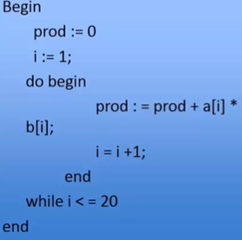
- Write a short note with example on code optimization techniques

