EX - 9: Backtracking

Aim: Implementation of different real time problems using Backtracking approach.
- N-Queens problem
- Sum of subsets problem
- Graph coloring problem

Program Description:
Backtracking is a problem-solving algorithmic technique that involves finding a solution incrementally by trying different options and undoing them if they lead to a dead end. It is commonly used in situations where you need to explore multiple possibilities to solve a problem, like searching for a path in a maze or solving puzzles like Sudoku. When a dead end is reached, the algorithm backtracks to the previous decision point and explores a different path until a solution is found or all possibilities have been exhausted.
Approach of Backtracking:
- Initialization: The algorithm begins with an initial state or partial solution, often represented as an empty container or a blank canvas, depending on the problem. It also sets up any necessary data structures to keep track of choices and constraints.
- Exploration: At each decision point, the algorithm makes a choice from a set of available options. This choice could involve selecting an element from a list, placing an object on a board, or any decision relevant to the specific problem.
- Checking: After making a choice, the algorithm checks whether it satisfies the problem's constraints and criteria. If the current choice is valid so far, the algorithm proceeds to the next step. Otherwise, it backtracks to the previous decision point.
- Recursion: If the choice is valid, the algorithm recursively explores further choices by returning to the exploration step. This means that it dives deeper into the decision tree to explore new possibilities.
- Backtracking: If, at any point, the algorithm encounters a situation where there are no valid choices left to explore or realizes that the current path cannot lead to a solution, it backtracks to the previous decision point. This involves undoing the last choice made and exploring an alternative path.
- Termination: The algorithm repeats steps 2 to 5 until it either finds a valid solution that meets all constraints or exhausts all possible choices without finding a solution. In the latter case, it concludes that no solution exists for the given problem instance.
Backtracking operates on a depth-first search principle, systematically exploring potential solutions and backtracking when a dead-end is encountered.

Types of problems addressed by Backtracking:
- Decision Problems: Decision problems are a class of computational problems that require a simple "yes" or "no" answer, indicating whether a feasible solution exists or not. Backtracking helps us determine the existence of such solutions by exploring the solution space while adhering to certain conditions or constraints.
Example: N-Queens Problem, Sum of subsets and graph coloring problems.
- Optimization Problems: Optimization problems are those where you need to find the best solution among a set of feasible solutions according to a certain criterion or objective function. Backtracking can be used to explore the solution space and gradually refine the search to find the optimal solution.
Examples: Traveling Salesman Problem (TSP), Knapsack Problem, Sudoko puzzle
- Enumeration Problems: Enumeration problems involve finding and listing all possible solutions to a problem within certain constraints. Backtracking is particularly suited for these problems because it systematically explores the entire solution space.
Examples: Permutations, combinations

Applications of Backtracking on decision problem approach;
- Implementation of n -Queens problem:
he N Queen is the problem of placing N chess queens on an N×N chessboard so that no two queens attack each other.
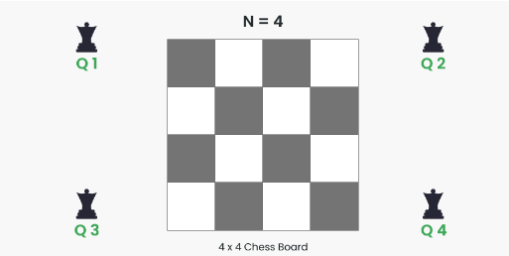.
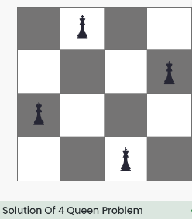

Idea Behind N-Queens problem using backtracking:
The idea is to place queens one by one in different columns, starting from the leftmost column. When we place a queen in a column, we check for clashes with already placed queens. In the current column, if we find a row for which there is no clash, we mark this row and column as part of the solution. If we do not find such a row due to clashes, then we backtrack and return false.

State space tree for the N- Queens problem:
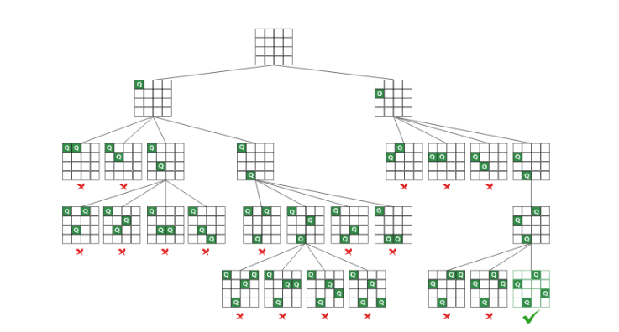

Time efficiency: O(N!)
Space efficiency: O(N²)
Program Code:

Input and Output:

- Sum of subsets problem:

Given a set[] of non-negative integers and a value sum, the task is to print the subset of the given set whose sum is equal to the given sum..
Examples:

Input: set[] = {1,2,1}, sum = 3
Output: [1,2],[2,1]
Explanation: There are subsets [1,2],[2,1] with sum 3.
Input: set[] = {3, 34, 4, 12, 5, 2}, sum = 30
Output: []
Explanation: There is no subset that add up to 30.

The idea behind Sum of subsets problem:

Subset sum can also be thought of as a special case of the 0–1 Knapsack problem. For each item, there are two possibilities:
- Include the current element in the subset and recur for the remaining elements with the remaining Sum.
- Exclude the current element from the subset and recur for the remaining elements.
Finally, if Sum becomes 0 then print the elements of current subset. The recursion’s base case would be when no items are left, or the sum becomes negative, then simply return.

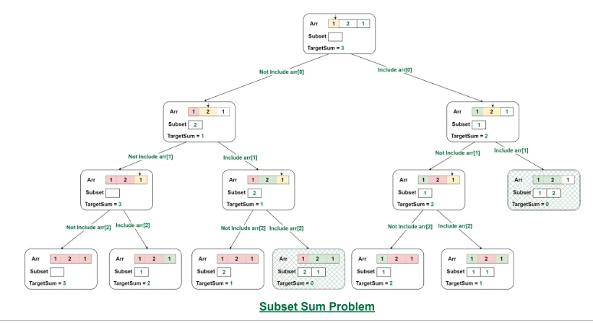

Time complexity: O(2^{N})
Space complexity: O(N)
Program Code:

Input and Output:

- Graph coloring problem using backtracking:

Given an undirected graph and a number m, the task is to color the given graph with at most m colors such that no two adjacent vertices of the graph are colored with the same color

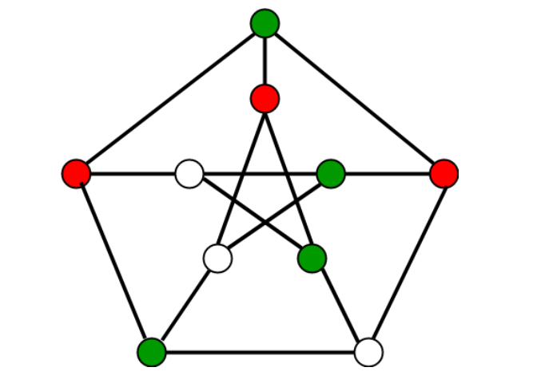

The idea behind hraph colori ng problem:
Assign colors one by one to different vertices, starting from vertex 0. Before assigning a color, check for safety by considering already assigned colors to the adjacent vertices i.e check if the adjacent vertices have the same color or not. If there is any color assignment that does not violate the conditions, mark the color assignment as part of the solution. If no assignment of color is possible then backtrack and return false.

Follow the given steps to solve the problem:
- Create a recursive function that takes the graph, current index, number of vertices, and color array.
- If the current index is equal to the number of vertices. Print the color configuration in the color array.
- Assign a color to a vertex from the range (1 to m).
- For every assigned color, check if the configuration is safe, (i.e. check if the adjacent vertices do not have the same color) and recursively call the function with the next index and number of vertices otherwise, return false
- If any recursive function returns true then return true
- If no recursive function returns true then return false
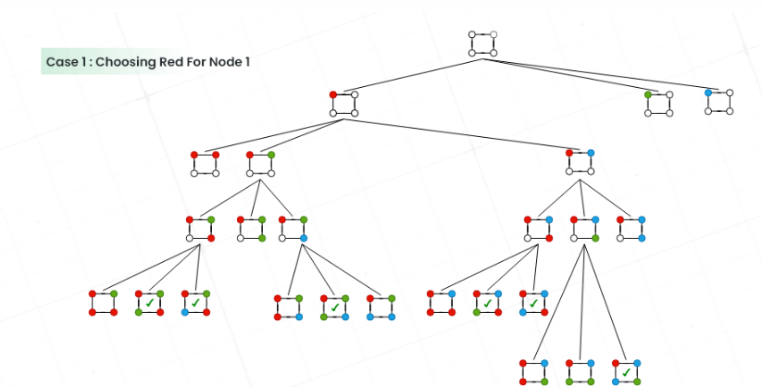
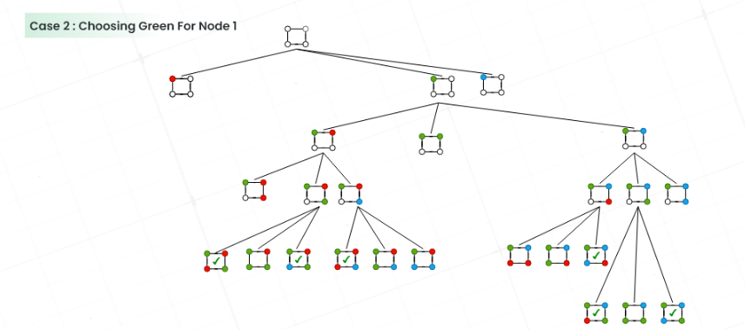
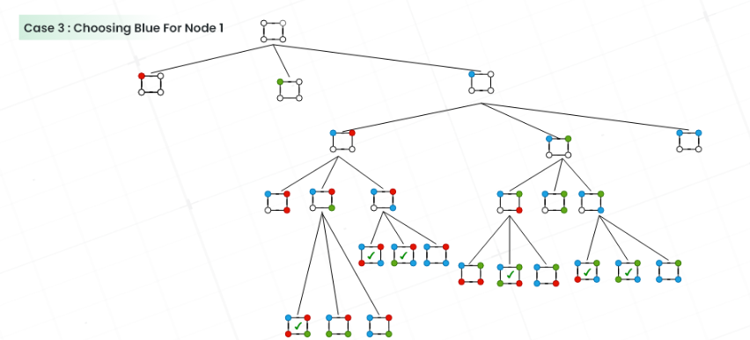

Time Complexity: O(mV). There is a total of O(mV) combinations of colors. The upper bound time complexity remains the same but the average time taken will be less.
Auxiliary Space: O(V). The recursive Stack of the graph coloring function will require O(V) space.Program code:

Input and Output:

