Code: 20CS4701A
PVP 20
PVP-20
PRASAD V POTLURI SIDDHARTHA INSTITUTE OF TECHNOLOGY
(AUTONOMOUS)
IV B.TECH I SEM A.Y : 2024-25
DESCRIPTIVE-II EXAMINATION ANSWERS
DEEP LEARNING
Duration: 1.5 Hours Max. Marks : 15
- Identify the Efficient Convolutional Algorithms and explain with Examples. [5M][CO-3] [L3]
Ans: Convolutional operations are the backbone of Convolutional Neural Networks (CNNs). However, standard convolution can be computationally expensive, especially for deep networks or edge devices. To address this, efficient convolutional algorithms have been developed.
- Depth wise Separable Convolution: Breaks a standard convolution into two steps:
- Depthwise Convolution: Applies a single filter per input channel.
- Pointwise Convolution: Uses 1×1 convolutions to combine the outputs.

Benefits:
- Reduces computation significantly.
- Fewer parameters and faster inference.
Uses: MobileNet, Xception

Example: A standard 3×3 convolution with 32 input and 64 output channels requires:
3×3×32×64 = 18,432 multiplications.
Depthwise separable convolution:
- Depthwise: 3×3×32 = 288
- Pointwise: 1×1×32×64 = 2,048
Total = 2,336 (almost 8× fewer computations)
- Grouped Convolution: Split input channels into groups and perform convolution separately in each group.

Benefits:
  - Reduces computation.
  - Encourages feature diversity.
Uses: AlexNet, ResNeXt
Example: If 64 input/output channels are split into 4 groups:
Each group has 16 input/output channels, reducing computations compared to a full 64x64 convolution.

- FFT-Based Convolution : Uses the Fast Fourier Transform (FFT) to compute convolution as a multiplication in the frequency domain.

Benefits: Efficient for large kernels or inputs
Drawbacks:
• Adds overhead due to FFT and inverse FFT.
• Not effective for small kernel sizes.
- Point wise Convolution : Applies a 1×1 convolution to combine channels
Benefits:
• Reduces dimensionality.
• Adds non-linearity between layers.
Uses: Network-in-Network, Inception modules
Example: Used to reduce 256 channels to 64 before applying a 3×3 convolution, improving efficiency.
- Stride Convolution : Uses a stride > 1 to down sample feature maps during convolution.
Benefits: Reduces spatial dimensions and computations.
Example: Stride = 2 reduces the output resolution by half.

2 A) Model the structure of LSTM component . [3M][CO-3] [L3]
Ans: LSTM stands for Long Short-Term Memory, and it is a type of recurrent neural network (RNN) architecture that is commonly used in natural language processing, speech recognition, and other sequence modeling tasks.
An LSTM cell consists of several components:
Input gate: This gate controls the flow of information from the current input and the previous hidden state into the memory cell.
Forget gate: This gate controls the flow of information from the previous memory cell to the current memory cell. It allows the LSTM to selectively forget or remember information from previous time steps.
Memory cell: This is the internal state of the LSTM. It stores information that can be selectively modified by the input and forget gates.
Output gate: This gate controls the flow of information from the memory cell to the current hidden state and output.

LSTM Architecture:
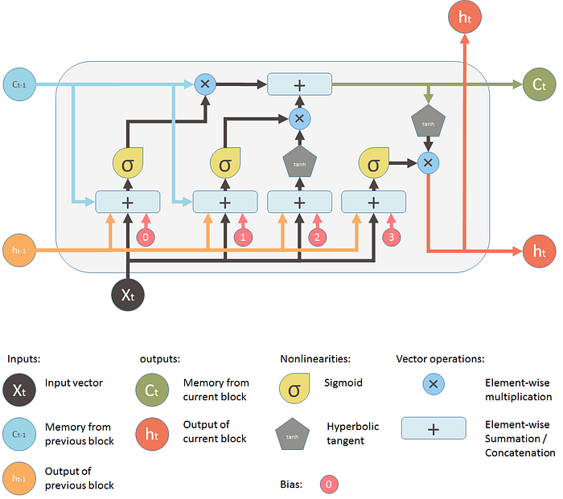

2 B) Compare Recurrent Networks and Recursive Networks . [2M][CO-4] [L4]
Ans:
S.No | Aspect | Recurrent Neural Network(RNN) | Recursive Neural Network)
1 | Definition | RNNs are neural networks where connections between nodes form a directed graph along a temporal sequence. | Recursive networks are a class of networks that apply the same operations on structured data like trees or graphs.
2 | Data Type | Sequential data  (e.g., time-series, sentences). | Hierarchical/structured data  (e.g., trees, graphs, nested structures).
3 | Structure | Data is processed step-by-step, with hidden states carrying information over time. | Data is processed recursively over tree-like or graph-like structures.
4 | Key Operation | Uses feedback loops to maintain state across time steps. | Applies the same set of operations recursively on substructures.
5 | Primary Use Case | Sequence modeling tasks, such as speech recognition, language modeling, and time-series prediction. | Parsing structured data, syntactic parsing, and tree-based tasks.
6 | Examples | - Long Short-Term Memory (LSTM) networks - Gated Recurrent Units (GRU) | -Recursive Neural Networks (RvNN) - TreeLSTMs

    - Examine the primary objective of Deep Learning in Natural Language Processing (NLP)? How do deep neural networks handle complex language understanding tasks. [5M][CO-4] [L4]
Ans: The primary objective of Deep Learning in Natural Language Processing (NLP) is to enable computers to understand, interpret, and generate human language with greater accuracy and fluency than traditional NLP methods. Deep neural networks, particularly recurrent neural networks (RNNs) and Transformers, are crucial for handling complex language understanding tasks by learning intricate patterns and representations from large amounts of text data.
Deep neural networks handle complex language understanding:
- Tokenization: Text is broken down into smaller units (tokens) like words or subword pieces.
How it works: The first step in NLP tasks is tokenization, where text is split into words, subwords, or characters. For example, the sentence "I love cats" could be split into tokens like ["I", "love", "cats"] or even smaller units, such as subword units (e.g., ["I", "lo", "ve", "cats"]).
- Word Embedding: Each token is represented by a numerical vector, capturing its semantic meaning.
How does it Works: Each token is mapped to a dense vector representation (embedding) in a high-dimensional space. Popular embeddings like Word2Vec, GloVe, and contextual embeddings like BERT or GPT represent words by their proximity in a semantic space. For example, "cat" and "dog" will have similar vector representations due to their semantic similarity.
- Neural Network Processing: RNNs or Transformers process the sequence of word embeddings, learning relationships between words and phrases.
How it works: Deep learning models such as Recurrent Neural Networks (RNNs) or Transformers process the sequence of word embeddings. These models handle sequential data (RNNs) or use self-attention mechanisms (Transformers) to learn the contextual relationships between tokens. For example, in a sentence, the model learns that "bank" in "river bank" refers to a shore, whereas "bank" in "financial bank" refers to a financial institution.
- Contextual Understanding: The network uses the context of the words to predict the next word in a sequence, classify the sentiment of a text, or translate the text into another language.
How it Works: Modern architectures like Transformers (e.g., BERT, GPT) allow for contextual understanding, where the meaning of a word changes depending on the words around it. For example, the word "bark" has different meanings in the contexts "dog's bark" and "tree's bark." Transformers use self-attention to capture long-range dependencies and relationships within the text.
5. Output Generation: The trained model generates text, classifies input, or performs other language-related tasks based on the learned patterns and representations.
How it Works: Once trained, deep learning models generate output depending on the NLP task. For text generation tasks (e.g., GPT), the model generates the next word in a sequence. For classification tasks (e.g., sentiment analysis), the model outputs a label or score indicating sentiment. For translation, the model outputs the translated text.

