Code: 20CS4701A
PVP 20
PVP-20
PRASAD V POTLURI SIDDHARTHA INSTITUTE OF TECHNOLOGY
(AUTONOMOUS)
IV B.TECH I SEM A.Y : 2024-25
DESCRIPTIVE-I EXAMINATION ANSWERS
DEEP LEARNING
Duration: 1.5 Hours Max. Marks : 15
- A) Outline the Common Architectural Principles of Deep Networks and Discuss loss functions in the context of deep neural networks. [3M][CO-1] [L2]
Ans: Common Architectural Principles of Deep Networks:
1. Layered Structure:
Deep networks consist of multiple layers, including input, hidden, and output layers, enabling the extraction of increasingly complex features from data.
2. Hierarchical Representations:
Each layer learns a representation of the input data, with subsequent layers building upon these representations to capture more abstract features.
3. Weight Adjustment:
The network learns by adjusting its weights (parameters) to minimize the loss function, which quantifies the error between the model's predictions and the actual values.
4. Backpropagation:
The process of calculating the gradient of the loss function with respect to each weight and using this gradient to update the weights, is known as backpropagation.
5. Activation Functions:
Non-linear activation functions introduce non-linearity into the network, allowing it to learn complex relationships in the data.
6. Optimization Algorithms:
Algorithms like gradient descent are used to iteratively adjust the network's weights to minimize the loss function.

- B) Compare any 4 differences between Machine Learning and Deep Learning [2M][CO-1] [L2]
Ans:
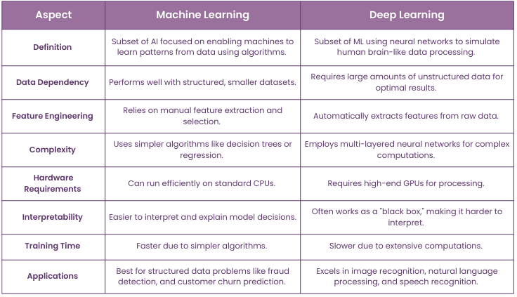
- A) Construct the principle of Restricted Boltzmann machine with neat Architecture. [3M]
[CO-2][L3]
Ans: Restricted Boltzmann Machine algorithm plays an important role in dimensionality reduction, classification, regression and many more which is used for feature selection and feature extraction. The RBM is called "restricted" because the connections between the neurons in the same layer are not allowed. In other words, each neuron in the visible layer is only connected to neurons in the hidden layer, and vice versa. This allows the RBM to learn a compressed representation of the input data by reducing the dimensionality of the input.
The RBM is trained using a process called contrastive divergence, which is a variant of the stochastic gradient descent algorithm. During training, the network adjusts the weights of the connections between the neurons in order to maximize the likelihood of the training data. Once the RBM is trained, it can be used to generate new samples from the learned probability distribution.
RBM has found applications in a wide range of fields, including computer vision, natural language processing, and speech recognition. It has also been used in combination with other neural network architectures, such as deep belief networks and deep neural networks, to improve their performance.
What makes RBMs different from Boltzmann machines is that visible node isn’t connected to each other, and hidden nodes aren’t connected with each other. Other than that, RBMs are exactly the same as Boltzmann machines.
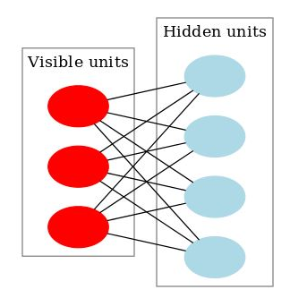
- Layers: Restricted Boltzmann Machines are shallow, two-layer neural nets that constitute the building blocks of deep-belief networks.
- The first Layer of the RBM is called the visible, or input layer, and
- The Second Layer is the Hidden Layer.
- Each circle represents a Neuron-like unit called a node.
- The nodes are connected to each other
- across layers, but no two nodes of the same layer are linked.
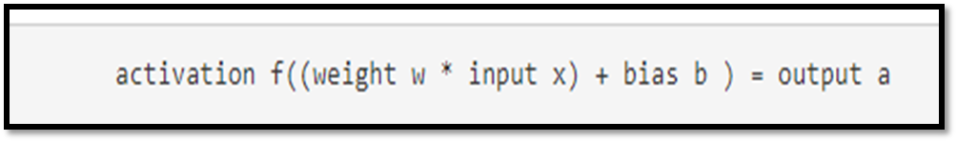
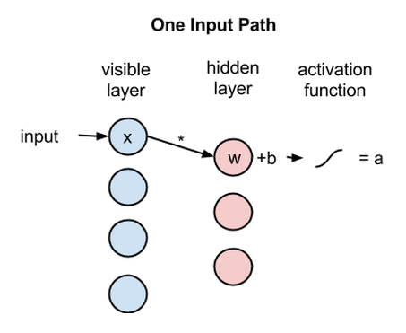
- Next, let’s look at how several inputs would combine at one hidden node.
- Each x is multiplied by a separate weight, the products are summed, added to a bias, and again the result is passed through an activation function to produce the node’s output.
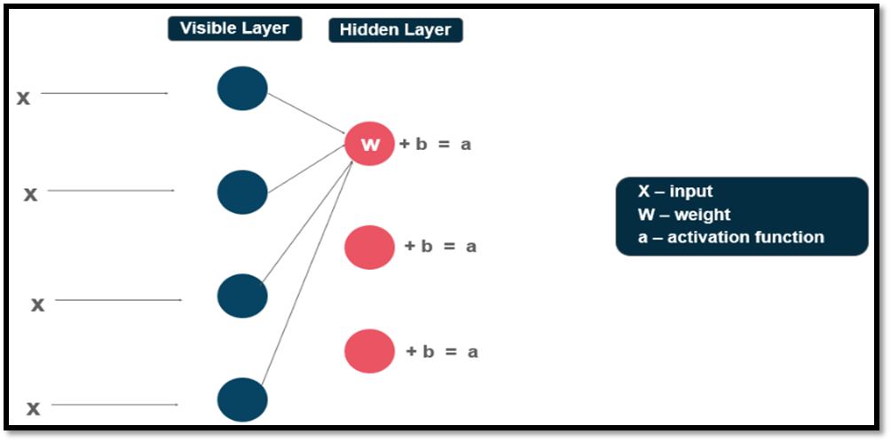
2B) Build the Deep Belief Network with neat Architecture. [2M] [CO-2][L3]
Ans: Deep Belief Network (DBN) architecture is built by stacking multiple Restricted Boltzmann Machines (RBMs). Each RBM is trained independently in an unsupervised manner, and the output of one RBM serves as the input for the next, creating a hierarchical representation. The final layer can be a supervised learning layer for tasks like classification.
Here's a more detailed explanation of the DBN architecture:
1. Stacking RBMs:
A DBN is essentially a stack of RBMs, where each RBM learns a probability distribution over the input data.
The first RBM learns the fundamental structure of the data, while subsequent RBMs learn higher-level features.
2. Greedy Layer-wise Training:
Each RBM is trained independently using contrastive divergence, an unsupervised learning method.
The output of the previously trained RBM is fed into the next RBM, allowing the network to learn a hierarchical representation.
3. Supervised Fine-tuning:
After unsupervised pre-training, the DBN can be fine-tuned using supervised learning techniques like backpropagation.
The final layer of the DBN can be a standard neural network layer, such as a softmax classifier, for tasks like classification.
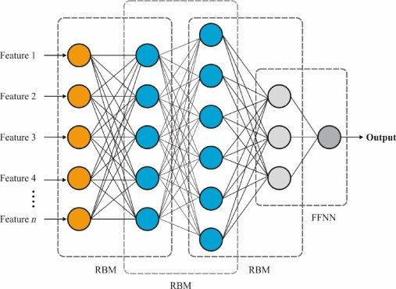

3A) Apply the pooling in CNNs, and how does it contribute to feature extraction and
Dimensionality reduction? [3M] [CO-3][L3]
Ans: Pooling layers are one of the building blocks of Convolutional Neural Networks.
- Where Convolutional layers extract features from images, Pooling layers consolidate the features learned by CNNs.
- we use a pooling function to modify the output of the layer further. Its purpose is to gradually shrink the representation’s spatial dimension to minimize the number of parameters and computations in the network.
- Pooling layers are used to reduce the dimensions of the feature maps.
- Similar to the convolutional layer, the pooling operation sweeps a filter across the entire input, but the difference is that this filter does not have any weights. Instead, the kernel applies an aggregation function to the values within the receptive field, populating the output array.
- Types of Pooling Layer:
  - 1. Max Pooling
  - 2. Average Pooling
  - 3. Min Pooling
1. Max Pooling: Finally, we can say it selects the maximum valued element from the region captured by the filter in any feature map.
This works by selecting the maximum value from every pool. Max Pooling retains the most prominent features of the feature map, and the returned image is sharper than the original image.
  - i.e, if we talk about image processing the max-pooling helps to extract the sharpest features on the image.
  - The Max Pooling layer summarizes the features in a region represented by the maximum value in that region. Max Pooling is more suitable for images with a dark background as it will select brighter pixels in a region of the input image.
- Kernel/filter is the size of a matrix that is applied over the complete input data. As the filter moves across the input, it selects the pixel with the maximum value to send to the output array.
- For Eg:
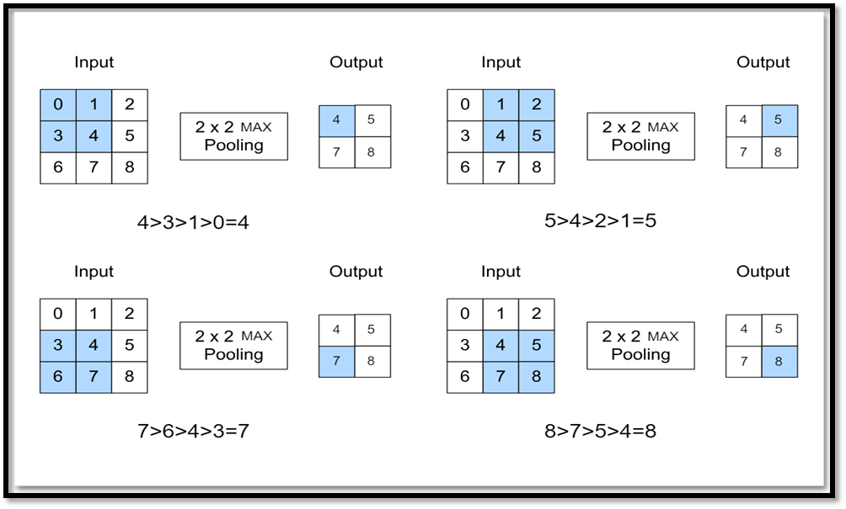
  - Mathematical Formulae: The pooling layer requires 2 hyperparameters
1. Kernel/filter size F and
2. Stride S.
On applying the pooling layer over the input volume, output dimensions of output volume will be ((n-f)/s +1) x ((n-f)/s +1)
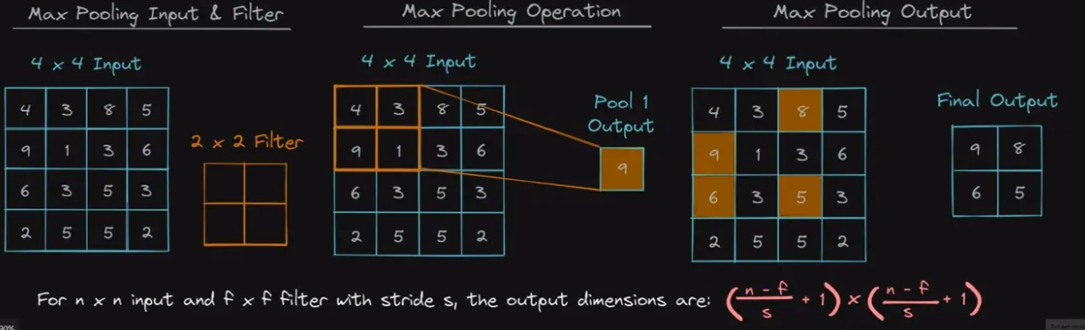
  - 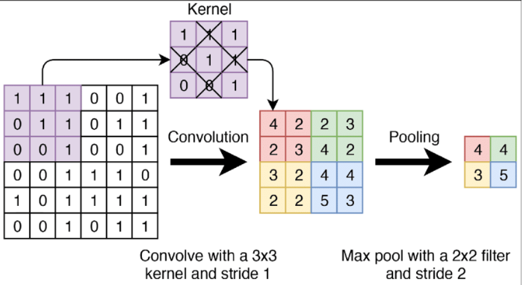
2. Average pooling : As the filter moves across the input, it calculates the average value within the receptive field to send to the output array.
  - This pooling layer works by getting the average of the pool. Average pooling retains the average values of features of the feature map.
  - Average pooling method smooth's out the image and hence the sharp features may not be identified when this pooling method is used.
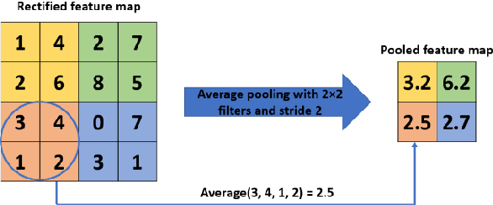
3. Min pooling : In this type of pooling, the summary of the features in a region is represented by the minimum value in that region.
It is mostly used when the image has a light background
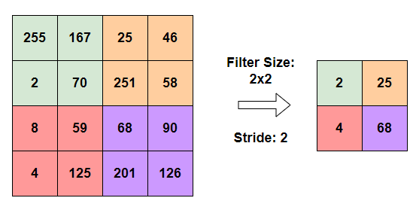

3B) Construct a convolutional network to demonstrate the effect of Padding Styles with an Example. [2M] [CO-3][L3]
Ans: Padding is a technique used to preserve the spatial dimensions of the input image after convolution operations on a feature map. Padding involves adding extra pixels around the border of the input feature map before convolution.
