PERIPHERAL DEVICES

- The input-output (I/O) subsystem allows efficient communication between a computer’s central system and the external environment.
- Programs and data are input into computer memory for processing, and results are output for user access.
- A computer requires an interface for receiving input and outputting results to be useful.
- A common input method is a keyboard, allowing direct alphanumeric entry by a user.
- The speed of data entry via a keyboard is limited by the user's typing speed.
- A CPU can perform operations much faster than data can be entered from a keyboard, creating idle time.
- For efficiency, programs and data are pre-stored on magnetic tapes or disks, then rapidly transferred into memory.
- Computed results are also transferred to high-speed storage, then printed as needed.
- Devices controlled directly by the computer, such as keyboards, are considered on-line and part of the system.
- Peripherals are devices attached to a computer, including keyboards, display units, printers, and storage drives.
- Auxiliary storage peripherals include magnetic disks and tapes.
- Peripherals are electromechanical and electromagnetic devices with specific functions.
- Video monitors, consisting of a keyboard and display unit, are widely used computer peripherals.
  - Most video monitors use cathode ray tubes (CRTs) to display output.
  - The CRT generates patterns on the screen by deflecting an electron beam to specific screen positions.
  - A cursor indicates the next character's position on display devices and can be moved.
  - Edit keys enable addition or deletion of information based on cursor position.
  - Display terminals can operate in single-character mode or block mode for data transfer.
- Printers create permanent records of computer output, commonly using daisywheel, dot matrix, or laser technologies.
  - Daisywheel printers rotate a character wheel to print text.
  - Dot matrix printers create characters using a pattern of dots.
  - Laser printers use a drum and photographic imaging for high-quality prints.
- Magnetic tapes provide sequential storage and are often used for bulk data, like payroll records.
  - Tape storage is inexpensive and slow, with removable tape cartridges.
- Magnetic disks offer high-speed access to stored data and are mainly used for program and data storage.
- Other I/O devices include plotters, character readers, and data acquisition equipment.
- Computers are used for real-time process control in industrial and chemical applications.
- Computers use sensors to monitor processes and send control signals in real-time applications.
- I/O setup depends on the computer’s size and connected devices.
- Small systems have fewer peripherals than large systems.
- It is impractical to detail all peripheral interconnections due to device variety.
- ASCII is a standard 7-bit binary code for alphanumeric characters, used in data communication.
- ASCII represents 128 characters, with 94 printable and 34 non-printable control characters.
- Printable characters include uppercase, lowercase, numerals, and special symbols.
- There are three types of control characters: format effectors, information separators, and communication control characters
- ASCII control characters manage data routing and printed text format.
  - ASCII includes format effectors like backspace, tab, and carriage return.
  - Information separators in ASCII organize data into divisions.
  - Communication control characters in ASCII facilitate text transfer between terminals.
- ASCII is often stored in an 8-bit byte, with the extra bit used for specific purposes.
- Some printers recognize ASCII as 8-bit, using the eighth bit for additional symbols or parity in data communication.
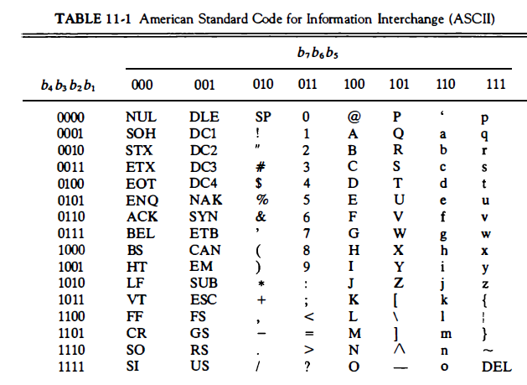

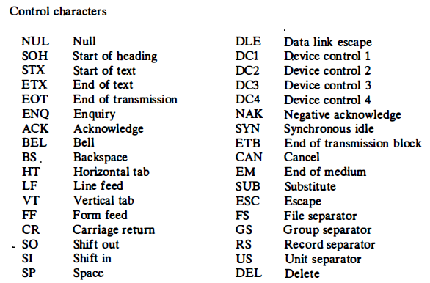

ASYNCHRONOUS DATA TRANSFER
- Clock Pulses for Synchronization: Digital systems synchronize internal operations using clock pulses from a common pulse generator.
- If an I/O interface and CPU share the same clock, data transfers between them are synchronous.
- In most systems, each unit (e.g., CPU, I/O interface) has an independent clock, making them asynchronous to each other.
- Asynchronous data transfer between units requires control signals to indicate when data transmission occurs.
  - Strobe Pulse Method: One asynchronous transfer method uses a strobe pulse from one unit to signal the other when to transfer data.
  - Handshaking Method: Another common asynchronous method is handshaking, where each data item has a control signal, and the receiving unit acknowledges receipt with a response signal.
- In asynchronous transfers, the transmitting unit is the source, and the receiving unit is the destination; the CPU is the source in output transfers and the destination in input transfers.
- Asynchronous transfers are typically specified with timing diagrams to show the timing relationships between control signals and data buses.
- The control sequence for asynchronous transfers depends on whether the source or the destination initiates the transfer.

1. Strobe Control Overview
- The strobe control method relies on a single control line (called the “strobe”) to time each data transfer between two independent units.
- The strobe signal can be generated either by the source unit (which sends data) or the destination unit (which receives data), depending on who initiates the data transfer.

a) Source-Initiated Transfer
- In a source-initiated transfer, the data bus carries the data from the source to the destination. The data bus typically consists of multiple lines to carry full bytes or words, allowing faster data transfers.
- The source unit activates the strobe signal to inform the destination unit that valid data is now available on the data bus.
- According to the timing diagram, here’s the sequence of operations:
  - The source places data on the bus and waits briefly to ensure it’s stable and valid.
  - Once data is steady, the source activates the strobe pulse. The active strobe signal notifies the destination unit that the data on the bus is ready to be read.
  - The data bus and strobe remain active for a period long enough for the destination unit to read the data.
  - The destination unit might use the falling edge of the strobe pulse (when it transitions from active to inactive) as a signal to load the data into one of its registers.
  - The source deactivates the strobe pulse and then removes data from the bus, signaling the end of that data transfer.

b) Destination-Initiated Transfer
- In a destination-initiated transfer, the destination unit activates the strobe, signaling the source unit to provide data.
- After receiving the strobe, the source places the requested data onto the data bus.
- The source must ensure that the data remains on the data bus long enough for the destination to read it.
- The falling edge of the strobe pulse may again be used by the destination to load the data from the bus into its register.
- After the data is read, the destination deactivates the strobe signal, ending the data transfer. The source then removes the data from the bus after a set interval.

Example: In many computer systems, the CPU controls the timing and use of strobe pulses for data transfers. The CPU’s clock pulses coordinate these strobe signals, managing data flow on the buses.
- Memory-Write Operation: When the CPU acts as the source, it can use a memory-write strobe signal to send data to a memory unit. The CPU places data on the data bus and activates the strobe to signal a write action to the memory unit (acting as the destination).
- Memory-Read Operation: Conversely, for reading data, the CPU (acting as the destination) initiates a memory-read strobe signal. This strobe prompts the memory unit (the source) to place the required data on the bus, which the CPU can then read.
Disadvantages of the Strobe Method:
- Lack of Acknowledgment: In the strobe method, the initiating unit (whether source or destination) has no way of confirming that the other unit has completed the data transfer.
  - For example, if the source initiates, it doesn’t know if the destination has successfully received the data.
  - Similarly, if the destination initiates, it doesn’t know if the source has placed valid data on the bus.
- Solution with Handshaking: The handshaking method addresses this issue by adding a second control signal to provide acknowledgment or feedback, ensuring both units are aware of each other's actions.

Two-Wire Handshaking Method
- This method uses two control lines in opposite directions to manage communication:
  - Data Valid Signal (Source to Destination): This control line runs from the source to the destination, indicating whether the data on the bus is valid.
  - Data Accepted Signal (Destination to Source): This control line runs from the destination to the source, informing the source unit that the destination is ready to receive or has received the data.
- The sequence of events for data transfer depends on whether the source or destination initiates the transfer.

3. Source-Initiated Transfer (Using Handshaking)
- The source initiates data transfer using two handshaking lines:
  - Data Valid: Activated by the source to indicate valid data on the bus.
  - Data Accepted: Activated by the destination to confirm it has received the data.
- Timing Diagram for Source-Initiated Transfer:
  - Step 1 - Data Placement: The source places data on the data bus and activates the Data Valid signal.
  - Step 2 - Data Acceptance: Once the destination receives the data, it activates the Data Accepted signal.
  - Step 3 - Invalidating Data: After acknowledging receipt, the source deactivates Data Valid, signaling that the data is no longer valid.
  - Step 4 - Reset to Initial State: The destination unit then deactivates Data Accepted, returning the system to its initial state.
- Next Transfer Timing: The source unit will only send new data when the destination disables its Data Accepted signal, signaling readiness for more data. This process allows flexibility, as each unit can operate at its own speed without risking data loss.
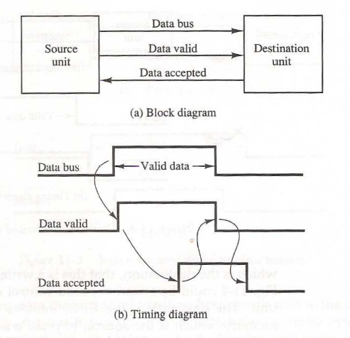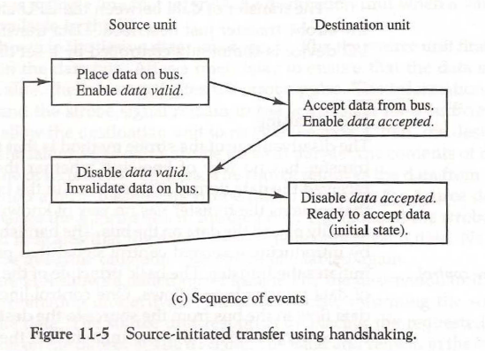

4. Destination-Initiated Transfer (Using Handshaking)
- When the destination initiates the transfer, it uses a signal named Ready for Data instead of Data Accepted, reflecting that it is now initiating the data request.
- Operation Sequence:
  - Ready for Data Signal: The destination activates the Ready for Data signal to prompt the source to place data on the bus.
  - Data Valid Signal: The source, upon receiving this signal, places data on the bus and activates the Data Valid signal.
  - Completion Sequence: After receiving data, the destination disables Ready for Data, and the source disables Data Valid.
- Symmetry in Signals: The sequence remains the same as in the source-initiated case if Ready for Data is treated as the opposite of Data Accepted. The primary difference between the two methods is the initial state and which unit initiates the data transfer.
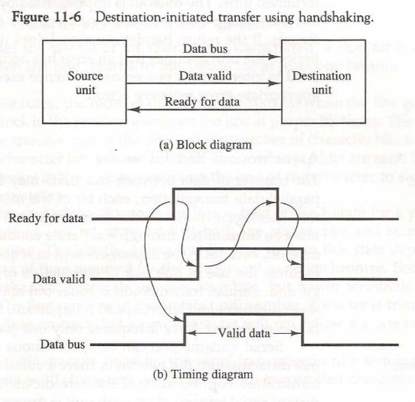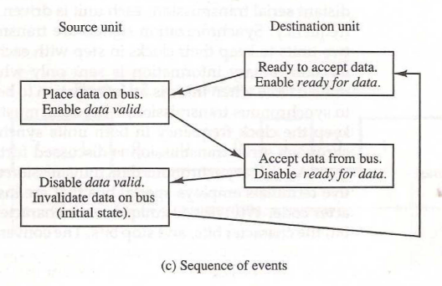

Advantages of Handshaking in Flexibility and Reliability
- Active Acknowledgment: Handshaking increases reliability because both units actively participate in each data transfer. Data is only transferred when both units signal their readiness, minimizing risks of data loss or miscommunication.
- Error Detection with Timeout Mechanism: If a unit does not receive an acknowledgment within a specific time, it triggers a timeout alert.
  - Timeout Mechanism: An internal clock begins counting when a handshaking signal is activated. If the return handshake signal isn’t received within a set timeframe, an error is presumed.
  - Error Recovery: A timeout signal can trigger an interrupt, allowing the CPU to run an error recovery routine to handle the fault.
Asynchronous serial transfer
- Parallel Transmission:
  - Each bit in a message has its own dedicated path, so all bits are transmitted simultaneously.
  - An n-bit message requires n separate conductor paths, making this method faster.
  - It’s used over short distances where high-speed data transfer is crucial, but it requires many wires, increasing the cost and complexity.
- Serial Transmission:
  - Bits are sent one at a time in sequence, requiring only one pair of conductors or a single conductor and ground.
  - It’s slower than parallel transmission but is less expensive because it only needs one conductor pair, making it ideal for long distances.

Synchronous vs. Asynchronous Serial Transmission
- Synchronous Transmission:
  - Both units (sender and receiver) share a common clock frequency, with bits transmitted continuously at a clock-synchronized rate.
  - For long-distance synchronous transmission, each unit might have its own clock with the same frequency, and synchronization signals are periodically sent to keep them in step.
- Asynchronous Transmission:
  - Data is sent only when available, and the line stays idle when no data is being transmitted.
  - Unlike synchronous transmission, asynchronous doesn’t need a continuous bit stream, so each data transfer is self-contained and independent.

Asynchronous Transmission Technique with Start and Stop Bits
- Character Framing:
  - To ensure accurate data transmission, each character is framed with additional start and stop bits.
  - Each character is split into three parts:
    - Start Bit: Signals the beginning of a character (always a binary 0).
    - Character Bits: The actual data bits.
    - Stop Bits: Signal the end of a character (always a binary 1).
- Idle State:
  - The transmitter remains in the idle state (binary 1) when not sending data.
  - When data needs to be sent, it starts with a start bit (binary 0), which alerts the receiver to begin interpreting the data stream.

Asynchronous Transmission Rules
- Detection of Transmission:
  - The receiver identifies a transmission when the line goes from 1 (idle state) to 0 (start bit).
- Receiving Data:
  - The receiver reads bits at a fixed rate based on the known bit transfer rate.
  - After reading all character bits, the stop bit is received, returning the line to the idle state (binary 1).
- Timing and Resynchronization:
  - After each character, the stop bits allow both units time to resynchronize, ensuring that the receiver has processed the previous data before the next character begins.

Stop Bits and Equipment Resynchronization
- Stop Bit Duration:
  - Stop bits give enough time for the receiver and transmitter to realign for the next data transmission.
  - Older terminals may use two stop bits for extra buffer time, but newer systems often use only one stop bit.
- Idle State Until Next Character:
  - After the stop bits, the line remains idle (binary 1) until the next character transmission, preventing overlapping transmissions.

Example of Asynchronous Serial Transmission
- Example Configuration:
  - Consider a terminal transmitting data at a rate of 10 characters per second.
  - Each character consists of:
    - 1 Start Bit (0)
    - 8 Character Bits
    - 2 Stop Bits (1)
  - Total Bits per Character: 11 bits (1 + 8 + 2).
  - 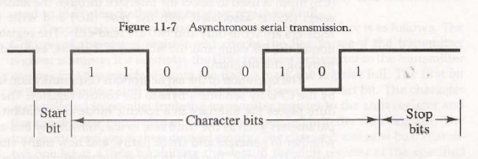
- Calculating Transmission Time:
  - With a rate of 10 characters per second, each character takes 0.1 seconds to transfer.
  - Since each character has 11 bits, the time per bit is 9.09 ms.
- Baud Rate:
  - The baud rate is the number of bits transmitted per second. For 10 characters with 11 bits each, the baud rate is 110 bits per second (bps).

Terminal Communication with UART
- Terminal Setup:
  - A terminal might have both a keyboard (input) and a printer (output).
  - When a key is pressed, the terminal sends the character as an 11-bit serial transmission.
  - To print a character, an 11-bit message must be received from the printer line.
- Terminal Interface (UART):
  - The Universal Asynchronous Receiver-Transmitter (UART) is a specialized circuit for asynchronous communication.
  - It converts the 8-bit character from the computer into an 11-bit serial message for the printer and vice versa, from serial to 8-bit format for data input.
  - UARTs are common in terminals and interactive devices to handle serial-to-parallel and parallel-to-serial data conversions, enabling seamless asynchronous communication with minimal hardware complexity.

Modes of Transfer
Data transfer to and from peripherals may be handled in one of three possible modes:
- Programmed I/O
Programmed I/O is the most basic method of data transfer between the CPU and peripheral devices, but it’s also the least efficient in terms of CPU usage. Here’s a deeper look:
- Process: The CPU initiates the transfer by executing specific I/O instructions, which are written directly in the program. Each piece of data transferred requires an instruction in the code. The CPU moves data between its own registers and the peripheral device. If the data needs to be transferred to or from memory, additional instructions are used to move it between the CPU registers and memory.
- CPU Monitoring: The CPU constantly monitors the I/O device interface to check if it’s ready for data transfer. This requires the CPU to stay in a loop, waiting for the device to signal that it’s ready. This process, called polling, keeps the CPU engaged with the peripheral device, resulting in inefficiency since the CPU could otherwise be performing other tasks.
- Drawbacks: Programmed I/O is time-consuming and keeps the CPU busy with unnecessary tasks. It’s particularly inefficient for slower devices, as the CPU might spend a long time waiting for the I/O device to be ready.
- Alternatives: Interrupt-initiated I/O and DMA (explained below) are more efficient alternatives because they reduce the CPU’s need to constantly monitor the peripheral.

2. Interrupt-Initiated I/O
Interrupt-initiated I/O is designed to make the CPU's data transfer process with peripherals more efficient by allowing the CPU to perform other tasks while waiting for the I/O device.
- Process: In this mode, the CPU initiates the data transfer but doesn’t wait in a loop to monitor the device’s status. Instead, the CPU sends a command to the device interface, and then it proceeds with other tasks.
- Interrupts: The device interface monitors the I/O device, and when the device is ready for data transfer, it sends an interrupt request signal to the CPU. An interrupt is a signal that temporarily halts the CPU’s current operations, alerting it that a specific event (in this case, the I/O device is ready) needs attention.
- CPU Action: When the CPU detects the interrupt, it stops its current task, saves its state, and branches to a special interrupt service routine to handle the data transfer with the I/O device. Once the transfer is complete, the CPU resumes its previous task.
- Advantages: This method is more efficient than programmed I/O, as it allows the CPU to work on other tasks and only deal with the I/O device when it’s necessary.

3. Direct Memory Access (DMA)
DMA is an advanced data transfer technique that allows peripheral devices to send or receive data directly to and from the memory, bypassing the CPU for much of the process.
- DMA Controller: DMA requires a special hardware component called a DMA controller, which takes charge of the data transfer. The CPU initiates the DMA transfer by sending the DMA controller the starting memory address, the number of words to transfer, and the direction of transfer (either to or from memory).
- Process: After setting up, the DMA controller takes control of the memory bus to perform the data transfer. It requests memory access cycles from the memory controller. When access is granted, the DMA controller transfers data directly between the memory and the I/O device.
- CPU’s Role: The CPU doesn’t stay involved in the transfer; it can continue executing other tasks. When the DMA controller needs access to the memory, it temporarily “borrows” the memory bus, causing a slight delay in the CPU’s access to memory. However, this delay is usually minimal because the CPU and peripherals operate at different speeds, with peripherals generally being slower.
- Advantages: DMA is highly efficient for large data transfers because it bypasses the CPU, freeing it up to perform other tasks. It’s ideal for tasks that involve large amounts of data or need high transfer speeds, such as disk operations.

4. I/O Processor (IOP)
In some computer systems, the interface logic and DMA functionality are combined into a unit called an I/O Processor (IOP), which further enhances data transfer efficiency.
- IOP Structure: The IOP manages multiple peripherals and can handle both DMA and interrupt-driven transfers. It functions as a mini-processor dedicated solely to managing I/O operations, allowing the main CPU to focus exclusively on computational tasks.
- System Organization: With an IOP, the computer system is divided into three main modules:
  - Memory Unit: Holds the data to be processed and is accessible by both the CPU and the IOP.
  - CPU: Manages general processing tasks, excluding routine I/O tasks.
  - IOP: Acts as a dedicated processor for managing peripherals, handling data transfers directly through DMA or initiating interrupts when necessary.
- Advantages: An IOP-equipped system enhances efficiency by offloading I/O management from the CPU. This setup is especially useful in complex systems with multiple peripherals, as it ensures that the CPU isn’t slowed down by I/O-related tasks.

Priority Interrupt
- Data transfer between CPU and an I/O device starts only when the device is ready, determined by an interrupt signal.
- CPU responds to interrupt by saving the return address and branching to a service routine.
- In multiple device systems, the interrupt system identifies the interrupt source and prioritizes if multiple requests arrive simultaneously.
- Priority Interrupt System: Establishes priority among various interrupt sources to determine the sequence of servicing.
  - Higher-priority devices (e.g., high-speed devices like magnetic disks) are prioritized over lower-priority devices (e.g., keyboards).
- Interrupt Handling: Can be done by software (polling) or hardware.

Software-Based Priority Handling: Polling Procedure
In a software-based approach, the system uses a polling procedure to establish priority among interrupt sources. Here’s how it works:
- Single Branch Address: All interrupt requests direct the program to a common starting point or "branch address" in memory. This branch address is where the program responsible for managing interrupts begins execution.
- Sequential Checking: The program then checks each interrupt source in a specific order, starting from the highest-priority source and moving down to lower-priority sources.
  - The priority of an interrupt source is determined by its position in this sequence. For example, if device A has higher priority than device B, the program checks device A’s interrupt signal before checking B’s.
- Conditional Branching: As it checks each interrupt source, the program looks for an active interrupt signal:
  - If an interrupt signal is found, the program branches to a service routine dedicated to handling that specific interrupt.
  - If no interrupt is found, the program moves to the next device in the priority sequence.
- Executing the Service Routine: Once the program reaches the service routine for the highest-priority active interrupt, it processes the necessary tasks to handle that interrupt, such as reading data from a device or resetting the interrupt signal.
- Loop Until All Interrupts Are Serviced: After servicing one interrupt, the program may return to the branch address to check if other interrupts are pending, repeating the sequence if necessary.
This method is known as polling because the CPU actively "polls" or checks each device in sequence to determine which one requires service.

Disadvantages of Polling
The polling procedure has limitations:
- Time Consumption: In systems with many interrupt sources, the time required to sequentially check each device can be substantial. If there are too many interrupts or if they occur frequently, the CPU may spend excessive time polling, which can impact system performance.
- Response Delay: In some cases, the time required to locate the highest-priority interrupt source may exceed the time available to service that interrupt, especially in real-time systems where prompt response is essential.
- CPU Load: Polling requires the CPU to run a dedicated program just to check interrupts, which takes away processing time from other tasks.

2. Hardware-Based Priority Handling: Priority-Interrupt Unit
To overcome the limitations of software polling, a hardware-based priority-interrupt unit can be used. This approach uses specialized hardware to quickly determine the highest-priority interrupt and direct the CPU to the appropriate service routine without sequential polling. Here’s how it works:
- Dedicated Hardware for Priority Resolution: The priority-interrupt unit is a circuit that is dedicated to managing interrupt priorities. It connects to all interrupt sources and monitors their status.
- Instantaneous Priority Determination: When multiple interrupts occur simultaneously, the priority-interrupt unit can instantly determine which interrupt has the highest priority based on a pre-defined priority hierarchy.
- Interrupt Vector: Each interrupt source is assigned a unique vector address (a code representing the interrupt). The priority-interrupt unit sends this vector address to the CPU, which then uses it to locate and execute the corresponding service routine directly.
  - The vector address allows the CPU to go directly to the service routine without polling each source, thus saving time.
- No Polling Required: Since the priority-interrupt unit resolves the priority and sends the vector address to the CPU directly, no polling is needed. The CPU can immediately respond to the highest-priority interrupt and execute its service routine.
- Scalability for Multiple Sources: Hardware-based interrupt handling scales better with multiple interrupt sources because the time to determine priority remains constant, regardless of the number of devices.

Advantages of a Hardware Priority-Interrupt Unit
- Faster Response: Hardware-based priority resolution allows for much faster response times, which is critical in real-time systems.
- Reduced CPU Load: The CPU doesn’t need to spend time polling each device, freeing it up for other tasks.
- Consistent Priority Handling: Priority is managed consistently and quickly by the hardware, minimizing the chances of missing high-priority interrupts due to polling delays.

Methods of Hardware Priority Handling
There are different hardware methods for establishing priority among interrupt sources:
- Daisy-Chaining: In this method, devices are connected in series in a “chain” with the highest-priority device placed first in the chain. The CPU’s interrupt acknowledge signal travels down the chain, stopping at the first device with an active interrupt. This device blocks the signal from reaching lower-priority devices, ensuring it gets serviced first.
- Parallel Priority Encoder: A more advanced approach uses a parallel priority encoder, which monitors all interrupt sources simultaneously. It assigns priority based on the position of each interrupt in an interrupt register and generates an output directly based on the highest-priority interrupt. Parallel encoders are faster than daisy-chaining because they allow the CPU to respond directly to the highest-priority interrupt without waiting for signals to propagate through a chain.
Daisy Chaining:

1. CPU Enables the Interrupt Acknowledge Line
- When an interrupt request occurs, the CPU responds by activating the interrupt acknowledge line. This signal is used to communicate back to the devices that the CPU is ready to handle an interrupt and is now looking to identify which device has the highest priority request.
- The interrupt acknowledge signal initiates the process of identifying which device needs service, starting with the highest-priority device in the chain.
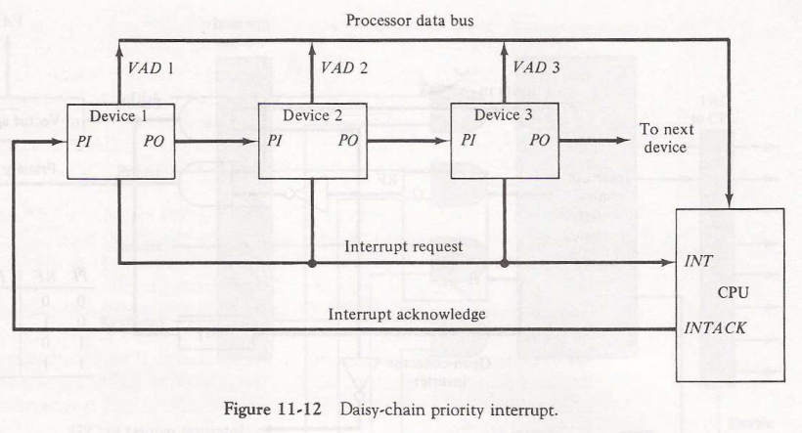

2. Priority In (PI) and Priority Out (PO) Signals
- Each device in the daisy chain has two key signals for interrupt handling:
  - PI (Priority In): This input signal tells the device whether it has permission to participate in the interrupt cycle.
  - PO (Priority Out): This output signal is used to communicate to the next device in the chain, either allowing it to participate in the interrupt cycle or blocking it if the current device has a pending interrupt.
- The interrupt acknowledge signal received by the highest-priority device (device 1 in this case) arrives at its PI input. Device 1 then decides whether to allow the acknowledge signal to pass on to the next device through its PO output.

3. Blocking the Acknowledge Signal if the Device Has a Pending Interrupt
- If the highest-priority device (device 1) has a pending interrupt request, it will "block" the interrupt acknowledge signal from reaching the next device in the chain by setting PO to 0.
- This blocking action prevents the interrupt acknowledge signal from moving down the chain and indicates that the current device (device 1) should handle the interrupt.
- By blocking the acknowledge signal, device 1 ensures it gets serviced before any lower-priority devices.

4. Device Places its Vector Address (VAD) on the Data Bus
- If the device with the highest priority and a pending interrupt request receives an interrupt acknowledge signal, it proceeds to place its interrupt vector address (VAD) onto the data bus.
- This vector address (VAD) contains the information the CPU needs to identify which service routine to run. Each device has a unique VAD, so the CPU can handle interrupts correctly for different devices.

5. Behavior of Devices with PI = 0
- If a device’s PI input is 0, it indicates that it is not allowed to participate in the current interrupt cycle, regardless of whether it has a pending interrupt. As a result:
  - The device will set PO = 0 and disable its VAD output so that it does not interfere with the data bus.
- This behavior passes control to the next device in the chain by effectively "disconnecting" the device from the interrupt cycle for this instance.

6. Behavior of Devices with PI = 1 and No Pending Interrupt (RF = 0)
- If a device has PI = 1 (it is allowed to participate in the interrupt cycle) but does not have a pending interrupt (indicated by RF = 0), it will set PO = 1 to pass the interrupt acknowledge signal along to the next device in the chain.
- In this condition, the vector address is disabled for this device, so it does not place anything on the data bus. Instead, the acknowledge signal reaches the next device, which checks its interrupt request status.

7. Active Device with PI = 1 and RF = 1
- A device is considered "active" and ready to handle an interrupt if both PI = 1 and RF (Request Flip-Flop) = 1.
- When these conditions are met:
  - The device sets PO = 0 to block any further propagation of the interrupt acknowledge signal to lower-priority devices.
  - The device then places its VAD (vector address) onto the data bus, allowing the CPU to read the address and begin executing the corresponding interrupt service routine.

8. Assigning Priority in the Daisy Chain
- In a daisy-chaining scheme, priority is determined by the device’s position in the chain:
  - The first device in the chain has the highest priority, and each subsequent device has progressively lower priority.
  - The farther a device is from the first position, the lower its priority, meaning it will only receive the interrupt acknowledge signal if all higher-priority devices pass it along.

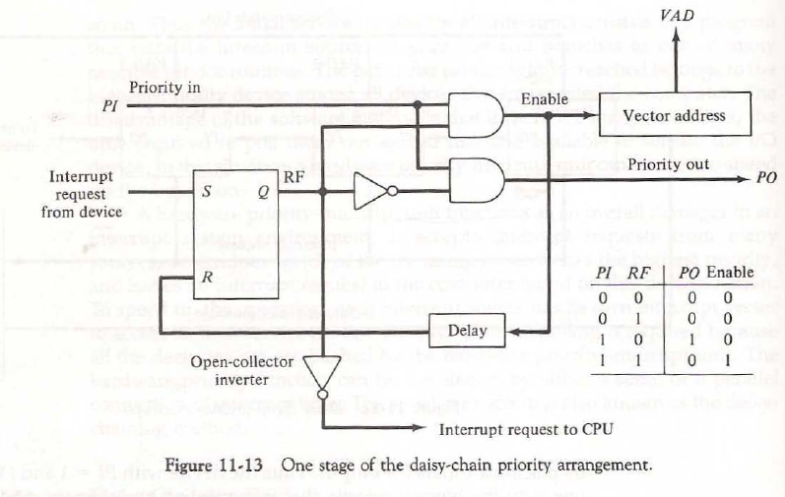

9. Internal Logic of Each Device for the Daisy Chain
- Each device has some internal logic circuitry, including an RF flip-flop (Request Flip-Flop) and open-collector inverters that help control the common interrupt line and priority signals.
- The RF flip-flop is set when a device has a pending interrupt, and its output connects to an open-collector inverter. This inverter is used to manage the wired logic for the common interrupt line.
  - If PI = 0 (i.e., the device is not allowed to participate), both PO and the VAD enable line are set to 0, regardless of the RF state. This disconnects the device from the interrupt cycle.
  - If PI = 1 and RF = 0 (i.e., the device has permission to participate but no pending request), then PO = 1 (passes the acknowledge signal) and the VAD output is disabled.
  - If PI = 1 and RF = 1, then PO = 0 (blocks the acknowledge signal from lower-priority devices) and enables VAD to place the device’s vector address onto the data bus.

10. Resetting the RF Flip-Flop After the Interrupt Cycle
- Once the CPU reads the vector address and begins executing the corresponding service routine, the RF flip-flop of the requesting device is reset.
- This reset happens after a slight delay to ensure that the CPU has received the vector address.
- Resetting the RF flip-flop clears the interrupt request for that device, making it ready to receive future interrupts when needed.

Priority Encoder:
A priority encoder is a digital circuit that encodes the input line with the highest priority, producing a binary output based on the position of the highest-priority active input. Priority encoders are often used in interrupt handling within computers, where multiple interrupt sources need to be prioritized.
