Code: 23CS3402, 23IT3402, 23AM3402, 23DS3402
PVP 23

PVP SIDDHARTHA INSTITUTE OF TECHNOLOGY

(Autonomous)

II B. Tech – II Semester
DATABASE MANAGEMENT SYSTEMS
((Common to CSE, IT, CSE(AI&ML), CSE(DS) )

Model Paper

Duration: 3 Hours Max. Marks: 70

Note: 1. This question paper contains two Parts A and B.
2. Part-A contains 10 short answer questions. Each Question carries 2 Marks.
3. Part-B contains 5 essay questions with an internal choice from each unit. Each Question carries 10 marks.
4. All parts of Question paper must be answered in one place.
BL-Blooms Level CO-Course Outcome

PART – A

Q. NO. | QUESTION | CO | LEVEL | MARKS
1. a) | List the main advantages of using a database system. | CO1 | L2 | 2M
1.b) | What is data abstraction? | CO1 | L2 | 2M
1.c) | Define candidate key and how is it different from a primary key. | CO1 | L2 | 2M
1.d) | Compare total and partial participation in relationships. | CO1 | L2 | 2M
1.e) | List the different types of constraints in the relational model. | CO1 | L2 | 2M
1.f) | Describe various SQL Functions. | CO1 | L2 | 2M
1.g) | Define Boyce-Codd Normal Form (BCNF) with an example. | CO1 | L2 | 2M
1.h) | Define Functional Dependencies with an example. | CO1 | L2 | 2M
1.i) | What are shared locks? | CO1 | L2 | 2M
1.j) | Describe No-UNDO/REDO recovery technique | CO1 | L2 | 2M

PART – B

UNIT-I
2 | (a) |  | Demonstrate the three schema architecture for database systems with a neat diagram. | L2 | CO1 | 5M
2 | (b) |  | Discuss the role of data independence and how it is achieved in the database approach. | L2 | CO1 | 5M
OR
3 | (a) |  | Describe the advantages and disadvantages of using client-server architecture compared to centralized database architecture | L2 | CO1 | 5M
3 | (b) |  | Explain various categories of Data Models. | L2 | CO1 | 5M
UNIT-II
4 | Draw an ERD containing the Order and Customer entity types connected by a 1-M relationship from Customer to Order. Choose an appropriate relationship name using your common knowledge of interactions between customers and orders. Define minimum cardinalities so that an order is optional for a customer and a customer is mandatory for an order. For the Customer entity type, add attributes CustNo (primary key), CustFirstName, CustLastName, CustStreet, CustCity, CustState, CustZip, and CustBal (balance). For the Order entity type, add attributes for the OrdNo (primary key), OrdDate, OrdName, OrdStreet,OrdCity, OrdState, and OrdZip.. |  |  | L4 | CO4 | 10M
OR
5 | Analyze the different types of relationships that can exist between entity sets. How do roles and structural constraints like cardinality and participation influence the design and implementation of these relationships in a database? Explain. |  |  | L4 | CO4 | 10M
UNIT-III
6 | (a) | Apply relational algebra operations inspired by set theory, such as UNION, INTERSECT, and DIFFERENCE. |  | L3 | CO2 | 5M
6 | (b) | - Create Products table with the following columns:  - ProductID (Primary Key, Integer)  - ProductName (String, Not Null)  - Price (Decimal, greater than 0 using a check constraint)  - CategoryID (Foreign Key referencing Categories(CategoryID)).  Explain the constraints you used. |  | L3 | CO2 | 5M
OR
7 | (a) |  | Make use of INNER JOIN, LEFT JOIN, RIGHT JOIN and FULL OUTER JOIN with an example. | L3 | CO2 | 5M
7 | (b) |  | Apply nested queries with examples in SQL. | L3 | CO2 | 5M
UNIT-IV
8 | (a) |  | Apply 2NF and remove partial dependencies from the following  Relation  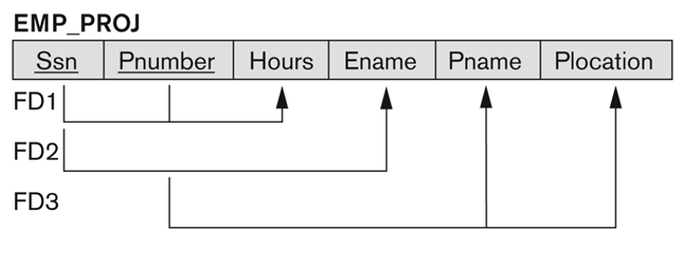 | L3 | CO3 | 5M
8 | (b) |  | Identify the challenges and benefits associated with implementing normalization. | L3 | CO3 | 5M
OR
9 | (a) |  | Consider the Universal Relation A(P,Q,R,S,T) and the set of functional dependencies.  P→QR,RS→T,Q→S,T→P  i). List the candidate keys  ii). Is it in the 2 NF ?  iii). Is it in 3NF? | L3 | CO3 | 5M
9 | (b) |  | Use Fourth Normal Form (4NF) to remove multi-valued dependencies from a relation. | L3 | CO3 | 5M
UNIT-V
10 | (a) |  | Discuss the criteria for characterizing schedules based on their recoverability and serializability properties. | L2 | CO1 | 5M
10 | (b) |  | Describe transaction. In what situation a transaction is said to be committed or aborted? | L2 | CO1 | 5M
OR
11 | (a) |  | Explain the principles of the Two-Phase Locking (2PL) protocol. Discuss the types of locks used in 2PL and their role in preventing conflicts among concurrent transactions. | L2 | CO1 | 5M
11 | (b) |  | Explore ACID properties of transactions. | L2 | CO1 | 5M

