WEEK – 1
AIM:a) Anaconda Software Installation and introduction to Jupyter Notebook.
b) Idle Software installation
c) Google colab
DESCRIPTION:
PROGRAMMING TOOLS:
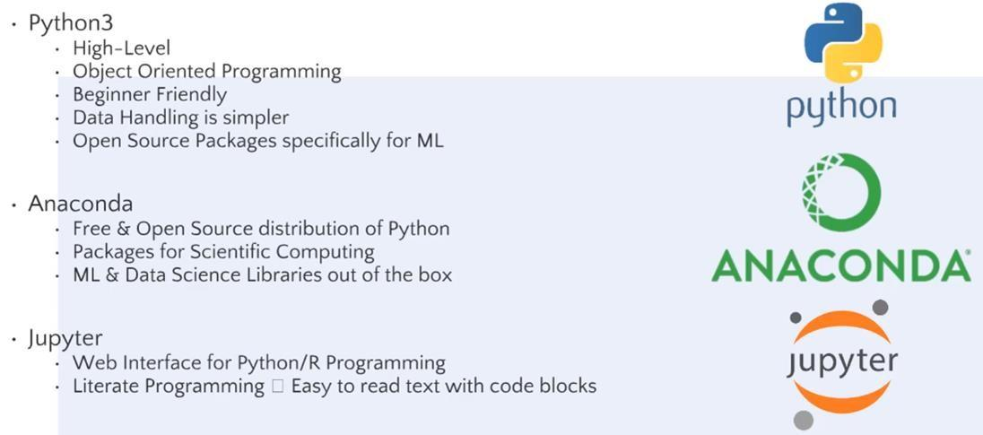

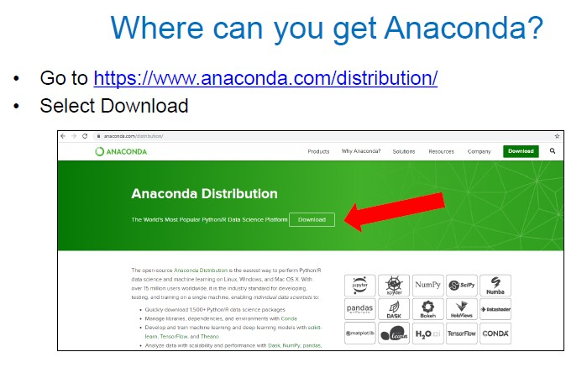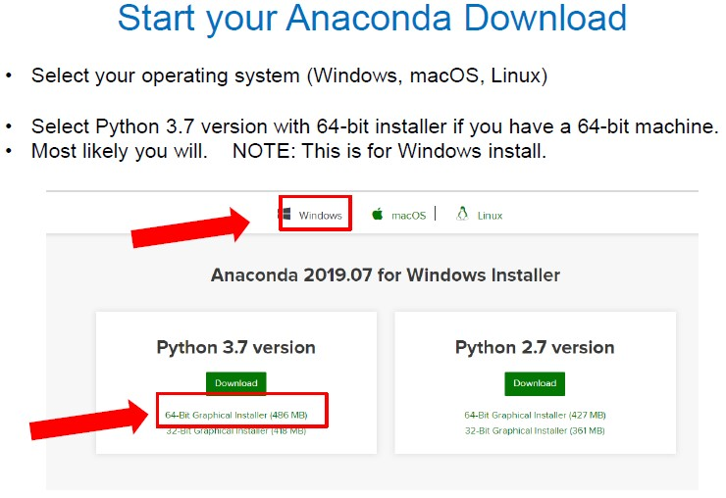

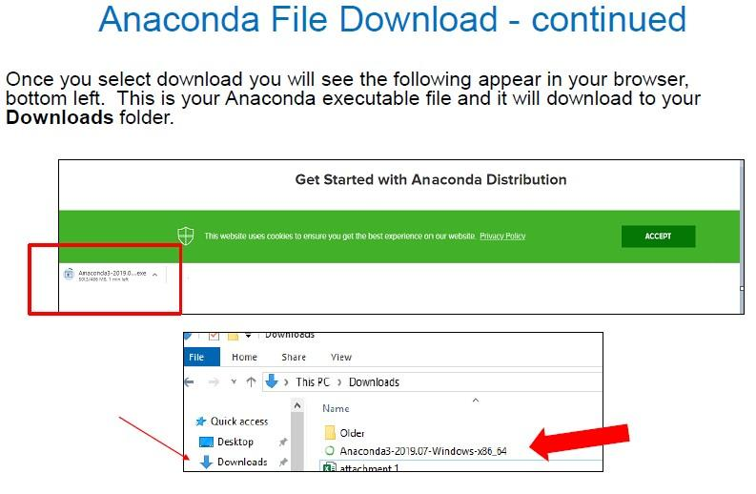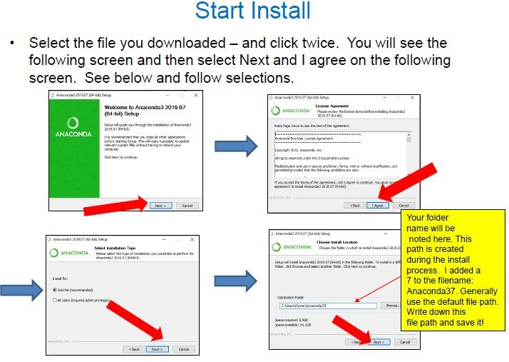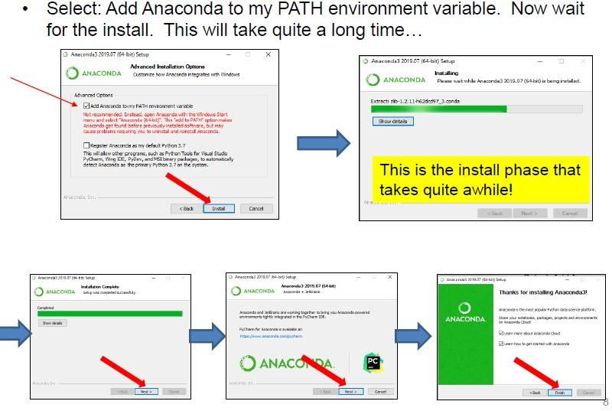
After that select the Jupyter Notebook 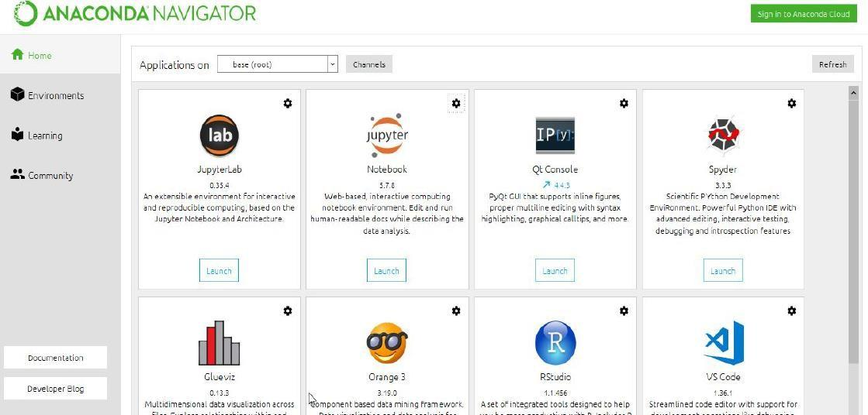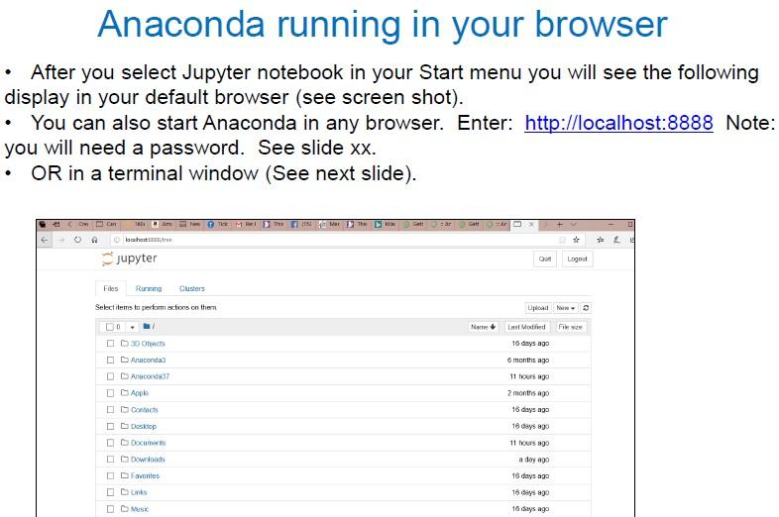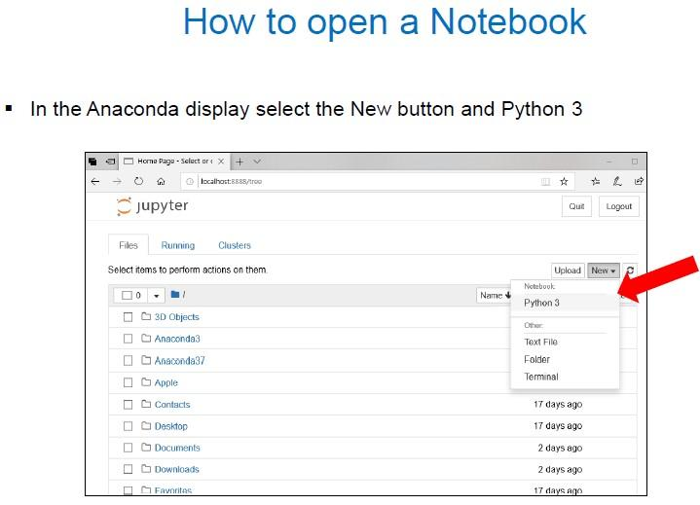 Jupyter Notebook Example:
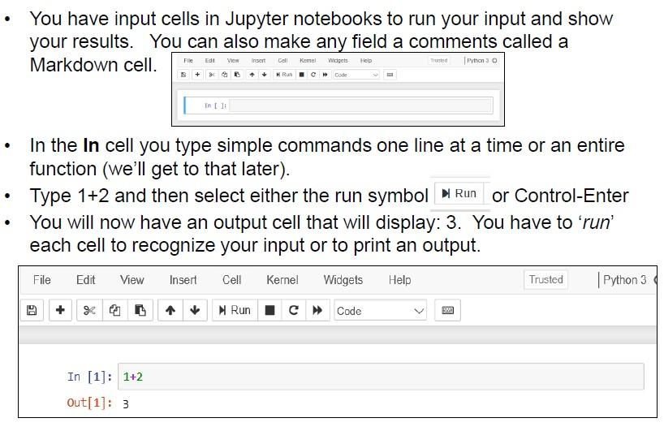

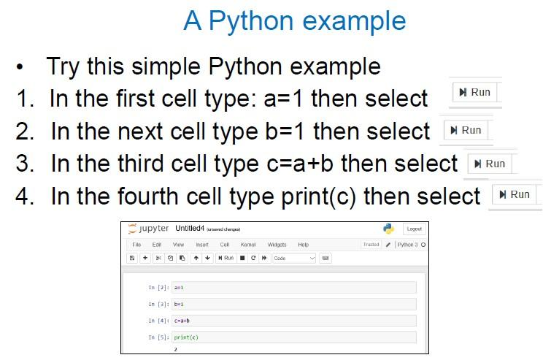

RESULT:
Anaconda naviagator with jupyter book was installed successfully.
b) Idle Software installation
To download Python on your system, you can use the following steps
Step 1: Select Version to Install Python
Visit the official page for Python https://www.python.org/downloads/ on the Windows operating system. Locate a reliable version of Python 3, preferably version 3.10.11, which was used in testing this tutorial. Choose the correct link for your device from the options provided: either Windows installer (64-bit) or Windows installer (32-bit) and proceed to download the executable file.
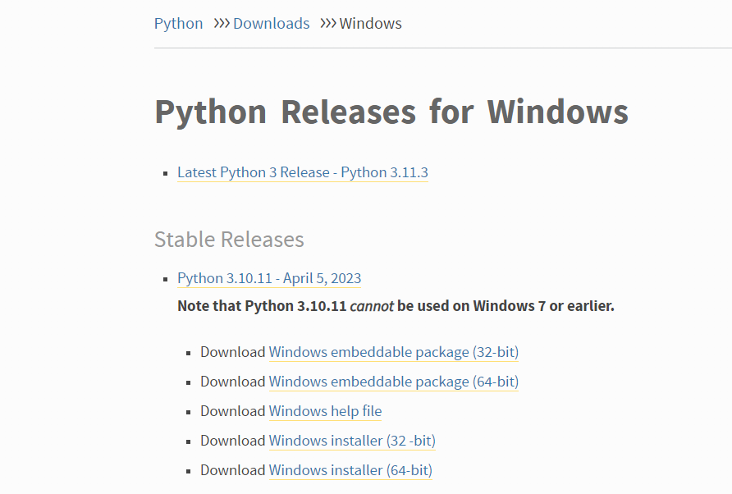
Python Homepage
Step 2: Downloading the Python Installer
Once you have downloaded the installer, open the .exe file, such as python-3.10.11-amd64.exe, by double-clicking it to launch the Python installer. Choose the option to Install the launcher for all users by checking the corresponding checkbox, so that all users of the computer can access the Python launcher application. Enable users to run Python from the command line by checking the Add python.exe to PATH checkbox.
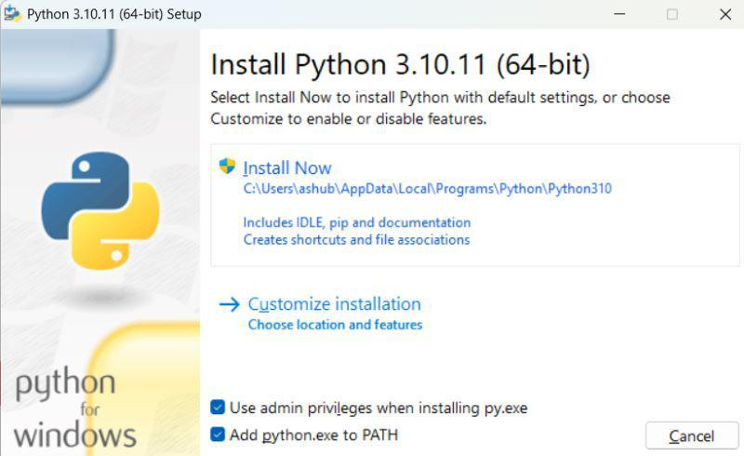
Python Installer
After Clicking the Install Now Button the setup will start installing Python on your Windows system. You will see a window like this.
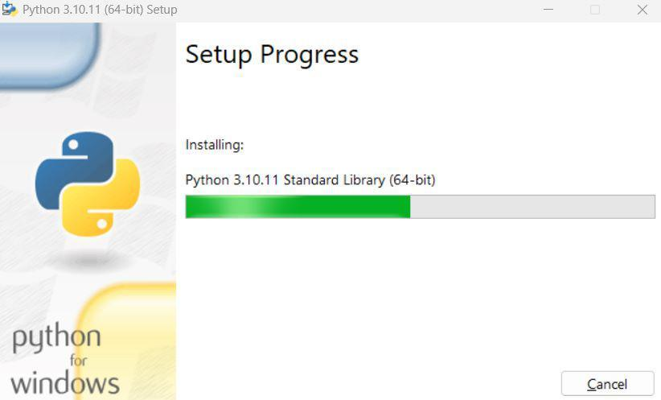
Python Setup

Step 3: Running the Executable Installer
After completing the setup. Python will be installed on your Windows system. You will see a successful message.
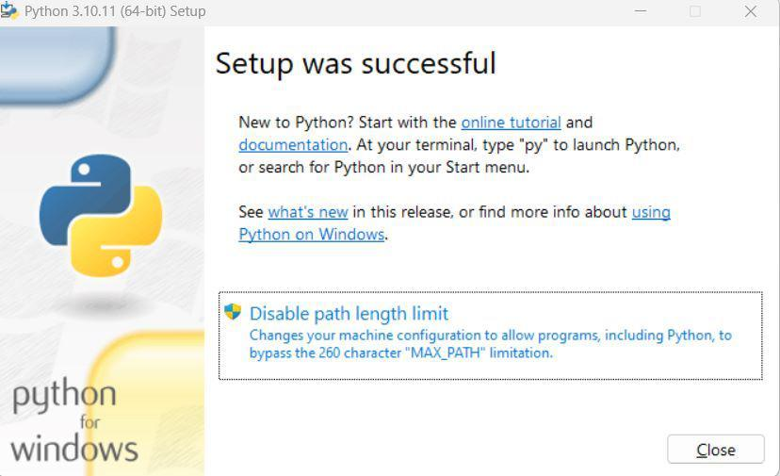
Python Successfully installed
Step 4: Verify the Python Installation in Windows
Close the window after successful installation of Python. You can check if the installation of Python was successful by using either the command line or the Integrated Development Environment (IDLE), which you may have installed. To access the command line, click on the Start menu and type “cmd” in the search bar. Then click on Command Prompt.
python --version
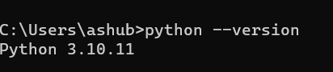
Python version
You can also check the version of Python by opening the IDLE application. Go to Start and enter IDLE in the search bar and then click the IDLE app, for example, IDLE (Python 3.10.11 64-bit). If you can see the Python IDLE window then you are successfully able to download and installed Python on Windows.
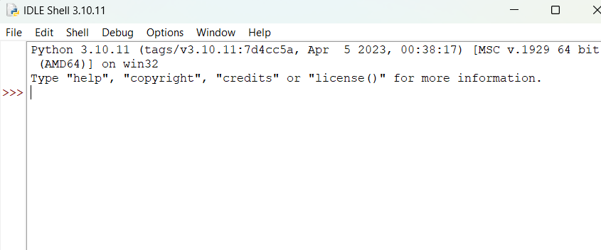
Python IDLE

RESULT:
IDLE software was installed successfully.

Aim:
What is Google Colab?
Google Colab, short for Colaboratory, is a free cloud-based platform provided by Google that allows users to write and execute Python code collaboratively in a Jupyter Notebook environment. Google Collaboratory notebook, is designed to facilitate machine learning (ML) and data science tasks by providing a virtual environment, Google colab python with access to free GPU resources.

Step1: Getting Started With Google Colab
To start working with Google Collaboratory Notebook you first need to log in to your Google account, then go to this link https://colab.research.google.com. Open Collaboratory Notebook
On opening the website you will see a pop-up containing the following tabs –
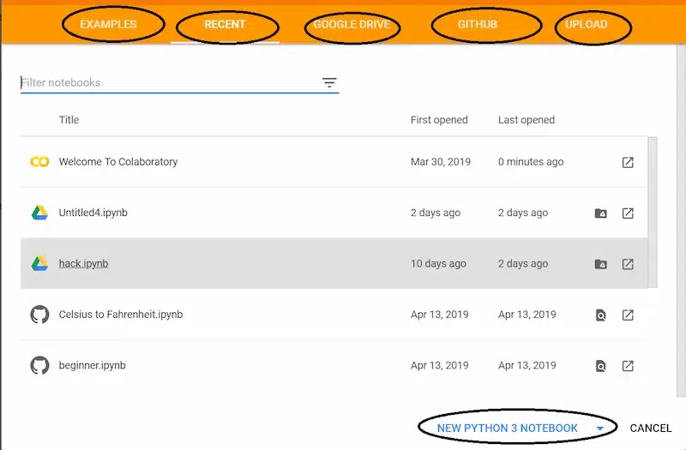
Google Collaboratory Notebook
On creating a new notebook, it will create a notebook with Untitled0.ipynb and save it to your google drive in a folder named Colab Notebooks.
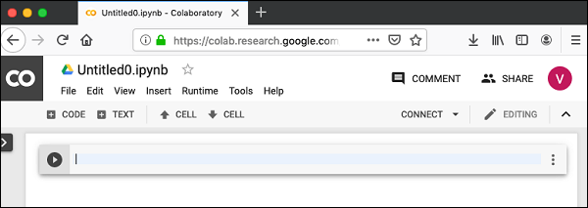
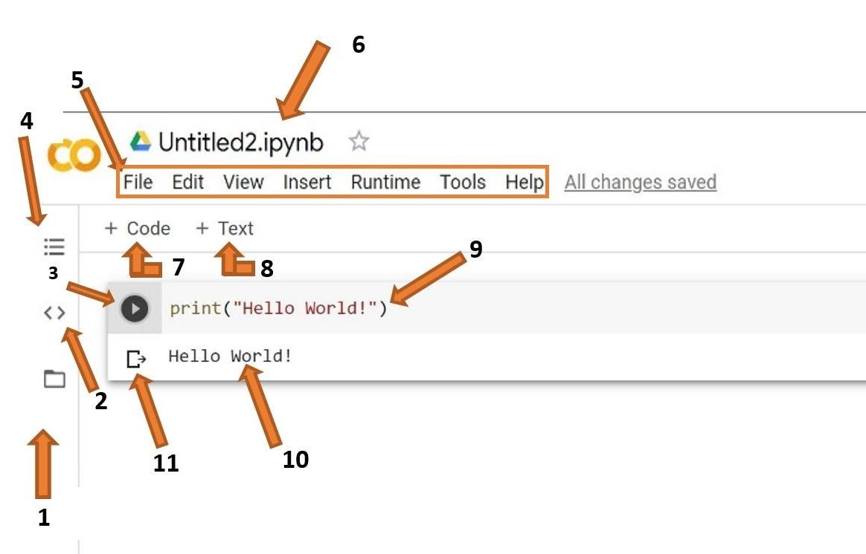
Step 2 : Before we start getting into the coding, let’s familiarize ourselves with the user interface (UI) of Google Colab.
- Files: Here you will be able to upload datasets and other files from both your computer and Google Drive
- Code Snippets: Here you will be able to find prewritten snippets of code for different functionalities like adding new libraries or referencing one cell from another.
- Run Cell: This is the run button. Clicking this will run any code that is inserted in the cell beside it. You can use the shortcut shift+enter to run the current cell and exit to a new one.
- Table of Contents: Here you will be able to create and traverse different sections inside of your notebook. Sections allow you to organize your code and improve readability.
- Menu Bar: Like in any other application, this menu bar can be used to manipulate the entire file or add new files. Look over the different tabs and familiarize yourself with the different options. In particular, make sure you know how to upload or open a notebook and download the notebook (all of these options are under “File”).
- File Name: This is the name of your file. You can click on it to change the name. Do not edit the extension (.ipynb) while editing the file name as this might make your file unopenable.
- Insert Code Cell: This button will add a code cell below the cell you currently have selected.
- Insert Text Cell: This button will add a text cell below the cell you currently have selected.
- Cell: This is the cell. This is where you can write your code or add text depending on the type of cell it is.
- Output: This is the output of your code, including any errors, will be shown.
- Clear Output: This button will remove the output.
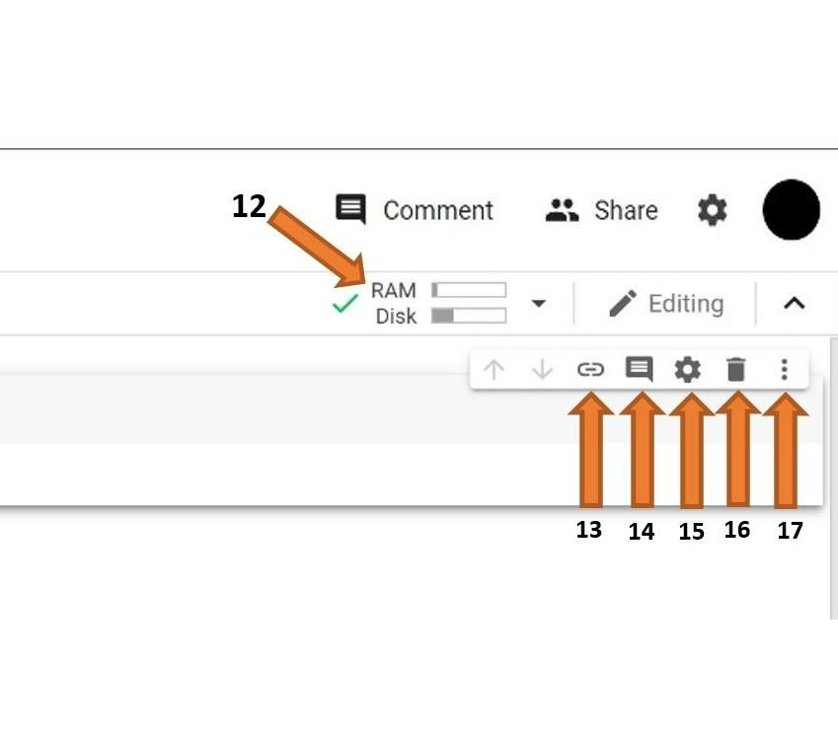
- Ram and Disk: All of the code you write will run on Google’s computer, and you will only see the output. This means that even if you have a slow computer, running big chunks of code will not be an issue. Google only allots a certain amount of Ram and Disk space for each user, so be mindful of that as you work on larger projects.
- Link to Cell: This button will create a URL that will link to the cell you have selected.
- Comment: This button will allow you to create a comment on the selected cell. Note that this will be a comment on (about) the cell and not a comment in the cell.
- Settings: This button will allow you to change the Theme of the notebook, font type, and size, indentation width, etc.
- Delete Cell: This button will delete the selected cell.
- More Options: Contains options to cut and copy a cell as well as the option to add form and hide code.

WEEK 2
1) AIM: Write a Program to print the student details using Escape sequence characters.(Example:\n,\t,\”)
Description: Escape sequence characters are special character combinations in programming (especially in strings) that allow you to include control characters that perform specific actions, like creating a new line or adding a tab. Each escape sequence starts with a backslash (\) followed by a character that represents the specific action. Here are a few common examples:
- \n : Inserts a new line, moving the text to the next line.
- \t : Inserts a horizontal tab, adding spacing in the text.
- \" : Allows the use of double quotes inside a string without ending the string.
Syntax:
To read input from user:
Name=input(“ “)
Integer values:
Variable=int(input())
To print:
Print()
Program :
Name = input(“Enter your name: “)
Age = int(input(“Enter your age: “))
Clgname = input(“Enter your college name: “)
Branch = input(“Enter your department: “)
Year = int(input(“Enter the year you’re studying in: “))
Print(“Your name is:”, name)
Print(“Your age is:”, age)
Print(“Your college name is:”, clgname)
Print(“Your department is:”, branch)
Print(“You’re studying in year:”, year)
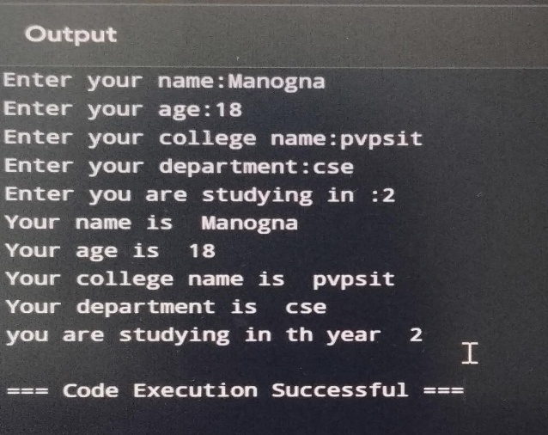
Output

2) AIM: The total number of students in a class are 45 out of which 25 are boys. If 80% of the total students secured grade 'A' out of which 16 are boys, then Develop a Program to calculate the total number of girls getting grade 'A'.
Description: To solve this problem, we need to calculate the total number of girls who secured grade 'A'. Here's the breakdown:
- Total Students: 45
- Total Boys: 25
- Total Girls: 45−25=2045 - 25 = 2045−25=20
- Students with Grade 'A': 80% of 45.
Syntax:
To read input:
Variable = value
Program:
Total students=45
Total_boys=25
Total_girls=20
A_Students=(80/100)*45
A_boys=16
A_girls=(A_students-A_boys)
Print (“The total number of girls with A grade are: “,A_girls)
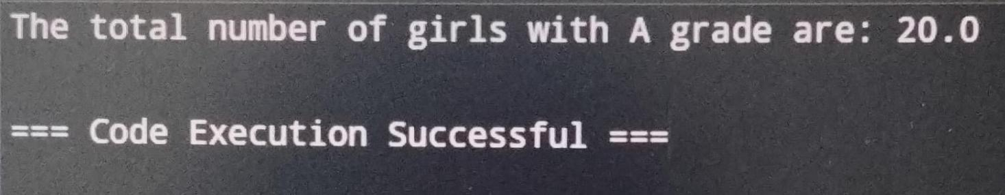
Output:

3) AIM: Develop a Program to calculate the sum of the first and the last digit of a 56743
Description: Input: We have a string, string = "56743".
- Extract the First Digit: Convert the first character (string[0]) to an integer and store it in num1.
- Extract the Last Digit: Convert the last character (string[-1]) to an integer and store it in num2.
- Calculate the Sum: Add num1 and num2.
- Output: Print the result.
Syntax :
To read a string:
String=”value”
Program :
String=”56743”
Num1=int(string [0])
Num2=int(string[0])
Print(“The sum of first and last number of the string is: “,num1+num2)
Output :
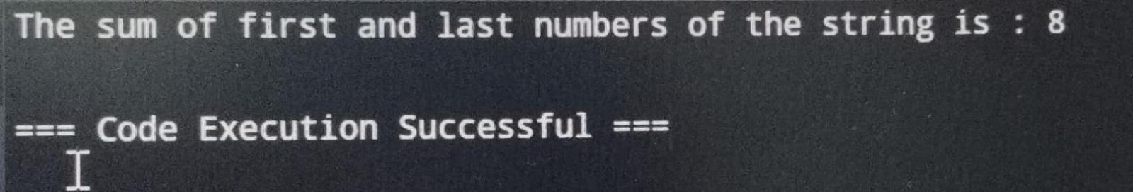

4) AIM: Write a program for calculating the bill amount for an item with the following scenarios
- The quantity of item sold, and price of the item must read from the user and calculate the bill
- After that there is a 10% discount on bill amount
- There is a tax amount of 12%
- Find the total bill after availing the discount and applying the tax
Description:
Input Quantity and Price: The user is prompted to enter the quantity of the item sold and the price per item.
Calculate Initial Bill: The program multiplies quantity by price to get the initial bill amount.
Apply Discount: A 10% discount is applied to the initial bill.
Calculate Tax: After the discount, a 12% tax is added to the discounted amount.
Final Bill: The program then outputs the final bill amount, after both the discount and tax are applied.
Program:
# Get user inputs
Quantity = int(input(“Enter the quantity: “))
Price = int(input(“Enter the price: “))
# Calculate bill amount
Bill_amount = quantity * price
# Calculate discount (10%)
Discount = (10 / 100) * bill_amount
# Calculate tax (12%)
Tax = (12 / 100) * bill_amount
# Calculate total amount
Total_amount = bill_amount – discount + tax
# Display results
Print(“The bill amount is:”, bill_amount)
Print(“The discount amount is:”, discount)
Print(“The tax amount is:”, tax)
Print(“The total amount is:”, total_amount)
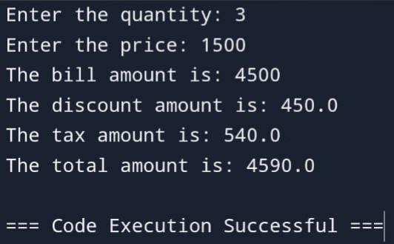
Output:
5) AIM: Implement a program to calculate in how many days a work will be completed by three persons A, B and C together. A, B, C take x days, y days and z days respectively to do the job alone. The formula to calculate the number of days if they work together is xyz/(xy + yz +xz) days where x, y, and z are given as input to the program.
Description:
Input: The program reads the number of days each person would take to complete the job alone (days taken by A, B, and C are x, y, and z respectively).
Calculation: Using the formula ​ xyz/(xy + yz +xz), the program calculates the combined days needed if all three work together.
Output: The program displays the calculated number of days.
Program:
# Get inputs from the user
X = int(input(“Enter number of days taken by A to complete work: “))
Y = int(input(“Enter number of days taken by B to complete work: “))
Z = int(input(“Enter number of days taken by C to complete work: “))
# Calculate total days when they work together using the formula
Total = (x * y * z) / (x * y + y * z + 2 * x * z)
# Display the result
Print(“\nTotal days when A, B, and C work together is:”, total)
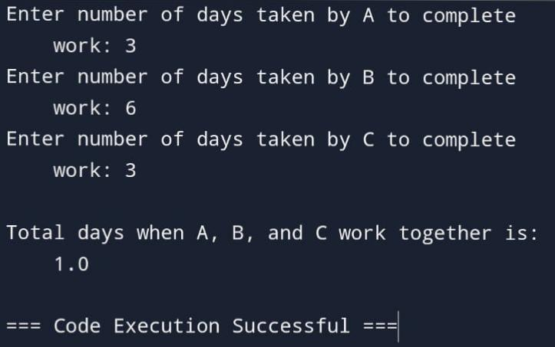
Output:

6) AIM: Implement a program to read two complex numbers and perform addition ,subtraction.
Description:
Input: The user inputs two complex numbers in the format a + bj.
Addition: The program adds the two complex numbers using the + operator.
Subtraction: The program subtracts the second complex number from the first using the - operator.
Output: The program displays the results of both the addition and subtraction.
Syntax:
To read complex numbers:
Variable= complex (i,j)
Program:
# Define complex numbers
A = complex(3, 4)
B = complex(1, 2)
# Perform arithmetic operations
Print(“The sum of complex numbers: “, a + b)
Print(“The difference of complex numbers: “, a – b)
Output:
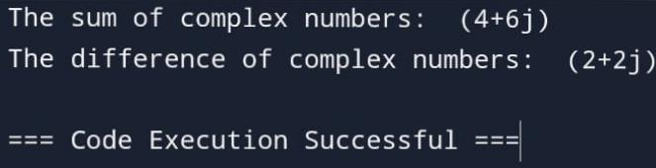
7) AIM: Develop a program to demonstrate evolution of following arithmetic expressions?
- Consider b=4, c=8, d=2,e=4,f=2
- a=b+c/d+e*f
- a=(b+c)/d+e*f
- a=b+c/((d+e)*f)
Description:
Set Variables: Initialize the variables b, c, d, e, and f with values: b=4, c=8, d=2, e=4, and f=2.
Calculate Different Expressions:
- a = b + c / d + e * f: This expression evaluates based on standard operator precedence (division and multiplication first, then addition).
- a = (b + c) / d + e * f: Here, b + c is evaluated first due to parentheses, followed by division and multiplication.
- a = b + c / ((d + e) * f): In this case, d + e is evaluated first, then multiplied by f, and finally used in division with c, followed by adding b.
Display Results: The program outputs the value of a for each expression, showing how different parenthetical groupings affect the result.
Program:
# Define variables
B = 4
C = 8
D = 2
E = 4
F = 2
# Perform calculations and print results
Print(“The value of a is:”, b + c / d + e * f)
Print(“\nThe value of a is:”, (b + c) / d + e * f)
Print(“The value of a is:”, b + c / ((d + e) * f))
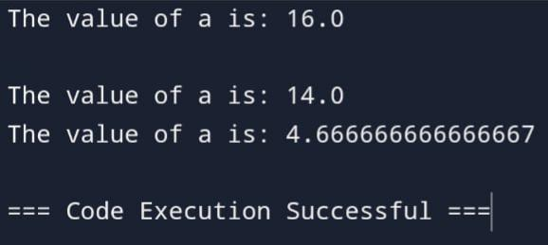
Output:

WEEK 3
1) AIM: Write a program to enter the marks of a student in four subjects. Then calculate the total and aggregate, and display the grade obtained by the student. If the student scores an aggregate greater than 75%, then the grade is Distinction. If aggregate is >=60 and <75, then the grade is First Division. If aggregate is >=50 and <60, then the grade is Second division. If aggregate is >=40 and <50, then the grade is third division. Else the grade is Fail.
Description:
Input Marks: The user inputs the marks for four subjects.
Calculate Total and Aggregate:
- Total: Sum of marks in all four subjects.
- Aggregate: Calculate as a percentage, i.e., (total / 400) * 100.
Determine Grade:
- Based on the aggregate, the program assigns a grade:
  - Distinction: Aggregate > 75%
  - First Division: Aggregate between 60% and 75%
  - Second Division: Aggregate between 50% and 60%
  - Third Division: Aggregate between 40% and 50%
  - Fail: Aggregate less than 40%
Display Result: The program outputs the total marks, aggregate percentage, and grade.
Syntax:
Else-if ladder:
If condition :
//Block of code
elif condition:
// Block of code
else:
// Block of code
Program:
# Input marks for 4 subjects
Sub1 = int(input(“Enter Subject 1 marks: “))
Sub2 = int(input(“Enter Subject 2 marks: “))
Sub3 = int(input(“Enter Subject 3 marks: “))
Sub4 = int(input(“Enter Subject 4 marks: “))
# Calculate total and aggregate
Total = Sub1 + Sub2 + Sub3 + Sub4
Aggregate = total / 4
# Determine division based on aggregate marks
If aggregate >= 75:
Print(“Distinction”)
Elif aggregate >= 60 and aggregate < 75:
Print(“First Division”)
Elif aggregate >= 50 and aggregate < 60:
Print(“Second Division”)
Elif aggregate >= 40 and aggregate < 50:
Print(“Third Division”)
Else:
Print(“Fail”)
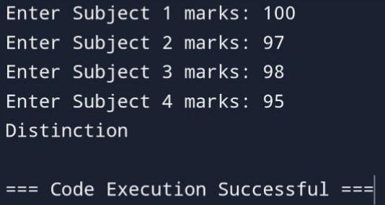
Output:

2) AIM: Write a program to calculate roots of a quadratic equation. The programmer has to identify whether the roots are real, equal or imaginary
Description:
Input Coefficients: The user enters values for aaa, bbb, and ccc.
Calculate Discriminant: Using the formula discriminant=b2−4ac\text{discriminant} = b^2 - 4acdiscriminant=b2−4ac, the program determines the nature of the roots.
Determine Root Type:
- Real and Distinct: If the discriminant is positive, calculate two real roots.
- Real and Equal: If the discriminant is zero, calculate one real root (roots are equal).
- Imaginary: If the discriminant is negative, calculate complex roots.
Display Roots: The program outputs the roots and their type.
Program:
Import math
# Take input values for a, b, and c
A = int(input(“Enter a value: “))
B = int(input(“Enter b value: “))
C = int(input(“Enter c value: “))
# Calculate the discriminant
D = b * b – (4 * a * c)
# Check the nature of the roots
If d < 0:
Print(“Roots are imaginary”)
# Compute imaginary roots
Real_part = -b / (2 * a)
Imaginary_part = math.sqrt(abs(d)) / (2 * a)
R1 = complex(real_part, imaginary_part)
R2 = complex(real_part, -imaginary_part)
Print(r1, r2)
Elif d > 0:
Print(“Roots are real”)
# Compute real roots
R1 = (-b + math.sqrt(d)) / (2 * a)
R2 = (-b – math.sqrt(d)) / (2 * a)
Print(r1, r2)
Else:
Print(“Roots are equal”)
# Compute equal real roots
R1 = r2 = -b / (2 * a)
Print(r1, r2)
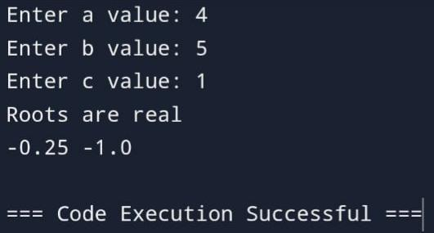
Output:

3) AIM: A company decides to give bonus to all its employees on Diwali. A 5% bonus on salary is given to the male workers and 10% bonus on salary to the female workers. Write a program to enter the salary and gender of the employee. If the salary of the employee is less than Rs.10,000 then the employee gets an extra 2% bonus on salary. Calculate the bonus that must be given to the employee and display the salary that the employee will get.
Description:
Input Salary and Gender: The user enters the salary and gender of the employee.
Determine Base Bonus Percentage:
- Male Employees: 5% of the salary.
- Female Employees: 10% of the salary.
Extra Bonus Condition: If the employee's salary is less than Rs.10,000, they receive an additional 2% bonus on their salary.
Calculate Total Bonus: The base bonus plus any additional bonus (if applicable).
Calculate Final Salary: Add the total bonus to the original salary.
Display Result: Output the bonus amount and the final salary after the bonus.
Program:
# Take user inputs for gender and salary
Gen = input(‘Enter gender of employee (M/F): ‘) # Gender input
Salary = int(input(“Enter Salary of employee: “)) # Salary input
# Check conditions for bonus based on salary and gender
If Salary < 10000 and gen == ‘F’:
Bonus = (12 / 100) * Salary # 12% bonus for female employees with salary < 10000
T_Salary = Salary + bonus
Print(“Bonus is:”, bonus)
Print(“Total Salary is:”, T_Salary)
Elif Salary < 10000 and gen == ‘M’:
Bonus = (7 / 100) * Salary # 7% bonus for male employees with salary < 10000
T_Salary = Salary + bonus
Print(“Bonus is:”, bonus)
Print(“Total Salary is:”, T_Salary)
Elif Salary >= 10000 and gen == ‘F’:
Bonus = (70 / 100) * Salary # 70% bonus for female employees with salary >= 10000
T_Salary = Salary + bonus
Print(“Bonus is:”, bonus)
Print(“Total Salary is:”, T_Salary)
Else: # Male employee with salary >= 10000
Bonus = (5 / 100) * Salary # 5% bonus for male employees with salary >= 10000
T_Salary = Salary + bonus
Print(“Bonus is:”, bonus)
Print(“Total Salary is:”, T_Salary)
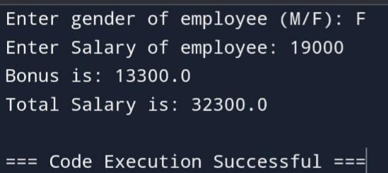
Output:
4) AIM: Display the appropriate message as per the colour of signal at the road crossing
Description:
Based on the color entered, the program displays the appropriate message:
- Red: Stop.
- Green: Go.
- Yellow: Slow down or prepare to stop.
Syntax:
if:
if condition:
//Block of code.
Program:
# Get the color input from the user
Colour = input(“Enter the colour: “).lower() # Converting input to lowercase for case-insensitive comparison
# Check the color and print the corresponding message
If Colour == ‘green’:
Print(“GO!”)
if Colour == ‘yellow’:
Print(“Get Ready to go”)
if Colour == ‘red’:
Print(“STOP”)

Output:
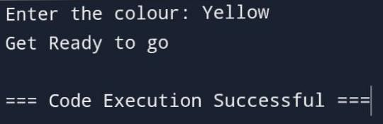
5) AIM: Check whether a number is positive ,negative or zero
Description:
- If the number is greater than zero, it is positive.
- If the number is less than zero, it is negative.
- If the number is equal to zero, it is neither positive nor negative (zero).
Program:
# Get input from the user
Num = int(input(“Enter a number: “))
# Check if the number is positive, negative, or zero
If num > 0:
Print(“Number is positive”)
Elif num < 0:
Print(“Number is negative”)
Else:
Print(“Number is equal to zero”)
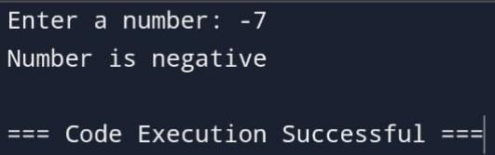
Output:

6) AIM: Write a program to create a simple calculator performing only four basic operations
Description:
Input Numbers: The user enters two numbers.
Choose Operation: The user selects one of the four operations (addition, subtraction, multiplication, or division).
Perform Calculation: The program performs the selected operation.
Display Result: The program outputs the result of the operation.
Program:
# Get input values from the user
A = int(input(“Enter any number: “))
B = int(input(“Enter any number: “))
C = input(“Enter the operator (+, -, *, /): “)
# Perform the operation based on the operator
If c == ‘+’:
Print(“Sum =”, a + b)
Elif c == ‘-‘:
Print(“Difference:”, a – b)
Elif c == ‘*’:
Print(“Product:”, a * b)
Elif c == ‘/’:
# Check if dividing by zero
If b != 0:
Print(“Dividend:”, a / b)
Else:
Print(“Error: Division by zero is not allowed.”)
Else:
Print(“Invalid operator entered.”)
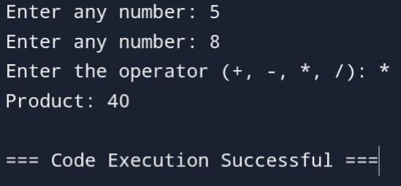
Output:

7) AIM: write a program to find the grades of a student on when grades are allocated as given in the table below.
Percentage of marks obtained by the student is input.
Percentage of marks | Grade
Above 90% | A
80% to 90% | B
70% to 80% | C
60% to 70% | D
Below 60% | E
Description:
Input Percentage: The user enters the percentage of marks obtained by the student.
Grade Allocation: Based on the entered percentage, the program checks which range the percentage falls into and assigns the corresponding grade:
- Above 90%: Grade A
- 80% to 90%: Grade B
- 70% to 80%: Grade C
- 60% to 70%: Grade D
- Below 60%: Grade E
Display Grade: The program outputs the grade based on the percentage.
Program:
# Get the percentage input from the user
Percentage = int(input(“Enter percentage: “))
# Determine the grade based on the percentage
If Percentage >= 90:
Print(“A”)
Elif Percentage >= 80 and Percentage < 90:
Print(“B”)
Elif Percentage >= 70 and Percentage < 80:
Print(“C”)
Elif Percentage >= 60 and Percentage < 70:
Print(“D”)
Else:
Print(“E”)
Output:
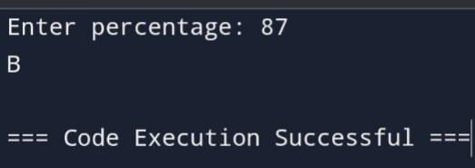

8) AIM: Write a program that takes the name and age of the user as input and displays a message whether the user is eligible to apply for a driving license or not. (the eligible age is 18 years).
Description: Checks if the age is greater than or equal to 18. If so, the user is eligible for a driving license.
Syntax:
if-else:
if condition:
//Block of code.
else:
// Block of code.
Program:
# Get the age input from the user
Age = int(input(“Enter your age: “))
# Check if the person is eligible based on age
If age >= 18:
Print(“ELIGIBLE”)
Else:
Print(“NOT ELIGIBLE”)
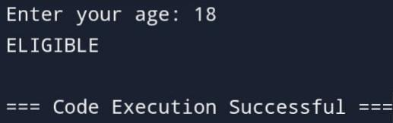
Output:

9) AIM: Write a program to check if the year entered by the user is a leap year or not.
Description:
- If the year is divisible by 4, it might be a leap year.
- If the year is divisible by 100, it must also be divisible by 400 to be a leap year.
Program:
# Get the year input from the user
Year = int(input(“Enter a year: “))
# Check if the year is a leap year
If (year % 4 == 0 and year % 100 != 0) or (year % 400 == 0):
Print(“The year is a leap year”)
Else:
Print(“The year is not a leap year”)
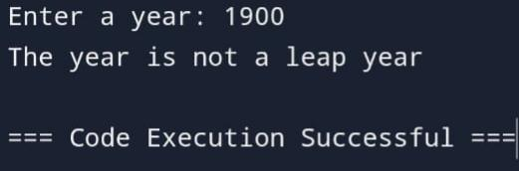
Output:

10) AIM: Python program to find whether the given number is Even or Odd
Description:
- If the number is divisible by 2 (i.e., number % 2 == 0), it is even.
- If the number is not divisible by 2 (i.e., number % 2 != 0), it is odd.
Program:
# Get the number input from the user
Num = int(input(“Enter any number: “))
# Check if the number is even or odd
If num % 2 == 0:
Print(“The number is even”)
Else:
Print(“The number is odd”)
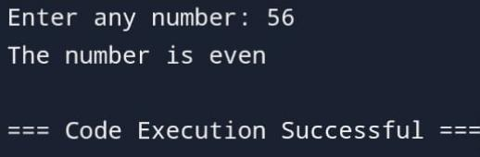
Output:
11) AIM: Write a Python program to get the difference between a given number and 17, if the number is greater than 17 return double the absolute difference else return the difference between given number and 17.
Description:
- If the given number is greater than 17, return double the absolute difference between the number and 17.
- If the given number is less than or equal to 17, return the normal difference (the difference between the number and 17).
Program:
# Get the number input from the user
Num = int(input(“Enter a number: “))
# Calculate the difference between the number and 17
Diff = num – 17
# Check if the number is greater than 17 and print the result
If num > 17:
Print(diff * 2) # Double the difference if the number is greater than 17
Else:
Print(diff) # Print the difference directly if the number is 17 or less
Output:
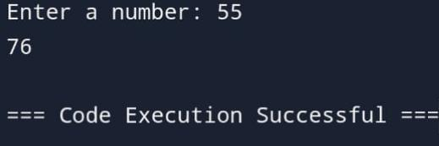
12) AIM: Write a Python program to calculate the sum of three given numbers, if the values are equal then return three times of their sum.
Description:
Input Three Numbers: The user enters three numbers.
Check If Values Are Equal: If all three numbers are equal, the program returns three times their sum.
Else, Return the Sum: If the numbers are not equal, the program returns the regular sum of the three numbers.
Display Result: The program displays the appropriate result based on the condition
Program:
# Get three numbers as input
Num1 = int(input(“Enter a number: “))
Num2 = int(input(“Enter a number: “))
Num3 = int(input(“Enter a number: “))
# Calculate the sum of the three numbers
Sum = num1 + num2 + num3
# Check if all three numbers are equal
If num1 == num2 == num3:
Print(3 * Sum) # If all numbers are equal, print three times the sum
Else:
Print(Sum) # Otherwise, print the sum
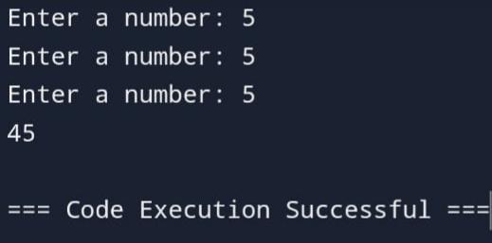
Output:

13) AIM: Write a python program to input week number and print weekday
Description:
Input Week Number: The user enters a number between 1 and 7, where each number corresponds to a day of the week.
Check the Week Number: Based on the input, the program will display the correct weekday.
Display Weekday: The program outputs the weekday corresponding to the entered week number.
Program:
# Get the week number input from the user
Week_num = int(input(“Enter the week number: “))
# Check the week number and print the corresponding day
If week_num == 1:
Print(“Monday”)
Elif week_num == 2:
Print(“Tuesday”)
Elif week_num == 3:
Print(“Wednesday”)
Elif week_num == 4:
Print(“Thursday”)
Elif week_num == 5:
Print(“Friday”)
Elif week_num == 6:
Print(“Saturday”)
Elif week_num == 7:
Print(“Sunday”)
Else:
Print(“Invalid week number”) # Handle invalid week numbers
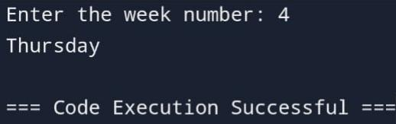
Output:

14) AIM: Write a python program to check whether a character is uppercase or lowercase alphabet.
Description:
Input a Character: The user enters a single character.
Check the Case:
- If the character is uppercase (A-Z), it will output that the character is an uppercase alphabet.
- If the character is lowercase (a-z), it will output that the character is a lowercase alphabet.
Handle Invalid Input: The program can also check if the input is a letter or not and give an appropriate message.
Program:
# Get the character input from the user
Character = input(‘Enter a character: ‘)
# Check if the character is uppercase
If ‘A’ <= character <= ‘Z’:
Print(“The given character is in upper case”)
# Check if the character is lowercase
Elif ‘a’ <= character <= ‘z’:
Print(“The given character is in lower case”)
# If neither, the character is not an alphabet letter
Else:
Print(“The given character is not a letter”)
Output:
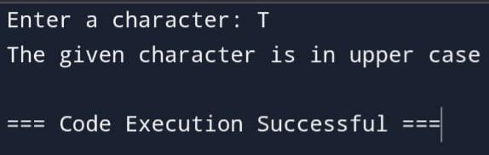
15) AIM: Write a python program to check whether a number is divisible by 5 and 11 or not
Description:
- If the number is divisible by both 5 and 11 (number % 5 == 0 and number % 11 == 0), it outputs that the number is divisible by both.
- Otherwise, it outputs that the number is not divisible by both 5 and 11.
Program:
# Get the number input from the user
Num = int(input(“Enter a number: “))
# Check if the number is divisible by both 5 and 11
If num % 5 == 0 and num % 11 == 0:
Print(“The given number is divisible by 5 & 11”)
Else:
Print(“The given number is not divisible by 5 & 11”)
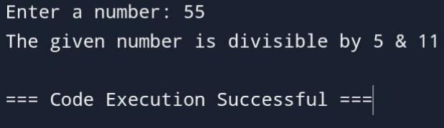
Output:

WEEK 4
1) AIM: Demonstrate a program to print the sum of the series 1/1**2 + 1/2**2+1/3**2+....... +1/n**2. where n is taken from the user.
Description:
Input n: The program first takes the value of n from the user, which represents the number of terms in the series.
Calculate the Sum: It then loops from 1 to n, calculating each term in the series as 1/i^2 and adds it to the running sum.
Display the Result: After completing the loop, the program outputs the sum of the series.
Syntax:
For:
for variable in sequence :
//Block of code.
Program:
# Get the value of n from the user
N = int(input(“Enter n value: “))
# Initialize the sum variable
Sum = 0.0
# Loop through the range from 1 to n
For I in range(1, n + 1):
Sum = Sum + 1 / (I ** 2)
# Print the result
Print(“Sum is: “, Sum)
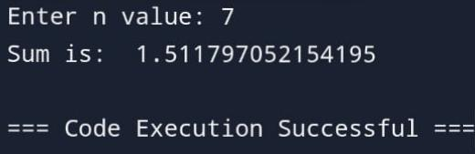
Output:

2) AIM: Write a program to find Sum of cubes of numbers from 1 to n using range ().
Description: range() function to iterate from 1 to n, and for each number i, it calculates the cube (i**3), and adds it to the running sum.
Program:
# Get the value of n from the user
N = int(input(“Enter n value: “))
# Initialize the sum variable
Sum = 0
# Loop through the range from 1 to n
For I in range(1, n + 1):
Sum += I ** 3 # Sum the cubes of i
# Print the result
Print(“The sum of cubes is:”, Sum)
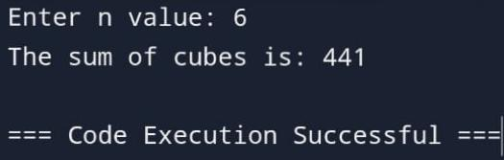
Output:

3) AIM: Write a program to Display the numbers in descending order using range ().
Description: Use range() for Descending Order: It uses the range() function to generate numbers from n down to 1. The range() function can be used with three arguments: range(start, stop, step). By setting the step to -1, we can get numbers in descending order.
Program:
# Get the value of n from the user
N = int(input(“Enter n value: “))
# Print the message
Print(“The numbers in descending order are:”)
# Loop through the range from n to 1 in descending order
For I in range(n, 0, -1):
Print(i)
Output:
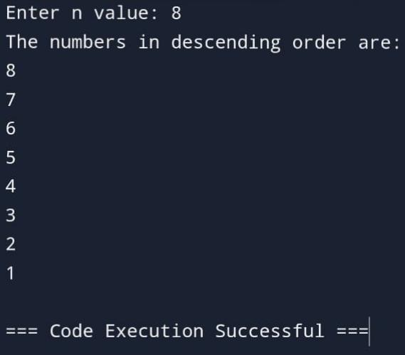
4) AIM: Write a program to find Sum of squares of even numbers from 1 to n using range ().
Description: uses the range() function to generate even numbers from 2 to n. For each even number, the program calculates its square and adds it to the running sum.
Program:
# Get the value of n from the user
N = int(input(“Enter n value: “))
# Initialize the sum variable
Sum = 0
# Loop through the even numbers from 2 to n
For I in range(2, n + 1, 2):
Sum += I ** 2 # Add the square of even numbers to Sum
# Print the result
Print(“The Sum of squares of even numbers is:”, Sum)
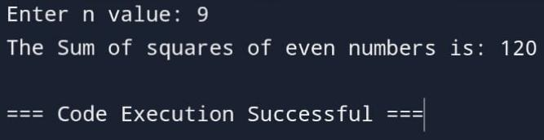
Output:

5) AIM: Write a program to find Display all leap years from 2000 – 2200 using range ().
Description:
Leap Year Condition: A year is a leap year if it satisfies these two conditions:
- The year is divisible by 4.
- If the year is divisible by 100, it must also be divisible by 400.
Program:
# Print message indicating leap years
Print(“The Leap years from 2000 to 2200 are:”)
# Loop through the years from 2000 to 2200
For y in range(2000, 2201):
# Check if the year is a leap year
If (y % 4 == 0 and (y % 100 != 0 or y % 400 == 0)):
Print(y)
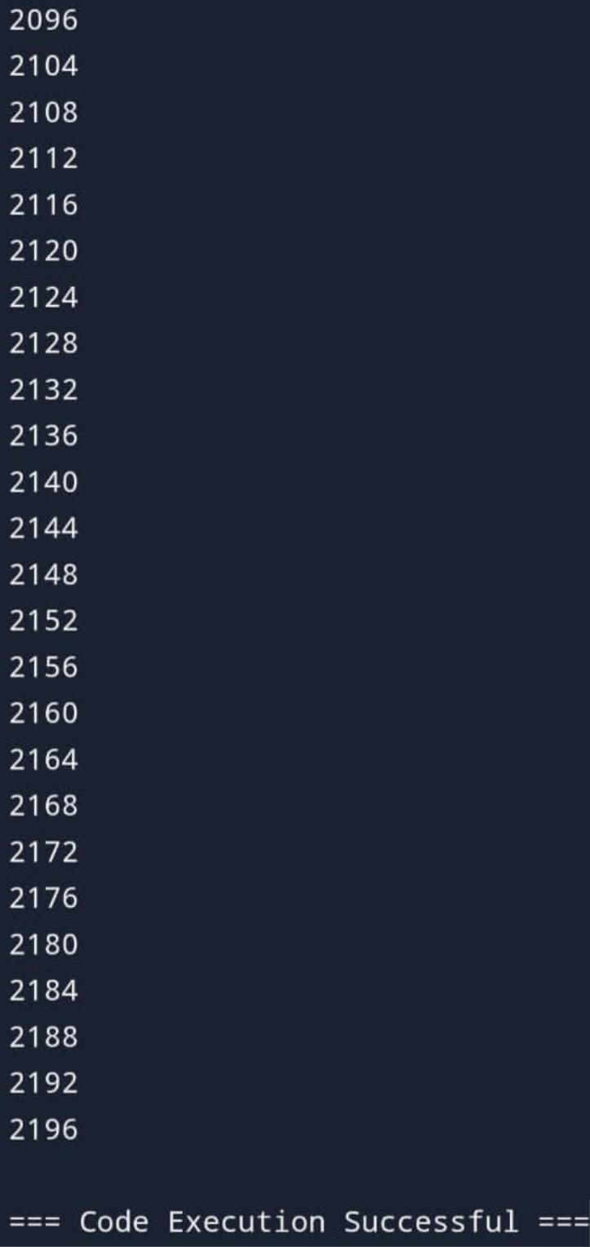
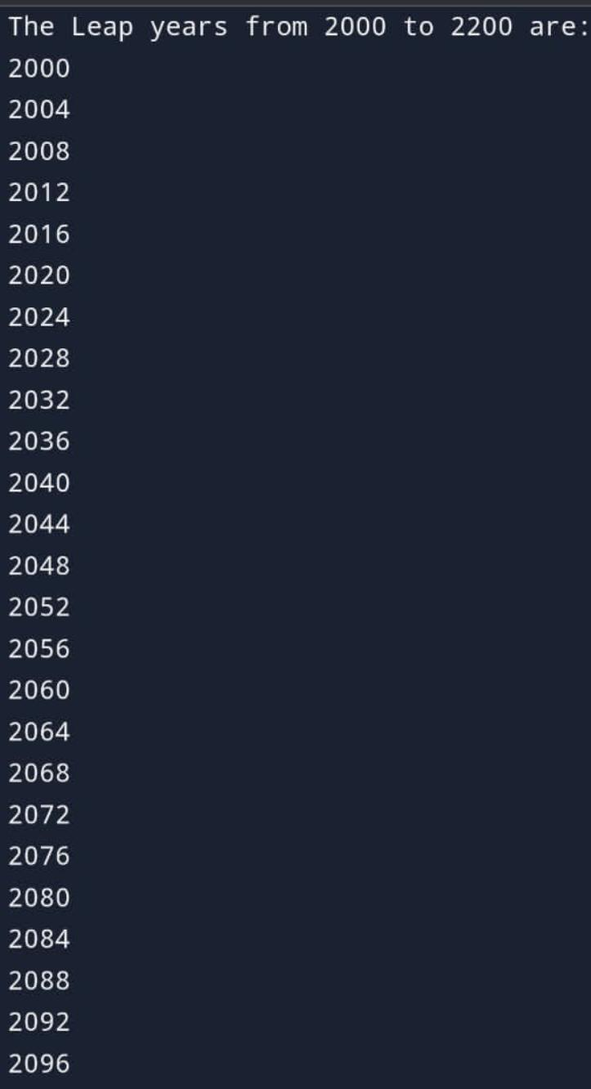
Output:

6) AIM: Write a program to print the below patterns
1  2 3  4 5 6  7 8 9 10  11 12 13 14 15 | 1  2 1  3 2 1  4 3 2 1  5 4 3 2 1 | 5 4 3 2 1  4 3 2 1  3 2 1  1 | *  * *  * * *  * * * *  * * * * * | 1  1 2  1 2 3  1 2 3 4  1 2 3 4 5

Description: Use for loops to print the given patterns.
Program:
# Set number of rows
Rows = 5
Num = 1
# Loop for each row
For I in range(1, rows + 1):
# Loop to print numbers in each row
For j in range(i):
Print(num, end=” “) # Print numbers on the same line
Num += 1 # Increment num after printing
Print() # Move to the next line after each row
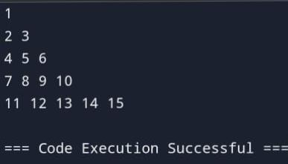
Output:

- Program
# Get the value of n from the user
N = int(input(“Enter the value of n: “))
# Outer loop to iterate through rows
For I in range(1, n + 1):
# Inner loop to print numbers in descending order
For j in range(I, 0, -1):
Print(j, end=” “) # Print numbers on the same line
Print() # Move to the next line after each row:

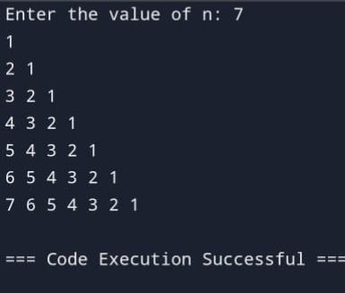
Output:

- Program:
# Get the value of n from the user
N = int(input(“Enter n value: “))
# Outer loop to iterate in reverse from n down to 1
For I in range(n, 0, -1):
# Inner loop to print numbers from I down to 1
For j in range(I, 0, -1):
Print(j, end=” “) # Print numbers on the same line
Print() # Move to the next line after each row
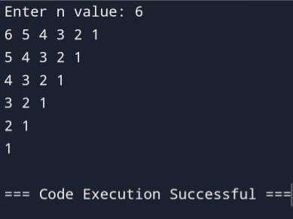
Output:

- Program:
# Get the value of n from the user
N = int(input(“Enter n value: “))
# Outer loop to iterate through the rows
For I in range(n):
# Loop to print spaces before stars
For j in range(n – I – 1):
Print(“ “, end=” “)
# Loop to print stars
For k in range(I + 1):
Print(“*”, end=” “)
# Move to the next line after each row
Print()
Output:
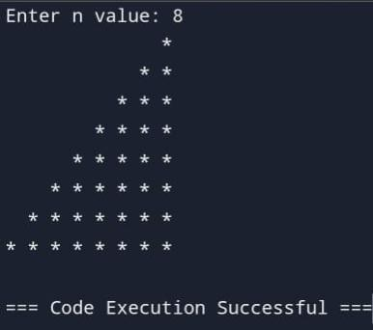

- Program:
# Get the value of n from the user
N = int(input(“Enter n value: “))
# Outer loop to iterate through each row
For I in range(1, n + 1):
# Loop to print spaces before the numbers
For j in range(n – i):
Print(“ “, end=” “)
# Loop to print numbers in each row
For k in range(1, I + 1): # Corrected to print 1 to I numbers
Print(k, end=” “)
# Move to the next line after each row
Print()
Output:
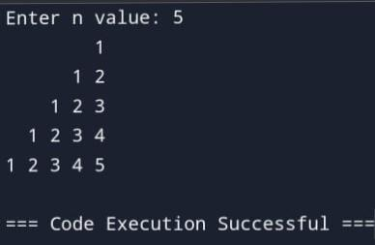

WEEK-5
1. AIM: Create a library with functions to input the values with exception handling in Python
Program:
def input_int(prompt="Enter an integer: "):
while True:
try:
return int(input(prompt))
except ValueError:
print("Invalid input. Please enter a valid integer.")

def input_float(prompt="Enter a float: "):
while True:
try:
return float(input(prompt))
except ValueError:
print("Invalid input. Please enter a valid float.")

def input_str(prompt="Enter a string: "):
while True:
try:
value = input(prompt)
if value.strip() == "":
raise ValueError("Empty string is not allowed.")
return value
except ValueError as e:
print(f"Invalid input. {e}")

def input_choice(prompt="Enter choice: ", choices=None):
if choices is None:
choices = []
while True:
try:
value = input(prompt)
if value not in choices:
raise ValueError(f"Input must be one of {choices}.")
return value
except ValueError as e:
print(f"Invalid input. {e}")
Program:
import input_utils

age = input_utils.input_int("Enter your age: ")
price = input_utils.input_float("Enter price: ")
name = input_utils.input_str("Enter your name: ")
option = input_utils.input_choice("Enter option (yes/no): ", ["yes", "no"])

OUTPUT:
Enter your age: twenty
Invalid input. Please enter a valid integer.
Enter your age: 25
Enter your salary: abc
Invalid input. Please enter a valid float.
Enter your salary: 55000.75
Enter your name:
Invalid input. Empty string is not allowed.
Enter your name: Ishu
Choose your role (admin/user): guest
Invalid input. Input must be one of ['admin', 'user'].
Choose your role (admin/user): admin
--- User Details ---
Name: Ishu
Age: 25
Salary: 55000.75
Role: admin
2.AIM: write a Python program input and add two integers only and handle the exceptions.
Program:
def input_integer(prompt):
while True:
try:
return int(input(prompt))
except ValueError:
print("Invalid input. Please enter an integer.")

def main():
print("Addition of Two Integers Only\n")
num1 = input_integer("Enter first integer: ")
num2 = input_integer("Enter second integer: ")
total = num1 + num2
print(f"\nThe sum of {num1} and {num2} is: {total}")

if __name__ == "__main__":
main()
OUTPUT:
Addition of Two Integers Only

Enter first integer: ten
Invalid input. Please enter an integer.
Enter first integer: 10
Enter second integer: 5.5
Invalid input. Please enter an integer.
Enter second integer: 20

The sum of 10 and 20 is: 30

WEEK-6

DESCRIPTION:
Functions in python:
- Definition: In Python, a function is defined using the def keyword, followed by the function name, parentheses (), and a colon :. Inside the parentheses, you can specify any parameters the function should accept. The function body is indented and contains the code to execute when the function is called.
- Syntax:
def function_name(parameters):
# Code to execute
return result
- Lambda Function: In Python, a lambda function is a small, anonymous function defined with the lambda keyword. It’s used to create functions on the fly, usually for simple operations that are passed as arguments to higher-order functions like map, filter, and sorted. A lambda function can take any number of arguments but can only contain a single expression.
- Syntax:
lambda arguments: expression
- Range Function: The range() function in Python generates a sequence of numbers, commonly used for looping a specific number of times. It produces an immutable sequence type of integers and is especially helpful in for loops.
- Syntax:
range(start, stop, step)

- Aim: Write a program to find sum of all odd numbers between 1 to n using functions.
Program:
def sum_odd_numbers(n):
sum = 0
for i in range(1, n+1, 2):
sum += i
return sum

n = int(input("Enter a positive integer: "))
result = sum_odd_numbers(n)
print("The sum of odd numbers from 1 to", n, "is", result)

Output:
Enter a positive integer: 7
The sum of odd numbers from 1 to 7 is 16

- Aim: Write a program to demonstrate default arguments with keyword arguments, to display name, age and salary of an employee. Where course (B. Tech) is passed as default argument.

Program:
Def inf(name,age,salary,course="B-Tech"):
print(f"{name} is {age} years old, getting a salary of {salary}Rs by completing the {course}!")
inf("Sudheshna","18","100,000")

Output:
Sudheshna is 18 years old, getting a salary of 100,000Rs by completing the B-Tech!

- Aim: Write a program to find the sum of first 10 natural numbers using lambda or anonymous function using range () function.

Program:
def sum_of_natural_numbers(n):
for i in range(1, n+1):
sum_of_natural_numbers=lambda n: (n * (n + 1)) // 2
print("The sum of natural numbers from 1 to", n, "is", sum_of_natural_numbers(n)) sum_of_natural_numbers(10)

Output:
The sum of natural numbers from 1 to 10 is 55

- Aim: Demonstrate a program to convert time into minutes using functions

Program:
def minutes(hours, mins):
minute=hours*60
total_minutes=minute+mins
return total_minutes
hours=int(input("Enter no.of hours: "))
mins=int(input("Enter no.of minutes: "))
result=minutes(hours, mins)
print("The total minutes: ",result)
Output:
Enter no.of hours: 5
Enter no.of minutes: 15
The total minutes: 315

- Aim: Write a program to calculate simple interest. Suppose the customer is a senior citizen. He is being offered 12% rate of interest (ROI).For all other customers, the ROI is 10%.
Program:
def ROI(P,T,R):
return ((P*T*R)/100)
P=int(input("Enter principle amount: "))
T=int(input("Enter time: "))
age=int(input("Enter age: "))
if(age>=60):
R=0.12
SI=ROI(P,T,R)
print(SI)
else:
R=0.01
SI=ROI(P,T,R)
print(SI)
Output:
Enter principle amount: 1000000
Enter time: 3
Enter age: 68
3600.0

- Aim: Python Program to check if two numbers are amicable numbers or not. Two different numbers are called amicable numbers if the sum of the proper divisors of each is equal to the other number.

Program:
def amicable(a,b,sum1,sum2):
for i in range(1,a):
if(a%i==0):
sum1=sum1+i
for j in range(1,b):
if(b%j==0):
sum2=sum2+j
if((sum1==b)and(sum2==a)):
print("Amicable")
else:
print("Not Amicable")
a=int(input("Enter a value: "))
b=int(input("Enter b value: "))
sum1=0
sum2=0
amicable(a,b,sum1,sum2)
Output:
Enter a value: 220
Enter b value: 284
Amicable
- Aim: Demonstrate a program to sum the series 1/1!+4/2!+27/3+...n using functions
Program:
import math
def factorial(n):
return math.factorial(n)
def term(n):
return (n ** n) / factorial(n)
def sum_of_series(n):
series_sum = 0
for i in range(1, n + 1):
series_sum += term(i)
return series_sum
n = int(input("Enter a number: "))
result = sum_of_series(n)
print(f"The sum of the series is: {result}")
Output:
Enter a number: 12
The sum of the series is: 30273.455370395423

- Aim: Write a program to generate the following pattern using default arguments. Consider four types in calling the function.
- Do not pass arguments
- Pass only the character as argument
- Pass character and no. of rows as argument
- Pass character, no. of rows and columns as arguments.
Program:
- def pyramid_pattern(char='*',rows=5, cols=5):
for i in range(1, rows + 1):
print(''* (cols - i) + char * (2 * i - 1))
pyramid_pattern()
pyramid_pattern('#')
pyramid_pattern('$',6,6)
Output:
*
***
*****
*******
*********
#
###
#####
#######
#########
$
$$$
$$$$$
$$$$$$$
$$$$$$$$$
$$$$$$$$$$
- def pyramid_pattern(char='*',rows=5, cols=None):
cols = cols if cols else rows
for i in range(1, rows + 1):
print(''* (cols - i) + char * (2 * i - 1))
pyramid_pattern('@',4)
Output:
@
@@@
@@@@@
@@@@@@@

- Aim: Write a program using recursive functions:
- Counting the no. of times, a recursive function is called
- Power of a number
- GCD of two given numbers
- Print the Fibonacci series
Program:
- def recursive_count(n):
global counter
counter += 1
if n<= 0:
return 0
return (n + recursive_count(n - 1))
n = 5
counter=0
result = recursive_count(n)
print(f"Result: {result}")
print(f"Recursive function was called {counter} times")

Output:
Result: 15
Recursive function was called 6 times

- def power(base, exp):
if exp == 0:
return 1
return base * power(base, exp - 1)
base = 3
exp = 4
result = power(base, exp)
print(f"{base}^{exp} = {result}")

Output:
3^4 = 81

- def gcd(a,b):
if b==0:
return a
return gcd(b,a%b)
a=int(input("Enter a value:"))
b=int(input("Enter b value:"))
result=gcd(a,b)
print(f"gcd of {a} and {b} is {result}")
Output:
Enter a value:56
Enter b value:98
gcd of 56 and 98 is 14

- def fibonacci(n):
if n<=1:
return n
return fibonacci(n-1)+fibonacci(n-2)
def print_fibonacci_series(n):
for i in range(n):
print(fibonacci(i),end=" ")
n=int(input("Enter n value"))
print(f"fibonacci series up to {n} terms:")
print_fibonacci_series(n)
Output:
Enter n value10
fibonacci series up to 10 terms:
- 1 1 2 3 5 8 13 21 34

WEEK-7

- Aim: Write a python program without using the built in functions to find the length of the string, reverse the string.
Program:
string="Sudheshna"
count=0
for i in string:
count+=1
print(count)
p=-1
for j in string:
print(string[p],end="")
p-=1
Output:
9
anhsehduS

- Aim: Write a python program to arrange string characters such that lowercase letters should come first.
Program:
def rearrange_string(s):
lower_chars = []
upper_chars = []
for char in s:
if char.islower():
lower_chars.append(char)
else:
upper_chars.append(char)
rearranged_string = ''.join(lower_chars + upper_chars)
return rearranged_string
string = "SuDhesHna"
result = rearrange_string(string)
print(result)
Output:
uhesnaSDH

- Aim: Write a program that uses regular expressions to validate dates entered by users. The program should check that the date is in a valid format, such as MM/DD/YYYY and that the month, day, and year values are within a valid range.
Program:
import re
date=r'\d{2}-\d{2}-\d{4}'
res=input("Enter date:")
result=re.search(date,res)
if result:
print(result.group())
else:
print("Invalid")
Output:
Enter date:29-04-2006
29-04-2006

- Aim: Write a program to validate a password using regular expressions using the following rules
  - At least 8 characters long
  - Contains at least one uppercase letter
  - Contains at least one lowercase letter
  - Contains at least one digit
Program:
import re
password_pattern = r'^(?=.[A-Z])(?=.[a-z])(?=.\d)(?=.[@#$%^&!])[A-Za-z\d@#$%^&!]{8,}$'
res = input("Enter password: ")
result = re.fullmatch(password_pattern, res)
if result:
print("Valid password")
else:
print("Invalid password")
Output:
Enter password: sudheshna29
Invalid password

- Aim: Write a program to remove all non-alphanumeric characters from a given string using regular expressions.
Program:
import re
def remove_non_alphanumeric(input_string):
result = re.sub(r'[^a-zA-Z0-9]', '', input_string)
return result
input_string = "Hello, World! @2023 #Python"
cleaned_string = remove_non_alphanumeric(input_string)
print("Original String:", input_string)
print("Cleaned String:", cleaned_string)

Output:
Original String: Hello, World! @2023
Cleaned String: HelloWorld2023Python

WEEK-8
1.AIM: Write a python program to add each element of list x with list y using nested loops.
PROGRAM:
x = list(map(int, input("Enter elements for list x separated by spaces: ").split()))
y = list(map(int, input("Enter elements for list y separated by spaces: ").split()))
result = []
for i in x:
for j in y:
result.append(i + j)
print("Result:", result)
OUTPUT:
Enter elements for list x: 1 2 3
Enter elements for list y: 4 5 6
Result: [5, 6, 7, 6, 7, 8, 7, 8, 9]

2. AIM: Write a python program to print index at which a particular value
exists. If the value exists at multiple locations in the list, then print
all the indices. Also, count the number of times that value is repeated
in the list.
PROGRAM:
numbers = list(map(int, input("Enter elements of the list separated by spaces: ").split()))
value = int(input("Enter the value to search for: "))
indices = []
for index, num in enumerate(numbers):
if num == value:
indices.append(index)
if indices:
print("Value", value, "found at indices:", indices)
print("Number of times", value, "is repeated:", len(indices))
else:
print("Value", value, "is not found in the list.")
OUTPUT:
Enter elements of the list: 1 2 3 4 2 5 2
Enter the value to search for: 2
Value 2 found at indices: [1, 4, 6]
Number of times 2 is repeated: 3
Enter elements of the list separated by spaces: 1 2 3 4 5
Enter the value to search for: 6
Value 6 is not found in the list.

3. AIM: Write a python program applying all the list methods (‘append’, ‘clear’, ‘copy’, ‘count’, ‘extend’, ‘index’, ‘insert’, ‘pop’, ‘remove, ‘reverse’) on the given list.
List = [100,’a’,’b’,102,2.3,4.5]
PROGRAM:
my_list = [100, 'a', 'b', 102, 2.3, 4.5]
print("Original list:", my_list)
my_list.append('new_element')
print("After append('new_element'):", my_list)
cleared_list = my_list.copy() # Copying to show clear later without losing original data
cleared_list.clear()
print("After clear():", cleared_list)
copied_list = my_list.copy()
print("After copy():", copied_list)
count_b = my_list.count('b')
print("Count of 'b':", count_b)
my_list.extend([200, 300])
print("After extend([200, 300]):", my_list)
index_a = my_list.index('a')
print("Index of 'a':", index_a)
my_list.insert(1, 'inserted_element')
print("After insert(1, 'inserted_element'):", my_list)
popped_element = my_list.pop(1) # Removes the element at index 1
print("After pop(1):", my_list)
print("Popped element:", popped_element)
my_list.remove(100)
print("After remove(100):", my_list)
my_list.reverse()
print("After reverse():", my_list)

OUTPUT:
Original list: [100, 'a', 'b', 102, 2.3, 4.5]
After append('new_element'): [100, 'a', 'b', 102, 2.3, 4.5, 'new_element']
After clear(): []
After copy(): [100, 'a', 'b', 102, 2.3, 4.5, 'new_element']
Count of 'b': 1
After extend([200, 300]): [100, 'a', 'b', 102, 2.3, 4.5, 'new_element', 200, 300]
Index of 'a': 1
After insert(1, 'inserted_element'): [100, 'inserted_element', 'a', 'b', 102, 2.3, 4.5, 'new_element', 200, 300]
After pop(1): [100, 'a', 'b', 102, 2.3, 4.5, 'new_element', 200, 300]
Popped element: inserted_element
After remove(100): ['a', 'b', 102, 2.3, 4.5, 'new_element', 200, 300]
After reverse(): [300, 200, 'new_element', 4.5, 2.3, 102, 'b', 'a']

4. AIM: Write a python program to add each element of x list with each
element of y list.
- Using loops
- Using list comprehension

PROGRAM:
x = list(map(int, input("Enter elements for list x separated by spaces: ").split()))
y = list(map(int, input("Enter elements for list y separated by spaces: ").split()))
result_with_loops = []
for i in x:
for j in y:
result_with_loops.append(i + j)
print("Result using loops:", result_with_loops)
result_with_comprehension = [i + j for i in x for j in y]
print("Result using list comprehension:", result_with_comprehension)
OUTPUT:
Enter elements for list x separated by spaces: 1 2 3
Enter elements for list y separated by spaces: 4 5 6
Result using loops: [5, 6, 7, 6, 7, 8, 7, 8, 9]
Result using list comprehension: [5, 6, 7, 6, 7, 8, 7, 8, 9]

5.AIM: Write a program using lambda and below functions to perform
tasks

- Using filter () to filter out even numbers from a list.
- Find squares of elements in a list using map ().
- Product of elements of a list using reduce() function.

PROGRAM:

from functools import reduce
numbers = list(map(int, input("Enter numbers separated by spaces: ").split()))
even_numbers = list(filter(lambda x: x % 2 == 0, numbers))
print("Even numbers:", even_numbers)
squared_numbers = list(map(lambda x: x ** 2, numbers))
print("Squares of elements:", squared_numbers)
product_of_elements = reduce(lambda x, y: x * y, numbers)
print("Product of all elements:", product_of_elements)

OUTPUT:
Enter numbers separated by spaces: 1 2 3 4 5
Even numbers: [2, 4]
Squares of elements: [1, 4, 9, 16, 25]
Product of all elements: 120

WEEK-9
1. AIM: Write a python program to do the below matrix operations
- Addition
- Subtraction
- Multiplication

PROGRAM:

def input_matrix(rows, cols):
matrix = []
print(f"Enter the elements of the matrix ({rows}x{cols}):")
for i in range(rows):
row = list(map(int, input(f"Enter row {i + 1} elements separated by spaces: ").split()))
matrix.append(row)
return matrix

def add_matrices(matrix1, matrix2):
return [[matrix1[i][j] + matrix2[i][j] for j in range(len(matrix1[0]))] for i in range(len(matrix1))]

def subtract_matrices(matrix1, matrix2):
return [[matrix1[i][j] - matrix2[i][j] for j in range(len(matrix1[0]))] for i in range(len(matrix1))]

def multiply_matrices(matrix1, matrix2):
result = [[0] * len(matrix2[0]) for _ in range(len(matrix1))]
for i in range(len(matrix1)):
for j in range(len(matrix2[0])):
for k in range(len(matrix2)):
result[i][j] += matrix1[i][k] * matrix2[k][j]
return result

rows = int(input("Enter the number of rows for the matrices: "))
cols = int(input("Enter the number of columns for the matrices: "))
print("\nMatrix 1:")
matrix1 = input_matrix(rows, cols)
print("\nMatrix 2:")
matrix2 = input_matrix(rows, cols)
addition_result = add_matrices(matrix1, matrix2)
print("\nAddition of matrices:")
for row in addition_result:
print(row)
subtraction_result = subtract_matrices(matrix1, matrix2)
print("\nSubtraction of matrices:")
for row in subtraction_result:
print(row)
if rows == cols:
multiplication_result = multiply_matrices(matrix1, matrix2)
print("\nMultiplication of matrices:")
for row in multiplication_result:
print(row)
else:
print("\nMatrix multiplication is not possible for non-square matrices.")

OUTPUT:
Enter the number of rows for the matrices: 2
Enter the number of columns for the matrices: 2

Matrix 1:
Enter row 1 elements separated by spaces: 1 2
Enter row 2 elements separated by spaces: 3 4

Matrix 2:
Enter row 1 elements separated by spaces: 5 6
Enter row 2 elements separated by spaces: 7 8

Addition of matrices:
[6, 8]
[10, 12]

Subtraction of matrices:
[-4, -4]
[-4, -4]

Multiplication of matrices:
[19, 22]
[43, 50]

2. AIM: Write a program to create tuples (name, age, address, college) for at least two members and concatenate the tuples and print the concatenated tuples.

PROGRAM:

def create_member_tuple():
name = input("Enter name: ")
age = int(input("Enter age: "))
address = input("Enter address: ")
college = input("Enter college: ")
return (name, age, address, college)

print("Enter details for Member 1:")
member1 = create_member_tuple()
print("\nEnter details for Member 2:")
member2 = create_member_tuple()
concatenated_tuple = member1 + member2
print("\nConcatenated tuple:", concatenated_tuple)

OUTPUT:

Enter details for Member 1:
Enter name: Alice
Enter age: 21
Enter address: 123 Maple St, Cityville
Enter college: City University

Enter details for Member 2:
Enter name: Bob
Enter age: 22
Enter address: 456 Oak St, Townsville
Enter college: Town College

Concatenated tuple: ('Alice', 21, '123 Maple St, Cityville', 'City University', 'Bob', 22, '456 Oak St, Townsville', 'Town College')

3. AIM: Write a program to count the number of vowels in a string (No
control flow allowed).

PROGRAM:

def count_vowels(s):
return sum(map(s.lower().count, 'aeiou'))

input_string = input("Enter a string: ")
vowel_count = count_vowels(input_string)
print("Number of vowels:", vowel_count)

OUTPUT:

Enter a string: Hello World
Number of vowels: 3

4. AIM: Write a program to check if a given key exists in a dictionary or not.

PROGRAM:
my_dict = {
'name': 'Alice',
'age': 25,
'city': 'New York',
'college': 'City University'
}

key_to_check = input("Enter the key to check: ")

if key_to_check in my_dict:
print(f"The key '{key_to_check}' exists in the dictionary.")
else:
print(f"The key '{key_to_check}' does not exist in the dictionary.")

OUTPUT:

Enter the key to check: age
The key 'age' exists in the dictionary.

5.AIM: Write a program to add a new key-value pair to an existing dictionary.

PROGRAM:
my_dict = {
'name': 'Alice',
'age': 25,
'city': 'New York',
'college': 'City University'
}
print("Current dictionary:", my_dict)
new_key = input("Enter the new key: ")
new_value = input("Enter the new value: ")
my_dict[new_key] = new_value
print("Updated dictionary:", my_dict)

OUTPUT:

Current dictionary: {'name': 'Alice', 'age': 25, 'city': 'New York', 'college': 'City University'}
Enter the new key: country
Enter the new value: USA
Updated dictionary: {'name': 'Alice', 'age': 25, 'city': 'New York', 'college': 'City University', 'country': '
USA'}

6.AIM: Write a program to sum all the items in a given dictionary.

PROGRAM:

def create_dictionary():
my_dict = {}
n = int(input("Enter the number of items you want to add to the dictionary: "))

for _ in range(n):
key = input("Enter the key: ")
value = input("Enter the value (number): ")

try:
value = float(value) # This allows both integers and floats
except ValueError:
print(f"Value '{value}' is not a number and will be ignored.")
continue

my_dict[key] = value

return my_dict

user_dict = create_dictionary()

total_sum = sum(value for value in user_dict.values() if isinstance(value, (int, float)))

print("Sum of all numerical items in the dictionary:", total_sum)

OUTPUT:

Enter the number of items you want to add to the dictionary: 3
Enter the key: a
Enter the value (number): 10
Enter the key: b
Enter the value (number): text
Value 'text' is not a number and will be ignored.
Enter the key: c
Enter the value (number): 20.5
Sum of all numerical items in the dictionary: 30.5

7. AIM: Write a program that reads string from user. Your program should create a dictionary having key as word length and value is count of words of that length. For example, if user enters ‘A fat cat is on the
mat’. The content of dictionary should be {1:1, 3:4, 2:2}

PROGRAM:

def word_length_count(sentence):
words = sentence.split()

length_count = {}

for word in words:
length = len(word)
if length in length_count:
length_count[length] += 1
else:
length_count[length] = 1

return length_count

input_string = input("Enter a string: ")

result_dict = word_length_count(input_string)

print("Word length count dictionary:", result_dict)

OUTPUT:

Enter a string: A fat cat is on the mat
Word length count dictionary: {1: 1, 3: 4, 2: 2}

WEEK-10

TYPES OF FILES
DESCRIPTION:
Files can be categorized into various types based on their content and structure. Common types include text files, binary files, and CSV files.
TEXT FILES
Text files store data in plain text format, making them easily readable by humans. They typically use extensions like .txt and can contain any character from the ASCII or Unicode sets.
BINARY FILES
Binary files store data in a format that is not directly readable by humans, consisting of sequences of bytes. They are used for various types of data, such as images, audio, and executable files, and often have extensions like .bin, .jpg, or .exe.
CSV FILES
CSV (Comma-Separated Values) files store tabular data in plain text, with each line representing a row and commas separating the columns. They are commonly used for data exchange between applications and have a .csv extension.
AIM:
To understand different file types and their appropriate usage
2. CREATING AND READING TEXT DATA
DESCRIPTION:
Text files contain human-readable characters, making them suitable for storing information like documents, notes, or configuration settings. You can create them using open(filename, 'w') for writing, which will overwrite any existing content, and read them with open(filename, 'r'), allowing you to access the stored data line by line or all at once. This functionality makes text files a fundamental choice for data persistence in many applications.
AIM:
To enable the storage and retrieval of textual data.
PROGRAM:
# Creating and writing to a text file
with open('example.txt', 'w') as file:
file.write("Hello, World!\n")
# Reading from the text file
with open('example.txt', 'r') as file:
content = file.read()
print(content)
OUTPUT:
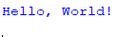
3. FILE METHODS TO READ AND WRITE DATA
DESCRIPTION:
Methods like `read()`, `readline()`, and `write()` enable efficient data handling in files, allowing for both bulk and line-by-line operations. The syntax for these methods includes `file.read(size)`, `file.readline()`, and `file.write(string)`, where `size` determines the number of characters to read, and `string` is the content to be written to the file.
AIM:
To manipulate file data effectively.
PROGRAM:
# Writing to a file
with open('data.txt', 'w') as file:
file.write("First line.\nSecond line.\n")
# Reading the file
with open('data.txt', 'r') as file:
content = file.readlines()
for line in content:
print(line.strip())
OUTPUT:
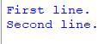
4. READING AND WRITING BINARY FILES
DESCRIPTION:
Binary files store data in a format not directly readable by humans, representing information in bytes instead of characters. This format is essential for handling complex data types like images and audio files. In Python, use open(filename, 'wb') for writing and open(filename, 'rb') for reading to ensure proper encoding and decoding of binary data.
AIM:
To handle non-text data, such as images or compiled programs.
PROGRAM:

data = bytes([120, 3, 255, 0, 100])
with
open('binary_file.bin', 'wb') as file:
file.write(data)
# Reading binary data
with open('binary_file.bin', 'rb') as file:
content = file.read()
print(list(content))
OUTPUT:
5. PICKLE MODULE
DESCRIPTION:
The `pickle` module in Python is used for serializing and deserializing Python objects, allowing you to save complex data types, such as lists and dictionaries, to a file and later retrieve them. This process enables you to persist data across program executions. The basic syntax for using `pickle` includes `pickle.dump(obj, file)` for serialization and `pickle.load(file)` for deserialization.
AIM:
To persist Python objects across sessions.
PROGRAM:
import pickle
# Writing an object to a file
data = {'name': 'Alice', 'age': 30}
with open('data.pkl', 'wb') as file:
pickle.dump(data, file)
# Reading the object back
with open('data.pkl', 'rb') as file:
loaded_data = pickle.load(file)
print(loaded_data)
OUTPUT:
6. READING AND WRITING CSV FILES

DESCRIPTION:
CSV files contain tabular data in plain text. Python’s csv module simplifies their handling.
- **Structure**: CSV (Comma-Separated Values) files store data in a tabular format where each line represents a row, and commas separate the columns.

- **Ease of Use**: They are simple to create and edit, making them widely used for data exchange between applications.
- **Data Types**: While CSV files store everything as text, they often represent numbers and dates that need conversion when read into applications.
- **Python’s `csv` Module**: Python’s `csv` module provides built-in functions to read from and write to CSV files, making it easy to handle the formatting and parsing of data.
- **File Extension**: CSV files typically have the `.csv` extension, and can be opened in spreadsheet applications like Excel for easy viewing and editing.
AIM:
To manage structured data in a text format.
PROGRAM:
import csv
# Writing to a CSV file
with open('people.csv', 'w', newline='') as file:
writer = csv.writer(file)
writer.writerow(['Name', 'Age'])
writer.writerow(['Alice', 30])
writer.writerow(['Bob', 25])
# Reading from the CSV file
with open('people.csv', 'r') as file:
reader = csv.reader(file)
for row in reader:
print(row)
OUTPUT:
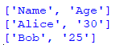
7. PYTHON OS AND OS.PATH MODULES
DESCRIPTION:

The os module provides a way of using operating system-dependent functionality, and os.path helps manipulate file paths.
- **os Module**: The `os` module provides a way to interact with the operating system, allowing you to perform operations like creating, removing, and changing directories, as well as executing system commands. It provides a portable way of using operating system-dependent functionality.

**os.path Module**: The `os.path` module contains utilities for manipulating file and directory paths. It helps to create, join, and check paths in a way that is compatible with the operating system, ensuring code portability.
- **Common Functions**:
- `os.getcwd()`: Returns the current working directory.
- `os.listdir(path)`: Lists all files and directories in the specified path.
- `os.mkdir(path)`: Creates a new directory.
- `os.path.join(path1, path2)`: Joins two or more pathname components intelligently.
- `os.path.exists(path)`: Checks if a specified path exists.
- **Cross-Platform Compatibility**: Both modules help ensure that your code runs on different operating systems (like Windows, macOS, and Linux) without needing modification.
AIM:
To perform file and directory operations in a platform-independent manner.
PROGRAM:
import os
# Getting the current working directory
cwd = os.getcwd()
print("Current Working Directory:", cwd)
# Listing files in the directory
files = os.listdir(cwd)
print("Files in Directory:", files)
OUTPUT:
#Current Working Directory: /path/to/current/directory
#Files in Directory: ['example.txt', 'data.txt', 'people.csv']
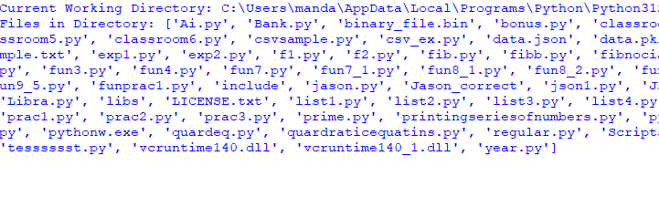

WEEK-11

CLASSES AND OBJECTS

DESCRIPTION:
Classes are blueprints for creating objects. An object is an instance of a class.
• Classes encapsulate data and behaviors.
• Objects are individual instances of classes, created using the class constructor.
DEFINE A CLASS:
class ClassName:
def __init__(self, attribute1, attribute2):
self.attribute1 = attribute1
self.attribute2 = attribute2
def method_name(self):
# Method implementation
Pass
CREATING AN OBJECT:
object_name = ClassName(value1, value2)
AIM:
To implement object-oriented programming for code organization.
PROGRAM:
class Car:
def __init__(self, model, year):
self.model = model
self.year = year
# Creating an object
my_car = Car("Toyota", 2020)

print(f"My car is a {my_car.year} {my_car.model}.")
Output:
9. CONSTRUCTOR METHOD
DESCRIPTION:
The constructor method (__init__) initializes an object’s attributes when it is created.The primary purpose of the constructor is to set up initial values for the object's attributes, ensuring that the object starts its life in a valid state.
class ClassName:
def __init__(self, par
ameter1, parameter2):
self.attribute1 = parameter1
self.attribute2 = parameter2
AIM:
To set initial values for object attributes.
PROGRAM:
class Book:
def __init__(self, title, author):
self.title = title
self.author = author
my_book = Book("1984", "George Orwell")
print(f"Title: {my_book.title}, Author: {my_book.author}")
OUTPUT:
10. CLASSES WITH MULTIPLE OBJECTS
DESCRIPTION:
Multiple objects can be instantiated from a single class, each maintaining its own state.
- DEFINITION: In Python, you can create multiple instances (objects) from a single class definition. Each object can have its own unique state and attributes while sharing the class's structure and behavior.
- INDEPENDENCE: Each object maintains its own copy of instance attributes, meaning changes made to one object do not affect others. This allows for encapsulation and organization of related data and behaviors.

- USE CASE: This feature is useful in scenarios where you need to represent multiple entities with similar properties, such as different cars, students, or animals, without duplicating code.
AIM:
To demonstrate how multiple instances can operate independently.
PROGRAM:
class Student:
def __init__(self, name):
self.name = name
student1 = Student("Alice")
student2 = Student("Bob")

print(student1.name)
print(student2.name)
OUTPUT:
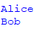
11.CLASS ATTRIBUTES VS DATA ATTRIBUTES
DESCRIPTION:
Class attributes are shared among all instances, while data attributes are unique to each instance.
- CLASS ATTRIBUTES: Class attributes are shared across all instances of a class. They are defined within the class body but outside of any instance methods. All objects of the class can access and modify these attributes, but changes affect all instances.
- DATA ATTRIBUTES: Data attributes, also known as instance attributes, are specific to each object created from the class. They are defined in the constructor (__init__ method) using the self keyword. Each instance maintains its own separate copy of these attributes.
SYNTAX:
class ClassName:
class_attribute = value # Class attribute
def __init__(self, instance_value):

self.instance_attribute = instance_value # Data attribute
AIM:
To differentiate between shared and instance-specific data.
PROGRAM:
class Dog:
species = "Canine" # Class attribute
def __init__(self, name):
self.name = name # Data attribute
dog1 = Dog("Buddy")
dog2 = Dog("Max")
print(dog1.species, dog1.name)
print(dog2.species, dog2.name)
OUTPUT:
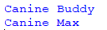
12. ENCAPSULATION

DESCRIPTION:
- DEFINITION: Encapsulation is an object-oriented programming principle that restricts direct access to certain attributes and methods of an object. It helps protect an object's internal state from unintended interference and misuse, promoting data hiding.
- PURPOSE: The main purpose of encapsulation is to maintain control over how attributes are accessed and modified, ensuring that the object's integrity is preserved.
- IMPLEMENTATION: In Python, encapsulation is typically implemented using private attributes (indicated by a leading double underscore) and public methods to access and modify those attributes.
SYNTAX
- DEFINING PRIVATE ATTRIBUTES:
class ClassName:
def __init__(self, value):
self.__private_attribute = value # Private attribute
def get_private_attribute(self):

return self.__private_attribute # Public method to access the private attribute
def set_private_attribute(self, value):
self.__private_attribute = value # Public method to modify the private attribute
AIM:
To protect an object’s integrity by preventing unauthorized access.
PROGRAM:
class Account:
def __init__(self):
self.__balance = 0 # Private attribute
def deposit(self, amount):
self.__balance += amount
def get_balance(self):
return self.__balance
account = Account()
account.deposit(100)
print("Balance:", account.get_balance())
OUTPUT:

13. INHERITANCE
DESCRIPTION:
Inheritance allows a class to inherit attributes and methods from another class.
INHERITANCE IN PYTHON
- DEFINITION: Inheritance is an object-oriented programming principle that allows a new class (called a subclass or derived class) to inherit attributes and methods from an existing class (called a superclass or base class). This promotes code reusability and establishes a relationship between classes.
- PURPOSE: The primary purpose of inheritance is to enable a new class to extend or modify the behavior of an existing class, reducing code duplication and enhancing maintainability.
SYNTAX
- DEFINING A BASE CLASS:
class BaseClass:

def __init__(self):
# Initialization code
pass
def method_in_base(self):
# Method in base class
pass
- DEFINING A DERIVED CLASS:
class DerivedClass(BaseClass):
def __init__(self):
super().__init__() # Call the constructor of the base class
# Additional initialization code
def method_in_derived(self):
# Method in derived class
pass
AIM:
To promote code reuse and establish relationships between classes.

PROGRAM:
class Animal:
def speak(self):
return "Animal speaks"
class Dog(Animal):
def bark(self):
return "Dog barks"
my_dog = Dog()
print(my_dog.speak())
print(my_dog.bark())
OUTPUT:
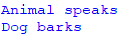
14. POLYMORPHISM

DESCRIPTION:
Polymorphism allows methods to do different things based on the object that it is acting upon.
POLYMORPHISM IN PYTHON
- DEFINITION: Polymorphism is an object-oriented programming principle that allows methods to perform different functions based on the object invoking them. This means that a single interface can represent different underlying forms (data types).
- PURPOSE: The main purpose of polymorphism is to enable flexibility and the ability to use a unified interface to operate on different types of objects, enhancing code maintainability and readability.
- TYPES OF POLYMORPHISM: There are two primary types:
  - METHOD OVERRIDING: Subclass can provide a specific implementation of a method that is already defined in its superclass.
  - METHOD OVERLOADING: Although not natively supported in Python like in some other languages, you can achieve similar functionality using default parameters or variable-length arguments.
AIM:
To implement methods in a way that can be used with different types of objects.
PROGRAM:
class Cat:
def sound(self):
return "Meow"
class Dog:
def sound(self):
return "Woof"
def make_sound(animal):
print(animal.sound())
cat = Cat()
dog = Dog()
make_sound(cat)
make_sound(dog)
OUTPUT:
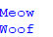

USING METHOD OVERRIDING:
class BaseClass:
def speak(self):
return "Sound from BaseClass"
class DerivedClass(BaseClass):
def speak(self):
return "Woof!"
def make_sound(animal):
print(animal.speak())
# Creating objects
animal = BaseClass()
dog = DerivedClass()
make_sound(animal) # Base class method
make_sound(dog) # Derived class method
OUTPUT:
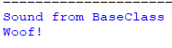

METHOD OVERLOADING IN PYTHON
While Python does not support traditional method overloading like some other programming languages (where you can define multiple methods with the same name but different parameters), you can achieve similar behavior using default parameters or variable-length arguments.
USING DEFAULT PARAMETERS
You can define a method with default parameter values, allowing the method to be called with varying numbers of arguments.
EXAMPLE
class MathOperations:
def add(self, a, b=0): # b has a default value of 0
return a + b
math_ops = MathOperations()

# Calling with two arguments
print(math_ops.add(5, 3)) # Output: 8
# Calling with one argument
print(math_ops.add(5)) # Output: 5
USING VARIABLE-LENGTH ARGUMENTS
You can also use *args to accept a variable number of arguments.
EXAMPLE
class MathOperations:
def add(self, *args):
return sum(args) # Sums all provided arguments
math_ops = MathOperations()
# Calling with multiple arguments
print(math_ops.add(1, 2, 3)) # Output: 6
print(math_ops.add(10, 20, 30, 40)) # Output: 100
print(math_ops.add(5)) # Output: 5
OUTPUT:
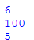

- DEFAULT PARAMETERS: Allow methods to be called with a variable number of arguments by providing default values.
- VARIABLE-LENGTH ARGUMENTS: Using *args, you can pass any number of arguments to a method, enabling flexible method calls.

WEEK-12
1.AIM: Python program to check whether a JSON string contains complex object or not.
PROGRAM:
import json
def contains_complex_object(json_str):
try:
data = json.loads(json_str)
def is_complex(obj):
if isinstance(obj, dict):
for value in obj.values():
if isinstance(value, (dict, list)) or is_complex(value):
return True
elif isinstance(obj, list):
for item in obj:
if isinstance(item, (dict, list)) or is_complex(item):
return True
return False
return is_complex(data)
except json.JSONDecodeError:
# If JSON string is invalid, return False
print("Invalid JSON format")
return False

json_str1 = '{"name": "Alice", "age": 30, "address": {"city": "New York", "zip": "10001"}}'
json_str2 = '{"name": "Bob", "age": 25}'
print(contains_complex_object(json_str1))
print(contains_complex_object(json_str2))
OUTPUT:
True
False

2. AIM: Python Program to demonstrate NumPy arrays creation using array () function.
PROGRAM:
import numpy as np
array_1d = np.array([1, 2, 3, 4, 5])
print("1D Array:")
print(array_1d)
array_2d = np.array([[1, 2, 3], [4, 5, 6]])
print("\n2D Array:")
print(array_2d)
array_3d = np.array([[[1, 2], [3, 4]], [[5, 6], [7, 8]]])
print("\n3D Array:")
print(array_3d)
array_float = np.array([1.5, 2.5, 3.5], dtype=float)
print("\nArray with specified data type (float):")
print(array_float)
array_from_tuple = np.array((10, 20, 30))
print("\nArray created from a tuple:")
print(array_from_tuple)
OUTPUT:
1D Array:
[1 2 3 4 5]

2D Array:
[[1 2 3]
[4 5 6]]

3D Array:
[[[1 2]
[3 4]]
[[5 6]
[7 8]]]

Array with specified data type (float):
[1.5 2.5 3.5]

Array created from a tuple:
[10 20 30]

3. AIM: Python program to demonstrate use of ndim, shape, size, dtype.the given list.
PROGRAM:
import numpy as np
array_2d = np.array([[1, 2, 3], [4, 5, 6], [7, 8, 9]])
print("Array:")
print(array_2d)
print("\nNumber of dimensions (ndim):", array_2d.ndim)
print("Shape of the array (shape):", array_2d.shape)
print("Total number of elements (size):", array_2d.size)
print("Data type of elements (dtype):", array_2d.dtype)
OUTPUT:
Array:
[[1 2 3]
[4 5 6]
[7 8 9]]

Number of dimensions (ndim): 2
Shape of the array (shape): (3, 3)
Total number of elements (size): 9
Data type of elements (dtype): int64

4. AIM: Python program to demonstrate basic slicing, integer and Boolean indexing.
PROGRAM:
import numpy as np
array_2d = np.array([[10, 20, 30], [40, 50, 60], [70, 80, 90]])
print("Array:")
print(array_2d)
print("\nBasic Slicing:")
print("First two rows and first two columns:\n", array_2d[:2, :2])
print("Last row:\n", array_2d[-1])
print("\nInteger Indexing:")
print("Element at (0, 1):", array_2d[0, 1])
print("Elements at (0, 0), (1, 1), and (2, 2):", array_2d[[0, 1, 2], [0, 1, 2]])
print("\nBoolean Indexing:")
bool_idx = array_2d > 50 # Find elements greater than 50
print("Boolean Index Array:\n", bool_idx)
print("Elements greater than 50:", array_2d[bool_idx])
OUTPUT:
Array:
[[10 20 30]
[40 50 60]
[70 80 90]]

Basic Slicing:
First two rows and first two columns:
[[10 20]
[40 50]]
Last row:
[70 80 90]

Integer Indexing:
Element at (0, 1): 20
Elements at (0, 0), (1, 1), and (2, 2): [10 50 90]

Boolean Indexing:
Boolean Index Array:
[[False False False]
[False False True]
[ True True True]]
Elements greater than 50: [60 70 80 90]

5.AIM: Python program to find min, max, sum, cumulative sum of array

PROGRAM:

import numpy as np

def array_operations(arr):
minimum = np.min(arr)
maximum = np.max(arr)
total_sum = np.sum(arr)

cumulative_sum = np.cumsum(arr)

print("Array:", arr)
print("Minimum value:", minimum)
print("Maximum value:", maximum)
print("Sum of elements:", total_sum)
print("Cumulative sum:", cumulative_sum)

arr = list(map(int, input("Enter the elements of the array separated by spaces: ").split()))

array_operations(arr)

OUTPUT:
Enter the elements of the array separated by spaces: 1 2 3 4 5
Array: [1, 2, 3, 4, 5]
Minimum value: 1
Maximum value: 5
Sum of elements: 15
Cumulative sum: [ 1 3 6 10 15]

WEEK-13

1. AIM: Create a dictionary with at least five keys and each key represent
value as a list where this list contains at least ten values and convert
this dictionary as a pandas data frame and explore the data through
the data frame as follows:
a) Apply head () function to the pandas data frame
b) Perform various data selection operations on Data Frame
PROGRAM:

import pandas as pd

data = {
'A': [10, 15, 20, 25, 30, 35, 40, 45, 50, 55],
'B': [5, 10, 15, 20, 25, 30, 35, 40, 45, 50],
'C': [2, 4, 6, 8, 10, 12, 14, 16, 18, 20],
'D': [7, 14, 21, 28, 35, 42, 49, 56, 63, 70],
'E': [3, 6, 9, 12, 15, 18, 21, 24, 27, 30]
}

df = pd.DataFrame(data)

print("First 5 rows of the DataFrame:")
print(df.head())

print("\nSelecting the first column 'A':")
print(df['A'])

print("\nSelecting multiple columns ('A' and 'C'):")
print(df[['A', 'C']])

print("\nSelecting rows where column 'B' is greater than 20:")
print(df[df['B'] > 20])

print("\nSelecting rows 2 to 5 (using iloc):")
print(df.iloc[2:6])

print("\nSelecting rows where column 'D' is divisible by 14:")
print(df[df['D'] % 14 == 0])

OUTPUT:
First 5 rows of the DataFrame:
A B C D E
0 10 5 2 7 3
1 15 10 4 14 6
2 20 15 6 21 9
3 25 20 8 28 12
4 30 25 10 35 15

Selecting the first column 'A':
0 10
1 15
2 20
3 25
4 30
5 35
6 40
7 45
8 50
9 55
Name: A, dtype: int64

Selecting multiple columns ('A' and 'C'):
A C
0 10 2
1 15 4
2 20 6
3 25 8
4 30 10
5 35 12
6 40 14
7 45 16
8 50 18
9 55 20

Selecting rows where column 'B' is greater than 20:
A B C D E
4 30 25 10 35 15
5 35 30 12 42 18
6 40 35 14 49 21
7 45 40 16 56 24
8 50 45 18 63 27
9 55 50 20 70 30

Selecting rows 2 to 5 (using iloc):
A B C D E
2 20 15 6 21 9
3 25 20 8 28 12
4 30 25 10 35 15
5 35 30 12 42 18

Selecting rows where column 'D' is divisible by 14:
A B C D E
1 15 10 4 14 6
3 25 20 8 28 12
5 35 30 12 42 18
7 45 40 16 56 24
9 55 50 20 70 30

2. AIM: Select any two columns from the above data frame, and observe the
change in one attribute with respect to other attribute with scatter
and plot operations in matplotlib
PROGRAM:

import pandas as pd
import matplotlib.pyplot as plt

data = {
'A': [10, 15, 20, 25, 30, 35, 40, 45, 50, 55],
'B': [5, 10, 15, 20, 25, 30, 35, 40, 45, 50],
'C': [2, 4, 6, 8, 10, 12, 14, 16, 18, 20],
'D': [7, 14, 21, 28, 35, 42, 49, 56, 63, 70],
'E': [3, 6, 9, 12, 15, 18, 21, 24, 27, 30]
}

df = pd.DataFrame(data)

x = df['A']
y = df['B']

plt.figure(figsize=(10, 5))

plt.subplot(1, 2, 1)
plt.scatter(x, y, color='blue')
plt.title("Scatter Plot of A vs B")
plt.xlabel("Column A")
plt.ylabel("Column B")

plt.subplot(1, 2, 2)
plt.plot(x, y, color='red', marker='o', linestyle='-')
plt.title("Line Plot of A vs B")
plt.xlabel("Column A")
plt.ylabel("Column B")

plt.tight_layout()
plt.show()

OUTPUT:
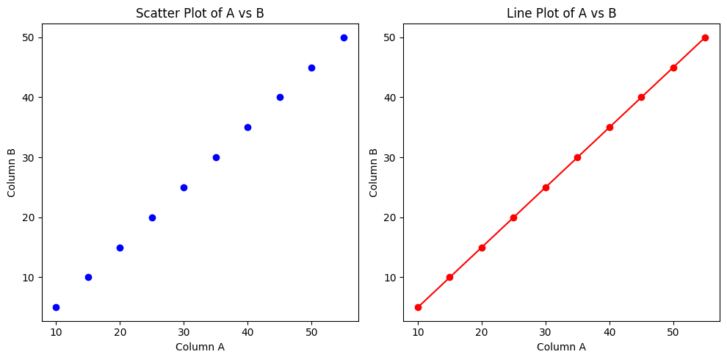
3. AIM: Create a heatmap using seaborn library showing the number of
passengers over the years and months using the flights dataset.
PROGRAM:

import seaborn as sns
import matplotlib.pyplot as plt

flights = sns.load_dataset("flights")

flights_pivot = flights.pivot(index="year", columns="month", values="passengers")

plt.figure(figsize=(12, 6))

sns.heatmap(flights_pivot, annot=True, fmt="d", cmap="YlGnBu", cbar_kws={'label': 'Number of Passengers'})
plt.title("Number of Passengers Over Years and Months")
plt.xlabel("Month")
plt.ylabel("Year")

plt.show()
plt.show()
OUTPUT:

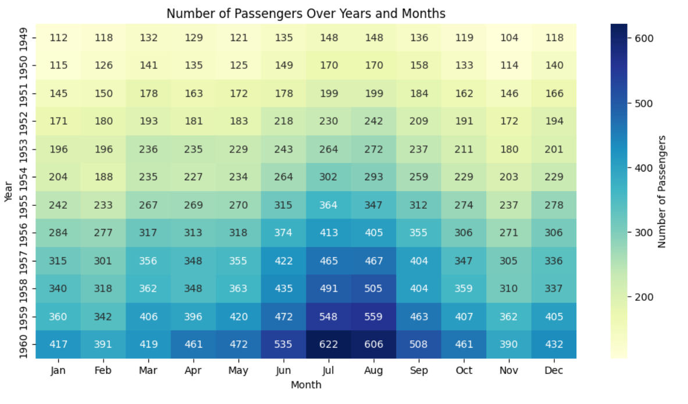

4.AIM: Create a simple linear regression plot using seaborn library showing the relationship between total bill and tip using the tips dataset.

PROGRAM:
import seaborn as sns
import matplotlib.pyplot as plt

tips = sns.load_dataset("tips")

sns.lmplot(x="total_bill", y="tip", data=tips)

plt.title("Relationship between Total Bill and Tip")
plt.xlabel("Total Bill ($)")
plt.ylabel("Tip ($)")

plt.show()
OUTPUT:

