P.V.P Siddhartha Institute of Technology(Autonomous)
Department of Computer Science and Engineering
MACHINE LEARNING IV CSE SEM-II
MID-I Answers Academic Year : 2024-25

- Construct a decision tree for the following example and Classify whether the person gets the Job offer or Not. (CO1-L2) (5M)
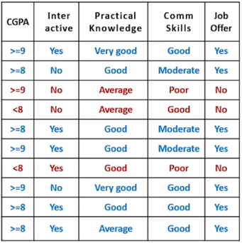

Ans: Step 1: Dataset Overview
We have the following attributes:
- CGPA: (>=9, >=8, <8)
- Interactive: (Yes, No)
- Practical Knowledge: (Very good, Good, Average)
- Communication Skills: (Good, Moderate, Poor)
- Job Offer (Target): (Yes, No)
We have 10 instances total.

Step 2: Count Total Positives and Negatives
- Job Offer = Yes → 7 records
- Job Offer = No → 3 records

Step 3: Calculate Entropy of the Entire Dataset (S)

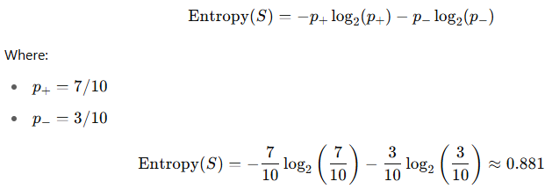

Step 4: Choose Best Attribute Using Information Gain
We compute Information Gain for each attribute and choose the one with highest gain.

Example Calculation: Attribute = CGPA
CGPA Values:
- >=9: 3 (Yes), 0 (No) → Entropy = 0
- >=8: 3 (Yes), 0 (No) → Entropy = 0
- <8: 1 (Yes), 3 (No) → Entropy:
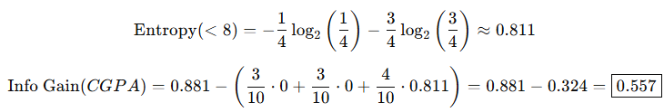

Try Next Attribute: Interactive
- Yes: 5 Yes, 1 No → Entropy ≈ 0.650
- No: 2 Yes, 2 No → Entropy = 1.0
Clearly, CGPA gives better gain.

Step 5: Root Node = CGPA
We use CGPA as the root node.

Build Branches from CGPA

Branch 1: CGPA = >=9 → All Yes → Leaf Node: Yes

Branch 2: CGPA = >=8 → All Yes → Leaf Node: Yes

Branch 3: CGPA = <8 → 1 Yes, 3 No
Subset:
- (Interactive: No, Practical: Average, Comm: Good) → No
- (Interactive: Yes, Practical: Good, Comm: Poor) → No
- (Interactive: No, Practical: Average, Comm: Good) → No
- (Interactive: Yes, Practical: Average, Comm: Good) → Yes
Let’s calculate gain on this subset.

Subset: Attribute = Interactive (on CGPA < 8)
- Yes: 1 Yes, 1 No → Entropy = 1
- No: 0 Yes, 2 No → Entropy = 0
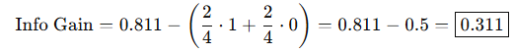
Let’s use Interactive for CGPA < 8 split.

Continue Tree: Branch CGPA < 8 → Split on Interactive

Branch 3.1: Interactive = No → Both No → Leaf: No

Branch 3.2: Interactive = Yes → 1 Yes, 1 No
Now split this on Comm Skills or Practical Knowledge.
Try Comm Skills:
- Poor → No
- Good → Yes → Perfect split

2a) Identify the differences between Biological Neuron and Artificial Neuron.(CO-2)(L3) 2M
Ans: 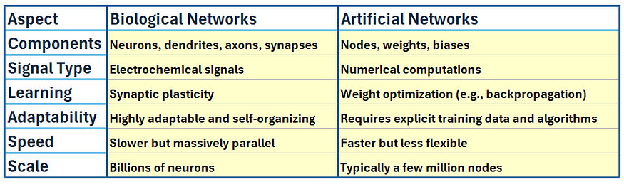
2b) Solve a given problem using back-propagation algorithm and perform the updated weight of W₃₅.(Use sigmoid activation function =1/1+e^{-x})(CO-2)(L3)(3M)
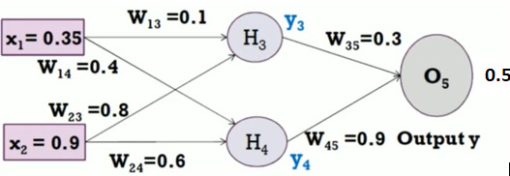
Ans: We are given a neural network and asked to perform backpropagation to update weight W35W_{35}W35​ using the sigmoid activation function:

Given Values:
- Inputs:
  - x1=0.35x_1 = 0.35x1​=0.35
  - x2=0.9x_2 = 0.9x2​=0.9
- Weights:
  - W13=0.1W_{13} = 0.1W13​=0.1, W23=0.8W_{23} = 0.8W23​=0.8
  - W14=0.4W_{14} = 0.4W14​=0.4, W24=0.6W_{24} = 0.6W24​=0.6
  - W35=0.3W_{35} = 0.3W35​=0.3 ⬅️ (to be updated)
  - W45=0.9W_{45} = 0.9W45​=0.9
- Target Output t=0.5t = 0.5t=0.5
- Activation Function (Sigmoid):
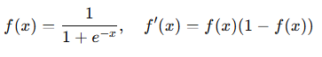
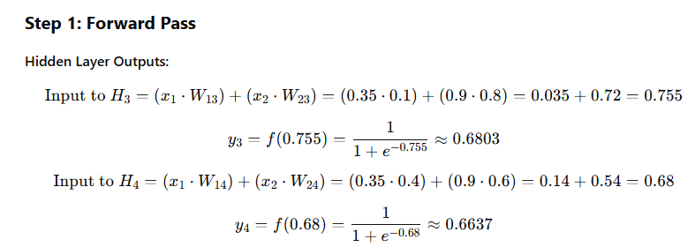
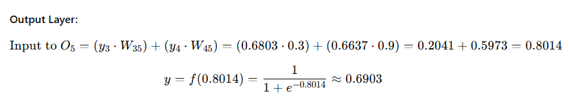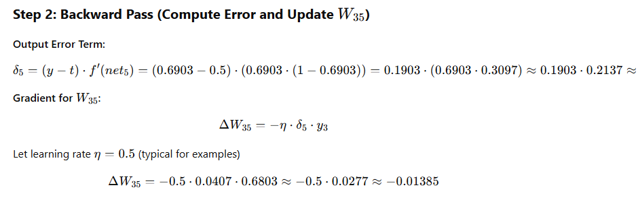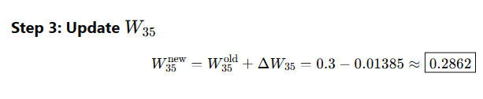

3) Apply Naïve Bayes Algorithm and predict if an accident will happen or Not?
{Weather Condition -Rain, Road Condition =Good, Traffic Condition = Normal, Engine Problem= No, Accident=?} (CO2-L3)(5M)
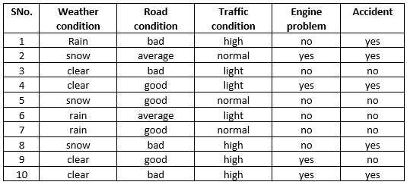

Ans: Step 1: Dataset Summary
We need to calculate the prior and likelihood for each class.

Target: Accident = {yes, no}

Step 2: Count Totals

Total Records: 10
- Accident = yes → 5 instances (Rows: 1, 2, 8, 9, 10)
- Accident = no → 5 instances (Rows: 3, 4, 5, 6, 7)
Step 3: Calculate Prior Probabilities
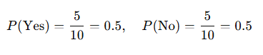

Step 4: Likelihoods for Given Conditions

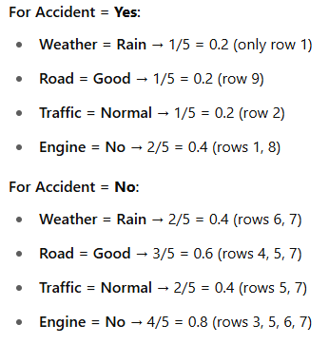

Step 5: Apply Naïve Bayes Formula

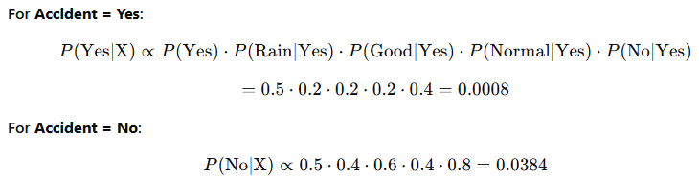

Step 6: Normalize Probabilities (Optional for Classification)

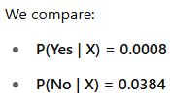

Final Prediction:
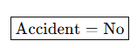
Based on the Naïve Bayes algorithm, no accident is predicted for the given conditions.

