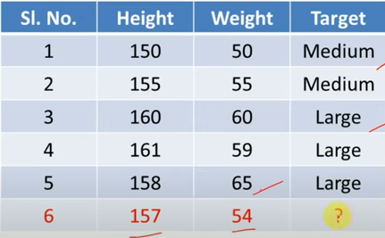
_____________________________________________________________________________________
Maths | Computer Science | Result
4 | 3 | Fail
6 | 7 | Pass
5 | 5 | Pass
7 | 7 | Fail
8 | 8 | Pass
Query = X= (Maths=6, Computer Science=8), K=3

