PRASAD V. POTLURI SIDDHARTHA INSTITUTE OF TECHNOLOGY,
KANURU, VIJAYAWADA
DEPARTMENT OF COMPUTER SCIENCE & ENGINEERING
INNOVATIVE TEACHING METHODOLOGY
Academic Year: 2024 - 25
Teaching Methodology - SEMINAR (Individual Presentation)
Class : III B.TECH
Semester: II - Semester
Section: S3
Name of the Course: MERN Stack Development
Name of the Faculty: Dr. K. Jyothsna Devi
---------------------------------------------------------------------------------------------------------------
Name of the Topic: University front end web site designing using HTML and CSS
Number of Students Involved: 70
Student Name &Regd Number:

S.No | Register No. | Name of the Student | S.No | Register No. | Name of the Student
1 | 22501A05D3 | PADAKALA ANAND KUMAR | 36 | 22501A05H0 | SOMALA THANU SRI
2 | 22501A05D4 | PAIDIMUKKULA LAVANYA | 37 | 22501A05H1 | SOMULA VENKATA SYAM PRASAD REDDY
3 | 22501A05D5 | PARASA KAMAL SIDDARDHA | 38 | 22501A05H2 | SREELAKSHMI SUDEEKSHA MEDARAMETLA
4 | 22501A05D6 | PARIMISETTI SAI ADVAITH | 39 | 22501A05H3 | SREERAM SARATH CHANDRA
5 | 22501A05D7 | PARVATANENI AMULYA | 40 | 22501A05H4 | SYED LATHEEF AHMMAD
6 | 22501A05D8 | PARVATHANENI PHANI KRISHNA | 41 | 22501A05H5 | SYED MUHAMMAD AFZAL
7 | 22501A05D9 | PATHIVADA HARSHAVARDHAN | 42 | 22501A05H6 | TADEPALLI NAGA SRI SAMANVITHA
8 | 22501A05E0 | PAVAN KUMAR CHENNUPATI | 43 | 22501A05H7 | TATI GAYATHRI
9 | 22501A05E2 | PEDAPATI MAHESH BABU | 44 | 22501A05H8 | TATIPARTHI MEGHANA

10 | 22501A05E3 | PEDAPUDI MEGHANA | 45 | 22501A05H9 | TATIPARTHI TEJ MAHENDRA REDDY
11 | 22501A05E4 | PEDDIBHOTLA SREE SATYA HARSHA | 46 | 22501A05I0 | THIRANDI RAMYA
12 | 22501A05E5 | PERUMALLA HARSHITHA | 47 | 22501A05I1 | THIYYAGURA HEMA HARSHITHA
13 | 22501A05E6 | PILLUTLA CHAITANYA | 48 | 22501A05I2 | THUMMALACHARLA THANUJA
14 | 22501A05E7 | PODILI NAVEEN KUMAR | 49 | 22501A05I3 | TIPPIREDDY YOGITHA
15 | 22501A05E8 | POLIMETLA NIKHIL | 50 | 22501A05I4 | TUMMURU VIMALA REDDY
16 | 22501A05E9 | POTHINENI THRINATH | 51 | 22501A05I5 | TUNGALA REVANTH
17 | 22501A05F0 | POTLURI NIKITHA | 52 | 22501A05I6 | UPPALAPATI HARSHITA
18 | 22501A05F1 | PRODDUTURU SUNANDA | 53 | 22501A05I7 | VALLABHANENI DHANUSH
19 | 22501A05F2 | PUVVADA MITHIL | 54 | 22501A05I8 | VALLABHANENI SUMANTH
20 | 22501A05F3 | RAYALA BABY AKSHITHA | 55 | 22501A05I9 | VALLURU DIVYA CHARITHA
21 | 22501A05F4 | RAYAPUDI SAI ROSHINI | 56 | 22501A05J0 | VANAMATLA ANITHA
22 | 22501A05F5 | RENDUCHINTALA SRIHARI SAI PRANEETH | 57 | 22501A05J1 | VARANASI VIJAYA SAI VIGNESH
23 | 22501A05F6 | RUKSANA SHAIK | 58 | 22501A05J2 | VEERANKI PHANI SIRISHA
24 | 22501A05F7 | SAMBHANA SURYA HARSHA | 59 | 22501A05J3 | VEMULAPALLI GNANESWARI
25 | 22501A05F8 | SANAPALA YASWANTH SAI NARASIMHA | 60 | 22501A05J4 | VIKRUTI SRIJA
26 | 22501A05F9 | SASANAM MOHIT | 61 | 22501A05J5 | VUYYURU KEERTHI REDDY
27 | 22501A05G0 | SAYILA SANTHI DEEPIKA | 62 | 22501A05J6 | YALAKALA ABIGNA
28 | 22501A05G1 | SHAIK FAKRUDDIN | 63 | 22501A05J7 | YANAGANTI ANUSHA
30 | 22501A05G2 | SHAIK IRFAN HARIS | 64 | 22501A05J8 | YARLAGADDA ESWAR ADITYA
31 | 22501A05G4 | SHAIK SAHIRA | 65 | 23505A0513 | SUDABATHULA SIVA TULASI TEJASWI
32 | 22501A05G5 | SHAIK SAMEENA | 66 | 23505A0514 | TIRUNAGARI SAI RITISH
33 | 22501A05G6 | SHAIK SEEMA JABEEN | 68 | 23505A0515 | VALLURU MALLIKA
34 | 22501A05G7 | SIDDHARTHA SAI VENKAT Y | 69 | 23505A0516 | VASANA VENKATA GANESH
35 | 22501A05G8 | SIDDULA SUSHRUTH | 70 | 23505A0517 | VEERANKI REVANTH

Topics:
- PVPSIT College website
- Inter college website
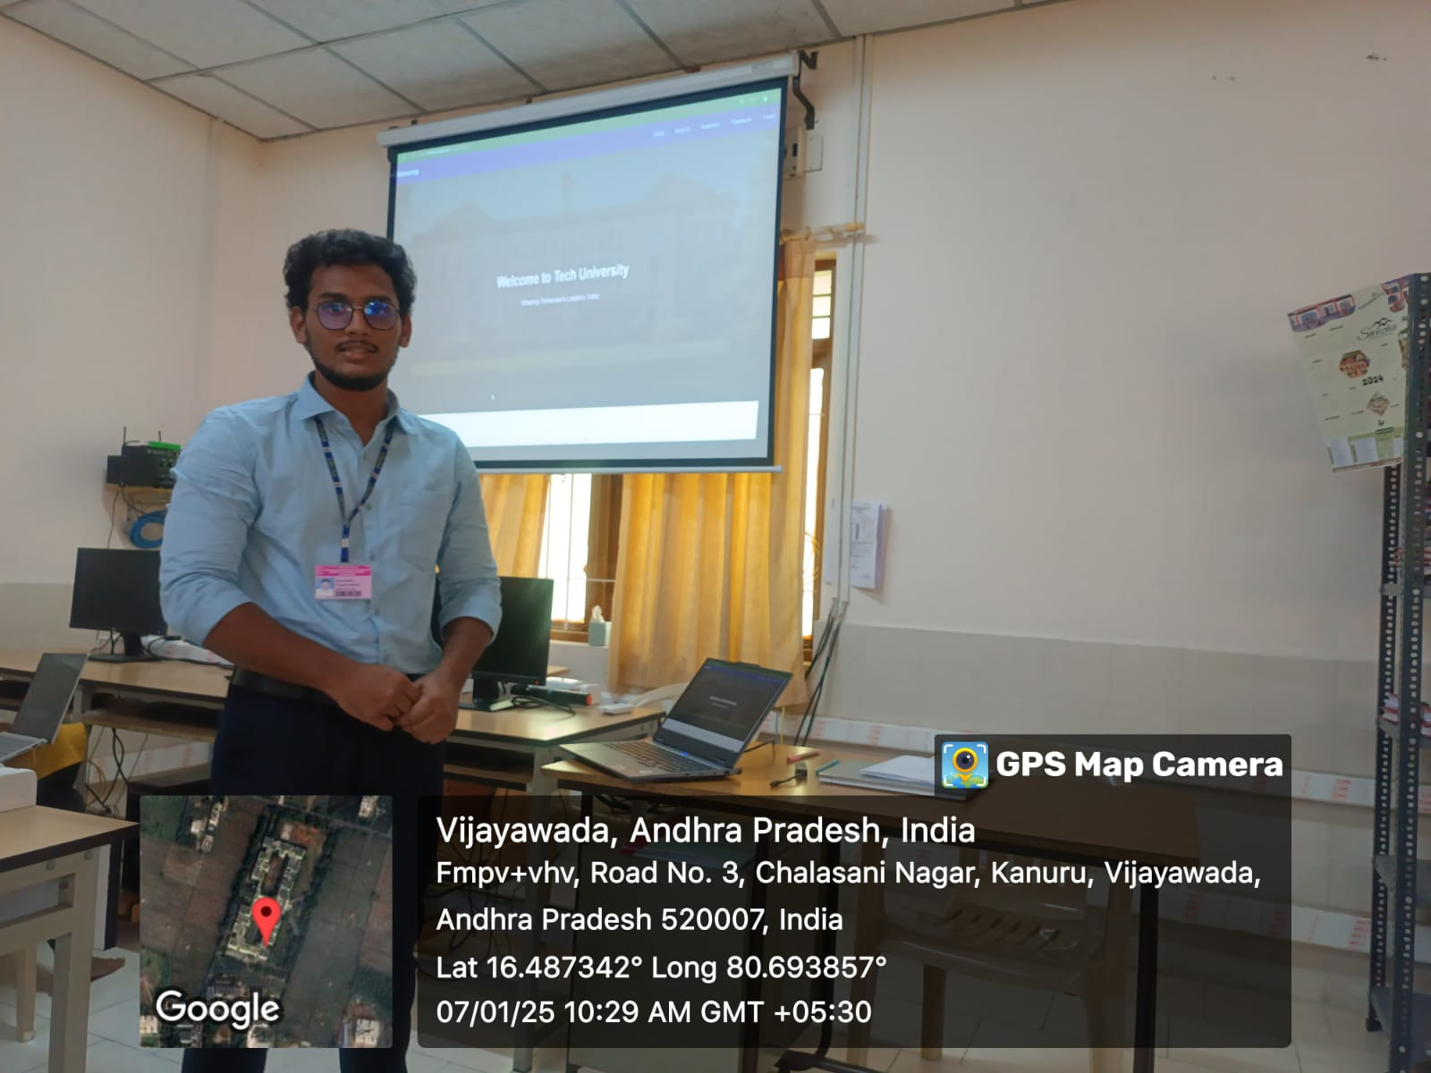
- University website
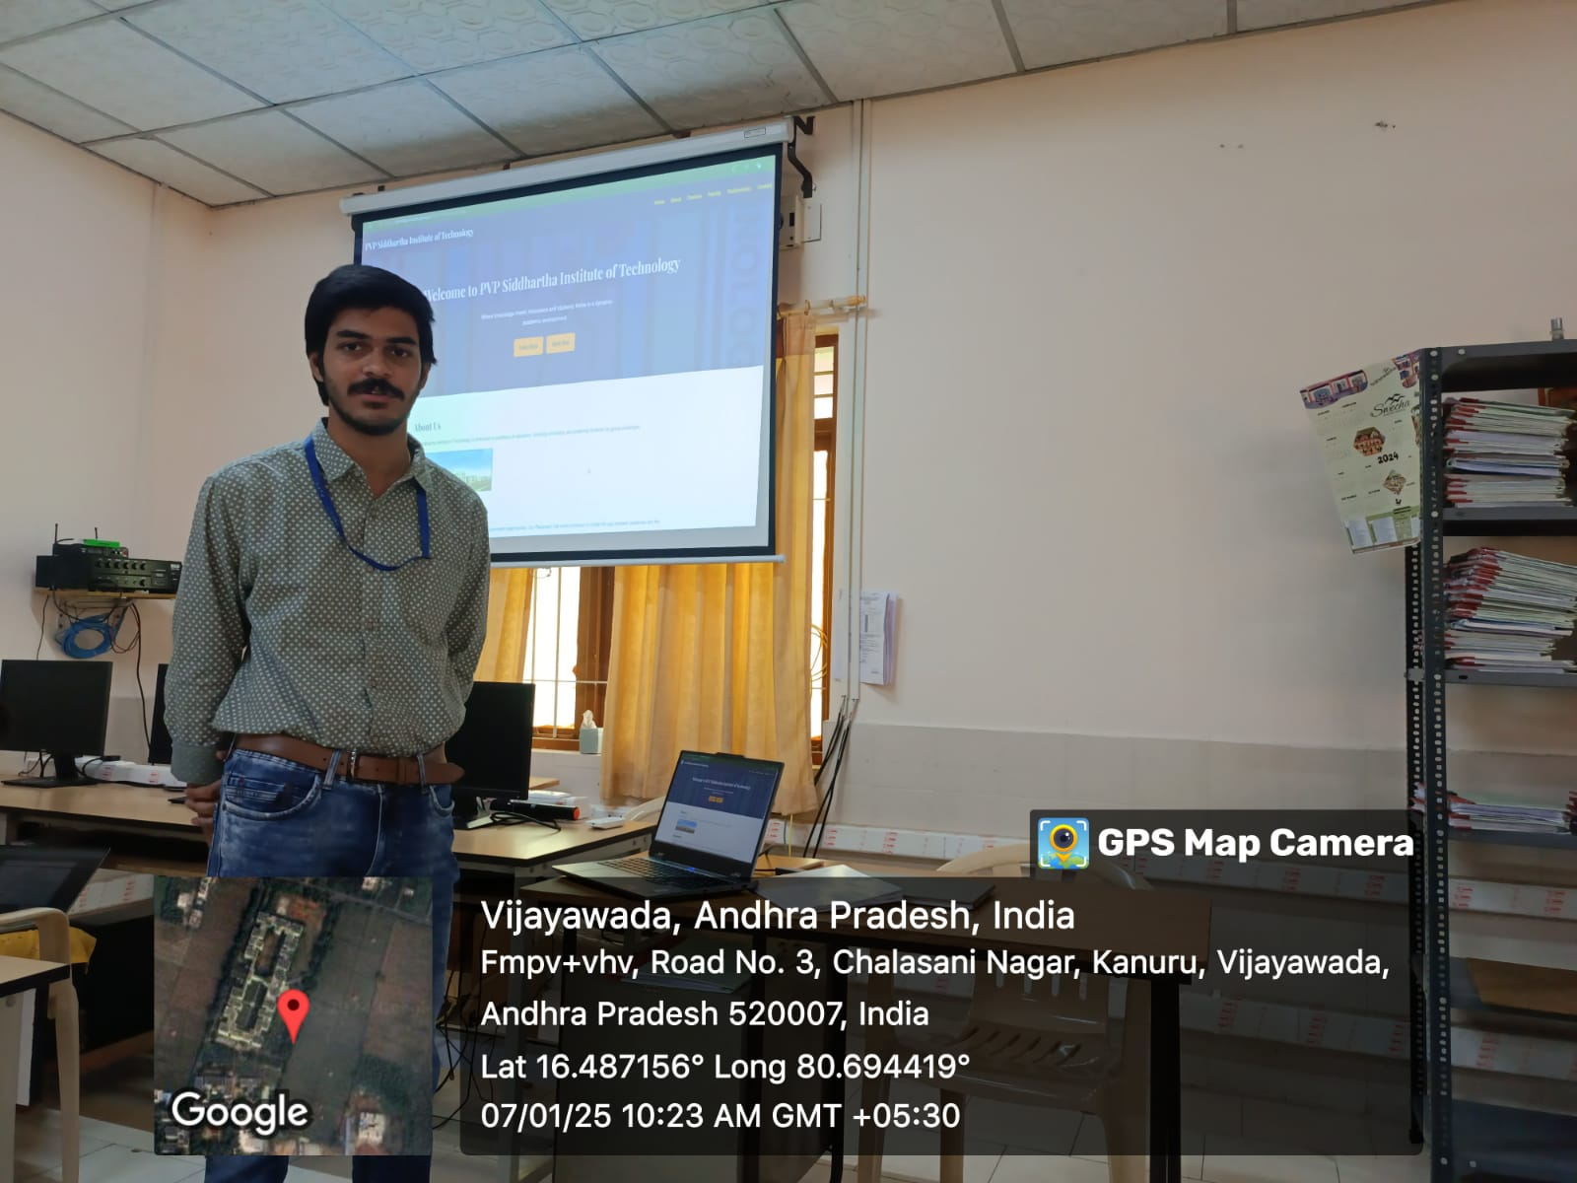

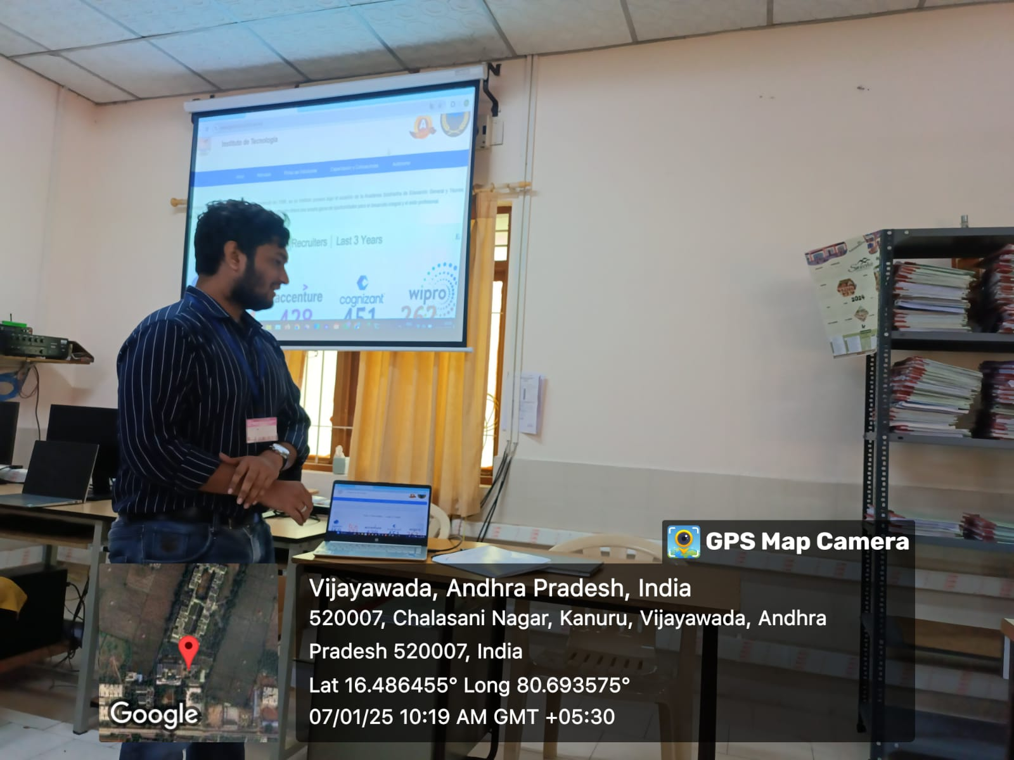
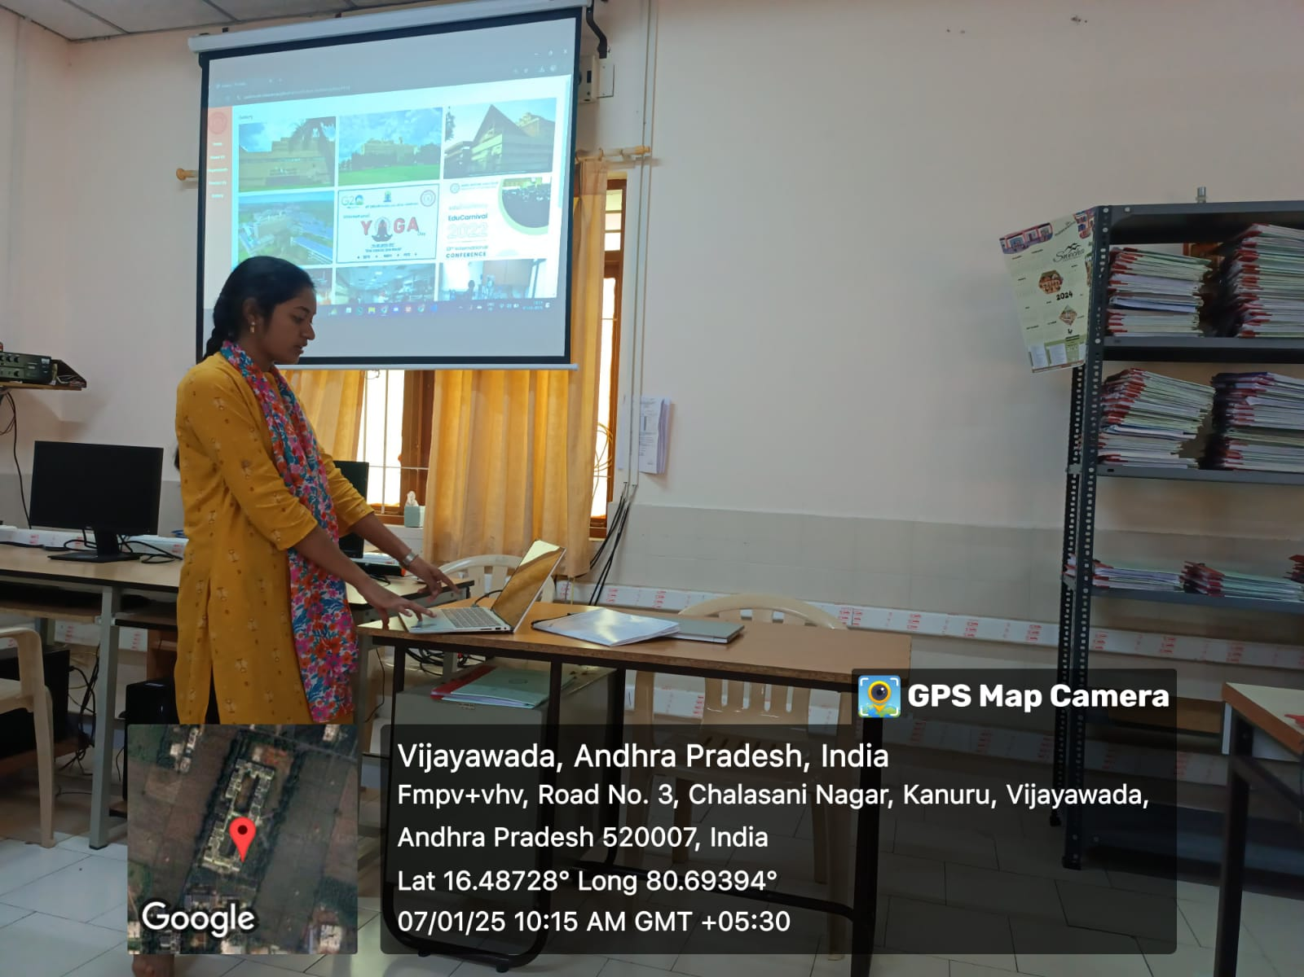

Signature of the Faculty

