EX- 4

Aim:

Develop a program to demonstrate operations on Graphs.

Description:
A Graph G=(V,E) consists of a finite non empty set of vertices V also called points or nodes and a finite set E of unordered pairs of distinct vertices called edges or arcs or links. Following two are the most commonly used representations of graph.

1. Sequential Representation or Adjacency Matrix
2. Linked Representation or Adjacency List

There are other representations also like, Incidence Matrix, Incidence List etc.

1. Sequential Representation or Adjacency Matrix:

Adjacency Matrix is a 2D array of size V x V where V is the number of vertices in a graph. Let the 2D array be adj[][], a slot adj[i][j] = 1 indicates that there is an edge from vertex i to vertex j. Adjacency matrix for undirected graph is always symmetric. Adjacency Matrix is also used to represent weighted graphs. If adj[i][j] = w, then there is an edge from vertex i to vertex j with weight w.The adjacency matrix example graph is shown below.
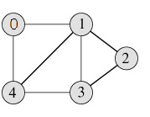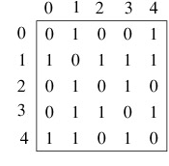
Figure 1: Adjacency Matrix Representation

2. Linked Representation or Adjacency List

An array of linked lists is used. Size of the array is equal to number of vertices. Let the array be array[]. An entry array[i] represents the linked list of vertices adjacent to the ith vertex. This representation can also be used to represent a weighted graph. The weights of edges can be stored in nodes of linked lists. Following is adjacency list representation of the above graph.

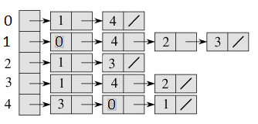
Figure 2: Linked Representation

Operations on Graphs:
- Storing or creating a Graph
- Insert vertex
- Delete vertex
- Insert edge
- Delete edge
- Traverse the graph

A Graph can be traversed in two ways:

- Depth-first search (DFS) is an algorithm for traversing or searching tree or graph data structures. One starts at the root (selecting some arbitrary node as the root in the case of a graph) and explores as far as possible along each branch before backtracking.
- Breadth-first search (BFS) is an algorithm for traversing or searching tree or graph data structures. It starts at the tree root (or some arbitrary node of a graph) and explores the neighbor nodes first, before moving to the next level neighbors.

Algorithm for Breadth-first search (BFS):

Procedure BFT (s)
/* s is the start vertex of the traversal in an undirected graph G */
/* Q is a queue which keeps track of the vertices whose adjacent
nodes are to be visited */
/* Vertices which have been visited have their ‘visited’ flags set
to 1 (i.e.) visited (vertex) = 1. Initially, visited (vertex) = 0 for all
vertices of graph G */
Initialize queue Q;
visited(s) = 1;
call ENQUEUE (Q,s); /* insert s into Q */
while not EMPTY_QUEUE(Q) do /* process until Q is empty */
call DEQUEUE (Q,s) /* delete s from Q*/
Print(s); /* output vertex visited */
for all vertices v adjacent to s do
if (visited (v) = 0) then
{ call ENQUEUE (Q, v);
visited (V) =1;
}
end
end while
end BFT.

Example: Consider the given graph for traversal.

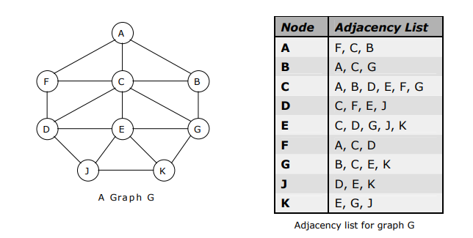

BFS traversal:

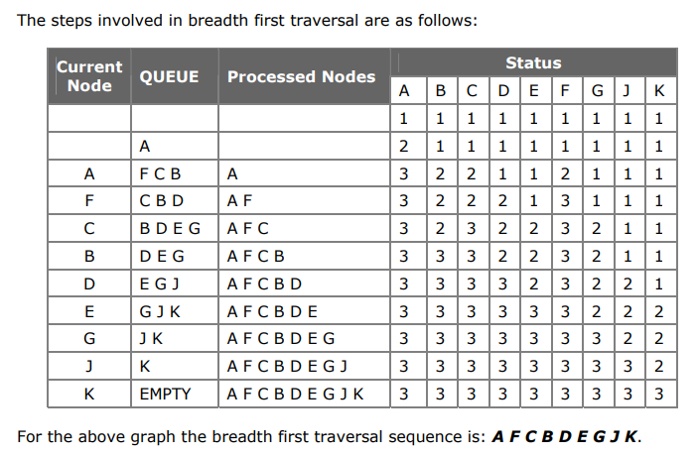

Algorithm for Depth-first search (DFS):

Procedure DFT( s)
/* s is the start vertex */
visited(s) = 1;
Print (s); /* Output visited vertex */
for each vertex v adjacent to s do
if visited(v) = 0 then
call DFT(v);
end
end DFT.

Example : DFS traversal.

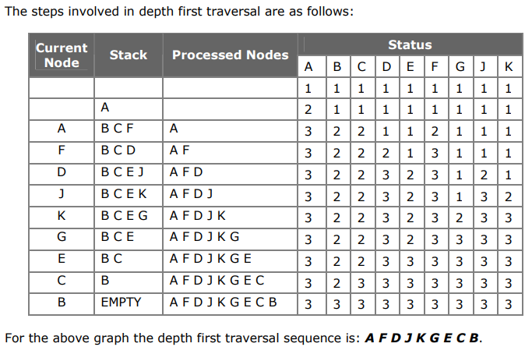

Program code:

Implement operations on a given graph

Input and Output:

Application Programs:
- https://www.hackerrank.com/challenges/torque-and-development/problem?isFullScreen=true
- https://www.hackerearth.com/practice/algorithms/graphs/graph-representation/practice-problems/algorithm/special-edge-3-1e932e1e/
- https://www.hackerearth.com/practice/algorithms/graphs/graph-representation/practice-problems/algorithm/split-the-bill-3-5a0690ff/

