PVP20
Code No: 20CS3602

PVP Siddhartha Institute OF TECHNOLOGY
(Autonomous)

Machine Learning
Duration: 3 Hours Max. Marks: 70

Note:
- Contains 5 essay questions with an internal choice. Each question carries 14 Marks.
- All parts of Question paper must be answered in one place.
5 x 14 = 70 Marks

 |  |  | Blooms Level | CO | Max. Marks
UNIT-I
1 | (a) | Explain important features that are required to well-define a learning Problem. | L2 | CO1 | 7
1 | (b) | Summarize the steps involved in designing a learning system. | L2 | CO1 | 7
OR
2 |  | Demonstrate a decision tree induction algorithm for classifying data tuples with a suitable example. | L3 | CO2 | 14
UNIT-II
3 | (a) | Illustrate the structure of a biological Neuron with a neat sketch? | L2 | CO1 | 7
3 | (b) | Relate the differences between Standard Gradient Descent and Stochastic Gradient Descent | L3 | CO2 | 7
OR
4 | (a) | Describe Multilayer feed forward networks. | L2 | CO1 | 7
4 | (b) | Using BPN, find the new weights for the given figure with the input pattern [0, 1] and the target output is 1. Using a learning rate α = 0.25 and binary sigmoidal function.  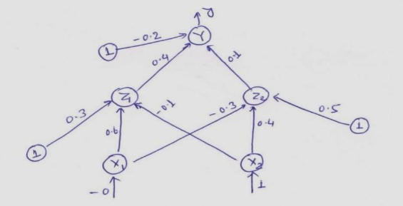 | L3 | CO2 | 7
UNIT-III
5 |  | Explain Naive Bayes Classifier and compare it to the conventional model using appropriate measures with an example. | L4 | CO4 | 14
OR
6 | (a) | What measures are used to improve the performance of classifier accuracy? | L2 | CO2 | 7
 | (b) | Apply ensemble methods for classification using the bagging approach. | L3 | CO2 | 7
UNIT-IV
7 |  | Elaborate the procedure to perform a classification task on linearly separable data using Support Vector Machine. | L3 | CO2 | 14
OR
8 | (a) | Use KNN algorithm for choosing nearest neighbor Parameters with an example. | L3 | CO2 | 7
8 | (b) | Relate the generic properties of systems that use case-based reasoning. | L3 | CO2 | 7
UNIT-V
9 | (a) | Illustrate in detail about any one Partitioning based clustering methods. | L3 | CO3 | 7
9 | (b) | Apply hierarchical method for clustering using agglomerative algorithm. | L3 | CO3 | 7
OR
10 | (a) | Examine how the DBSCAN algorithm performs cluster analysis by making use of Silhouette Coefficient measure? | L4 | CO4 | 7
10 | (b) | How is the Sting grid-based method used for clustering? | L3 | CO3 | 7

