P. V. P. SIDDHARTHA INSTITUTE OF TECHNOLOGY
BRANCH: CSE/AI&ML/DS | REGULATION: PVP23
COURSE: B. TECH | SUBJECT: Advanced Data Structures & Algorithm Analysis
SUBJECT CODE: 23CS3301/23AM3301/23DS3301 | YEAR AND SEMESTER: II B.TECH SEMESTER I
QUESTION BANK
UNIT – I
PART - A
Short Answer Questions (2 Marks Each)

Q. No. | QUESTION | CO | LEVEL | MARKS
1 | What is an algorithm? Why is the need of studying algorithms? | CO1 | L2 | 2
2 | What are the fundamental steps involved in algorithmic problem solving? And also explain what is order of growth? | CO1 | L2 | 2
3 | What is the height of an AVL tree with n nodes in the worst case? | CO1 | L2 | 2
4 | What property ensures the balanced nature of an AVL tree? | CO1 | L2 | 2
5 | Why do AVL trees require rotations | CO1 | L2 | 2
6 | Why are B-Trees used in databases and file systems? | CO1 | L2 | 2
7 | What is the minimum degree t of a B-Tree? | CO1 | L2 | 2
8 | What is the height of a B-Tree with n keys and minimum degree t in the worst case? | CO1 | L2 | 2
9 | What is the primary advantage of B-Trees over binary search trees in terms of disk access? | CO1 | L2 | 2
10 | What does it mean if an algorithm has a time complexity of O(n^2)? | CO1 | L2 | 2

PART- B
Long Answer Questions (10 Marks Each)

Q. No. | QUESTION |  | CO | LEVEL | MARKS
1 | a)Discuss the various notations used for computing the complexity of an algorithm?  Express the Time complexities for the following control statements with an example:  a) conditional statements  b) iterative statements  c) recursive statements |  | CO1, CO3 | L2 | 5
1 | b)Calculate the time complexities of the following code:
1 | a)  x=y+z;  for(i=1;i<=n;i++)  x=y+z; | b)  x=y+z;  for(i=1;i<=n;i++)  {  for(j=1;j<=n/2;j++)  x=y+z;  } | CO1, CO3 | L3 | 5
1 | c)  x=y+z;  for(i=1;i<=n;i++)  { for(j=1;j<=i;j++)  {  for(k=1;k<=133;k++)  x=y+z;  }  } | d)  while(n>1)  {  n=n/2;  x=y+z;  }
2 | Evaluate the following equalities are correct:  i)5n2 -6n=ϴ(n² )  ii)n!=O(n^{n} )  iii)n3 +106 n 2 =ϴ(n³ )  iv)2n2 2 n +n logn=ϴ(n² 2 ^{n} ) |  | CO3 | L3 | 10
3 | a) Explain the concept of time complexity and its importance in algorithm analysis |  | CO3 | L3 | 5
3 | b)Describe the difference between worst-case, best-case, and average-case time complexity, providing examples for each. |  | CO3 | L3 | 5
4 | a)Construct an AVL Tree using the following data entered as a sequence set. Show the balance factors in the resulting tree: 13, 22, 6, 9, 32, 55, 79, 65, 70 |  | CO3 | L3 | 5
4 | b) Insert 42, 43, 46 and 49 in the above constructed AVL tree and show a balanced AVL Tree. |  | CO3 | L3 | 5
5 | a)Apply the steps in insertion operation in B tree with an example? |  | CO3 | L3 | 5
5 | b)Construct 2-3 tree by using the following sequence of numbers 6, 7, 9, 22, 13, 31, 35, 28, 24, 5, 34, 8, 25, 10, 11, 12, 14 and 39. |  | CO3 | L3 | 5
6 | a)Construct an AVL Tree using the following data entered as a sequence set. Show the balance factors in the resulting tree: 13, 22, 6, 9, 32, 55, 79, 65, 70 |  | CO3 | L3 | 5
6 | b) )Illustrate the deletion algorithm in AVL tree with example?. |  | CO3 | L3 | 5
7 | a)Discuss the significance of time complexity in the context of large-scale data processing and real-time systems. |  | CO1 | L2 | 5
7 | b)Explain the concept of space complexity and its significance in algorithm analysis. |  | CO1 | L2 | 5
8 | - Apply deletion of 38, 5 and 8 from the following B- trees and show the resulting B- tree after every deletion operation.  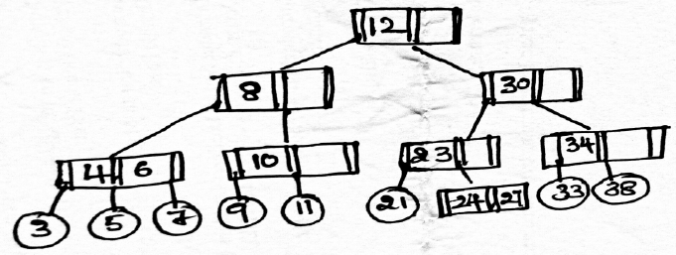 |  | CO3 | L3 | 5
8 | b)Explain the process of insertion by using the properties of B- trees with an example. |  | CO1 | L2 | 5
10 | a)Explain the structure and properties of a B-Tree. Why are B-Trees used in databases and file systems? |  | CO2 | L3 | 5
10 | b)How does deletion work in a B-Tree? Describe the different cases and the strategies used to maintain the B-Tree properties. |  | CO2 | L3 | 5

UNIT – II

PART - A
Short Answer Questions (2 Marks Each)

Q. No. | QUESTION | CO | LEVEL | MARKS
1 | How does a binary heap differ from a binary search tree (BST)? | CO1 | L2 | 2
2 | How do you insert an element into a binary heap? | CO1 | L2 | 2
3 | How can a binary heap be represented in an array? And what is the heapify operation. | CO1 | L2 | 2
4 | What are some applications of binary heaps? | CO1 | L2 | 2
5 | Differentiate between directed and undirected graphs. | CO1 | L2 | 2
6 | What data structure is typically used to implement DFS and BFS | CO1 | L2 | 2
7 | Differentiate adjacency matrix and incidence matrix | CO1 | L2 | 2
8 | What is the difference between a tree and a forest in graph theory? | CO1 | L2 | 2
9 | What is a disjoint set? What is the role of the "parent" array in the union-find data structure? | CO1 | L2 | 2
10 | What are the two main operations of the union-find data structure? | CO1 | L2 | 2

PART- B
Long Answer Questions (10 Marks Each)

Q. No. | QUESTION | CO | LEVEL | MARKS
1 | - Explain the Binary Heap Structure property with an example? | CO1 | L2 | 3
1 | - Apply the following operations of priority queues  (i) Construct the min and max heap with the following elements 20, 10, 5, 18, 6, 12, 14, 4, and 22.  (ii) Insert 2 and 28 in the min heap  (iii) Perform two successive deletion operations on max heap | CO3 | L3 | 7
2 | - Explain the following  - Priority Queue  - Min Heap  - Max Heap | CO1 | L2 | 4
2 | - Build insertion and deletion algorithms of max priority heap. | CO3 | L3 | 6
3 | - Apply the sequence of steps in deleting the elements in a successive order from the following heap 18, 12, 14, 8, 7, 10, 9. | CO3 | L3 | 5
3 | - Develop code to implement insertion and deletion algorithms of min priority heap? | CO3 | L3 | 5
4 | - Apply the following operations of heap tress  (i) Construct the max heap tree with the following elements 11, 10, 5, 69, 6, 12, 14, 4, and 2.  (ii) Insert 1 and 99 in the heap tree  (iii) Perform two successive deletion operations on heap tree | CO3 | L3 | 6
4 | b)Develop the code to implement deletion in both min and max heap. | CO3 | L3 | 4
5 | a)Discuss the difference between Depth-First Search (DFS) and Breadth-First Search (BFS) algorithms. | CO3 | L3 | 4
5 | b. Illustrate BFS and DFS procedure with an example graph | CO1,CO3,CO4 | L3 | 6
6 | Explain the Heap Sort algorithm, including its steps and time complexity. | CO1,  CO3 | L2,  L3 | 10
7 | a)Illustrate the various ways of representing a Graph? Show the various mechanisms of representation for the following Graph:  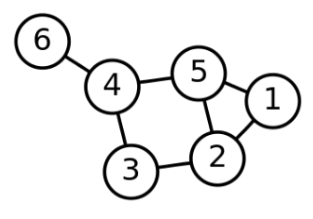 | CO1, CO3, CO4 | L2 | 5
7 | b)Compare the following:  a) Directed v/s Undirected graph  b) Tree v/s Graph  c) DFS v/s BFS | CO1, CO3, CO4 | L3 | 5
8 | a)Explain the Depth First Search graph traversal technique. Write an algorithm using stack to perform DFS. | CO1, CO3, CO4 | L3 | 5
8 | b)Trace the algorithm for the following Graph stating from node 0:  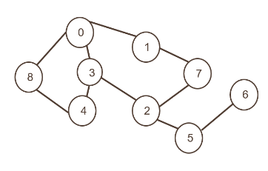 | CO1, CO3, CO4 | L3 | 5
9 | a)Design a simple find algorithm in a disjoin sets. Explain with an example. | CO2 | L3 | 5
9 | b)Design a simple union algorithm in a disjoin sets. Explain with an example. | CO2 | L3 | 5
10 | a)Explain the Breadth First Search graph traversal technique. Write an algorithm using stack to perform BFS. | CO1, CO3, CO4 | L3 | 5
10 | b) Trace the algorithm for the following Graph starting from Node A:  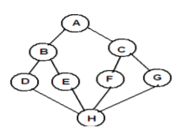 | CO1, CO3, CO4 | L3 | 5

UNIT III

Short Answer Questions (2 Marks Each)

Q. NO. | QUESTIONS | CO | Bloom’s Level | MARKS
1 | What is the Divide and Conquer strategy? | CO1 | L2 | 2M
2 | What are the three main steps in the Divide and Conquer approach? | CO1 | L2 | 2M
3 | Give an example of an algorithm that uses Divide and Conquer. | CO1 | L2 | 2M
4 | What is the time complexity of Merge Sort. | CO1 | L2 | 2M
5 | How does the Divide and Conquer approach improve efficiency? | CO1 | L2 | 2M
6 | What is a Greedy Algorithm? | CO1 | L2 | 2M
7 | Can Greedy Algorithms guarantee an optimal solution? | CO1 | L2 | 2M
8 | What is a Minimum Spanning Tree (MST)? | CO1 | L2 | 2M
9 | Name two algorithms used to find the Minimum Spanning Tree. | CO1 | L2 | 2M
10 | What is the Single Source Shortest Path problem? | CO1 | L2 | 2M

Long Answer Questions (10 Marks Each)

UNIT- III
S.No. | Question | CO | BTL | Marks
1 | How do we analyze the time complexity of the algorithm that are based on divide and conquer techniques? | CO2 | 2 | 10
2 | Explain divide and conquer technique. Construct a recursive algorithm for finding the maximum and minimum element from a list. | CO2 | 3 | 10
3 | Discuss how Quick sort algorithm works to sort an array and trace the following dataset.  25, 91, 46, 35, 11, 82, 14, 55  Analyze the best case complexity of Quick sort algorithm. | CO2,  CO3 | 4 | 10
4 | Develop an algorithm for sorting elements using simple merge. Apply the same for sorting list of elements given below:67, 90, 12, 56, 23, 34, 45  Analyze the time complexity. | CO2,  CO3 | 4 | 10
5 | Apply Strassen’s matrix multiplication on following matrices  4 5 2 10  5 9 1 6 | CO3 | 3 | 10
6 | How fractional knapsack problem can be solved using Greedy method? Discuss with an example. Also analyze its time complexity | CO2,  CO3 | 3 | 10
7 | Compute an optimal solution using greedy method to the following instance of job sequencing with deadlines and profit problem  N=7,  [P1:P7]=(3,5,20,18,1,6,30), [D1:D7]=(1,3,4,3,2,1,2) | CO2 | 3 | 10
8 | Interpret Kruskal’s algorithm for minimum spanning tree with a suitable example. Also analyze it’s time complexity. | CO2,  CO3 | 4 | 10
9 | Construct minimum cost spanning tree using Prim’s algorithm  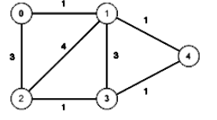 | CO2 | 3 | 10
10 | Apply single source shortest path problem for the following graph  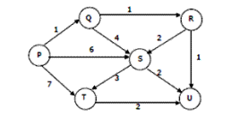 | CO2 | 3 | 10

UNIT IV

Short Answer Questions (2 Marks Each)

Q. NO. | QUESTIONS | CO | Bloom’s Level | MARKS
1 | State the principle of optimality | CO1 | L2 | 2M
2 | List any two applications of Dynamic Programming | CO1 | L2 | 2M
3 | State the Merge Rule in 0/1 Knapsack Problem using Dynamic Programming. | CO1 | L2 | 2M
4 | State the Purge Rule in 0/1 Knapsack Problem using Dynamic Programming. | CO1 | L2 | 2M
5 | State Longest Common Subsequence Problem | CO1 | L2 | 2M
6 | What is String Editing Problem? | CO1 | L2 | 2M
7 | Define Optimal Binary Search Tree | CO1 | L2 | 2M
8 | Name algorithms used to compute shortest path | CO1 | L2 | 2M
9 | What is the time complexity of  a)OBST Algorithm  b)Travelling Salesman Problem | CO1 | L2 | 2M
10 | What is Travelling Salesman Problem? | CO1 | L2 | 2M

Long Answer Questions (10 Marks Each)

UNIT- 4
S.No. | Question | CO | BTL | Marks
1 | - Differentiate greedy method and dynamic programming. | CO4 | 4 | 5
1 | - Apply Floyd’s algorithm to compute lengths of shortest paths between all pairs of nodes for the given 3X3 adjacency matrix  [ 0 6 13, 8 0 4, 5 $∞$ 0] | CO3 | 3 | 5
2 | Implement OBST algorithm to find optimal binary search tree for the identifier set (a₁, a₂, a₃, a₄) = (for, else, if, while) with p(1)= 1/20, p(2) =1/5, p(3)=1/10, p(4) =1/20 and q(0) = 1/5, q(1) =1/10,  q(2) = 1/5, q(3) = 1/20 and q(4) =1/20 | CO3 | 3 | 10
3 | Apply dynamic programming to construct OBST for the following  (a₁, a₂, a₃, a₄) = (do, if, int, while),  P(1:4)= (3,3,1,1), q(0:4) = (2,3,1,1,1) | CO3 | 3 | 10
4 | Solve the following 0/1 knapsack problem using dynamic programming n=3, m=6 profits (p1,p2,p3) = (1,2,5) weights (w1,w2,w3) = (2,3,4) and provide an optimal solution. | CO3 | 3 | 10
5 | a.Compare divide and conquer and dynamic programming design techniques | CO4 | 4 | 5
5 | b.What is principle of optimality? What are merging and purging rules to get the solution of 0/1 knapsack problem by dynamic programming? | CO1 | 2 | 5
6 | - Apply dynamic progamming to find the shortest tour of Travelling Salesman Problem for the following 4X4 cost matrix  [0 10 15 20, 5 0 9 10, 6 13 0 12, 8 8 9 0] | CO3 | 3 | 5
6 | b.Apply dynamic Programming to find a minimum cost edit sequence that transforms X into Y.  X= a, a, b, a, b and Y= b, a, b, b | CO3 | 3 | 5
7 | a.Given two sequences X = <A, B, C, B, D, A, B> and  Y = <B, D, C, A, B, A>. Find the LCS of X and Y using Dynamic Programming | CO3 | 3 | 5
7 | b.Draw all possible binary search trees for the identifier set { do, if, stop} | CO1 | 2 | 5
8 | a.Analyze the time complexity of Floyd’s All pairs shortest path algorithm | CO4 | 4 | 5
8 | b.Explain the methodology of Dynamic Programming. Mention applications of Dynamic Programming. | CO1 | 2 | 5
9 | a.Analyze the time complexity of Travelling Salesman Problem using Dynamic Programming. | CO4 | 4 | 5
9 | - Apply dynamic progamming to find the shortest tour of Travelling Salesman Problem for the following 4X4 cost matrix  [0 10 9 3, 5 0 6 2, 9 6 0 7, 7 3 5 0] | CO3 | 3 | 5
10 | Apply Floyd’ s algorithm to the following graph  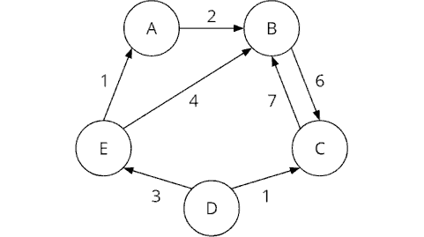  for computing shortest paths between every pair  of vertices | CO3 | 3 | 10
11 | Solve the following instance of 0/1 knapsack problem using dynamic programming n=3, m=4, profits (p1,p2,p3) = (3,7,12) weights (w1,w2,w3) = (3,5,7) and provide an optimal solution. | CO3 | 3 | 10
12 | Consider 4 elements a₁< a₂ < a₃ < a₄ with q(0) = 1/8, q(1) = 1/16, q(2) = 1/16, q(3) = 1/16, q(4)= 1/16 and p(1) = 1/4, p(2) = 1/8, p(3) = 1/16, p(4) = 1/16.  Construct the table of values of W(i,j),R(i,j) and C(i,j) computed by the algorithm to compute the roots of optimal sub trees. | CO3 | 3 | 10

UNIT V

Short Answer Questions (2 Marks Each)

Q. NO. | QUESTIONS | CO | Bloom’s Level | MARKS
1 | How does backtracking differ from brute force? | CO1 | L2 | 2M
2 | Identify the P and NP problems in the following  a) merge sort  b) single-source shortest paths  c) 0/1 knapsack problem  d) Travelling salesperson problem.  e) Searching  f) Graph coloring | CO1 | L2 | 2M
3 | Write a solution for 4-Queens problem by placing a queen in respective cell? | CO1 | L2 | 2M
4 | Define State space tree in backtracking | CO1 | L2 | 2M
5 | Define Explicit and Implicit constraints in backtracking. | CO1 | L2 | 2M
6 | What is the difference between FIFO Branch and Bound and LIFO Branch and Bound? | CO1 | L2 | 2M
7 | How does Branch and Bound differ from Backtracking? | CO1 | L2 | 2M
8 | What is the class P in computational complexity? | CO1 | L2 | 2M
9 | What is the class NP in computational complexity? | CO1 | L2 | 2M
10 | Define NP-complete ? Mention any two NP-complete problems? | CO1 | L2 | 2M

Long Answer Questions (10 Marks Each)
UNIT- V
S.No. | Question | CO | Bloom’s Level | Marks
1 | Apply back-tracking technique to solve the below instance of the sum-of-subset problem. Generate a possible feasible solution, S= {1,3,4,6} d=7 | CO2 | L3 | 10
2 | Apply the backtracking algorithm to solve the following instance of the sum of subsets problem S={5,10,12,13,15,18} and d=30 | CO2 | L3 | 10
3 | Elaborate how backtracking technique can be used to solve the n-queens problem. Construct an optimal solution for n=4Queens. | CO4 | L3 | 10
4 | Draw the state space tree generated by backtracking approach for the following graph and mention the possible solutions.  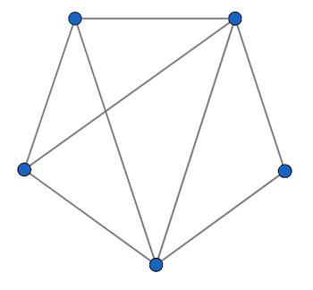 | CO2 | L3 | 10
5 | Write a backtracking algorithm for the sum of subsets problem using the state space tree corresponding to the variable tuple size formulation. | CO2 | L3 | 10
6 | What do you understand by branch and bound techniques? Explain LC branch and bound and FIFO branch and bound. | CO1 | L2 | 10
7 | Draw the state space tree generated by LCBB for the following knapsack instances:  (a) n = 5, (p1,p2,p3,p4,p5)= (10,15,6, 8, 4), (w1,w2,w3,w4,w5) = (4,6,3,4,2) and m = 12  (4, 6, 3, 4, 2), and m = 12. | CO2 | L3 | 10
8 | Solve the following instance of travelling sales person problem using Least Cost Branch Bound  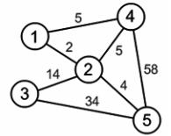 | CO2 | L3 | 10
9 | What are the different complexity classes? Explain each with an example. | CO1 | L2 | 10
10 | Explain P, NP and NP complete problems. | CO1 | L2 | 10

Course Coordinators Module Coordinators
- P. Bala Bhasker Dr. G. Lalitha Kumari
- Dr. K. Jyothsna Devi
- L.V Krishna Rao

Prof. & Head, Dept. of CSE (Dr. A. JayaLakshmi)

