WEEK-01

AIM: Generate a simple graph by using python matplotlib.

DESCRIPTION: Matplotlib is an amazing visualization library in Python for 2D plots of arrays. Matplotlib is a multi-platform data visualization library built on NumPy arrays and designed to work with the broader SciPy stack. It was introduced by John Hunter in the year 2002. One of the greatest benefits of visualization is that it allows us visual access to huge amounts of data in easily digestible visuals. Matplotlib consists of several plots like line, bar, scatter, histogram etc.

SIMPLE GRAPHS USING MATPLOTLIIB.
PROGRAM 1:
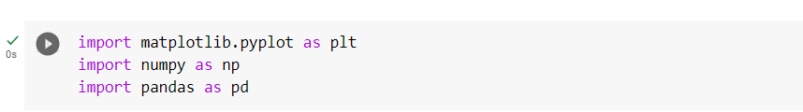
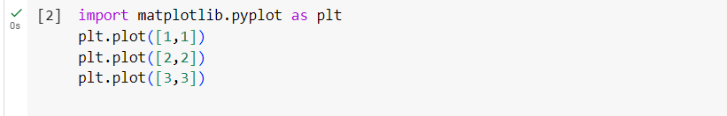
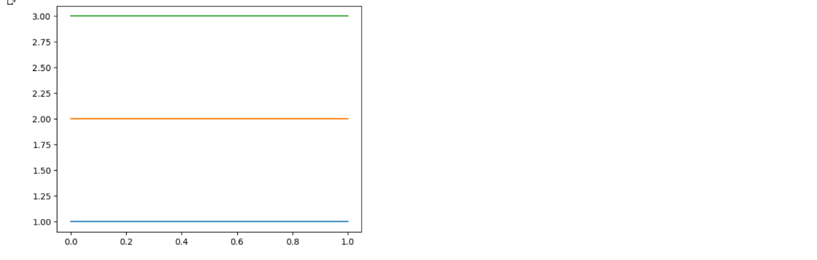

PROGRAM 2:
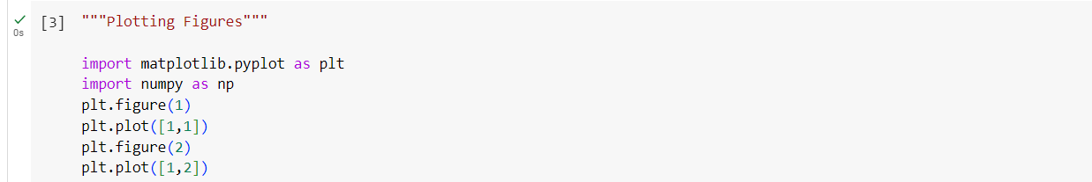
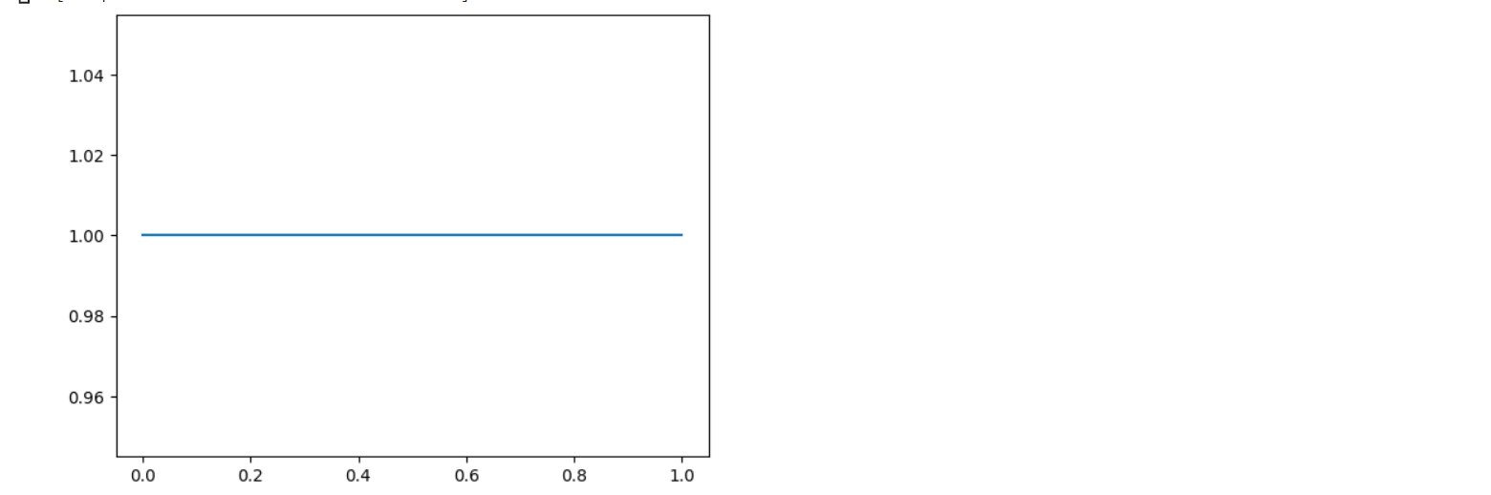
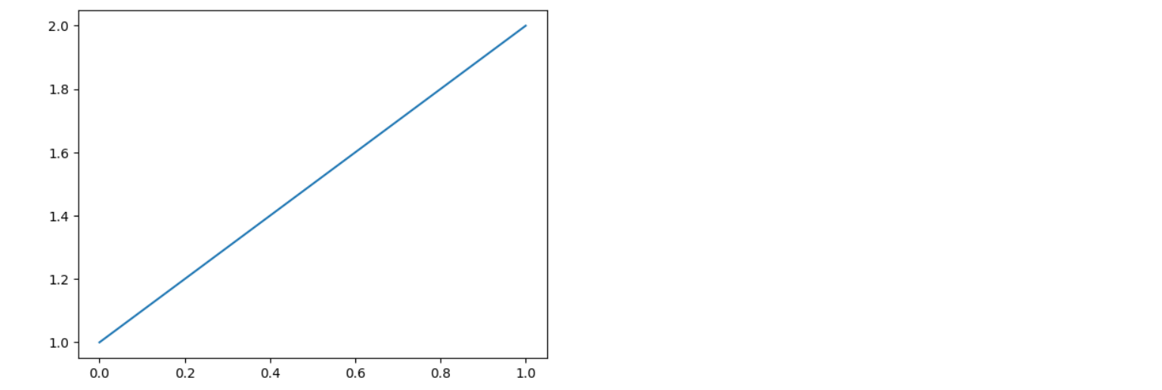
PROGRAM 3:
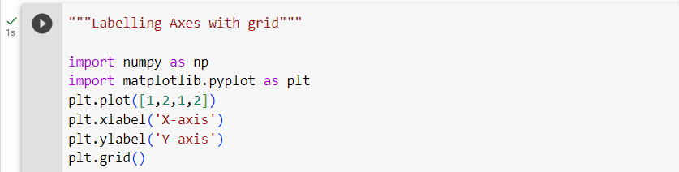
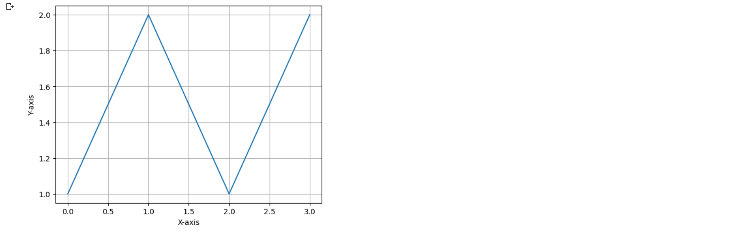

RESULT: Generated simple graphs using matplotlib.

WEEK-02

AIM: Implement different types of plots available in python matplotlib.

DESCRIPTION: Visualization is the perfect form of representing data so that developers can understand what the data wants to express. It also gives a clear insight into the data demonstrating approaches. But not all data requires the same format of representation. That is where Matplotlib comes with different ways of generating visuals against data. This tutorial will explain the different types of two-dimensional plotting systems that Matplotlib pyplot can render.
The six most commonly used Plots come under Matplotlib. These are:
- Line Plot
- Bar Plot
- Scatter Plot
- Pie Plot
- Histogram Plot

Line Plot: Line plots are drawn by joining straight lines connecting data points where the x-axis and y-axis values intersect. Line plots are the simplest form of representing data. In Matplotlib, the plot() function represents this.
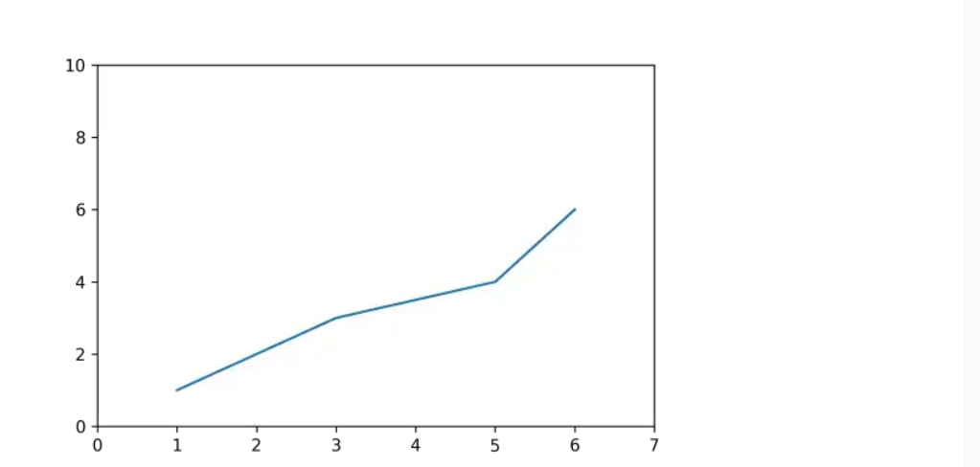
Bar Plot: The bar plots are vertical/horizontal rectangular graphs that show data comparison where you can gauge the changes over a period represented in another axis (mostly the X-axis). Each bar can store the value of one or multiple data divided in a ratio. The longer a bar becomes, the greater the value it holds. In Matplotlib, we use the bar() or barh() function to represent it.
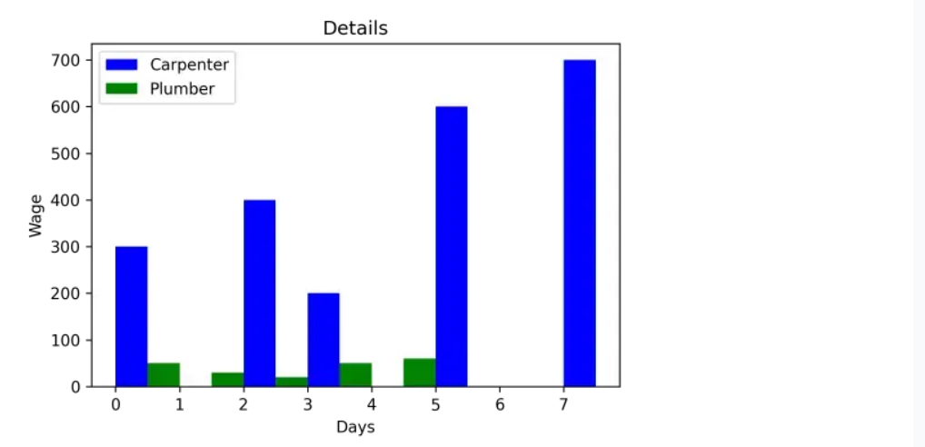
Scatter Plot: We can implement the scatter (previously called XY) plots while comparing various data variables to determine the connection between dependent and independent variables. The data gets expressed as a collection of points clustered together meaningfully. Here each value has one variable (x) determining the relationship with the other (Y). We use ht
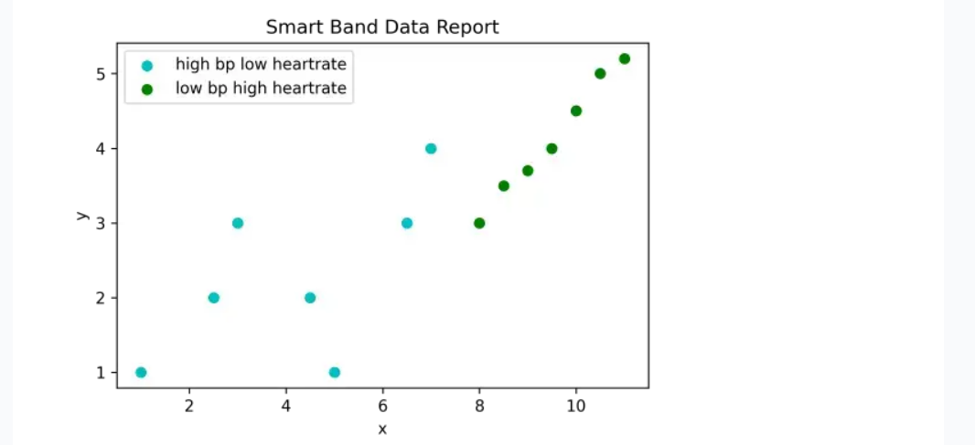
Pie Plot: A pie plot is a circular graph where the data get represented within that components/segments or slices of pie. Data analysts use them while representing the percentage or proportional data in which each pie slice represents an item or data classification. In Matplotlib, the pie() function represents it.
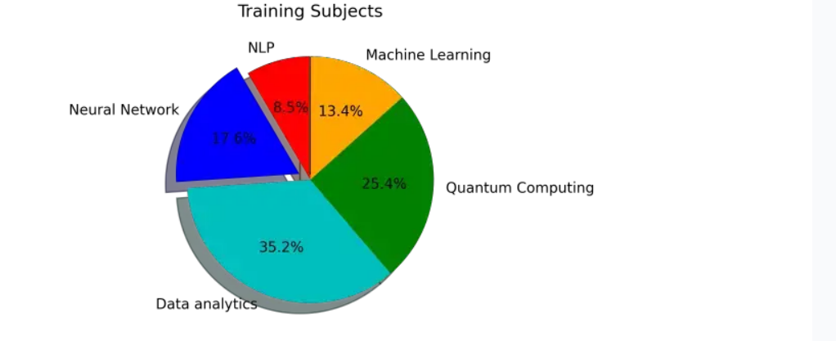
Histogram Plot: We can use a histogram plot when the data remains distributed, whereas we can use a bar graph to compare two entities. Both histogram and bar plot look alike but are used in different scenarios. In Matplotlib, the hist() function represents this.
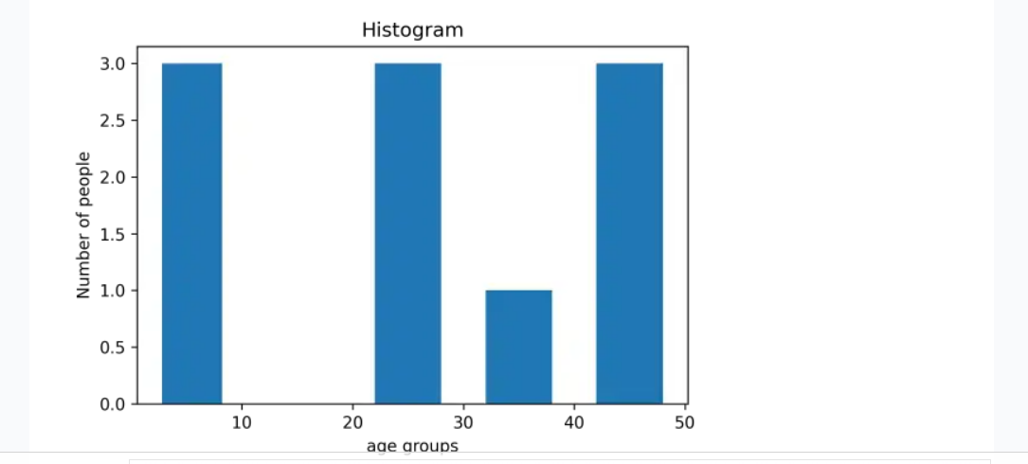

PROGRAM:
LINE GRAPH:
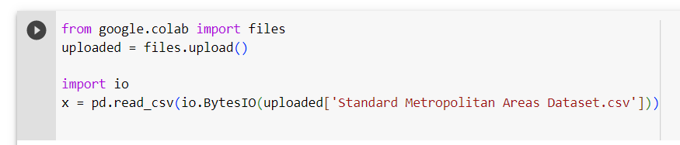
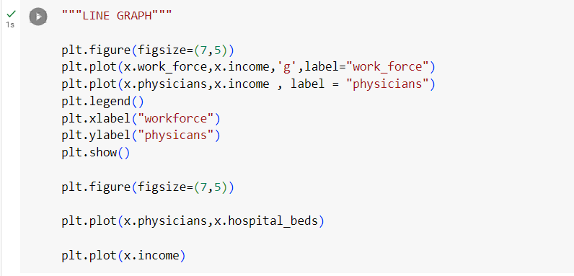
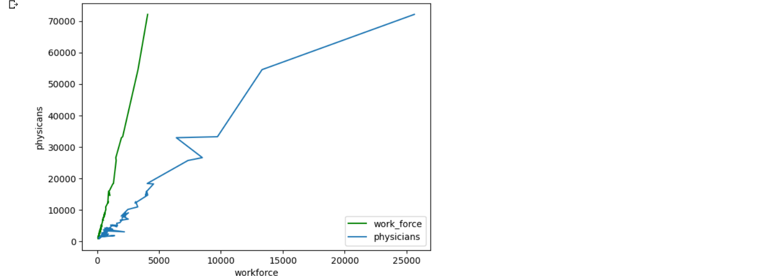
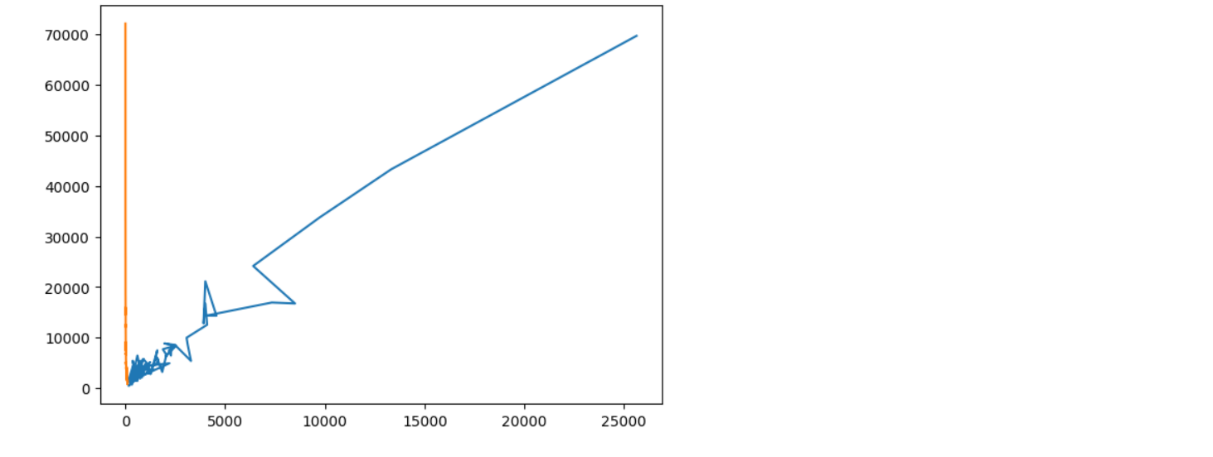

SCATTER PLOT:
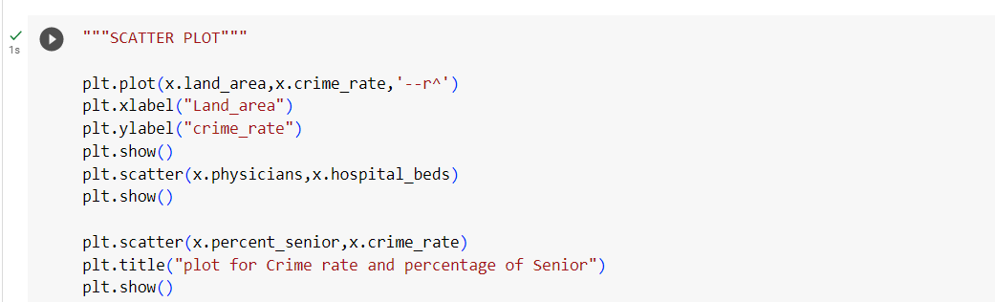
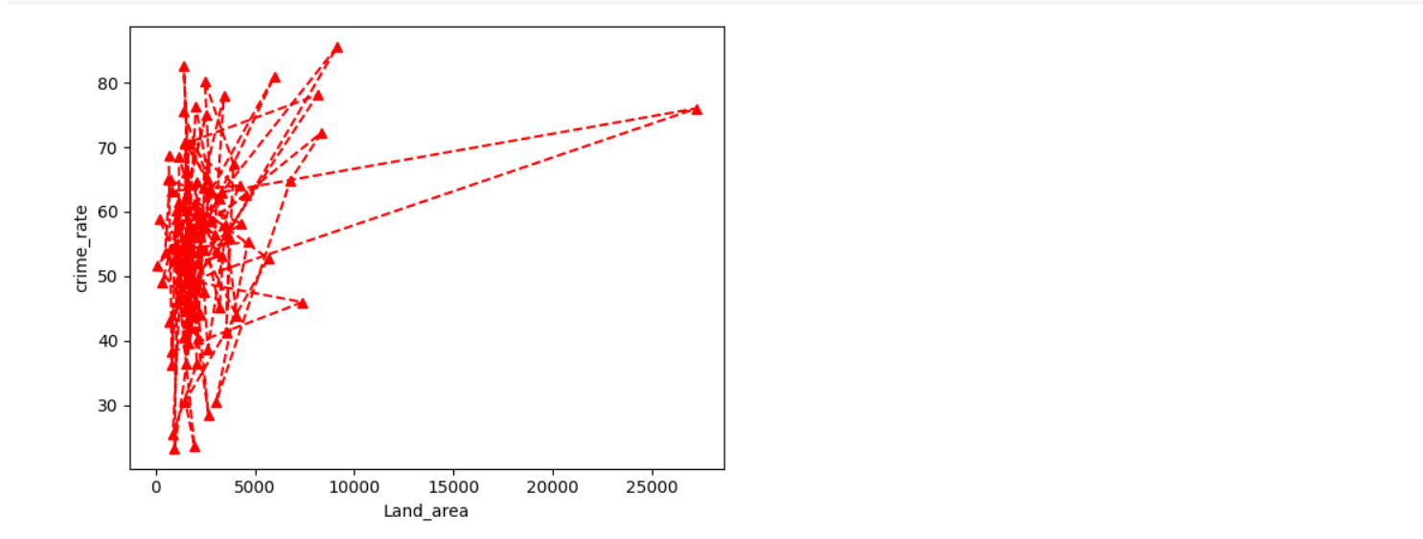
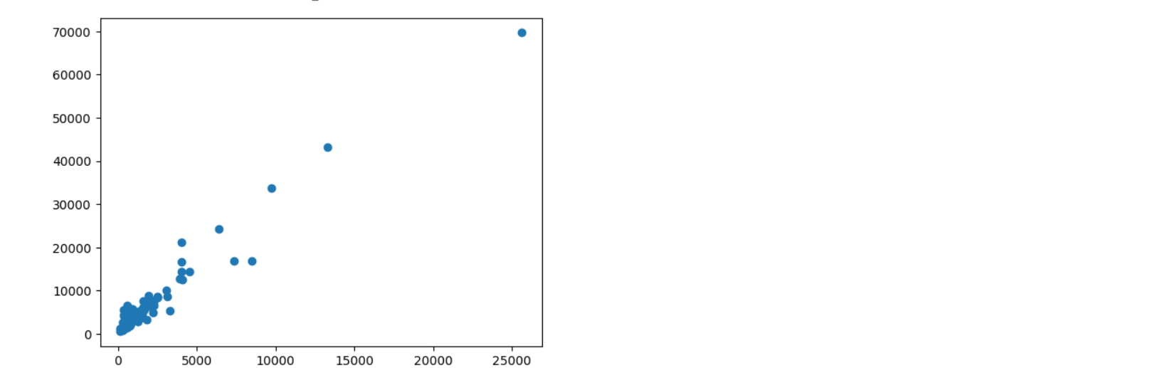
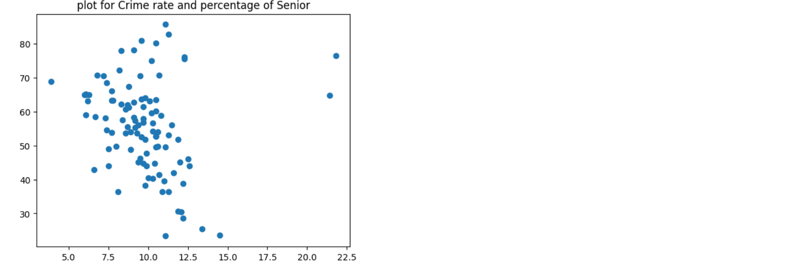
HISTOGRAM:
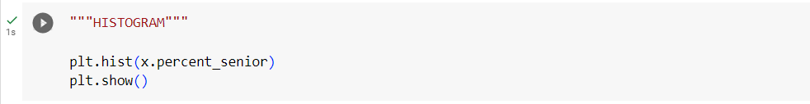
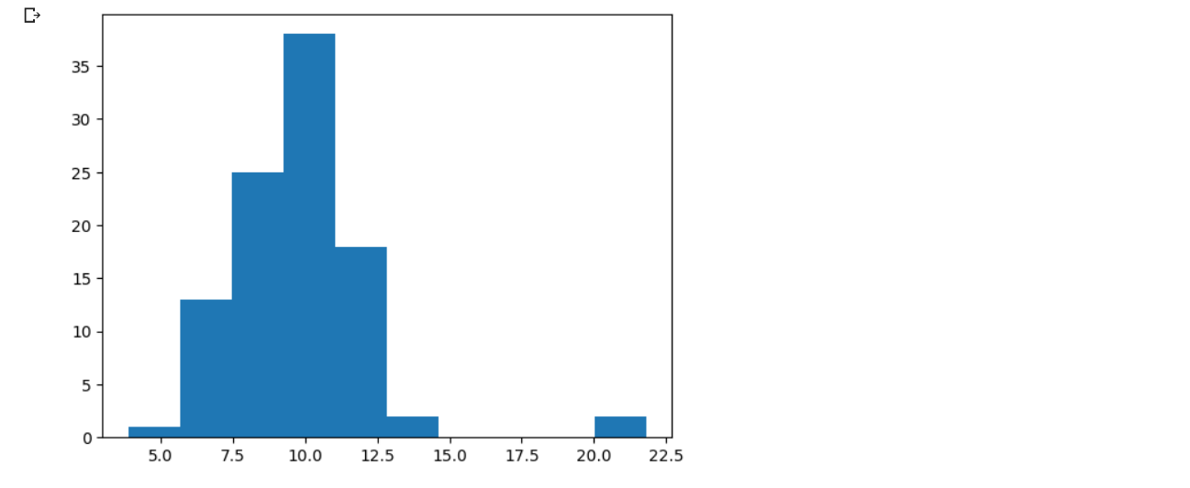
BAR GRAPH:
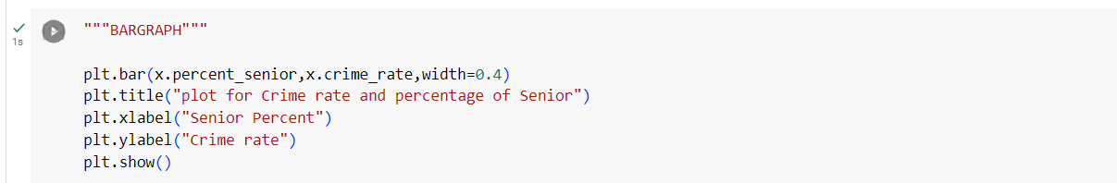
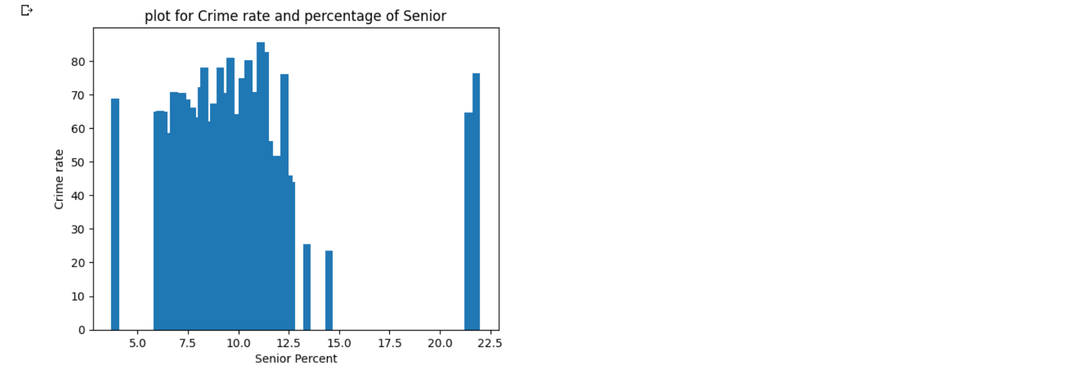

3D PLOT:
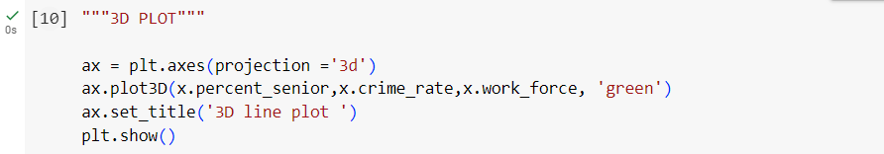
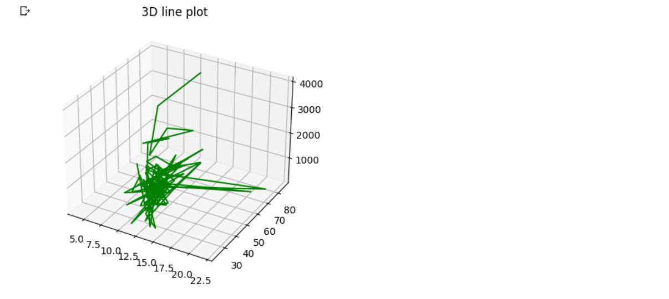
PIE CHART:
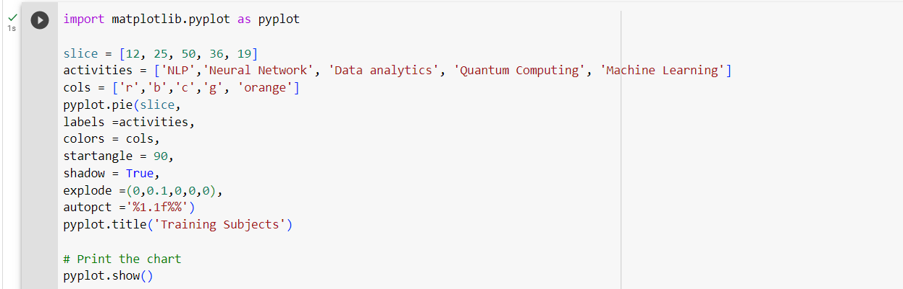
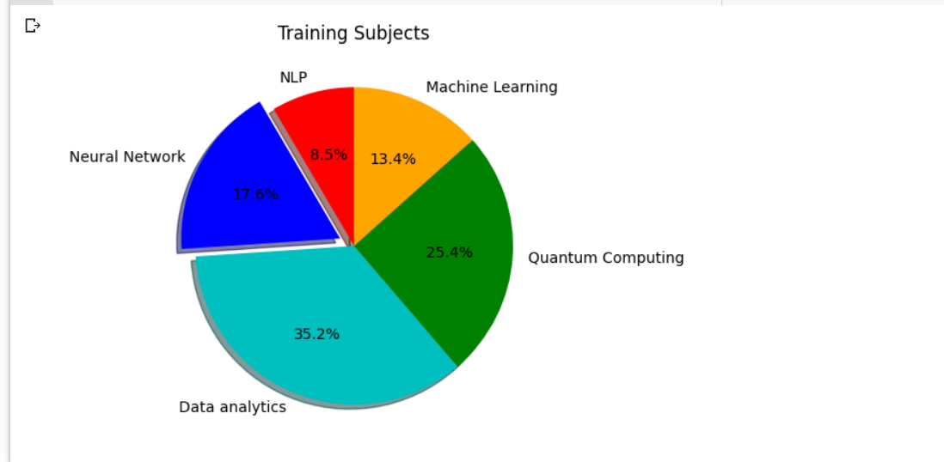
RESULT : Different type of plots are implemented using matplotlib.

WEEK-03

AIM: Develop multiple plots using subplot( ) function in matplotlib.

DESCRIPTION: Matplotlib is a popular Python library for creating visualizations. Subplots in Matplotlib refer to the ability to create multiple plots within a single figure. Subplots are useful for comparing different visualizations side-by-side, or for displaying different views of the same data
To create subplots in Matplotlib, you can use the subplots() function. This function takes three arguments: the number of rows, the number of columns, and the index of the subplot you want to create. The index starts at 1 in the upper left corner and increases to the right and then down.
There are many customization options available for subplots in Matplotlib, such as adjusting the spacing between subplots, sharing axes between subplots, and setting titles and axis labels. Matplotlib's documentation provides more information on these options.

PROGRAM 1:
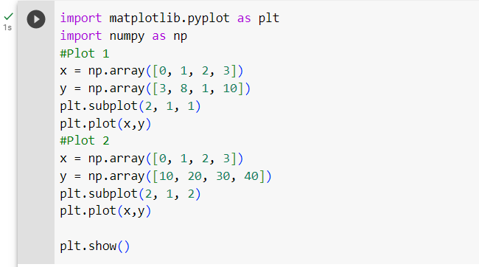
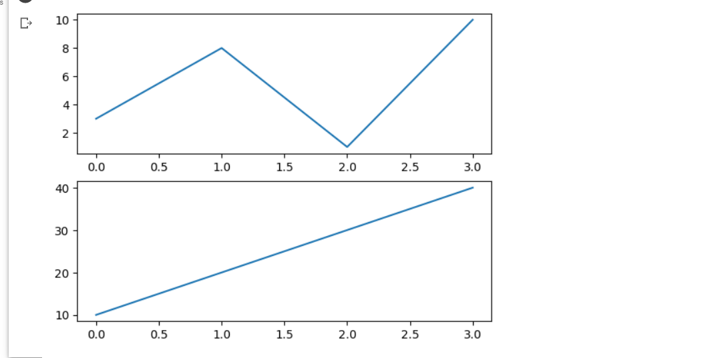

PROGRAM 2:
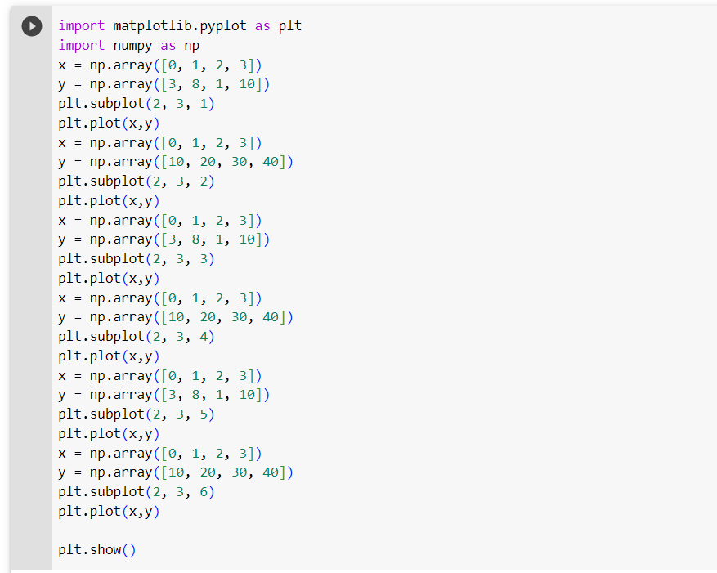
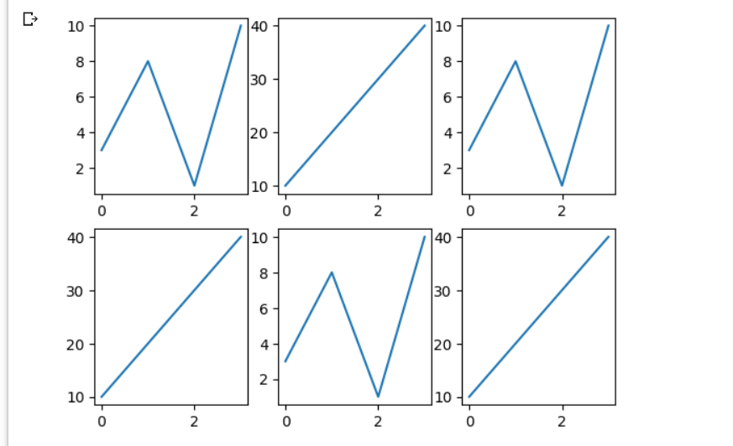

RESULT: Developed multiple plots using subplot function in matplotlib.

WEEK-04

AIM: Demonstrate how to connect to various data sources in Tableau.
DESCRIPTION:
Few Important data sources available in the tableau desktop which are used to connect our data file are:
    - Microsoft Excel
    - Text File
    - JSON File
    - PDF File
    - Google Cloud SQL
    - Google Drive
    - Google Sheets
    - MySQL etc..
DEMONSTATION:
1) Microsoft Excel.
1) Open tableau desktop
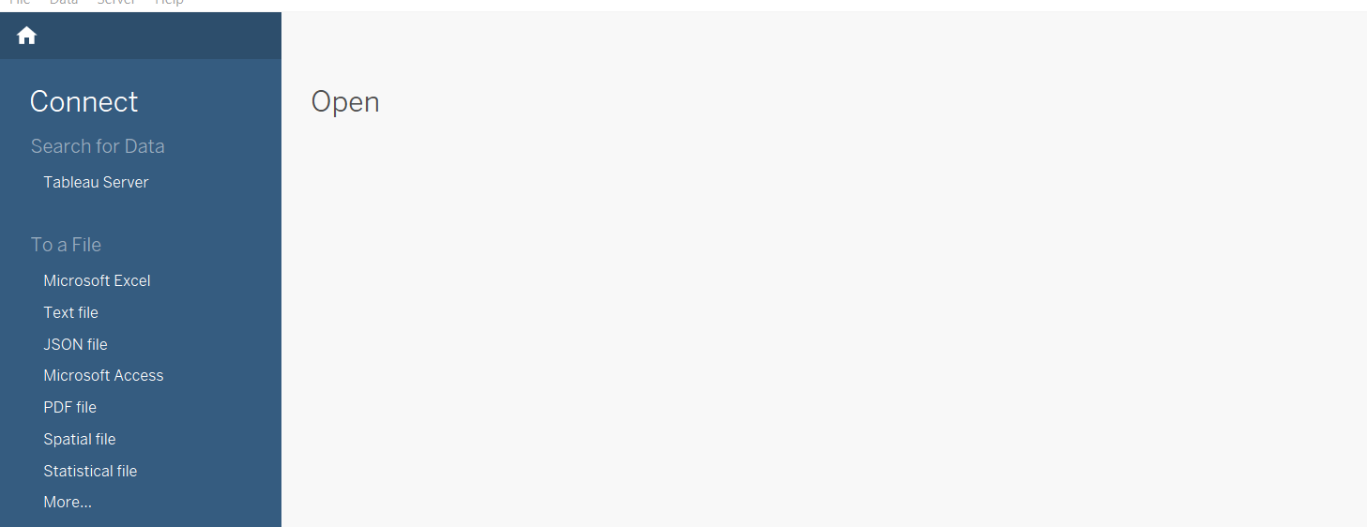
2) Click on Required Data Source Type you want to use and Select the File.
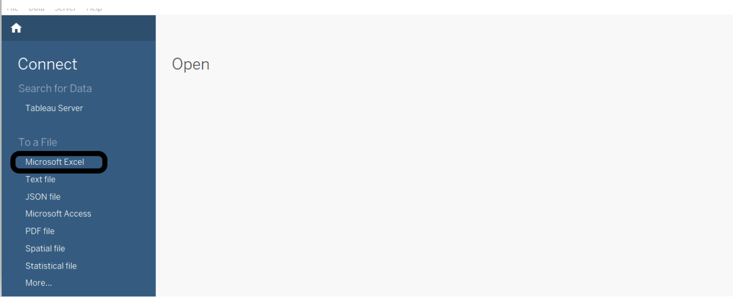
2) Google Drive
STEP 1; click on More
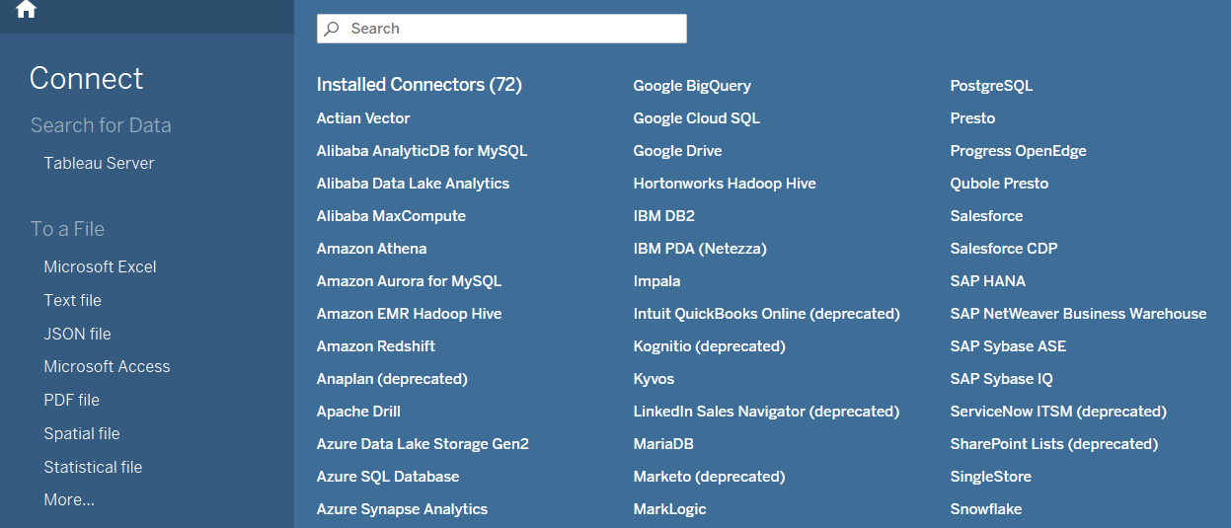
STEP 2: Select Google Drive
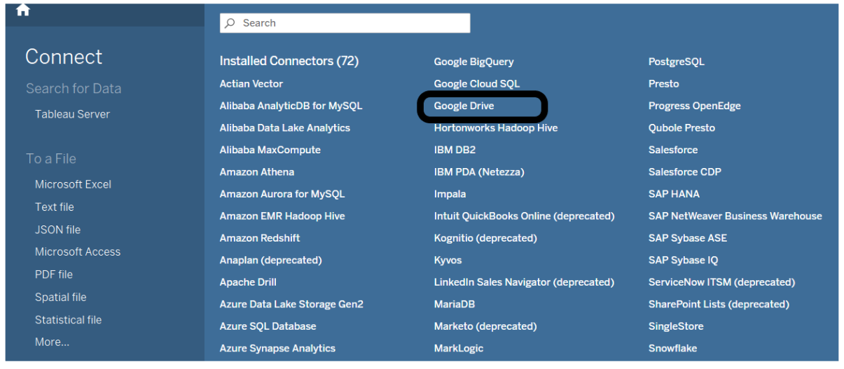
STEP 3: A Sign up box will be displayed. Sign in to your account
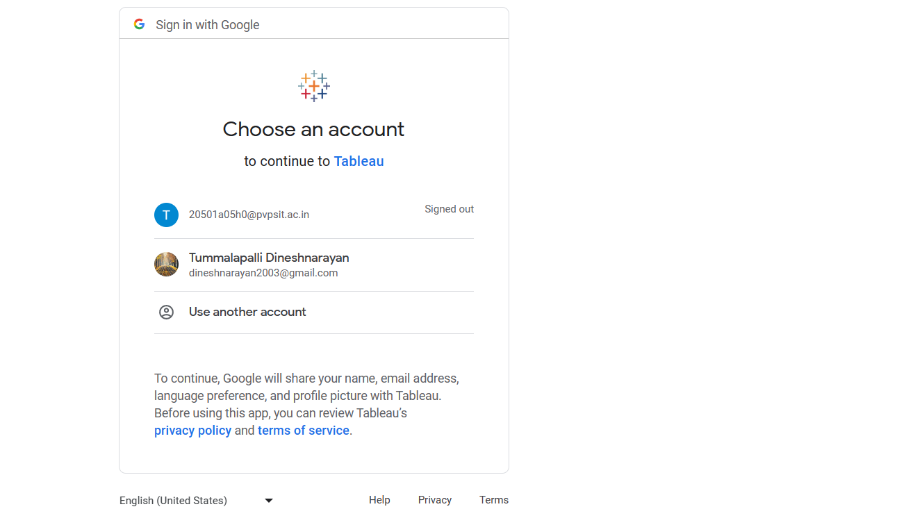

Step 4: Click Allow to access your drive files in your tableau desktop.

Step 5: Select the file you want to use for visuvalization.
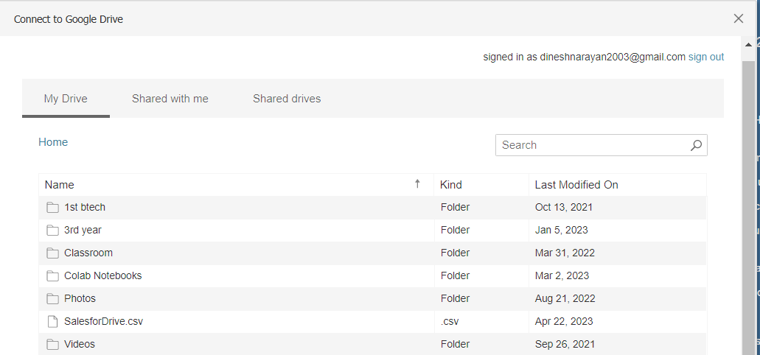

RESULT: Demonstrated successfully how to connect to various data sources in Tableau.

WEEK-05

AIM : Build Data Views from scratch using Tableau.

DEMONSTRATION:

STEP 1) : Create a new Workbook in the tableau desktop.(Click Ctrl+N)
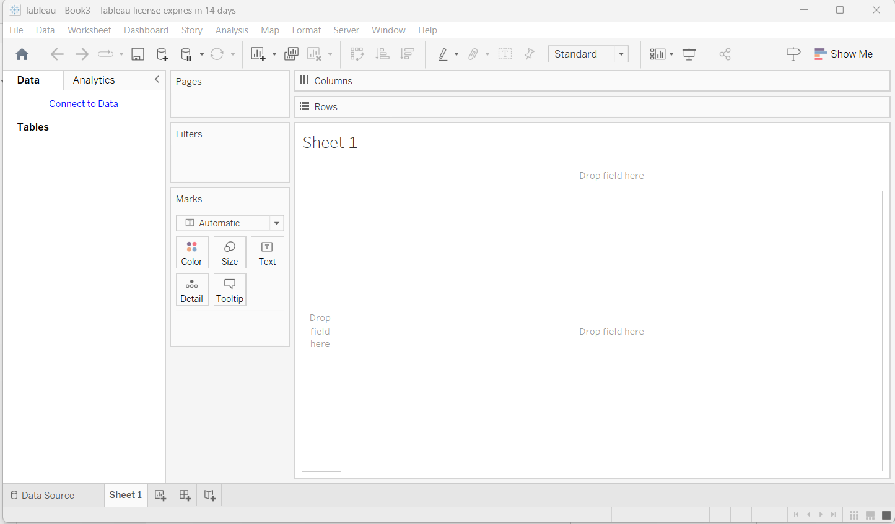
STEP 2) Click on Connect to Data and Select(/Documents/My Tableau Repository/Datasources/version number/[language].)
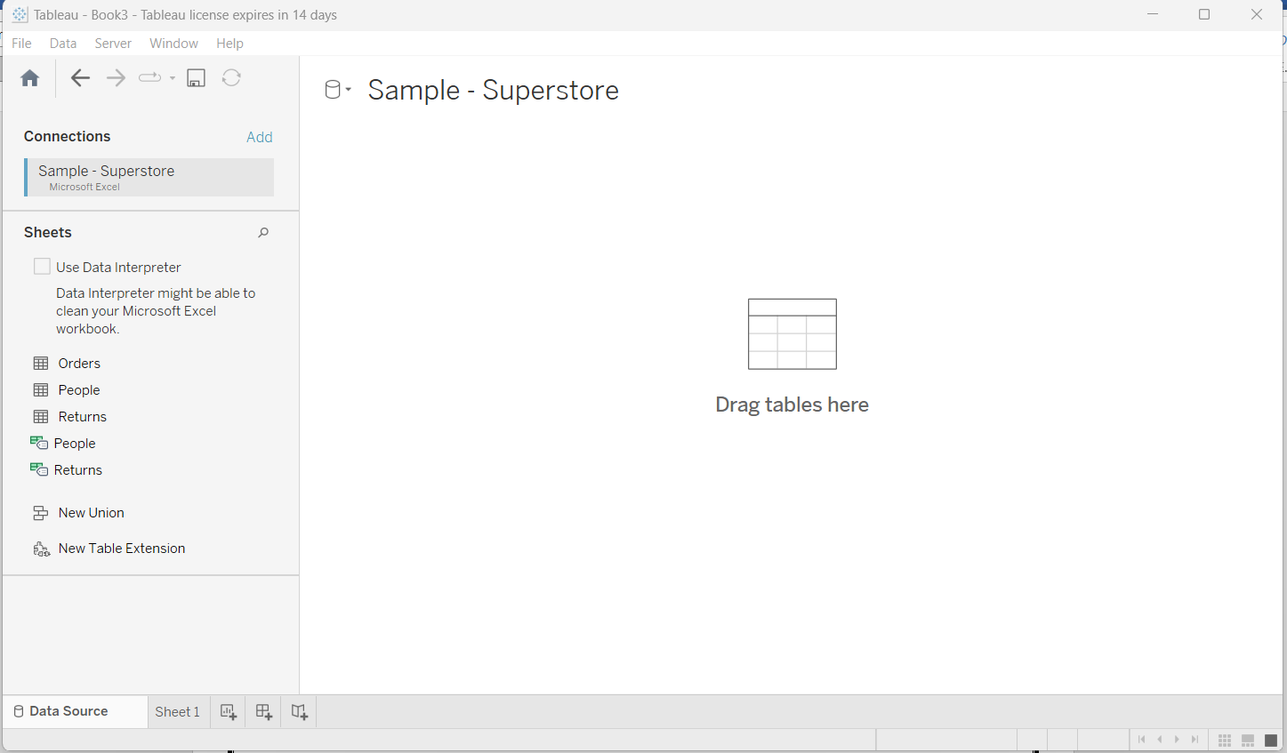
STEP 3) Drag and drop the tables which you want to visualize and click on sheet 1 which is available at the bottom.
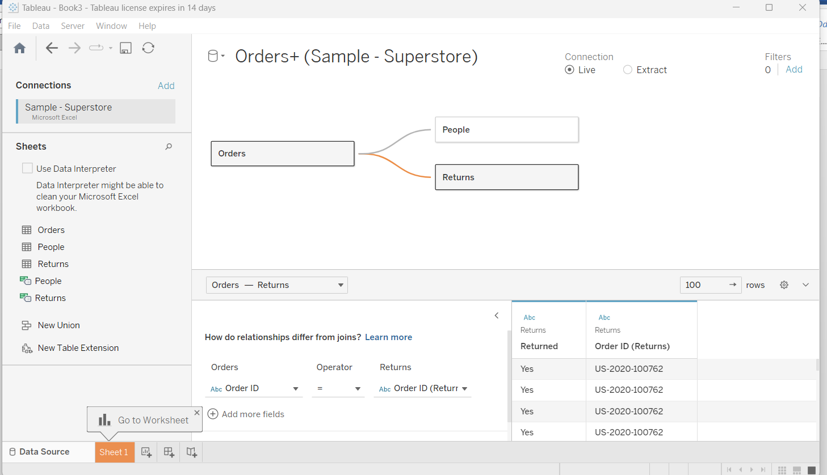

STEP 4) Drap and drop the fields from the Data pane

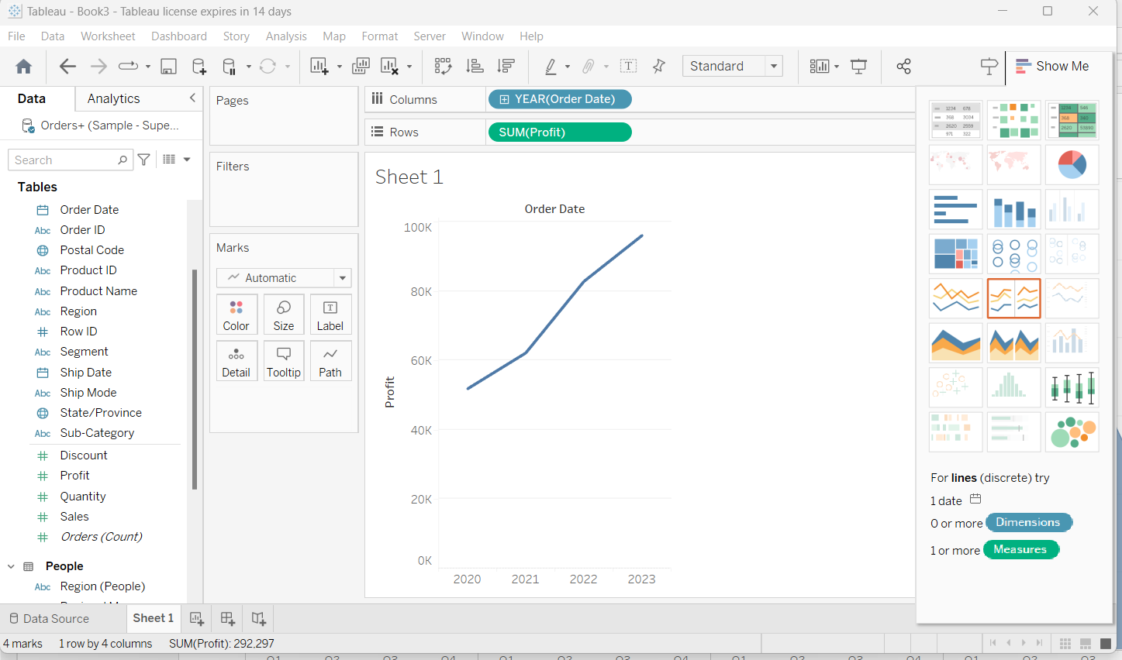

STEP 5) We can visualize data in different views by selecting the views present at right side.
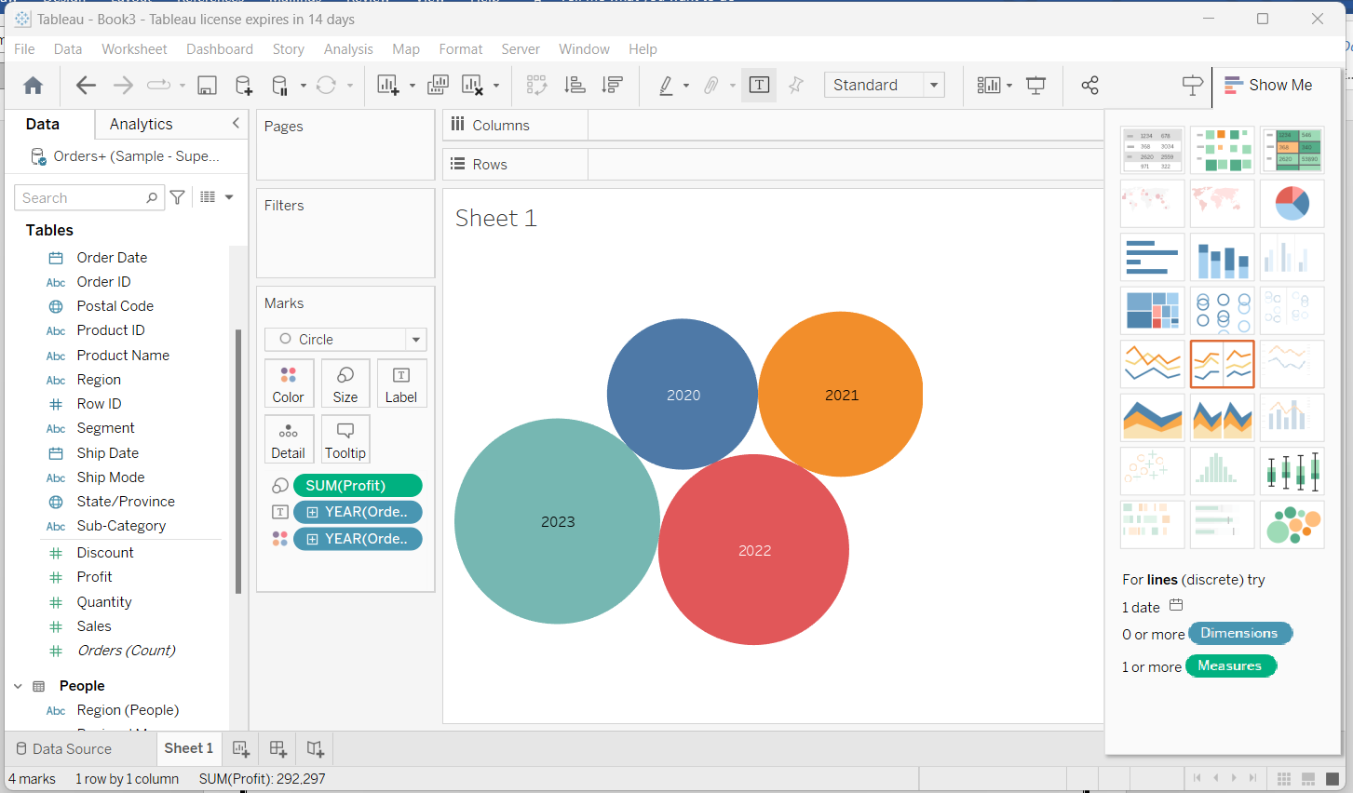
We can modify the colour’s and we can filter the data by using the filter method
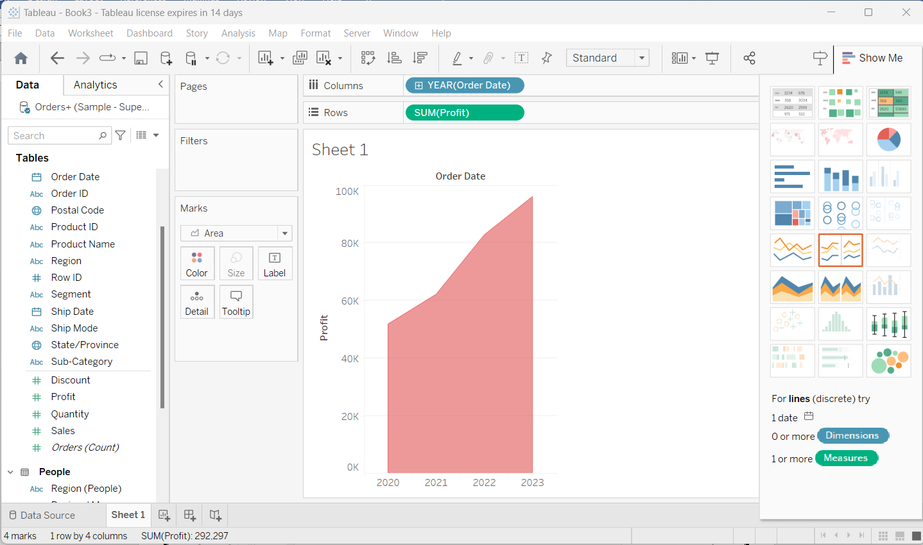
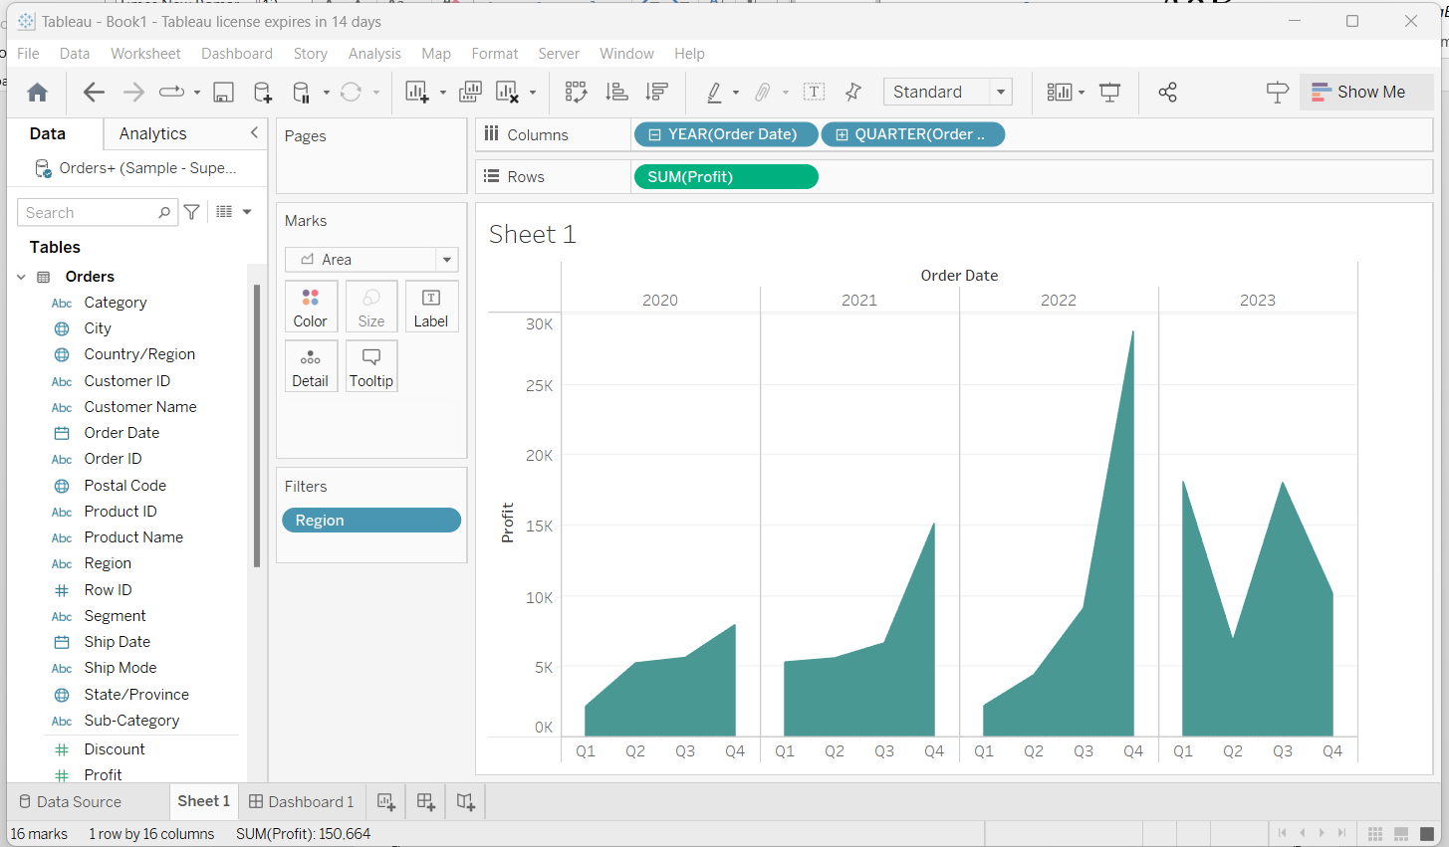

RESULT: Different views are demonstrated from scratch using tableau desktop.

