P.V.P SIDDHARTHA INSTITUTE OF TECHNOLOGY
BRANCH : CSE / IT |  | REGULATION : PVP20
Course: B. Tech | SUBJECT : DISCRETE MATHEMATICAL STRUCTURES
Subject Code: 20BS1303 |  | Year and Semester: II / I
QUESTION BANK
UNIT I
Q. NO. | QUESTION | CO | LEVEL
1 | Construct the Truth Table for (P ∧ (Q⟶ R)) ⟶ (Q⟶ R) | CO2 | L3
2 | i) Show the following equivalences  P → (Q → P) ⇔¬P→ (P → Q)  ii) Show the following without constructing the truth tables  (P → Q) → Q => P V Q | CO1 | L2
3 | i) Prove that $\left[(p∧\text{\sim }q)→r\right]→\left[p→(q∨r)\right]$ is a tautology.  ii) Prove that P ∧ (Q V R) ⟷ ((P∧Q) V (P∧R)) is a Tautology. | CO1 | L2
4 | Obtain the Disjunctive normal form(DNF) and conjunctive normal form (CNF) of the following expression | CO2 | L3
5 | Obtain the principal disjunctive normal form of | CO2 | L3
6 | Obtain the PCNF of the formula A given by (~P -> R) (Q ↔ P) | CO2 | L3
7 | Obtain the principal conjunctive normal form and principal disjunctive normal form of the formula A given by  (∼P → R ) ⋀ ( Q ⟷ P) | CO2 | L3
8 | Show the following equivalencies without using truth tables  ¬ ( P ∧ Q ) → (¬P ∨ (¬ P ∨ Q ) ) ⇔ ( P → Q ) | CO1 | L2
9 | Show that (P ⋁ Q) ⋀ (∼P ⋀ (∼P ⋀ Q)) ⬄ (∼P ⋀ Q) | CO1 | L2
10 | Obtain the principal conjunctive normal form and principal disjunctive normal form of the formula A given by  (P ⋀ Q) ∨ (~P ⋀ Q ⋀ R) | CO2 | L3

UNIT II
Q. NO. | QUESTION | CO | LEVEL
1 | Using rules of inference, Show that R∧ (P V Q) is a valid conclusion from the premises P V Q, Q → R, P → M, and ¬M | CO2 | L3
2 | Show that follows logically from the premises  P∧Q), QvR, R | CO2 | L1
3 | Symbolize the following argument and check for its validity. :  Lions are dangerous animals. There are Lions. Therefore, there are dangerous animals. | CO2 | L3
4 | Apply the rules of inference verify the validity of the following inference: All men are mortal. Socrates is a man therefore Socrates is a mortal | CO2 | L3
5 | Show that (∃ follows logically from the premises  and (∃ x) H(x) | CO2 | L3
6 | Using rules of inference, verify the validity of the conclusion from the premises given below:  Premises: R→(S→~T), ~R v W, ~P→S, ~W  Conclusion: T→P | CO2 | L3
7 | Using rules of inference, Show that RVS follows logically from the premises CvD, (CvD)→~H, ~H→(A∧~B) and  (A∧~B) → (R v S) | CO2 | L3
8 | Show that (x) | CO1 | L2
9 | Given an argument which will establish the validity of the following inference:  All integers are rational numbers. Some integers are powers of 5. Therefore, some rational numbers are powers of 5. | CO2 | L3
10 | Prove by indirect method | CO2 | L3

UNIT III
Q. NO. | QUESTION | CO | LEVEL
1 | Solve recurrence relation $a−3a_{n−1}−4a_{n−2}=0 \text{for} n≥2$ | CO3 | L3
2 | Solve recurrence relation $a−9a_{n−1}+\text{27}a_{n−2}−\text{27}a_{n−3}=0$ | CO3 | L3
3 | Solve $a−7a_{n−1}+\text{10}a_{n−2}=0 \text{for} n≥2 a_{0}=\text{10}, a_{1}=\text{41}$ | CO3 | L3
4 | Solve the recurrence relation  $$\begin{aligned}a−7a_{n−1}+\text{16}a_{n−2}−\text{12}a_{n−3}=0 \text{for} n≥3 \text{with} \text{the} \text{initial} \text{condition} \\ a_{0}=1, a_{1}=4 \text{and} a_{2}=8\end{aligned}$$ | CO3 | L3
5 | Solve the Fibonacci relation $a=a_{n−1}+a_{n−2} \text{with} a_{0}=0, a_{1}=1 \text{as} \text{initial} \text{conditions}$ | CO3 | L3
6 | $$\text{Solve} a=2(a_{n−1}−a_{n−2}) \text{for} n≥2 \text{with} a_{0}=1, a_{1}=2$$ | CO3 | L3
7 | Solve the recurrence relation $a−7a_{n−1}+\text{10}a_{n−2}=6+8n \text{for} n≥2 a_{0}=1, a_{1}=2$ | CO3 | L3
8 | $$\text{Solve} a−a_{n−1}−6a_{n−2} =−\text{30} \text{with} a_{0}=\text{20}, a_{1}=−5$$ | CO3 | L3
9 | $$\text{Solve} a−7a_{n−1}+\text{10}a_{n−2} =4^{n}$$ | CO3 | L3
10 | Solve the recurrence relation $a+a_{n−1} =3n2^{n}$ | CO3 | L3

UNIT IV
Q. NO. | QUESTION | CO | LEVEL
1 | - Define relation?List the special properties of relations  ii.Define complete lattice and complement lattice? | CO1 | L2
2 | Let R = {( a b ), (b ,c ), (c ,d ), (b ,a )} be a relation on A = {a ,b ,c ,d } Find the transitive closure of R | CO1 | L2
3 | Let R be a relation on A = {1, 2, 3, 4, 6} defined by a R b if and only if a is a multiple of b. Represent the relation matrix for R and draw its digraph. | CO1 | L2
4 | Let P (S ) denote the power set defined on S = {1, 2, 3 } The relation R on P (S ) defined by X R Y if and only if X Y ⊆ . Show that R is a partial order on P (S). Draw its Hasse diagram. | CO1 | L2
5 | Draw the Hasse diagram representing the positive integers of 24. Analyse Minimal, Maximal, Greatest and Least elements. | CO4 | L4
6 | Let Z denote the set of integers and the relation R on Z be defined by a R b if and only if (a – b) is an integer. Show that R is an equivalence relation. | CO1 | L2
7 | Identify, which of the partially ordered sets (hasse diagrams) are lattices(with explanation)  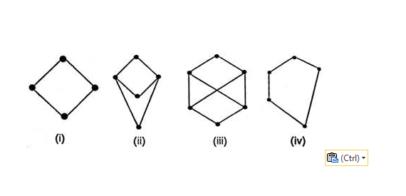 | CO4 | L4
8 | Draw the Hasse Diagram for $D_{6}$,$D_{\text{12}}$,$D_{\text{24}}$,$D_{\text{30}}$,$D_{\text{60}}$,$D_{\text{72}}$ where D is the relation of division. | CO1 | L2
9 | Analyze Warshall’s algorithm with an example. | CO4 | L4
10 | Define Directed graph and Adjacency matrix. Draw the graph for the following adjacency matrix.  $$\begin{aligned}\left[1000 | \right]\left[0100 | \right]\left[1110 | \right] \\ \end{aligned}$$ | CO1 | L2

UNIT V
Q. NO. | QUESTION | CO | LEVEL
1 | Define the following graph with examples  - Cycle graph and Complete graph  - Show that the chromatic number of complete bipartite graph m n, k is 2.  - Explain planar graph, Multigraphs, Euler circuits and Hamilton graph with examples for each. | CO1 | L2
2 | Examine whether the following graphs are isomorphic or not. Justify your answer  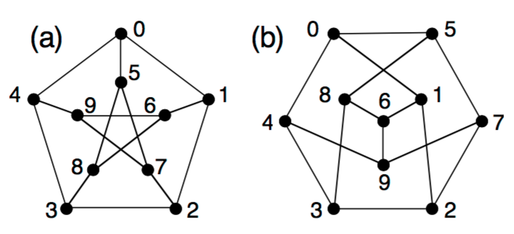 | CO4 | L4
3 | Find the chromatic number of the following graph  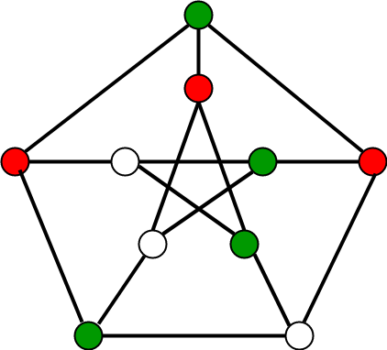 | CO4 | L4
4 | Examine whether the following graph is planar or not. Justify your answer  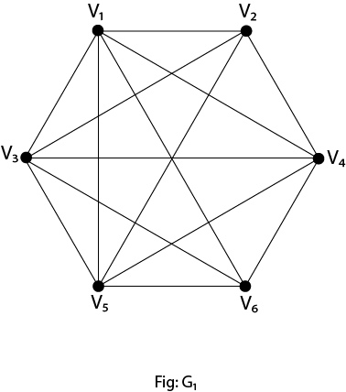 | CO4 | L4
5 | Examine whether the following graph has an Euler circuit. Construct such a circuit if it exists  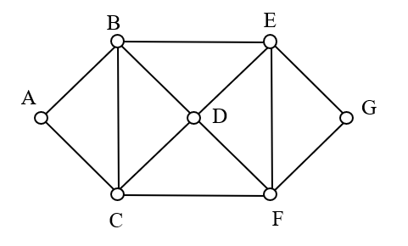 | CO4 | L4
6 | Using Prim’s algorithm discover a minimal Spanning tree for the Weighed graph shown below  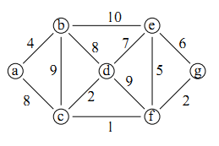 | CO4 | L4
7 | Show that the following graphs are Hamiltonian but not Eulerian.  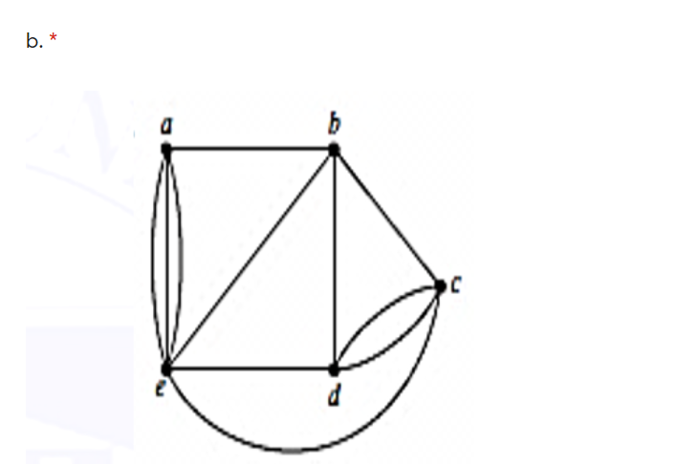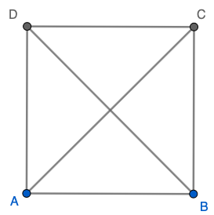 | CO1 | L2
8 | Demonstrate Depth first Search Algorithm with an Example. | CO1 | L2
9 | Using Kruskal’s algorithm discover a minimal Spanning tree for the Weighed graph shown below  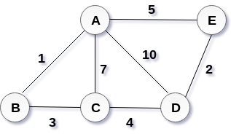 | CO4 | L4
10 | Demonstrate Breadth first Search Algorithm with the following Example.  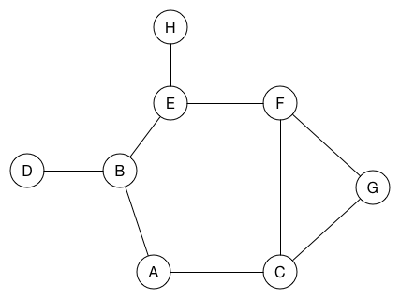 | CO1 | L2

